How have mutations and natural selection affected fur color in mice?

Rock pocket mice live in a desert. Most of this desert is covered by light-colored rocks and sand. Scattered areas have dark rocks.  Some of the rock pocket mice have light-colored fur, and some have dark fur. This difference in fur color is the result of genetic differences.  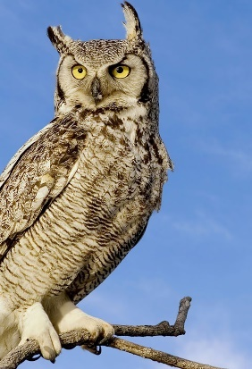  1. Rock pocket mice are eaten by owls, coyotes and other predators that use vision to find their prey. On the light-colored rocks, which color mice would be more likely to survive long enough to reproduce?  light-colored mice ___ dark mice ___ | 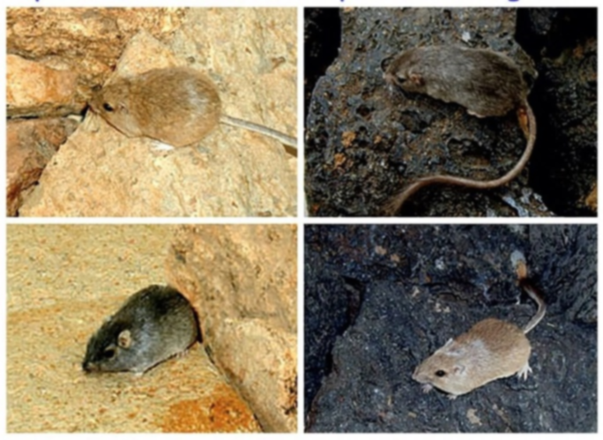

The dark rocks in this desert are cooled lava from volcanic eruptions about 1000 years ago. The light-colored rocks are much older than the dark rocks.

2a. Think about the mice that lived on the light-colored rocks before there were any dark rocks. Which color do you think most of these mice were? light-colored mice ___ dark mice ___

2b. Explain your reasoning.

3a. Your biology teacher says, “Mutations resulted in the alleles for dark fur.” What are mutations?

3b. What are alleles?

4. Based on this information, what do you think happened after the volcanic eruptions about 1000 years ago? As the lava cooled to dark rock, how do you think the populations of rock pocket mice probably changed?

The first figure shows the mice that were living on a little part of a much larger area of light-colored rock. This figure also shows a little part of a new lava flow that was too hot for mice to live on.  The second figure shows the mice in the same area a year later, after the volcanic rock had darkened as it cooled enough for mice to live there. | 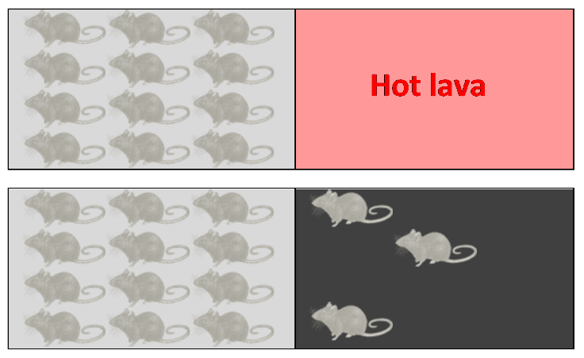

5. What changes occurred between the first and second figures? What caused these changes? (A complete answer will include total number of mice, births, deaths, and migrated.)

Figures A-D show what the population of mice looked like at different times over the next 1000 years.  Figure A shows the result of the continuing increase in the number of mice. Light-colored mice were more likely to be killed by predators on the dark rock. However, the mice had so many babies that there was a large population of light-colored mice on the dark rock.  6a. What do you think happened between figures A and B?  6b. What do you think happened after figure B to cause the changes observed in figures C and D? | 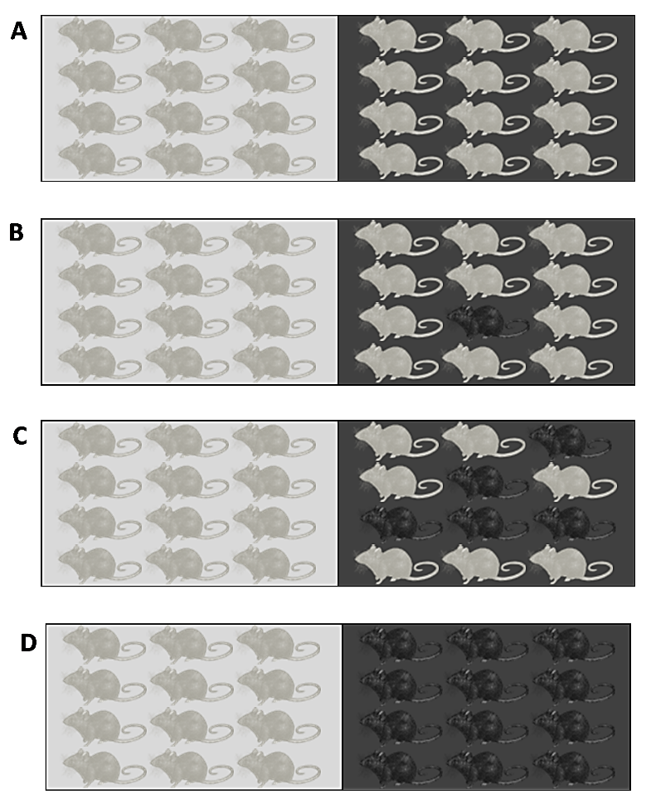

7a. Suppose that a mother mouse that lived on the light-colored rock had a baby mouse with a mutation that resulted in dark fur. Do you think that dark mice would become increasingly common on the light-colored rock? yes ___ no ___

7b. Explain why or why not.

Watch the video “The Making of the Fittest: Natural Selection and Adaptation” (https://www.biointeractive.org/classroom-resources/interactive-questions-natural-selection-and-adaptation). Answer the questions in this video.

8a. What does “fittest” mean in the title, “The Making of the Fittest: Natural Selection and Adaptation”?
- can run the fastest and farthest
- can win fights with other mice
- most able to survive and have offspring

8b. What is the adaptation that increases fitness?

In the process of natural selection, a heritable trait that increases fitness becomes common in a population because:
• Individuals that have this trait are more likely to survive and reproduce.
• Offspring tend to have the same trait as their parents.

9. Explain how the evolution of fur color in rock pocket mice on dark rocks illustrates the above definition of natural selection. For example, what is the heritable trait and how does it influence fitness?

10. As shown in the video, the desert has many miles of light-colored rocks, with scattered areas of dark rock from past volcanic eruptions. Researchers have found that:
- Most of the rock pocket mice that live on these different areas of dark rock have a similar phenotype (dark fur).
- However, different mutations are responsible for the dark fur in two different populations of mice that live on two different areas of dark rock.
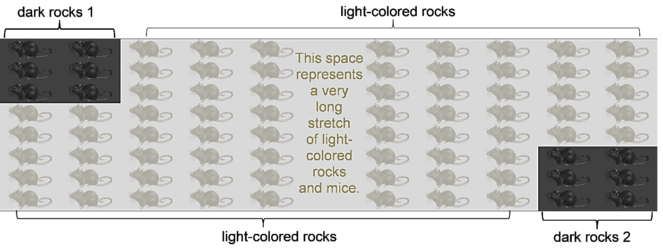
Explain why the mice on two different areas of dark rock have similar phenotypes but different genotypes.

11. Researchers have found an exception to the results described thus far. On one lava flow of dark rock, all the mice have light fur. This lava flow of dark rock is relatively young (<800 years old) and is far from any population of rock pocket mice that have dark fur. What is the likely explanation for why dark fur has not evolved in the population of mice that live on this lava flow?

12a. At the borders between light-colored rock and dark rock, the mice move freely between the two types of rock. One of your classmates thinks that this movement of mice between light-colored rock and dark rock should eventually lead to a mixture of light-colored and dark mice on both types of rock. Why doesn’t this happen?

12b. Does natural selection affect fur color in populations of rock pocket mice that live on light-colored rocks? yes ___ no ___ Explain your reasoning.

13a. How does natural selection affect individual mice? Does an individual mouse change its fur color as a result of natural selection?

13b. How does natural selection affect a population of mice? How does natural selection affect the proportion of a population that has an allele for an adaptive characteristic?

14. What is meant by the following statement?
Mutation is random, but natural selection is not random.

By Ingrid Waldron, Dept Biology, Univ Pennsylvania, © 2024. This Student Handout and Teacher Notes with instructional suggestions and background information are available at https://serendipstudio.org/exchange/bioactivities/NaturalSelectionMice.

