

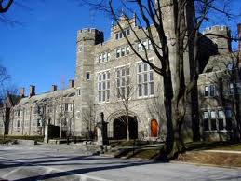

**STATION 4 College**







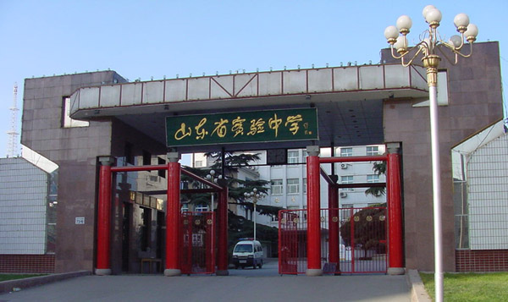

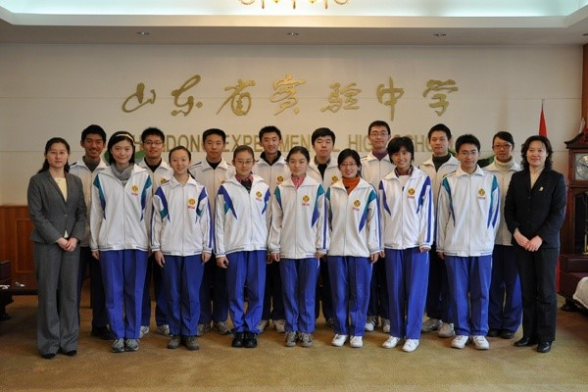

•Competitive •Student Government!! • “American Dream”&SAT •Choice

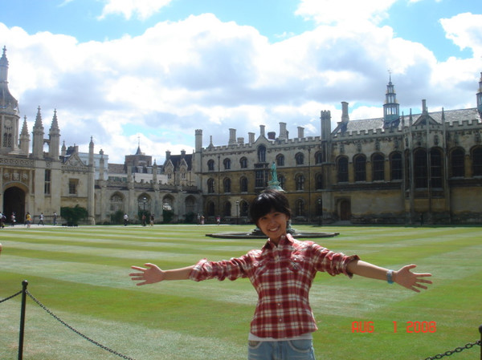









•Ballet Dancer? •Best Friends!! •Books •Graduation Test

 •Athletic •Hardworking •Traveling • England







**STATION 3 High School**

**STATION 2 Middle School**

**STATION 1 Primary School**

**ELLEN’S EDUCATION MAP**