UV, Mutations, and DNA Repair

I. Introduction
Sunlight contains all the colors of the rainbow, which correspond to light of different wavelengths. Sunlight also contains ultraviolet (UV) light, including UVA, UVB and UVC, which have progressively shorter wavelengths.
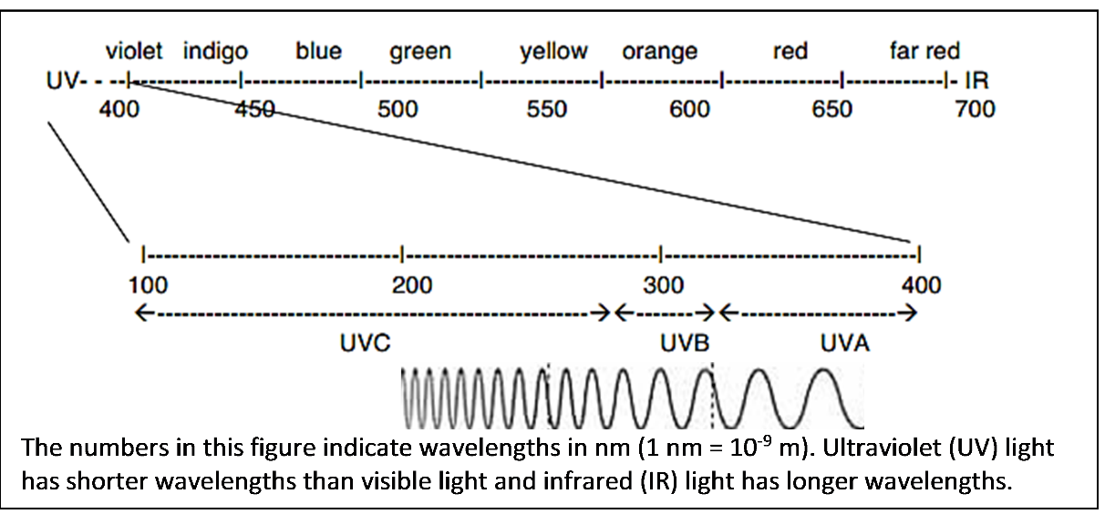

UV light can damage DNA. For example, when UVC light strikes a DNA molecule, two nucleotides that are next to each other in a DNA strand can bond together and form a dimer. The dimer distorts the shape of the DNA double helix.  1. Circle and label the dimer in the figure. | 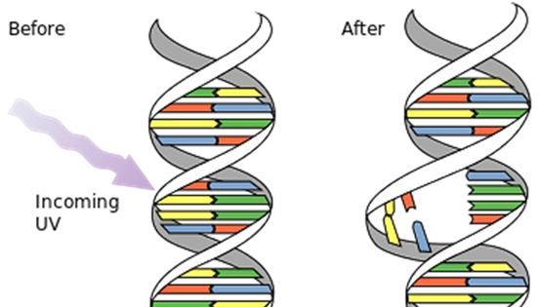

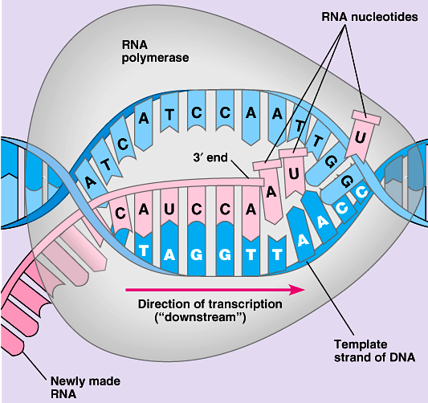
2. Explain how a dimer would interfere with transcription, the first step in protein production. (Include RNA polymerase in your answer.)

3a. Germicidal lights, which produce mainly UVC, are used to kill bacteria and other microorganisms. How could exposure to UVC kill a bacterium? (Include dimers, proteins and transcription in your answer.)

3b. Even if a bacterium is not killed by UV light, the effects of UV light can prevent the bacterium from dividing into two daughter cells. Explain how this could happen. (Include DNA polymerase in your answer.)

3c. After a very brief UVC exposure, many of the bacteria may have little or no DNA damage. A longer UVC exposure can cause more DNA damage and thus have a bigger effect on a population of bacteria. Explain why a small population of bacteria can grow to become a much larger population of bacteria after a very brief UVC exposure, but not after a longer UVC exposure.

The DNA in cells is constantly being damaged by multiple causes, not just UV light. One scientist has estimated that the DNA in a single cell can experience half a million DNA changes per day. If the DNA damage is not repaired or the repair is inaccurate, this introduces a mutation (a permanent change in the DNA). Many mutations have harmful effects.

4. Describe some of the other causes of DNA damage and mutations, in addition to UV light.

5. Many mutations involve a change in the nucleotide sequence in the DNA. Use your understanding of molecular biology to explain how a change in the nucleotide sequence can be harmful.

To maintain the accuracy of the DNA code and prevent these harmful effects, cells need to be able to repair DNA damage. In fact, evolution has produced multiple molecular mechanisms for DNA repair.

One type of DNA repair is called photorepair. In photorepair the enzyme, photolyase, uses energy from visible light to break the abnormal bond in a dimer and restore the DNA to its original, normal structure.
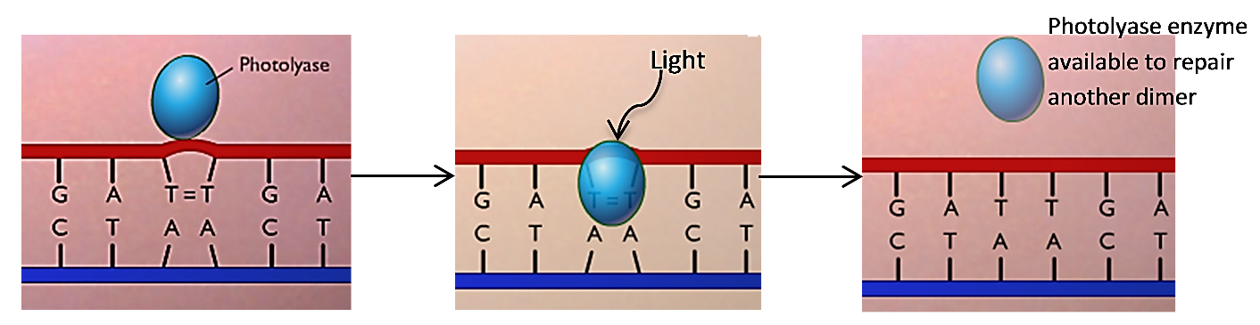

6. In one experiment, scientists exposed two populations of archaea to the same intermediate-duration of UVC. (Like bacteria, archaea are single-cell prokaryotic organisms.)

After this UVC exposure, one population of archaea was immediately put in the dark and the other population of archaea had a chance to recover in the light. The population of archaea that recovered in the light had much higher survival and more cell division, resulting in more population growth.

Give a molecular explanation for why the archaea that recovered in the light were more likely to survive and produce daughter cells.

II. Testing for DNA Damage and Photorepair of DNA in Haloferax volcanii

Haloferax volcanii is a type of archaea that lives in very salty water such as the Dead Sea, Great Salt Lake, or the very salty brine that results when seawater is evaporated to produce salt. In these very sunny environments Haloferax is exposed to intense UV light. Your experiment will test two research questions:
- What are the effects of different amounts of UVC light on Haloferax survival and growth?
- Does Haloferax have a photorepair mechanism that can reverse the DNA damage caused by UVC light?

Each student group will spread Haloferax on a plate of agar that contains the nutrients needed by Haloferax. For each plate, four sectors will each have a different duration of UVC exposure.  After the UVC exposures, half the plates will be wrapped so the Haloferax are not exposed to visible light, and the other plates will not be wrapped so the Haloferax can recover in visible light. After a recovery period, the plates will be incubated so any healthy Haloferax cells can produce daughter cells. | Duration of UVC exposure

7a. Which research question can be investigated by comparing the wrapped plates vs. the unwrapped plates? ___A ___B

7b. Explain your reasoning.

For each sector of the plate:
- If many Haloferax cells survive and produce daughter cells, then Haloferax will cover the whole sector and you will see a pink coating of Haloferax on the agar; this is called a lawn.
- If only a few Haloferax cells survive and produce daughter cells, you will see a few colonies; each colony includes the many, many descendants of a single cell that survived UVC exposure.
- If the UVC exposure kills all the Haloferax cells in a sector, you will see no growth in that sector.

8. In the above figure, use an L to mark the sector that will be most likely to have a lawn.
Use an N to mark the sector that will be most likely to have no lawn and no colonies.

Experimental Procedure
- Each group should get and label a plate.
- On the bottom draw four sectors and label each sector with the appropriate duration of UVC exposure, as shown in the above figure.
- If your group has been assigned a plate that will be wrapped and have no Visible Light Exposure after the UVC exposures, write "no VLE". If your plate will not be wrapped, write "VLE".
- Add your group initials.

- Rub your swab (Q-tip) gently on the plate with Haloferax. Streak the Haloferax onto your plate. Make sure to cover the whole plate by first spreading the Haloferax cells from one side to the other in one direction and then rotating the plate 90° and spreading the Haloferax cells from one side to another in the perpendicular direction. | 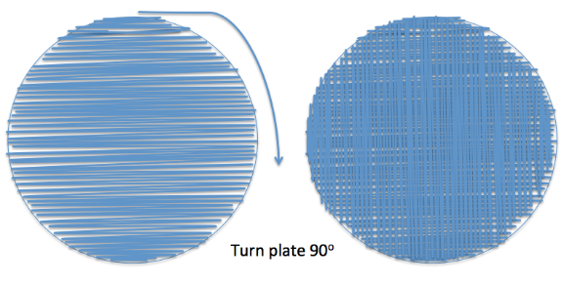
- To prepare the plate for UVC light exposure, you will take the lid off the plate and cover the plate with plastic wrap. (UVC can penetrate the plastic wrap to reach the Haloferax. UVC cannot penetrate the lid of the plate.) Spread your piece of plastic wrap flat (no wrinkles) on your lab table, place the plate upside down onto the plastic wrap, and pull the plastic wrap tightly around the plate. (You will probably need to tug the plastic wrap tight at four or five points around the plate to get rid of all the wrinkles. Cut off any excess plastic wrap on the bottom.)
- As shown in the table below, you will make three 15 second UV exposures for each plate; for each 15 second exposure, pieces of heavy paper or plastic lid on the plastic wrap will cover specific sectors of the plate to prevent the UV light from reaching the Haloferax on those sectors.
 | Sectors which will be covered by cardboard pieces
 | 0 sec. | 15 sec. | 30 sec. | 45 sec.
During the first 15 sec. exposure
During the second 15 sec. exposure
During the third 15 sec. exposure

- Since UV rays can be harmful, the UV light will be inside a protective cardboard box. To prepare for each UV exposure, put your plate on the circle marking the center of the UV light and place the paper or lid pieces to cover the appropriate sectors.
- Put the cover on the front of the box before you turn on the UV light. Also, the student who is making the exposure will wear goggles. Do not look at the lamp or expose your skin to UV. Turn on the UV light switch which is outside the box for 15 seconds for each exposure.
- As soon as the UV exposures have been completed, take off the plastic wrap and put the lid back on your plate. If you have been assigned a plate with no visible light exposure, immediately wrap your plate in aluminum foil.
- Give your plate to your teacher.

While you're waiting for all the groups to finish the UV exposures, answer questions 9 and 10.

9. The unwrapped plates will be put near a window for exposure to the visible light that is needed for photorepair. Should the wrapped plates also be put near the window or should they be put in a dark drawer? Explain your reasoning.

10. UVB and UVA are contained in sunlight and in the light from tanning lamps. UVB and UVA can induce mutations in the DNA of your skin cells. After intense exposure to sunlight or tanning lamps, the DNA of some skin cells is so severely damaged that the cells die. If the amount of UV exposure is sufficient to cause sunburn, dead cells will be removed as part of the peeling skin.

With shorter or less intense exposures to the UV in sunlight or the light from tanning lamps, skin cells with less severely damaged DNA can survive. Explain why the cells with damaged DNA may have different characteristics from normal skin cells.

Results (to be completed after the Haloferax on the plates have grown for several days)

11. Draw the growth on your plate. Label each sector with:
- L if it had a lawn
- C if it had colonies
- N for no colonies or lawn.
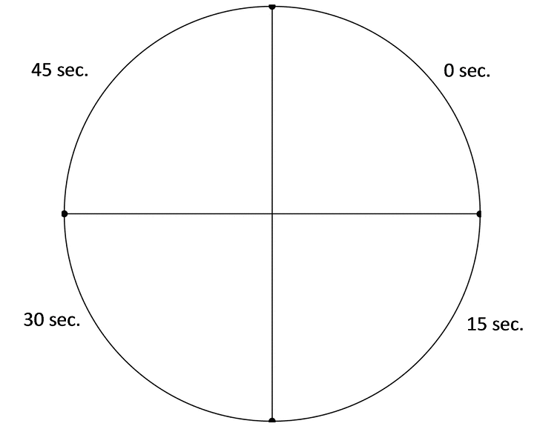

Was your plate ___ no VLE or ___ VLE?

Report your results to your teacher.

While you're waiting for your teacher to compile the results from all the groups, answer question 12.

12. Explain how a few Haloferax cells could survive to produce colonies even on a sector of the plate that received a generally lethal dose of UVC. Use your imagination to come up with possible reasons!

13a. Once the results from all of the student groups have been compiled, your teacher will provide the information you need to complete this table.
For sectors with this UVC exposure: | followed by visible light exposure | or | followed by no visible light exposure
 | % with lawn |  | % with lawn
0 seconds
15 seconds
30 seconds
45 seconds

13b. Graph the values from the above table. Use:  • for results with visible light exposure after the UVC  ○ for results with no visible light exposure after the  UVC | 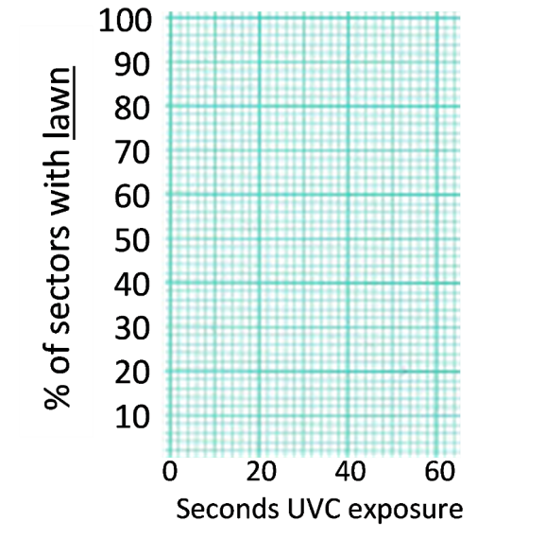

Interpretation
14. Do these results support the prediction that longer duration UVC exposures kill more of the Haloferax? Explain how your conclusion is supported by the results of the experiment.

15a. For the plates with visible light exposure, estimate the lethal exposure time (the minimum duration of UVC exposure that results in no lawn of Haloferax). Based on your class data, what is the range of possible values for the lethal exposure time?

15b. For the plates with no visible light exposure, estimate the lethal exposure time. What is the range of possible values for this lethal exposure time?

16. Based on the evidence from your class experiment, did photorepair occur in the Haloferax? Explain your reasoning.

17. What procedures could you use to get a more precise estimate of the lethal exposure times?

18a. Your results suggest a paradox. In your experiment, a brief exposure to UVC light killed Haloferax, even when the Haloferax had a chance for photorepair. But we know that Haloferax survive in very sunny environments, even though sunlight contains a lot of UV light.

To begin to understand this seeming paradox, mark the portion of the X-axis that corresponds to UVC in the figure below. (Hint: See the figure near the top of page 1.)
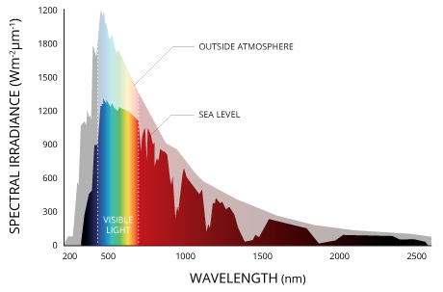
INTENSITY OF LIGHT ENERGY
AT EACH WAVELENGTH

The upper gray area indicates the intensity of the sun's energy that reaches the earth's outer atmosphere. The lower darker (or colored) area indicates the intensity of the sun's energy that reaches the surface of the earth at sea level. Notice that much of the UV light in sunlight is absorbed by the ozone in the earth's atmosphere.

18b. What happens to the UVC light that reaches the earth's outer atmosphere?

18c. Explain how Haloferax can survive in very sunny environments.

III. How well does sunscreen protect cells against UV light?

Sunscreen helps to prevent sunburn and reduce the risk of skin cancer by reducing the amount of UV light that reaches skin cells. In theory, a sunscreen with an SPF (skin protection factor) of 15 increases the amount of time a person can stay in the sun without getting sunburned by a factor
of 15. However, to actually achieve adequate protection, sunscreen should be reapplied every two hours and after swimming or heavy sweating.

19. Describe an experiment to answer this question:
Does SPF 15 sunscreen applied to the plastic wrap over a plate with Haloferax increase the lethal exposure time by a factor of 15?
Use your results in question 14 to plan the specific durations of UVC exposure in your experiment.

Your teacher will lead a discussion to develop a class plan for an experiment to test whether SPF 15 sunscreen increases the lethal exposure time by a factor of 15. Your class will carry out this experiment.

While you're waiting for your classmates to finish the UV exposures for the sunscreen experiment, read "IV. Mutations and Cancer" and answer questions 21-25 (on the next two pages).

Results (to be completed after the Haloferax on the plates have grown for several days)

20a. Summarize the results of your class sunscreen experiment.

20b. Do these results support the conclusion that SPF 15 sunscreen increased the lethal exposure time by a factor of 15? If yes, explain your reasoning. If no, explain what conclusion is supported by the results.

20c. Compare the different plates to see if there was any variation in results for sectors that had the same UV exposure. If yes, describe the variation and suggest what could have caused this variation.

IV. Mutations and Cancer
You have seen how UVC exposure can cause cell death due to lethal mutations in Haloferax. The UVB and UVA in sunshine and tanning lamps can also cause mutations. As discussed in question 10, mutations often do not result in cell death, but instead change the characteristics of a cell. For example, an accumulation of mutations can result in the development of cancer cells which multiply excessively and can invade nearby tissues.

Melanocytes are skin cells that produce the pigment melanin. This figure shows how mutations can change melanocytes into increasingly abnormal cells that eventually become melanoma, the most dangerous type of skin cancer. First, mutations in genes that code for proteins that regulate cell division can result in excessive cell division. Then, additional mutations can result in cancer cells that can enter blood vessels so the cancer can spread to other parts of the body.

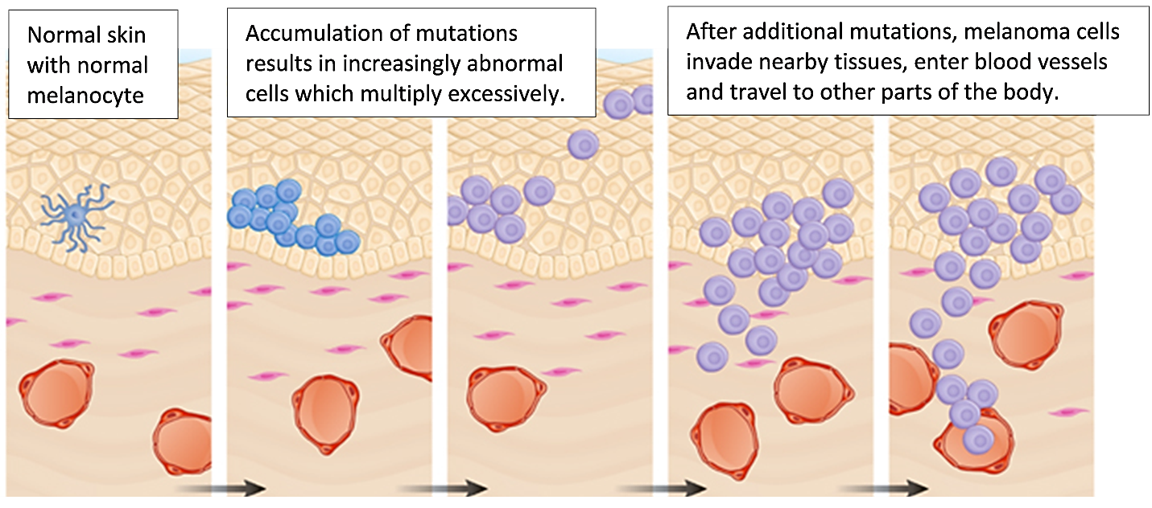

21. Explain how exposure to intense sunshine or tanning lamps can increase a person's risk of developing melanoma.

22. Some people inherit a mutation that causes their cells to have defective DNA repair mechanisms. Explain why these people have an increased risk of cancer.

This figure shows how, over a lifetime, mutations can accumulate in a cell line (a cell and its descendants). The development of a cancer requires the accumulation of multiple mutations in a single cell line. Mutations that contribute to the development of cancer are relatively rare, so it typically takes decades for a cell line to accumulate the multiple mutations that cause cancer.
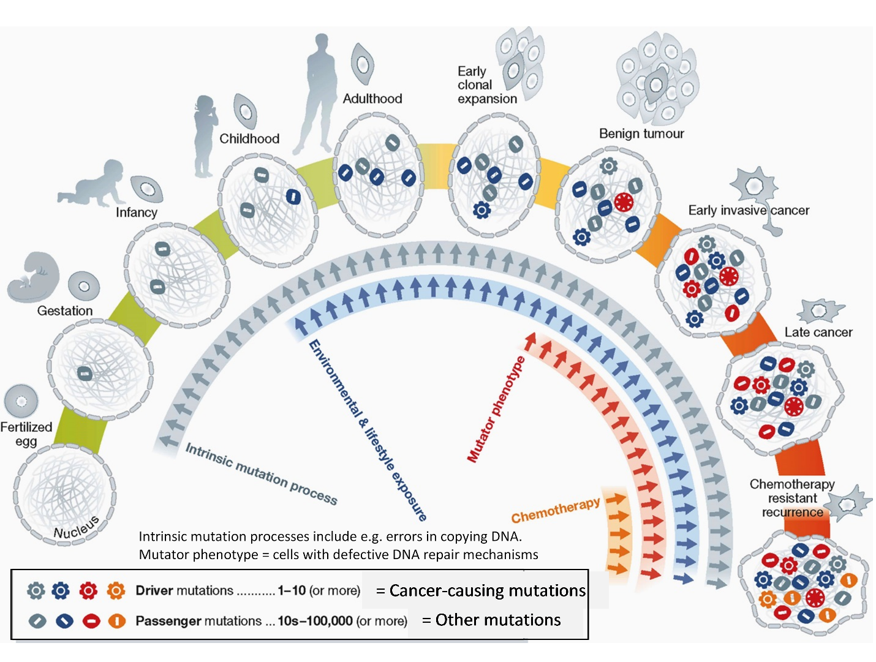
¹ (From: Stratton, M. R. (2013), Journeys into the genome of cancer cells. EMBO Mol Med, 5: 169–172. doi:10.1002/emmm.201202388).

23. Give two examples of environmental and lifestyle exposures that can increase a person’s risk of cancer.

24. Explain how your behavior as a teenager (e.g. high exposure to the UV in sunlight or tanning beds) can affect your risk of developing cancer decades later as an older adult.

25. If a cell is unable to repair DNA damage, molecular processes within the cell may result in cell suicide (programmed cell death). When a cell in your body has DNA damage that the cell cannot repair, how could cell suicide be helpful?

By Dr. Ingrid Waldron, Joshua Kouassi, Dr. Manuela Tripepi and Dr. Mecky Pohlschroder, Department of Biology, University of Pennsylvania, 2016. This Student Handout (intended for use in university classes) and Teacher Preparation Notes with instructional suggestions and background information are available background information are available at http://serendipstudio.org/exchange/waldron/HaloferaxUV.

