Teacher Notes for “Soap Opera Genetics – Genetics to Resolve Real-Life Dilemmas”

This analysis and discussion activity contains three "soap opera" episodes that help students to understand the principles of inheritance and the relevance of genetics to everyday life. In the first episode, students answer the probing questions of a skeptical father who wants to know how his baby could have albinism when neither he nor his wife have albinism. The second episode, "Were the babies switched?", covers the concepts of codominance, incomplete dominance, and polygenic inheritance, and reinforces student understanding that the alleles of a gene give the instructions for making different versions of a protein. In the third episode, students analyze sex-linked inheritance. Each episode can be used separately or with other episodes, depending on your teaching goals.

Before beginning this activity, students should have a basic understanding of:
- how meiosis and fertilization result in inheritance and how these processes are summarized in Punnett squares
- dominant and recessive alleles, with heterozygous individuals having the same phenotype as homozygous dominant individuals.
To provide this background you may want to use the first four pages of “Introduction to Genetics – Similarities and Differences between Family Members” (https://serendipstudio.org/exchange/bioactivities/geneticsFR) or the first three pages of "Genetics" (https://serendipstudio.org/sci_edu/waldron/#genetics).

Learning Goals Related to National Standards
In accord with the Next Generation Science Standards and A Framework for K-12 Science Education:
      - Students will gain understanding of several Disciplinary Core Ideas:
- LS1.A: Structure and Function –"All cells contain genetic information in the form of DNA molecules. Genes are regions in the DNA that contain the instructions that code for the formation of proteins."
- LS3.A: Inheritance of Traits – "The instructions for forming species' characteristics are carried in DNA."
- LS3.B: Variation of Traits – In sexual reproduction, meiosis and fertilization can create new genetic combinations. Environmental factors also affect the expression of traits.
- Students will engage in several Scientific Practices:
- Constructing Explanations: “Apply scientific ideas, principles, and or evidence to provide an explanation of phenomena….”
- Engaging in Argument from Evidence: “Compare and evaluate competing arguments… in light of currently accepted explanations….”
- Developing and Using Models: “… use a model… to generate data to support explanations, predict phenomena, analyze systems, and/or solve problems.”
- This activity provides the opportunity to discuss the Crosscutting Concept, Cause and Effect: Mechanism and Prediction: “Cause and effect relationships can be suggested and predicted for complex natural… systems by examining what is known about smaller scale mechanisms within the system.”
- This activity helps to prepare students for the following Performance Expectations.
- HS-LS3-1, "Ask questions to clarify relationships about the role of DNA and chromosomes in coding the instructions for characteristic traits passed from parents to offspring."
- HS-LS3-2, "Make and defend a claim based on evidence that inheritable genetic variations may result from: (1) new genetic combinations through meiosis…"
- HS-LS3-3, "Apply concepts of statistics and probability to explain the variation and distribution of expressed traits in a population."

This activity will also help students meet Common Core English Language Arts Standards for Science and Technical Subjects, including "write arguments focused on discipline-specific content".

Additional, content learning goals for each section are presented below.

General Instructional Suggestions
To maximize student learning, we recommend that you have your students work individually or in pairs to complete each group of related questions and then have a class discussion of student answers to these questions. In each discussion, you can probe student thinking and help them to develop a sound understanding of the concepts and information covered before moving on to the next part of the activity.

If your students are learning online, I recommend that they use the Google Doc version of the Student Handout available at https://serendipstudio.org/exchange/bioactivities/SoapOperaGenetics. You may want to revise the Word document or Google Doc to prepare a version of the Student Handout that will be more suitable for your students. If you use the Word document, please check the format by viewing the PDF.

If you would like to have a key with the answers to the questions in the Student Handout, please send a message to iwaldron@upenn.edu. The following paragraphs provide additional instructional suggestions and background information – some for inclusion in your class discussions and some to provide you with relevant background that may be useful for your understanding and/or for responding to student questions.

How could our baby be albino?
Content Learning Goals
- Students will understand how meiosis and fertilization provide the basis for inheritance of genes.
- Students will understand how to interpret Punnett squares, including prediction of the genotypes of offspring and determination of phenotypes based on understanding recessive and dominant alleles.
- Students will understand the limitations of Punnett square predictions, including that:
  - Punnett square predictions are limited to couples with the specified genotypes. To predict the population prevalence of phenotypes you need to know the population prevalence of genotypes.
  - Random variation in which sperm fertilizes which egg means that the genotype of each sibling is independent of the genotype of any previous siblings. As a result, the distribution of genotypes of siblings in an individual family often deviates from Punnett square predictions.

Suggestions for Implementation and Biology Background
If your students have completed the recommended introductory part of “Introduction to Genetics – Similarities and Differences between Family Members” (https://serendipstudio.org/exchange/bioactivities/geneticsFR) or "Genetics" (http://serendipstudio.org/sci_edu/waldron/#genetics), then this first "Soap Opera Genetics" episode can be used for review and assessment. You can enhance student learning and retention of important concepts and vocabulary by having your students complete this episode using active recall (without referring to previous notes or materials), and then providing prompt feedback to clarify any points of confusion and correct any misconceptions (by having a class discussion of student answers).

Questions 1-3 engage students in explaining genetics concepts and Punnett squares to Joe. This approach follows the principle that one way to develop better understanding of a concept is to try to teach it to someone else. This episode assumes that the child has a different phenotype than either parent because both parents are heterozygous for a recessive allele. The possibility that the different phenotype of the child could be due to a new mutation is not discussed, since that would be rare.

The allele for normal skin and hair color codes for a functional enzyme (tyrosinase) that produces melanin (the pigment that gives color to skin and hair). This allele is dominant because, even when there is only one copy of this allele, it codes for enough functioning enzyme to produce enough melanin to prevent albinism. The recessive albinism allele codes for a nonfunctional protein that does not produce melanin. Recessive alleles often code for a non-functional protein, while dominant alleles often code for a functional protein. The single dominant allele in a heterozygous individual can code for enough functional protein so the phenotype of the heterozygous individual is the same as the phenotype of an individual who is homozygous for the dominant allele.

To reinforce student understanding that genes code for proteins, you may want to add the following question after question 2d.

2e. How do genes influence whether or not a person has albinism?

In the most common form of albinism, the lack of the pigment melanin affects not only skin and hair color, but also the appearance and function of the eyes. For additional information about albinism, see https://medlineplus.gov/ency/article/001479.htm and https://omim.org/entry/203100.

Question 4 provides the opportunity to discuss the distinction between the predictions of Punnett squares and population prevalence of alleles and phenotypes. Discussion of question 5 should reinforce student understanding that each fertilization event is independent of previous fertilization events. As discussed in the Coin Flip Genetics section of “Genetics” (https://serendipstudio.org/sci_edu/waldron/#genetics), random variation in small samples accounts for the discrepancies between the characteristics of siblings in individual families and Punnett square predictions (which are accurate for large samples of the children of parents with the specified genotypes). Discussion of student answers to questions 4 and 5 should help students understand important points to consider when interpreting Punnett square predictions.

Were the babies switched?
Content Learning Goals
- Students will understand that genes code for proteins which influence a person's characteristics.
- Students will understand codominance (when both alleles of a gene have different observable effects on the phenotype of a heterozygous individual).
- Students will understand incomplete dominance (when the phenotype of a heterozygous individual is intermediate between the phenotypes of the two different types of homozygous individuals).
- Students will understand that some genes have more than two alleles.
- Students will understand that some characteristics are influenced by multiple genes and environmental factors.
- More practice with Punnett squares

Biology Background and Suggestions for Implementation
Question 1 is designed to get students thinking about the inheritance of blood types and skin color. This question is revisited in questions 6-7 and 10-11.

The Genetics of Blood Types
This section of the Student Handout (especially page 4) provides the opportunity to reinforce student understanding that:
- genes code for proteins which influence an organism’s characteristics
- genes often have more than two alleles.
Specifically, question 2 provides the opportunity to reinforce student understanding that genes code for proteins which influence an organism’s characteristics.

The figure below shows that the A and B transferase enzymes add different monosaccharides to the end of an oligosaccharide that had previously been attached to a protein or lipid in the cell membrane. The Student Handout does not mention that other enzymes are needed to add each monosaccharide in the oligosaccharide.

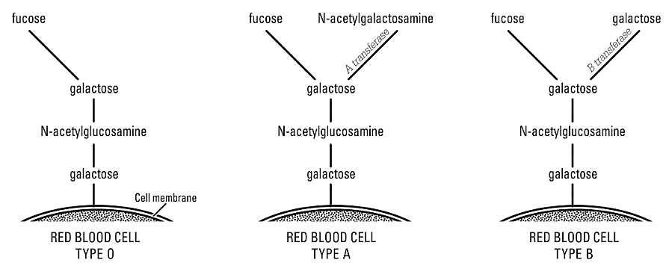
(From “ABO Blood Groups”, American Biology Teacher 77(8): 583-586, 2015; this article provides an excellent explanation of the molecular biology of ABO blood groups.)

The E^{A} allele codes for the A transferase enzyme, and the E^{B} allele codes for the B transferase enzyme. The e allele codes for an inactive protein. Thus, the three alleles of the gene for ABO blood types provide the instructions for making three versions of the protein enzyme that attaches the final monosaccharide to the oligosaccharide molecules on the outer surface of red blood cell membranes. This results in glycoproteins and glycolipids extending outward from the red blood cell membrane. (See figure below.)

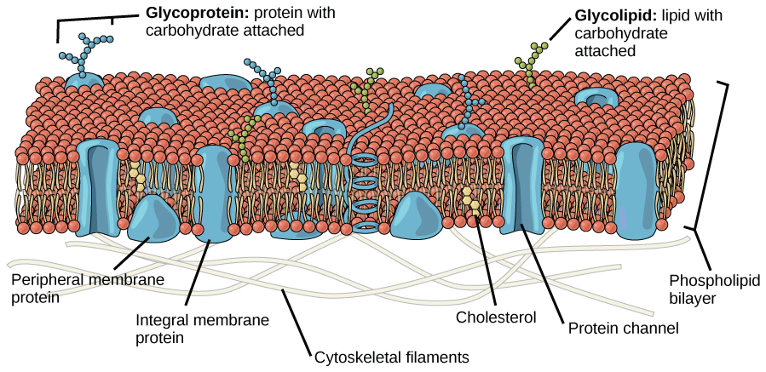
(https://cnx.org/resources/3a229fd6909a56722463c77805188a3f/Figure_05_01_01.jpg )

The function of the carbohydrate molecules is unknown. In general, people who have type O blood with neither type A nor type B carbohydrates are as healthy as people who have the type A and/or type B carbohydrates. Different blood types are correlated with certain illnesses and vary in frequency in different ethnic groups, but the reasons are unknown.

Before question 3, you may want to ask your students to “Explain why a person with the ee genotype has blood type O.”

For a dominant-recessive pair of alleles, heterozygous individuals have the same phenotype as individuals who are homozygous for the dominant allele. You may also want to point out that recessive alleles often code for a nonfunctional protein. In a heterozygous individual, a single dominant allele can code for enough functional protein to result in the same phenotype as the phenotype of the homozygous dominant individual. For example, the e allele codes for a nonfunctional protein, and the e allele is recessive relative to the E^{A} or E^{B} alleles because, in a heterozygous individual, the single dominant E^{A} or E^{B} allele codes for enough functional enzyme to result in the same blood type as observed in a homozygous dominant individual.

This episode helps students to understand the molecular basis for codominance. Each cell in the body contains two copies of each gene and typically both alleles are transcribed. Thus, at the molecular level, the alleles of most genes are codominant. For example, the E^{A}E^{B} genotype results in the production of both the version of the enzyme that puts type A carbohydrate on red blood cells and the version of the enzyme that puts type B carbohydrate on red blood cells. Therefore, the E^{A}E^{B} genotype results in type AB blood.

The type A and type B glycoproteins and glycolipids can stimulate the body to produce an immune response, including antibodies. Normally, your body does not make antibodies against any molecules that are part of your body. This is useful because antibodies against molecules that are part of your body can trigger harmful reactions. As would be expected, a person does not make antibodies against the blood type carbohydrates present on their red blood cells. However, a person with type A blood does make anti-B antibodies. The figure below shows the type of antibodies in the blood plasma for each blood type. These antibodies are believed to be induced by ubiquitous environmental antigens such as antigens on influenza viruses or gut bacteria. (An antigen is a molecule that can stimulate the production of antibodies.)

(https://biology-forums.com/gallery/14755_01_10_12_7_59_21_9228594.jpeg)

The figure below shows what would happen if a person with type A blood were given a transfusion of type B blood. The anti-B antibodies in the recipient’s blood would cause the donated type B red blood cells to clump together and burst. This could block blood vessels and result in kidney failure and other health problems and symptoms (https://medlineplus.gov/ency/article/001306.htm).

This figure shows what would happen if a person with type A blood were given a transfusion of type B blood.
(https://biology-forums.com/gallery/14755_01_10_12_7_59_21_9228594.jpeg)

The most common type of transfusion includes just red blood cells without the liquid plasma which contains the antibodies.
- Type O red blood cells can be safely given to people with type A, B, AB or O blood, since type O red blood cells do not have either A or B antigens. (However, if a person with type O blood is Rh positive, his/her blood should not be given to anyone who is Rh negative because they may have anti-Rh antibodies in their blood.)
- People with type AB blood can safely receive transfusions of type A, B, AB or O red blood cells, since people with type AB blood do not have anti-A or anti-B antibodies in their blood. (However, if a person with type AB blood is Rh negative, he/she may produce anti-Rh antibodies, so he/she should not be given Rh positive blood.) The unique ability of people with type AB blood to safely receive transfusions of all four blood types illustrates codominance at the phenotypic level.

To prevent a transfusion reaction, medical personnel test whether a person's blood is compatible with the donated blood before they give a transfusion. The ABO blood types are the major determinant of which type of blood will cause a transfusion reaction. However, determination of blood type is more complex than the ABO blood types discussed in this activity. For additional information on blood types, see:
- http://www.ncbi.nlm.nih.gov/books/NBK2264/.
- https://bio.libretexts.org/Bookshelves/Human_Biology/Book%3A_Human_Biology_(Wakim_and_Grewal)/17%3A_Cardiovascular_System/17.6%3A_Blood_Types
- https://www.britannica.com/science/ABO-blood-group-system

Question 6b provides the opportunity to discuss:
- how meiosis and fertilization result in new combinations of alleles, so children may have different blood types (and other phenotypic characteristics) than their parents have
- how transmission of genes via meiosis and fertilization result in similarities between offspring and parents. For example, a child can only have type A blood if one or both parents have type A or AB blood (i.e. a child with the E^{A} allele must have at least one parent with this allele).

Question 7 uses the blood type inheritance data to determine whether the hospital accidentally switched the baby girls. Modern methods use DNA testing to determine biological relatedness; these results are much more definitive than testing blood types (http://en.wikipedia.org/wiki/Parental_testing).

Why do the twins look so different?
The bottom of page 5 of the Student Handout introduces the important distinction between identical (monozygotic) twins and fraternal (dizygotic) twins.

The top of page 6 of the Student Handout introduces a very simplified model of the genetic determination of skin color, with a single gene that illustrates incomplete dominance. The table below may be helpful for your class discussion of student answers to question 9.

Type of Dominance | Phenotype of Heterozygous Individual
Dominant-recessive pair of alleles | Same as phenotype of individual who is homozygous for the dominant allele
Codominance | Shows different observable phenotypic effects of both alleles; phenotype different from either homozygous individual
Incomplete dominance | Intermediate between phenotypes of the two types of homozygous individual (typically observed for quantitative traits); phenotype different from either homozygous individual

The bottom of page 6 of the Student Handout develops a more realistic and complex model of the genetic factors that influence skin color. During your discussion of student answers to question 11, you will probably want to explain that the genotype/phenotype table at the top of the page and the students’ Punnett squares in response to question 10 provide a very simplified initial model of the genetics of skin color. A person with a Tt genotype could have lighter or darker skin, depending on whether he or she:
- has alleles for other genes that contribute to lighter or darker skin color
- has developed a tan due to sun exposure or tanning booth use.
Similarly, two people with a TT genotype (or a tt genotype) could have different skin colors, depending on the alleles of the other genes that influence skin color and the amount of UV exposure. You will probably want to explain that scientists often begin with a simple model of a phenomenon, which is superseded by a more complex model as the scientists learn more.

You may want to further explain that, compared to the Punnett square in answer to question 10, this figure provides a more accurate representation of the Punnett square for inheritance of skin color. Even this relatively complex Punnett square is a simplified representation of reality, since it assumes a simple additive model with only two alleles for each gene and incomplete dominance for all of the alleles. | 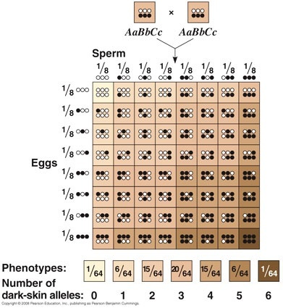  (https://www.quora.com/How-is-skin-color-determined-in-babies )
One gene that influences skin color codes for the enzyme tyrosinase, which is a crucial enzyme involved in the synthesis of melanin, the primary pigment in skin and hair. The normal allele of this gene codes for functional tyrosinase; other alleles code for defective, non-functional versions of this enzyme which result in albinism. The alleles for albinism are recessive because, even when there is only one copy of the normal allele, this allele codes for enough functioning enzyme to produce enough melanin to result in normal skin and hair color.

Another important gene that influences skin color is the MC1R gene which codes for the melanocortin receptor. When alpha-melanocyte stimulating hormone binds to the melanocortin receptor, different versions of the MC1R receptor protein influence the amount and type of melanin produced. More than 80 alleles of the MC1R gene have been identified, resulting in varied functioning of the melanocortin receptor and corresponding variation in skin tones. Heterozygotes for these alleles have intermediate skin color, between the lighter and darker homozygotes (called incomplete dominance or a dosage effect). The multiple alleles and the effects of incomplete dominance result in multiple different phenotypes for skin color (and hair color). Additional information on this gene is available at https://ghr.nlm.nih.gov/gene/MC1R.

Recent research indicates that the genetic control of skin color is very complex. There are multiple genes that code for proteins that directly or indirectly influence skin color. It appears that the activity of these genes is regulated by hundreds of variants in non-coding parts of the DNA (https://www.nature.com/articles/s41588-023-01626-1).

Additional information on the complex genetics and molecular biology involved in regulation of skin color is available at:
- https://www.jbc.org/article/S0021-9258(20)58649-3/fulltext
- https://academic.oup.com/hmg/article/18/R1/R9/2901093 and
- https://penntoday.upenn.edu/news/molecular-look-mechanisms-behind-pigmentation-variation.

This analysis provides the opportunity to reinforce student understanding that, often, an individual phenotypic characteristic is influenced by multiple alleles of multiple genes, as well as environmental factors. Our introductory genetics teaching often focuses on inheritance and phenotypic effects of single genes. However, this is only a beginning for understanding the genetics of most traits.

I don't want my children to be color blind like me!
Learning Goals
- Students will understand inheritance of recessive alleles on the X chromosome (sometimes called sex-linked inheritance).
- More practice with Punnett squares

Biology Background and Suggestions for Implementation
If your students are not familiar with the genetics of sex determination, you can provide a brief explanation or use the mini-activity shown on the last page of these Teacher Preparation Notes.

To increase student engagement, you may want to have two of your students act out the introductory dialogue.

The X chromosome has multiple important genes, including the genes that code for the protein part of two types of photoreceptor molecule, one in the “green cones” and the other in the “red cones” in the retina of eye (see figure below). Color vision depends on neural processing that compares the relative activity of different types of cones. When the allele for the protein portion of the red or green photoreceptor molecule is mutated, this can result in a reduced ability to distinguish red and green, known as red-green color blindness. (For a demonstration of the effects of red-green color blindness, see https://ib.bioninja.com.au/options/option-a-neurobiology-and/a3-perception-of-stimuli/perception-issues.html.)

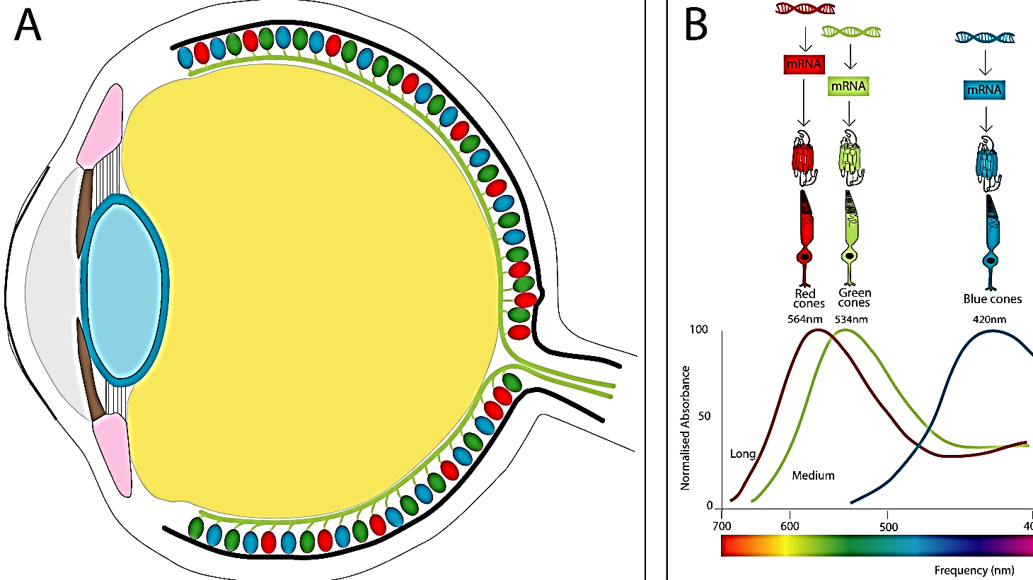
(https://droso4schools.wordpress.com/l5-vision/)

In a heterozygous female, a defective photoreceptor allele is recessive because the normal allele codes for enough normal photoreceptor molecule to result in normal color vision. Discussion of student answers to question 3 will help your students understand why sex-linked recessive conditions are much more common in males. For populations with northern European ancestry, red-green color blindness is observed in about 1 in 12 males vs. 1 in 200 females (8% vs. 0.4%). Rates are lower in almost all other populations studied.

Additional information about color vision and color blindness is available at:
- https://www.unm.edu/~toolson/human_cone_response.htm
- https://droso4schools.wordpress.com/l5-vision/
- https://medlineplus.gov/genetics/condition/color-vision-deficiency/

Question 5 introduces the concept of an unaffected carrier. To help your students understand this concept, you may want to substitute the explanation and questions on the next page for question 5 in the Student Handout.

This pedigree shows inheritance of color blindness in one extended family. Black squares represent color blind males, white squares represent males who are not color blind, and circles represent females who are not color blind.
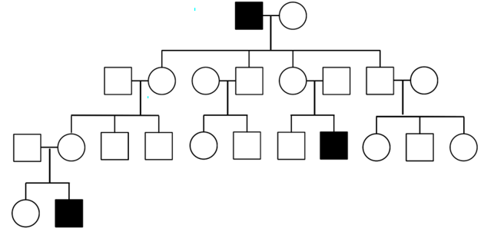
5a. What was the genotype of the daughters of the first couple shown?
X_{N}X_{N} ___ X_{N}X_{cb} ___ X_{cb}X_{cb} ___

5b. How do you know?

5c. What was the genotype of the first female in the third row (the mother of the color blind great-grandson)? X_{N}X_{N} ___ X_{N}X_{cb} ___ X_{cb}X_{cb} ___

6a. A carrier is someone who does not have a condition (e.g., color blindness), but who can pass the condition onto his or her offspring. In the pedigree, circle three carriers of the allele for colorblindness.

6b. Explain why a woman can be a carrier for an X-linked recessive condition like colorblindness, but a man cannot be a carrier for this type of condition.

Related Activities
"Genetics – Major Concepts and Learning Activities" (https://serendipstudio.org/exchange/bioactivities/GeneticsConcepts)
Part I summarizes key concepts in genetics. Part II presents common misconceptions. Part III recommends an integrated sequence of learning activities on the biological basis of genetics, plus seven human genetics learning activities. These learning activities develop student understanding of key concepts and counteract common misconceptions. Each of the recommended learning activities supports the Next Generation Science Standards (NGSS).

Mini-activity on the genetics of sex determination that you could use as an introduction to the last episode, “I don’t want my children to be color blind like me!"

Genetics of Sex Determination

A crucial gene that stimulates the development of male anatomy is located on the Y chromosome. Therefore,
- a person with an X and a Y chromosome (XY) is male
- a person with two X chromosomes (XX) is female.

1. In this figure, cells are represented by circles. Label each cell with the appropriate symbols (X, Y) for the sex chromosomes or chromosome. | 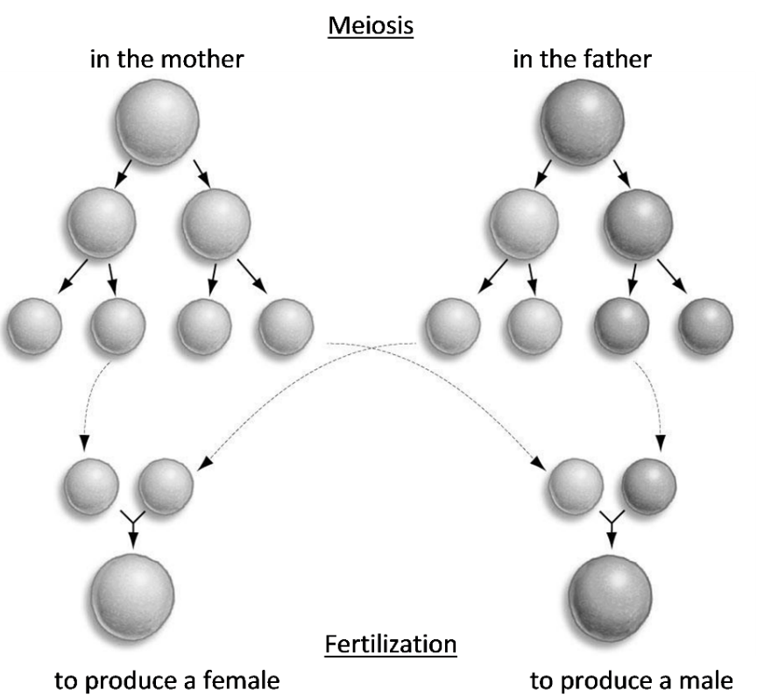

2a. Complete this Punnett Square to show the inheritance of the sex chromosomes. Use X and Y to indicate the genetic makeup of the father’s and mother’s gametes and the zygotes.

2b. Based on this Punnett square, what percent of babies are predicted to be male?

By Dr. Ingrid Waldron, Department of Biology, University of Pennsylvania, 2024. These Teacher Notes and the related Student Handout are available at https://serendipstudio.org/exchange/bioactivities/SoapOperaGenetics .
NGSS "High School Life Sciences" http://www.nextgenscience.org/sites/default/files/HS%20LS%20topics%20combined%206.13.13.pdf
http://www.nap.edu/catalog.php?record_id=13165
From http://www.corestandards.org/
Students may ask questions concerning the distinction between inherited albinism and vitiligo. Albinism results from the inability of the body's cells to produce melanin and affects the whole body. Vitiligo results from the destruction of melanocytes, the cells that produce melanin, and results in light patches in a normally pigmented skin. (Additional information is available at www.nvfi.org.)
If you prefer, you can use a hands-on version of this episode in which students use simple chemicals to simulate blood type tests (available as “Were the babies switched? – The Genetics of Blood Types” at https://serendipstudio.org/exchange/waldron/bloodtests).
The E in the symbols for the allele stands for enzyme. The usual symbols use I for isoagglutinogen; isoagglutinogen refers to an antigen that can stimulate the production of antibodies in other members of the same species; these antibodies result in agglutination (clumping) upon exposure to the antigen. The type A and type B glycoproteins and glycolipids are often referred to as type A and type B antigens, because they can trigger an immune response.
There is more than one version of each of these three alleles, but this is not mentioned in the Student Handout.
For example, a person who is heterozygous for the allele for normal hemoglobin and sickle cell hemoglobin has both types of hemoglobin in their red blood cells. Due to the normal hemoglobin in the red blood cells of a heterozygous person, the hemoglobin molecules very rarely clump into rods that distort the shape of the red blood cells, so the heterozygous person very rarely develops the symptoms of sickle cell anemia. The sickle cell hemoglobin in the red blood cells of a heterozygous person inhibits the reproduction of the malaria parasite in the red blood cells, so the heterozygous person is protected against severe malaria infections.
These generalizations apply also to whole blood, since the amount of antibodies in a transfusion is relatively small.
Incomplete dominance can occur when each wild type allele produces a set dose of protein product and the phenotype is proportionate to the amount of protein. The Student Handout uses a capital letter and lowercase letter to indicate the two alleles for a gene with incomplete dominance; you may prefer to use an alternate notation such as t/t⁺ or T/T’.
Alpha-melanocyte stimulating hormone is one type of melanocortin.
Genes for two important clotting proteins are also located on the X chromosome. Therefore, hemophilia is another X-linked recessive condition. For more information on hemophilia, see https://learn.genetics.utah.edu/content/genetics/hemophilia/.
This mini-activity focuses on the determination of biological sex. Additional information, including descriptions of some anomalies in sex determination, is presented in the Teacher Notes for "Genetics and Probability – Sex Ratios of Births" (https://serendipstudio.org/exchange/bioactivities/geneticsSRB). A discussion of transgender people is available at https://www.mayoclinic.org/healthy-lifestyle/adult-health/in-depth/transgender-facts/art-20266812.

