Teacher Notes for “Food, Physical Activity, and Body Weight”

This analysis and discussion activity helps students to understand the relationships between food, physical activity, cellular respiration, and changes in body weight. Analysis of a representative scenario helps students to understand how challenging it is to prevent weight gain by exercising to offset what seems to be a relatively modest lunch. In an optional research project, each student asks an additional question and prepares a report based on recommended reliable internet sources.

Before students begin this activity, they should have a basic understanding of biological molecules and cellular respiration. A helpful introductory activity is "How do organisms use energy?" (http://serendipstudio.org/exchange/bioactivities/energy).

Learning Goals
In accord with the Next Generation Science Standards, this activity:
- helps students to prepare for Performance Expectation HS-LS1-7, "Use a model to illustrate that cellular respiration is a chemical process whereby the bonds of food molecules and oxygen molecules are broken and the bonds in new compounds are formed resulting in a net transfer of energy."
- reinforces student understanding of the Disciplinary Core Idea LS1.C: "… amino acids and other carbon-based molecules can be assembled into larger molecules … Cellular respiration is a chemical process whereby the bonds of food molecules and oxygen molecules are broken”, carbon dioxide and water are formed, and the energy released is used in the production of ATP from ADP and P. Then, the hydrolysis of ATP provides the energy needed for many biological processes.
- engages students in the recommended Scientific Practice, “Constructing Explanations: Apply scientific ideas, principles, and/or evidence to provide an explanation of phenomena.”
- can be used to illustrate the Crosscutting Concept:
  - “Energy and matter: Flows, cycles and conservation: Changes of energy and matter in a system can be described in terms of energy and matter flows into, out of, and within that system.”
  - “Cause and Effect: Mechanism and Prediction: Cause and effect relationships can be suggested and predicted for complex natural and human designed systems by examining what is known about smaller scale mechanisms within the system.”
Additional Content Learning Goals
Students learn that food, energy and calories are not equivalent concepts.
- Food contains organic molecules which can be used for cellular respiration which produces ATP; hydrolysis of ATP provides the energy for the processes of life. Food also provides molecules that can be used for growth and repair of body tissues.
- Energy is a property of all sorts of biological and non-biological systems (e.g. the chemical energy available from cellular respiration of food molecules or the kinetic energy of moving muscles or cars).
- A calorie is a unit of measure for energy.
Instructional Suggestions and Background Information
To maximize student participation and learning, I suggest that you have your students work individually or in pairs to complete groups of related questions and then have a class discussion after each group of related questions. In each discussion, you can probe student thinking and help them develop a sound understanding of the concepts and information covered before moving on to the next group of related questions.

If your students are learning online, we recommend that they use the Google Doc version of the Student Handout available at https://serendipstudio.org/exchange/bioactivities/foodenergy. To answer question 2, students can either print the relevant page, draw on it and send a picture to you, or they will need to know how to modify a drawing online. To answer online, they can double-click on the relevant drawing in the Google Doc to open a drawing window. Then, they can use the editing tools to answer the questions.

You can use the Word document for the Student Handout to prepare a revised version that will be more suitable for your students. If you use the Word document, please check the format by viewing the PDF.

A key is available upon request to Ingrid Waldron (iwaldron@upenn.edu). Additional background information and instructional suggestions are included in the paragraphs below.

Estimated annual per capita food consumption in the US includes 75 pounds of added fats and oils, 152 pounds of caloric sweeteners, 195 pounds of meat and fish, 200 pounds of grains, 593 pounds of dairy, and 708 pounds of fruits and vegetables (http://www.usda.gov/factbook/chapter2.pdf; accessed in 2016). Notice that the types of foods at the beginning of this list have high calorie density. In contrast, some dairy, fruits and vegetables weigh substantially more per calorie consumed, in large part because they contain a lot of water.

Cellular respiration converts many of the molecules in food to CO₂ and H₂O. Also, beverages and some foods contain a lot of H₂O. Any H₂O which is not needed to replace the H₂O lost by breathing and sweating is excreted in the urine. CO₂ leaves the body in each exhalation. Some food molecules are not absorbed from the digestive system and leave the body in the feces. Finally, some of the weight of the food is retained, either as fat in fat cells or as growth.

The flowchart in question 2 summarizes how our bodies use food to provide (1) energy for body processes and (2) atoms and molecules needed for growth and repair of our bodies. This flowchart is obviously a very simplified version of the complex metabolism of macronutrients. One important omission is that glucose can be stored as glycogen (a polymer of glucose which is stored in the liver and muscles). I have omitted this because the maximum weight of glycogen in the body is only about 500 g (1 pound) (not counting the associated water). Less than a day's worth of energy is stored in the form of glycogen (~800 calories). In contrast, a normal weight person has enough stored fat to provide energy for about two months (~140,000 calories). Fat provides more energy per gram than carbohydrates or proteins (9 calories per gram vs. 4) and fat stores also have less associated water. For both reasons, fat requires less weight per calorie, and this is a major advantage of fat as the main type of energy storage in animals. The figure below provides additional information about the digestion and cellular respiration of different types of macromolecules.
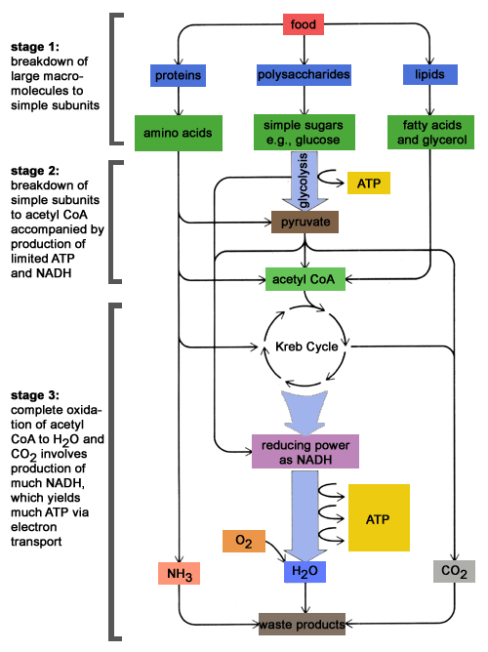
(https://schoolworkhelper.net/wp-content/uploads/2010/07/catabolism.gif)

In discussing questions 1-3, you will probably want to emphasize the following general principles. Although the atoms in reactant molecules can be reorganized into atoms in different product molecules, atoms are neither created nor destroyed (conservation of matter). Although energy can be converted to other forms of energy, energy cannot be converted to matter nor vice versa.

The top of page 2 of the Student Handout discusses one aspect of metabolism that can occur when there is a long interval between meals or when a person is eating food with fewer calories than required for the person’s metabolism (e.g. during dieting or famine). The figure below provides additional information.
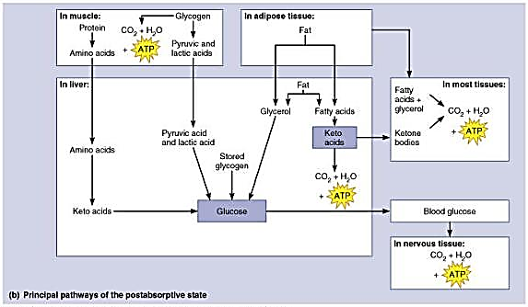
(https://www.slideserve.com/atira/metabolism)

The section on Eating and Exercising is based on a case study for teaching nutrition, "A Light Lunch? A Case in Calorie Counting" (https://www.nsta.org/ncss-case-study/light-lunch). The table below gives the estimated calories for each food item.

Alicia |  |  | Maria
Food Item | Calories |  | Food Item | Calories
Two slices of cheese pizza | 280 |  | Two slices of pepperoni pizza | 358
Garden salad | 38 |  | Taco salad | 284
Iced tea | 88 |  | Grape soda | 166
Total calories | 406 |  | Total calories | 808

The number of calories used during physical activity depends on the intensity of the exercise, which for walking depends on body weight, walking speed and changes in elevation. A person who weighs 150 pounds typically uses ~240 calories per hour when walking at the rate of 2 miles per hour (https://www.nsta.org/ncss-case-study/light-lunch). A person who weighs 125 pounds typically uses ~240 calories per hour when walking at the rate of 3.5 miles per hour (https://www.health.harvard.edu/diet-and-weight-loss/calories-burned-in-30-minutes-of-leisure-and-routine-activities; this source gives typical caloric expenditures for many different types of physical activity and body weights of 125, 155 or 185 pounds).

Current research suggests that aerobic physical activity contributes to both weight loss and a decrease in visceral fat (https://www.ncbi.nlm.nih.gov/pmc/articles/PMC8365736/). The decrease in visceral fat contributes to the health benefits of regular physical activity. Substantial evidence indicates that regular aerobic exercise results in multiple health benefits, even when there is little or no weight loss (https://www.cdc.gov/physical-activity-basics/benefits/index.html; https://www.who.int/news-room/fact-sheets/detail/physical-activity#:~:text=Regular%20physical%20activity%20is%20proven,of%20life%20and%20well%2Dbeing.; https://www.ncbi.nlm.nih.gov/pmc/articles/PMC9102424/).

The Student Handout omits many aspects of the complex physiology of weight gain and weight loss. For example, this activity does not discuss the hormonal and metabolic changes which make it difficult to maintain weight loss after obesity (https://www.ncbi.nlm.nih.gov/pmc/articles/PMC4766925/).

Optional Research Project
This section invites students to explore their questions related to obesity or physical activity. The Student Handout provides the URLs for informative and reliable sources. If you want to allow your students to explore additional resources, you can distribute the last page of these Teacher Notes and ask students to follow the listed procedures to evaluate each source. This research project can be used to engage your students in the NGSS-recommended science practice of "Obtaining, Evaluating, and Communicating Information" (https://www.nextgenscience.org/sites/default/files/Appendix%20F%20%20Science%20and%20Engineering%20Practices%20in%20the%20NGSS%20-%20FINAL%20060513.pdf).

One problem that I have encountered is that some students tend to copy information from their sources without understanding the material well enough to put it in their own words. To avoid this problem, you can encourage your students to follow these guidelines.
1. Use online dictionaries to find the meaning of any unfamiliar technical terms. Reread the original passage until you understand its full meaning.
2. Put the original where you can’t see it, and write the main points you remember in a document in a word processing program or on a note card.
3. Check your version with the original to make sure that your version accurately expresses all the essential information in your own words.
4. Use quotation marks to identify any unique term or phraseology you have borrowed exactly from the source.
5. Record the source (including the page number) in your document or note card so that you can credit it easily if you decide to incorporate the material in your paper.

Related Activities
“How do muscles get the energy they need for athletic activity?” (https://serendipstudio.org/exchange/bioactivities/energyathlete)
In this analysis and discussion activity, students learn how muscle cells produce ATP by aerobic cellular respiration, anaerobic fermentation, and hydrolysis of creatine phosphate. They analyze the varying contributions of these three processes to ATP production during athletic activities of varying intensity and duration. Students learn how multiple body systems work together to supply the oxygen and glucose needed for aerobic cellular respiration. Finally, students use what they have learned to analyze how athletic performance is improved by the body changes that result from regular aerobic exercise.

"Cellular Respiration and Photosynthesis – Important Concepts, Common Misconceptions, and Learning Activities" (https://serendipstudio.org/exchange/bioactivities/cellrespiration) provides an overview of energy, ATP, cellular respiration, and photosynthesis. This overview summarizes important concepts and common misconceptions and suggests a sequence of learning activities designed to develop student understanding of these concepts and overcome any misconceptions.

“How do food molecules reach our muscles? – Structure and Function of Organ Systems, Organs and Cells”
https://serendipstudio.org/exchange/bioactivities/SFCellOrgan
In this analysis and discussion activity, students learn about how food is digested and how the digested food molecules reach the muscles. Students analyze multiple examples of the relationship between structure and function in the organs and cells of the digestive system. Students also analyze several examples that illustrate how organs and organ systems work together to accomplish functions needed by the organism. Finally, students use a claim, evidence and reasoning framework to evaluate the claim that structure is related to function in cells, organs and organ systems.

Instructions for Evaluating Sources
(if students use sources other than recommended sources)
Rubric for Evaluating Sources | Additional Points
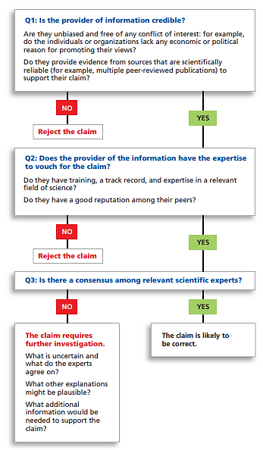 | To find out whether sources may have a conflict of interest, use Wikipedia or fact-checking sources such as Snopes. Do not use “.org” as a sign of reliability. Be cautious about any source that uses emotional language.  Experts in one subject are often unreliable when they write about another subject.  What are the risks of accepting a claim that is ultimately proven to be wrong? What are the risks of not accepting a claim that is ultimately proven to be correct?

By Dr. Ingrid Waldron, Department of Biology, University of Pennsylvania, 2024. These Teacher Notes and the related Student Handout are available at https://serendipstudio.org/exchange/bioactivities/foodenergy.
https://www.nextgenscience.org/ or https://www.nextgenscience.org/sites/default/files/HS%20LS%20topics%20combined%206.13.13.pdf
In this activity I use the lower case "calories" because this usage of nutritional calories is familiar to students, even though technically I am referring to Calories = kilocalories.
To draw a shape - At the top of the page, find and click Shape. - Choose the shape you want to use. - Click and drag on the canvas to draw your shape. To insert text - At the top of the page, click Insert. - To place text inside a box or confined area, click Text Box and drag it to where you want it. - Type your text. - You can select, resize and format the word art or text box, or apply styles like bold or italics to the text. When you are done, click Save and Close.
This rubric is from https://sciedandmisinfo.stanford.edu/sites/g/files/sbiybj25316/files/media/file/why_trust_science-ecb.pdf.

