Food and Climate Change
– How can we feed the growing world population without increasing global warming?

This flowchart describes the main cause and consequence of global warming.
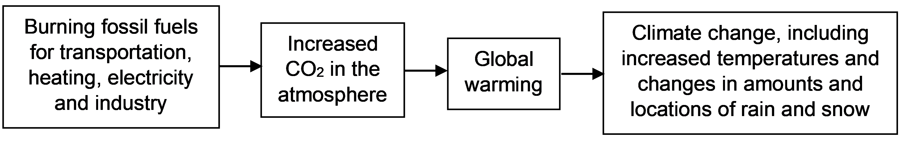
Agriculture has been another important cause of global warming. In this activity, you will learn how agriculture increases three major greenhouse gases in the atmosphere – carbon dioxide (CO₂), nitrous oxide (N₂O), and methane (CH₄).

1. To begin, summarize what you already know about how agriculture increases greenhouse gases in the atmosphere.

How does agriculture increase carbon dioxide (CO₂) in the atmosphere?
To understand how agriculture increases CO₂ in the atmosphere, you first need to understand the simple carbon cycle shown in this figure. Carbon atoms cycle between CO₂ in the air and organic molecules in the grass and cow.  2. After CO₂ enters the grass (A arrow), how do the carbon atoms in CO₂ become carbon atoms in organic molecules in the grass? | 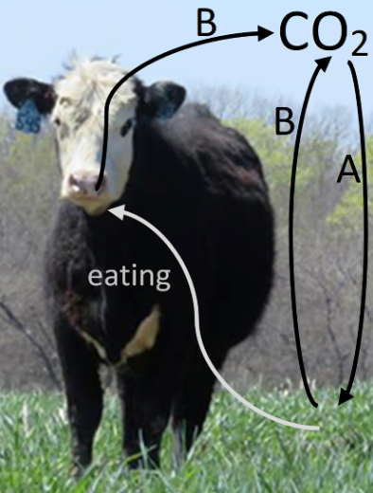
3a. Some of the organic molecules in the grass and cow are used in a process that produces CO₂. Name this process.

3b. How is this process useful for the grass and the cow?

4. This diagram is another way to show this carbon cycle. Fill in the blanks with the names of the biological processes in the carbon cycle. | 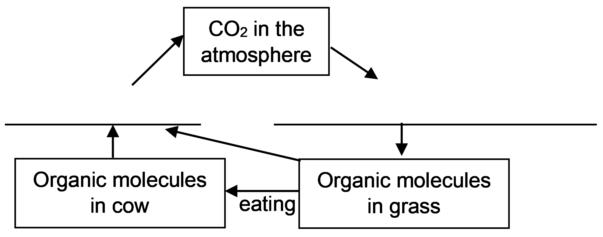
5. In a balanced carbon cycle, the amount of CO₂ that plants use for photosynthesis equals the amount of CO₂ produced by cellular respiration in plants, animals, and other organisms. As a result of a balanced carbon cycle, the concentration of CO₂ in the atmosphere will ___________________.
(decrease / increase / stay the same)

6. This figure shows a more complete agricultural carbon cycle. Describe one way that farming increases CO₂ in the atmosphere.  7a. One way to reduce CO₂ levels in the atmosphere is to grow forests, so the total biomass of trees on earth increases. How would growing more trees reduce the amount of CO₂ in the atmosphere? | 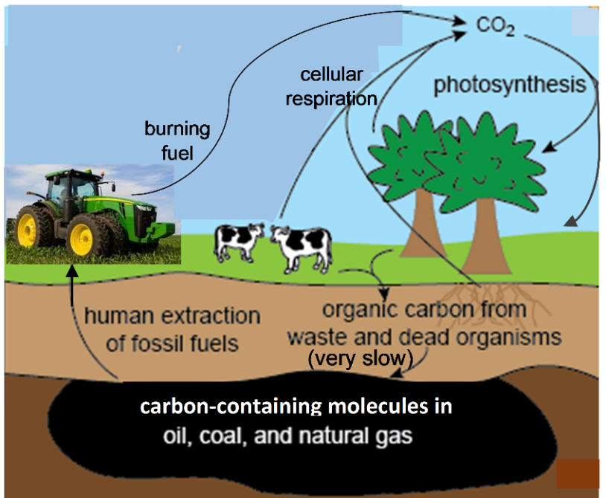

7b. When people cut down trees and burn them to clear land for agriculture, this increases CO₂ levels in the atmosphere. Explain why.

8a. A cow weighs much less than the weight of all the food that the cow has ever eaten. What happened to the extra weight of the food that the cow ate? For example, where did the carbon atoms in the food molecules go?

8b. Why does it take more land to feed a meat eater than to feed a vegetarian? | 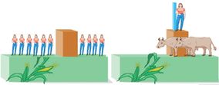

9a. Which would result in more increase in CO₂ in the atmosphere?
- growing enough food to feed a strict vegetarian
- growing enough food to feed someone who eats mainly meat

9b. Explain your reasoning.

How does agriculture increase nitrous oxide (N₂O) in the atmosphere?

This figure shows a basic nitrogen cycle. N₂ is abundant in the air, but plants can’t use N₂. Plants depend on bacteria that convert N₂ to ions that the plants can use.  10. Plants use nitrate  (NO₃-) to make organic molecules that contain nitrogen atoms. What kinds of molecules in plants and other organisms contain nitrogen atoms? | 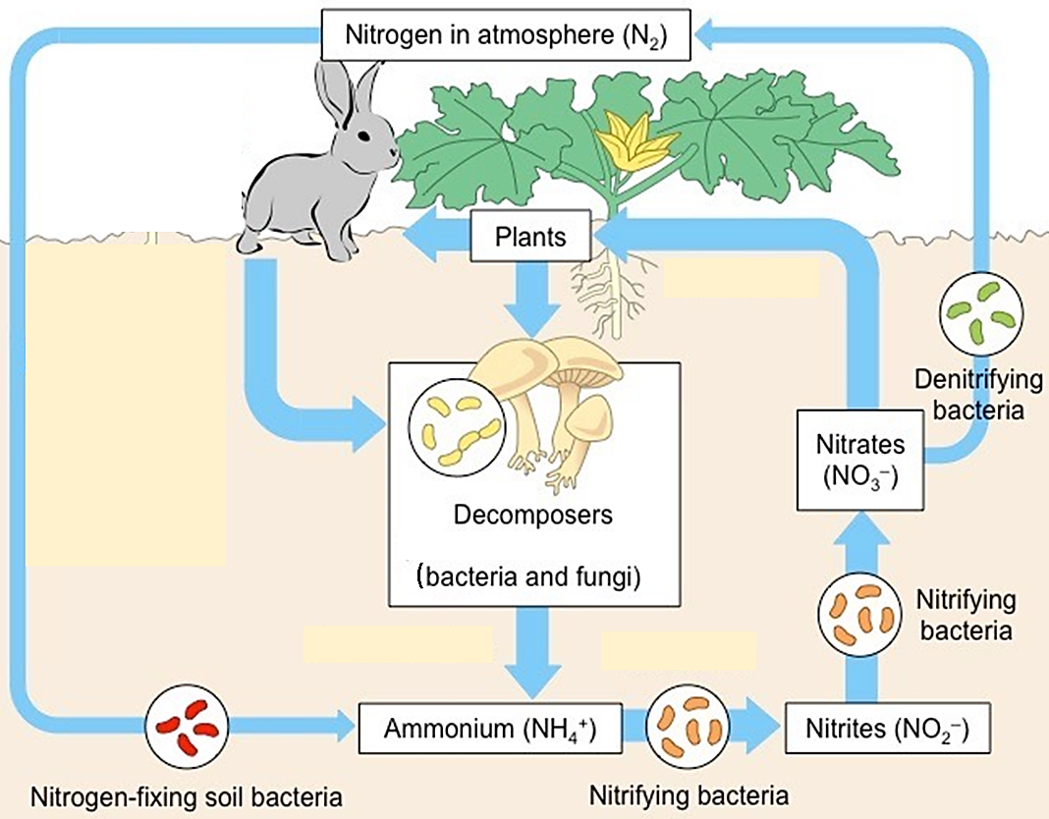

This figure shows an agricultural nitrogen cycle.  11. In each figure, draw a line around the part of the figure that shows how N₂ is used to produce ammonium (NH₄⁺). | 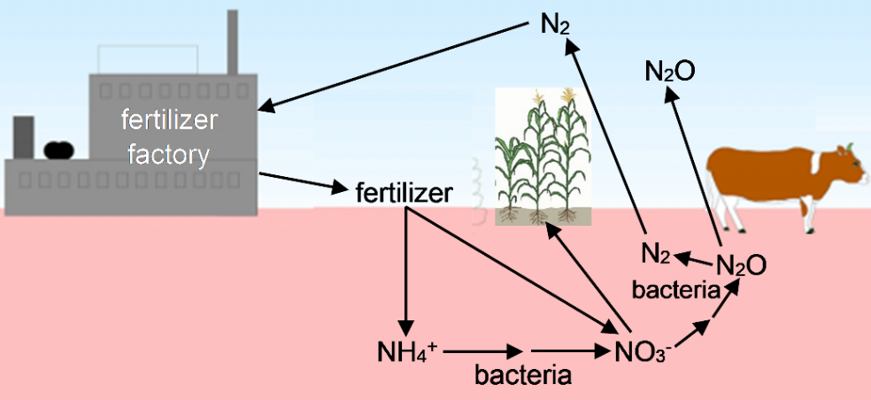
To increase crop growth, many farmers spread fertilizer with NH₄⁺ or NO₃⁻ on their fields. Bacteria convert NH₄⁺ to NO₃⁻. Excess fertilizer can result in more NO₃⁻ than crop plants can use, and some of the excess NO₃⁻ is converted to N₂O which is released to the atmosphere.

12. If farmers use excess fertilizer on their fields, how does this contribute to global warming? (Hint: N₂O is a greenhouse gas, but N₂ is not.)

13a. A cow consumes roughly 25 pounds of feed for every pound of meat the cow produces. Which would result in more N₂O released to the atmosphere?
- producing a pound of beef b. producing a pound of beans

13b. Explain your reasoning.

Total Greenhouse Gases Released during the Production of Different Types of Food

The figure below shows the total amount of greenhouse gases released to the atmosphere during the production of an amount of each food that contains 100 g of protein. The amount of greenhouse gases is measured in CO₂ equivalents (CO₂e). This measure gives greater weights to a kilogram of nitrous oxide (N₂O) or methane (CH₄), because each kilogram of these greenhouse gases contributes more to global warming than a kilogram of CO₂.

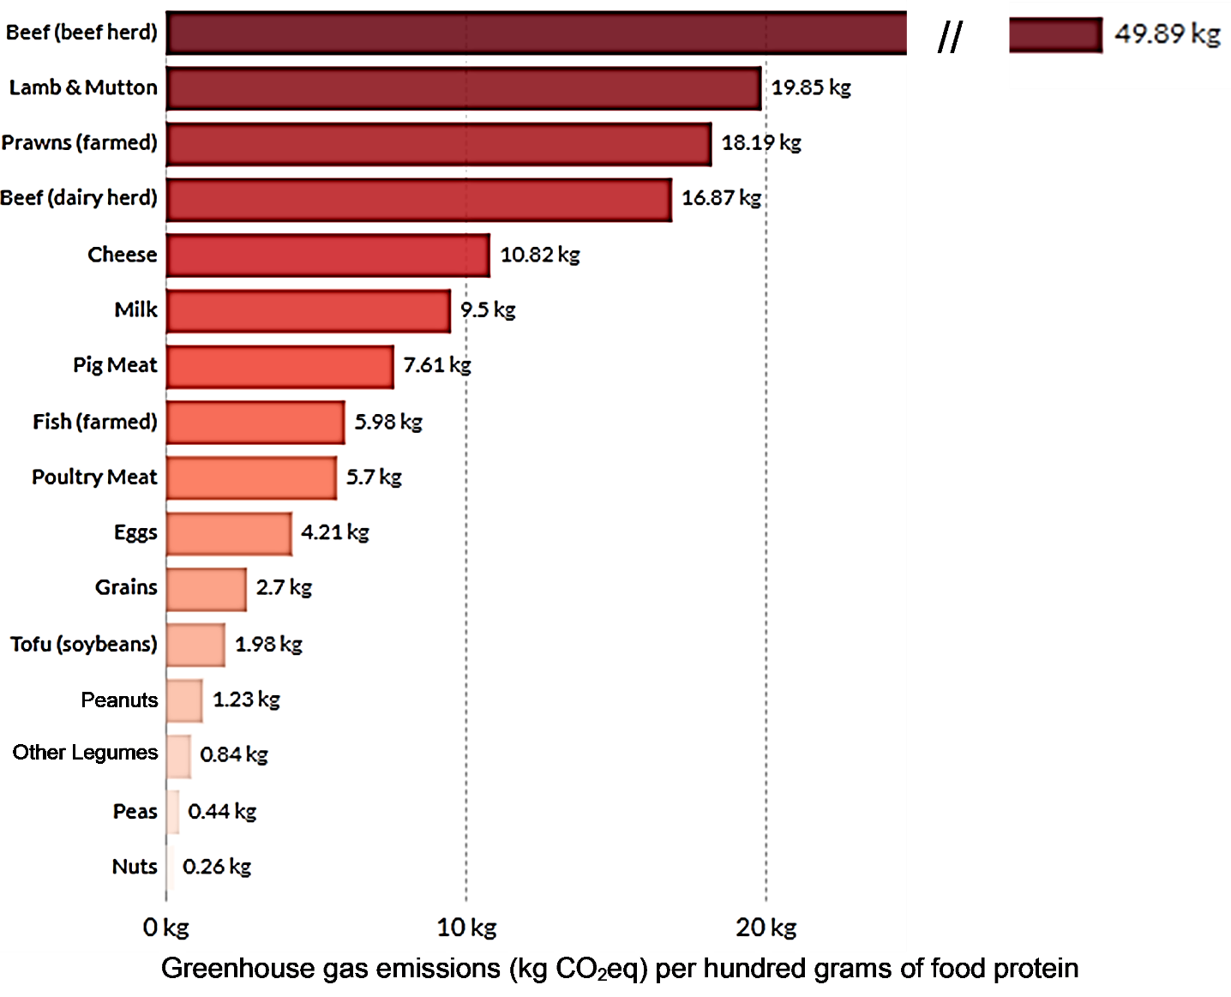

14a. Based on the information in this figure, which results in more greenhouse gases released during the production of 100 g of food protein? foods from animals ___ foods from plants ___

14b. Explain two reasons for this difference between foods from animals vs. foods from plants.

15. Based on the above figure, which results in more greenhouse gases released during the production of 100 g of food protein?
- food from cows and sheep (beef, cheese, milk, lamb and mutton)
- food from pigs and chickens (pig meat, poultry meat, eggs)

Animals cannot make enzymes that digest cellulose, a molecule that is abundant in grass and
hay. Microorganisms that can digest cellulose live in the stomachs of cows and sheep. These microorganisms produce:  - molecules that the cow or sheep can use  - methane (CH₄), which the cow or sheep releases to the air. | 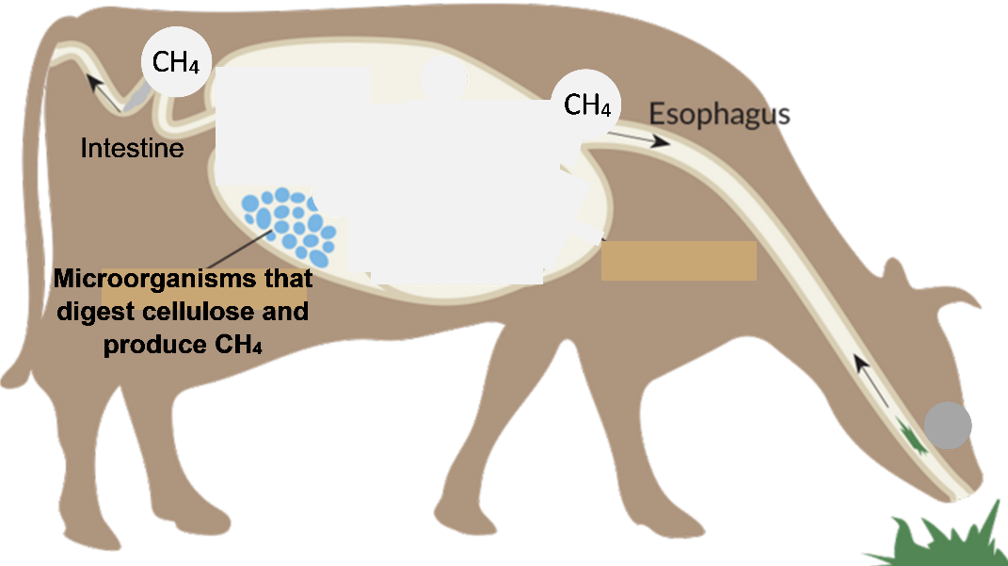

16. Explain why more greenhouse gases are released during the production of a serving of beef, compared to production of the same amount of chicken meat.

17. Roughly a quarter of the food produced globally gets wasted. For example, some food is thrown away before or after it spoils, and some food is eaten by rodents or insects. Explain how food waste contributes to increased greenhouse gases in the atmosphere.

How can we feed the growing world population without increasing global warming?
Any approach that could avoid serious damage due to global warming and climate change must include reductions of greenhouse gas emissions during food production. However, the amount of greenhouse gases released during food production has been increasing because:
- the number of people in the world is increasing and
- meat consumption per capita has been increasing, especially in low-income countries (although meat consumption in low-income countries is still much less than in the US).

18. Propose several strategies to reduce the amount of greenhouse gases that will be released by food production in the future. (Hint: To get ideas for possible strategies, you can review the Reliable Relevant Sources listed on pages 6-7.)

19. The first column of this table suggests several criteria to use when evaluating a proposed strategy to reduce greenhouse gas emissions during food production. Answer the questions in the second column of the table.
A good proposed strategy should: | Do you agree or disagree with each proposed criterion?  If you disagree, suggest a better version of the criterion.
be feasible (e.g., should not use
too many scarce resources)
use lots of fossil fuels
reduce the amount of food available
in low-income countries or have
other harmful effects

20. Prepare a brief report that describes and evaluates a proposed strategy to reduce the amounts of greenhouse gases released during future food production. Use the information from the Reliable Relevant Sources listed below to:
- improve your proposed strategy (e.g., by making it more specific)
- evaluate the advantages and disadvantages of your proposed strategy (i.e., evaluate how well the proposed strategy would meet the criteria developed in response to question 19).
In your report, describe any additional information that you would want in order to better evaluate your proposed strategy.

Reliable Relevant Sources

Healthy eating can reduce greenhouse gas emissions.
- Healthy Diet May Reduce Gas; Greenhouse Gas, That Is (http://www.climatecentral.org/news/diet-may-reduce-gas-greenhouse-gas-that-is-20160)
- Meat and Your Health (https://www.ewg.org/meateatersguide/a-meat-eaters-guide-to-climate-change-health-what-you-eat-matters/meat-and-your-health/)
- What Humanity Should Eat to Stay Healthy and Save the Planet (https://www.nature.com/articles/d41586-021-03565-5)
- Tax high carbon food, sugar for climate and health gains – study (http://www.climatechangenews.com/2016/02/03/the-bitter-taste-of-taxing-your-steaks-carbon-footprint/)

Reducing Food Loss and Waste to Reduce Greenhouse Gases
- 10 Ways to Cut Global Food Loss and Waste (https://www.wri.org/insights/10-ways-cut-global-food-loss-and-waste)
- Reducing Food Loss and Waste (pages 1, 3, 14-19, 22-27 in https://files.wri.org/d8/s3fs-public/reducing_food_loss_and_waste.pdf)
- Release: New research finds companies saved $14 for every $1 invested in reducing food waste (https://champions123.org/2017/03/06/release-new-research-finds-companies-saved-14-for-every-1-invested-in-reducing-food-waste/)

Improving Agricultural Methods to Reduce Greenhouse Gas Emissions
- Intensive farming may ease climate change (http://www.nature.com/news/2010/100615/full/465853a.html)
- Boosting milk-production efficiency can reduce cow methane-emission intensity (https://news.psu.edu/story/383607/2015/12/07/campus-life/boosting-milk-production-efficiency-can-reduce-cow-methane)
- Most new farmland comes from cutting tropical forest, says Stanford researcher (https://news.stanford.edu/news/2010/september/farmland-cutting-forests-090210.html)
- Management of Nitrogen Fertilizer to Reduce Nitrous Oxide (N₂O) Emissions from Field Crops (http://msue.anr.msu.edu/resources/management_of_nitrogen_fertilizer_to_reduce_nitrous_oxide_emissions_from_fi)
- Wetting and Drying: Reducing Greenhouse Gas Emissions and Saving Water from Rice Production (pages 1-2 in https://files.wri.org/d8/s3fs-public/wetting-drying-reducing-greenhouse-gas-emissions-saving-water-rice-production.pdf)

Using insects as food or feed for farm animals can reduce greenhouse gas emissions.
- Five reasons we should all be eating insects
(https://qz.com/84127/five-reasons-we-should-all-be-eating-insects/)
- 5 reasons why eating insects could reduce climate change (https://www.weforum.org/agenda/2022/02/how-insects-positively-impact-climate-change/)
- Plant Ecologist: We Should Be Eating More Insects and Using Their Waste To Grow Crops (https://scitechdaily.com/plant-ecologist-we-should-be-eating-more-insects-and-using-their-waste-to-grow-crops/)

Reducing Population Growth to Reduce the Amount of Food Needed
- Climate Curious: How much does population growth contribute to climate change? (https://www.mprnews.org/story/2019/12/11/climate-curious-how-much-does-population-growth-contribute-to-climate-change)
- Population Matters – Climate Change (https://populationmatters.org/climate-change)
- Population Matters – Solutions (https://populationmatters.org/solutions)

By Dr. Ingrid Waldron, Department of Biology, University of Pennsylvania. © 2022. This Student Handout and Teacher Notes with instructional suggestions and background information are available at https://serendipstudio.org/exchange/bioactivities/FoodClimateChange.

