Food, Energy and Body Weight

The average American consumes almost 2000 pounds of food each year. Luckily, we do not gain 2000 pounds of weight each year!

1. What happens to all the weight of the food we eat? Where do the atoms in the food molecules go?

This flowchart summarizes how the atoms in different types of food molecules can leave your body or become part of your body.

2a. In each blank box, write the appropriate type of molecule (amino acids, fatty acid, or glucose).  2b. Circle the molecules in the bottom row that leave the body. | 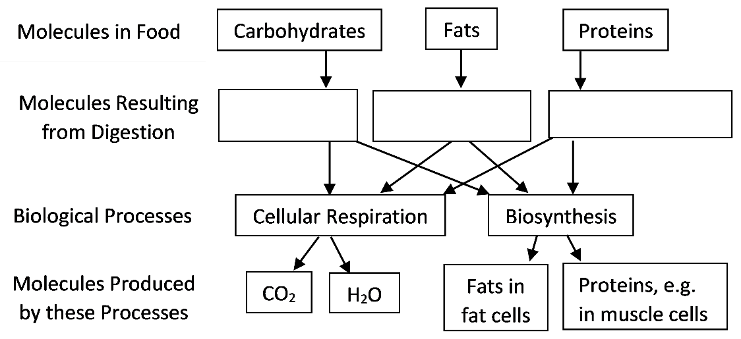

2c. Why do cells need to carry out cellular respiration? What output from cellular respiration is not shown in the flowchart and what inputs are needed to make that output?

3. Review your answer to question 1, and add any information that will make your answer more complete and accurate.

4a. A person will gain weight if he/she consumes food with more calories than he/she needs to provide the energy for body activities. Which explanation is correct?
- Excess calories (energy) in the food are converted to fat molecules and stored in fat cells.
- Food molecules that are not needed for cellular respiration are converted to fat molecules and stored in fat cells.

4b. Explain your reasoning.

5. Explain how increased physical activity can help to prevent weight gain. A complete answer will include ATP, energy, cellular respiration, CO₂ and H₂O.

6. Suppose that the food you eat provides fewer molecules than your cells need for cellular respiration. What will happen to the fat molecules stored in your fat cells?

Eating and Exercising

The figure below shows the lunches that two friends ate. The length of each box is proportional to the calories in that food item. The total calories in each lunch are shown on the right.

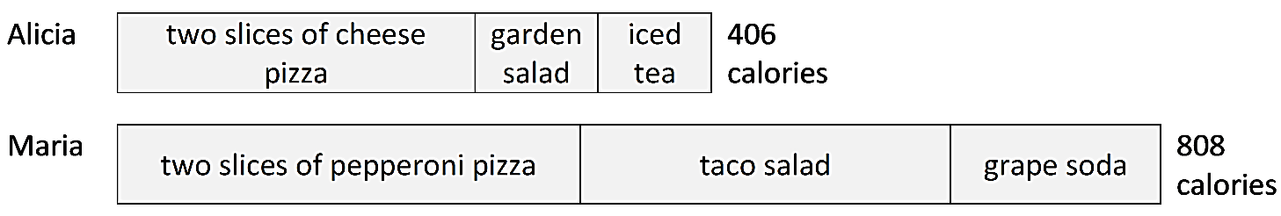
7a. Alicia and Maria are teenage girls who don’t play sports or do other vigorous physical activity. Therefore, each girl is likely to gain weight if she consumes food with more than about 1800 calories per day. If she divides the 1800 calories equally between breakfast, lunch, dinner and snacks, how many calories should she consume for lunch?
250 ___ 450 ___ 900 ___ 1200 ___

7b. What advice do you think a nutritionist would give to Maria?

Both girls expect to eat a big dinner at a birthday celebration that evening. They want to avoid weight gain, so they plan to walk long enough to use all the calories in the food they ate for lunch. Each girl uses about 240 calories per hour as she walks.

8a. Fill in the blanks to give the number of calories used after:
1 hour of walking → 240 calories used
2 hours of walking → _____ calories used
3 hours of walking → _____ calories used

8b. How long would Alicia have to walk to use all the calories she consumed at lunch?
<1 hour___ between 1 and 2 hours ___ between 2 and 3 hours ___ >3 hours ___

8c. How long would Maria have to walk to use all the calories she consumed at lunch?
<1 hour___ between 1 and 2 hours ___ between 2 and 3 hours ___ >3 hours ___

Optional Research Project

9. State one or more questions you have concerning factors that contribute to weight gain or weight loss, or the health effects of obesity or physical activity.

Here are some informative and reliable sources to research your question.
- “Weight-Loss and Nutrition Myths” (http://www.niddk.nih.gov/health-information/health-topics/weight-control/myths/Pages/weight-loss-and-nutrition-myths.aspx)
- “Eat More, Weigh Less?” (http://www.cdc.gov/healthyweight/healthy_eating/energy_density.html)
- “Physical Activity for a Healthy Weight” (https://www.cdc.gov/healthyweight/physical_activity/index.html)
- “Role of Physical Activity for Weight Loss and Weight Maintenance” (http://spectrum.diabetesjournals.org/content/30/3/157)
- “Exercise & Fitness” (https://www.health.harvard.edu/topics/exercise-and-fitness)
- “Physical Activity” (https://www.cdc.gov/physicalactivity/basics/index.htm)
- “Health Tips for Adults” (https://www.niddk.nih.gov/health-information/weight-management/healthy-eating-physical-activity-for-life/health-tips-for-adults)
- “Obesity” (http://www.mayoclinic.org/diseases-conditions/obesity/basics/prevention/con-20014834)

10. Write a brief report that summarizes the information you found concerning your question. Include the sources for each major point.

By Dr. Ingrid Waldron, Biology Dept, Univ Pennsylvania, © 2020. This Student Handout (including a Google Doc version) and Teacher Notes (with background information and instructional suggestions) are available at http://serendipstudio.org/exchange/bioactivities/foodenergy.

