Cellular Respiration and Photosynthesis
– Important Concepts, Common Misconceptions, and Learning Activities

Table of Contents
Section I. Overview of Concepts and Learning Activities – pages 1-2
Section II. Energy – pages 2-5
Section III. ATP, Cellular Respiration and Fermentation – pages 5-12
Section IV. Photosynthesis – pages 12-13
Section V. Carbon Cycles and Energy Transfer in Ecosystems – pages 13-14
Section VI. Learning Activities – pages 14-17

I. Overview of Concepts and Recommended Learning Activities
Major Concepts
- In biological reactions:
  - Energy is neither created nor destroyed (conservation of energy).
  - Matter is neither created nor destroyed (conservation of matter).
- Organisms use a combination of two processes to provide the energy needed for most biological processes.
  - In cellular respiration, glucose and oxygen are inputs for reactions that provide the energy to make ATP from ADP and P. (In the absence of oxygen, anaerobic fermentation of glucose provides the energy to make ATP.)
  - Hydrolysis of ATP provides energy in the form needed for many biological processes.
- In photosynthetic organisms, sunlight provides the energy for photosynthesis which produces sugars. Some sugar molecules are used for cellular respiration and some are used to synthesize other organic molecules.

Learning activities for these major concepts are summarized in this table. For each learning activity, a Student Handout and Teacher Notes are available at the URL provided. Each of these activities supports the Next Generation Science Standards. For additional information about the learning activities, see Section VI.

Concepts | Learning Activities
Conservation of energy and matter  Cellular respiration and hydrolysis of ATP | Students develop a basic understanding of these concepts:  - How do organisms use energy? (https://serendipstudio.org/exchange/bioactivities/energy)  - Using Models to Understand Cellular Respiration (http://serendipstudio.org/exchange/bioactivities/modelCR)  Students apply these concepts and expand their understanding (For example, the second and third learning activities introduce students to anaerobic fermentation.):  - Food, Energy and Body Weight  (https://serendipstudio.org/exchange/bioactivities/foodenergy)  - How do muscles get the energy they need for physical activity? (http://serendipstudio.org/exchange/bioactivities/energyathlete)  - Alcoholic Fermentation in Yeast – A Bioengineering Design Challenge (http://serendipstudio.org/sci_edu/waldron/#fermentation)
Photosynthesis | Students develop a basic understanding of photosynthesis:  - Using Models to Understand Photosynthesis (http://serendipstudio.org/exchange/bioactivities/modelphoto)  Students apply and expand their understanding of photosynthesis in the activities recommended for Bioenergetics and biosynthesis.
Bioenergetics and biosynthesis | Students develop a basic understanding of bioenergetics and biosynthesis:  - Photosynthesis, Cellular Respiration and Plant Growth (hands-on)  or  Photosynthesis and Cellular Respiration – Understanding the Basics of Bioenergetics and Biosynthesis and  Where does a tree’s mass come from? (analysis and discussion activities)  Students apply and expand their understanding of bioenergetics and biosynthesis:  - Food Webs, Energy Flow, Carbon Cycle and Trophic Pyramids (hands-on)  or  Food Webs,  Carbon Cycles and Energy Flow through Ecosystems, and Trophic Pyramids (analysis and discussion activities)  - Food, the Carbon Cycle and Global Warming – How can we feed a growing world population without increasing global warming?  (https://serendipstudio.org/exchange/bioactivities/global-warming)

II. Energy

A. What is energy?

Energy is a difficult concept to define. Energy can be thought of as a property or characteristic of things that can make something happen. Although this definition is unsatisfactorily vague, energy is nevertheless a valuable concept because of the important principles related to energy which help us predict and understand multiple scientific and real-world phenomena. These important principles include:
- Energy can be transformed from one type to another (e.g. during photosynthesis, light energy is transformed to chemical energy).
- Energy is neither created nor destroyed (in biological processes). In other words, energy lasts forever. This conservation of energy principle is the First Law of Thermodynamics.
- Every energy transformation is inefficient; i.e. some of the energy is transformed to thermal energy. This principle is one implication of the Second Law of Thermodynamics.
To help younger students understand the concept of energy, it can be useful to introduce them to different types of energy, including:
- light energy
- chemical energy (see section below)
- kinetic energy, i.e. the energy of moving objects
- thermal energy = the kinetic energy in the random motion of molecules or other microscopic particles.

As teachers we should be aware that when we refer to different types or forms of energy, students often have the misconception “that energy is some material substance that can take on various physical characteristics.” We can counteract this misconception “by doing activities and facilitating discussions that reinforce that all forms of energy can change into one another and, thus, are fundamentally the same thing…”

Common Misconceptions | Accurate Principles
“Energy is some material substance that can take on various physical characteristics” (e.g. light energy, chemical energy, kinetic energy, thermal energy). | Energy is a property of various systems (e.g. thermal energy increases as the random motion of molecules or other microscopic particles increase).  “All forms of energy can change into one another and, thus, are fundamentally the same thing…”

If energy is never destroyed, why do we "run out of energy" at the end of a race?
- This question reflects one of the many ways that the word "energy" is used loosely rather than in the strict scientific sense of conservation of energy. When a person runs a race, the total amount of energy remains constant if you take into account all the energy transformations (e.g. chemical energy to thermal energy) and transfers (e.g. from the person to the environment).
- The subjective experience of "running out of energy" is due primarily to two factors.
  - As our bodies use chemical energy for physical activity and for necessary cellular processes, we need to replace the molecules that are used to provide chemical energy. (So, you could say “The body has run out of usable energy.”)
  - Our bodies need to dispose of accumulated metabolites and waste products and repair micro-damage (e.g. to muscles).

B. Chemical Energy
The following table summarizes:
- some very common misconceptions found even in otherwise accurate textbooks and other sources
- accurate principles for understanding chemical energy.

Common Misconceptions | Accurate Principles
Energy is released when bonds are broken (e.g. the breakdown of glucose or ATP releases energy). | A chemical bond results from an attraction between the bonded atoms, so it requires energy input to separate the atoms and break a chemical bond. Conversely, the formation of a chemical bond releases energy.  A chemical reaction releases energy when the energy required to break the bonds in the reactants is less than the energy released by the formation of the products. (For these reactions, the bonds that are formed are more stable than the bonds that are broken. These reactions are called exergonic)
Chemical energy is stored in high energy molecules such as glucose or ATP. | Because energy can only be released when molecules react to form other molecules, it is more accurate to think of energy as stored in a system (e.g. a system of reactants), rather than in individual molecules or bonds.

The energy required to break a bond contributes to the activation energy of a chemical reaction. However, in many chemical reactions, the transition state doesn’t involve fully breaking one bond before forming another (see figure). This is one reason why the activation energy is not equal to the energy required to break the bonds in the reactants.  An enzyme speeds up a reaction by lowering the Gibbs free energy of the transition | 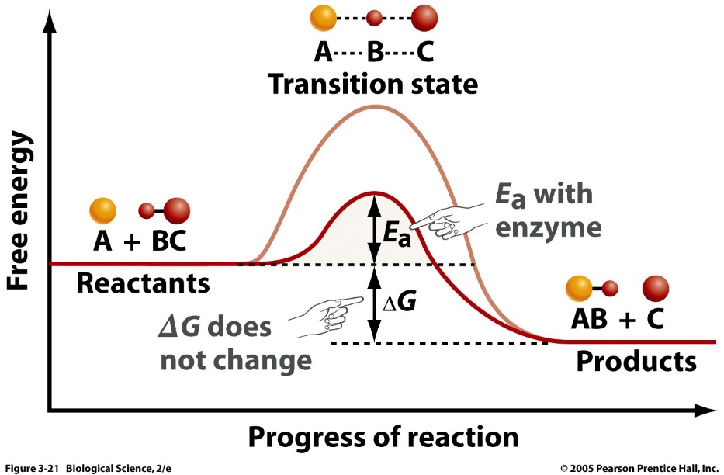  E_{a} (activation energy) without enzyme  (Freeman et al., Biological Science, Fifth Edition)
state and thus reducing the activation energy.

Activation energy should be distinguished from whether a reaction is exothermic or endothermic.
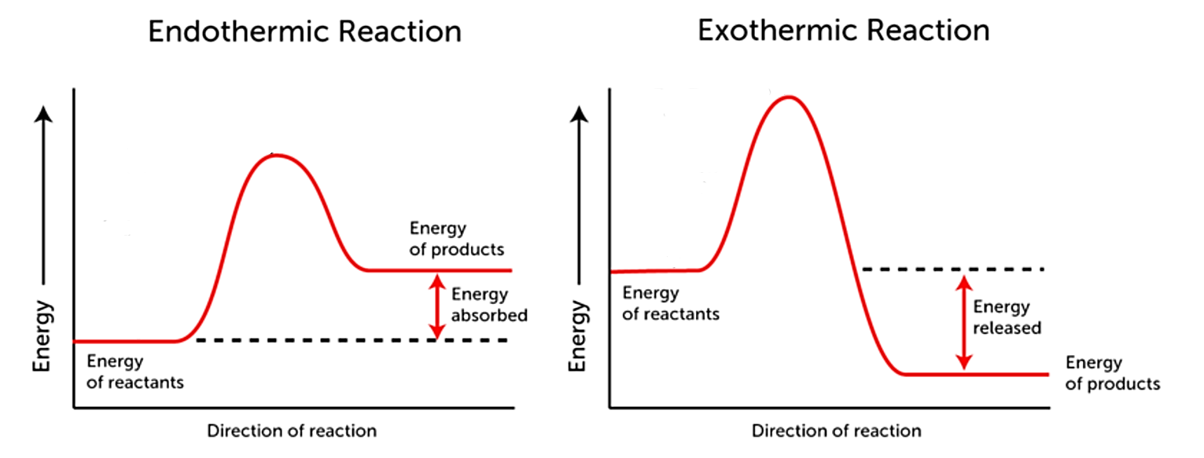
(http://www.theunforgivingminute.co/wp-content/uploads/2016/01/exo-endo-thermic.png)

An accurate understanding of energy, including chemical energy, requires a sophisticated understanding of physics and chemistry. Many high school biology students lack this background. Teachers need to simplify their explanations of energy metabolism so students can grasp basic concepts and are not overwhelmed by complexities. In teaching about energy, it is challenging to simplify in ways that do not reinforce common misconceptions, but instead provide a solid foundation for developing increasingly accurate and sophisticated understanding in the future. In the sections that follow and in the recommended learning activities, I have taken care to use wording that avoids the common misconceptions, but I have not attempted to explicitly convey the accurate principles listed in the tables on pages 3-4. If your students have learned these accurate principles in a previous chemistry course, you will want to incorporate these principles as you teach about bioenergetics.

III. ATP, Cellular Respiration and Fermentation

A. The Importance of ATP
Different types of organisms get their energy input from different sources (e.g. food, sunlight),
but all organisms use two basic steps to provide the energy needed for most of their biological processes.
- First, ATP is synthesized from ADP plus a phosphate using chemical energy released when organic molecules like glucose undergo cellular respiration (or anaerobic fermentation).
- Then, the hydrolysis of ATP provides the energy for many biological processes (e.g. synthesizing molecules and pumping ions into and out of cells).

Our cells are constantly using hydrolysis of ATP to provide the energy for biological processes and using cellular respiration to restore ATP levels. On average, each ATP molecule in our body is used and re-synthesized more than 30 times per minute when we are at rest and more than 500 times per minute during strenuous exercise.

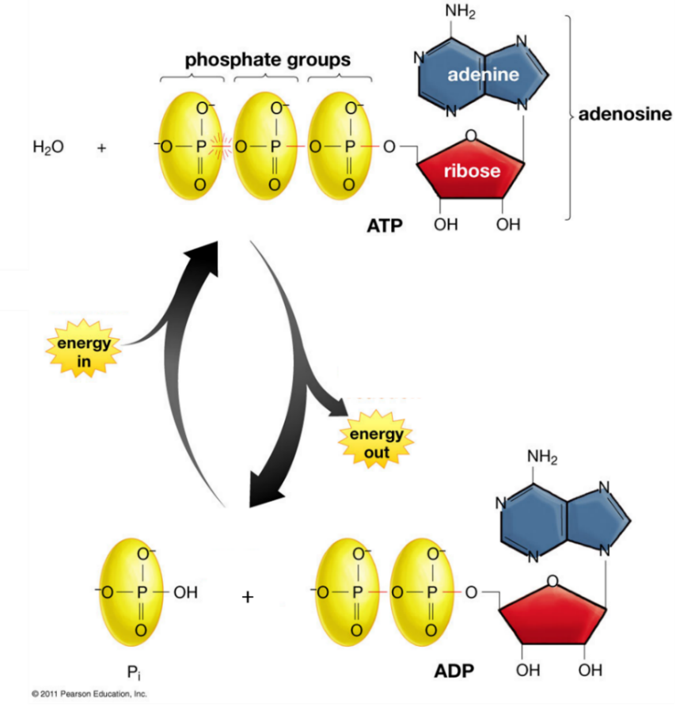
(adapted from Krogh, Biology -- A Guide to the Natural World, Fifth Edition)

Notice that ATP (adenosine triphosphate) has three negatively charged phosphates. When ATP reacts with water to form ADP (adenosine diphosphate) and a phosphate, negatively charged phosphates are separated and energy is released. Conversely, when ATP is synthesized, energy input is required to join the third negatively charged phosphate to the two negatively charged phosphates in ADP. More complete explanations of the reasons for the energy difference between ATP vs. ADP and P are provided in “Metabolism Is Composed of Many Coupled, Interconnecting Reactions” (http://www.ncbi.nlm.nih.gov/books/NBK22439/) and "Phosphate
Group Transfers and ATP” (http://www.bioinfo.org.cn/book/biochemistry/chapt13/bio3.htm).

B. The hydrolysis of ATP is shown in the figure below. As you know, hydrolysis refers to a chemical reaction in which a molecule is split into smaller molecules by reacting with water.

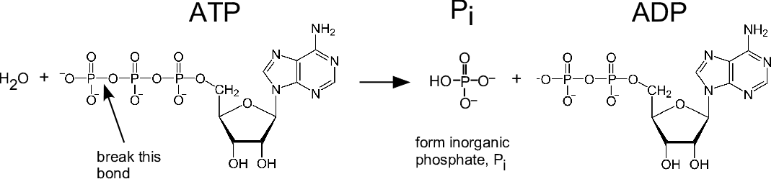
The hydrolysis of ATP illustrates the general principles described on page 4 of these Teacher Notes. It requires energy input to break a chemical bond, and the formation of a chemical bond releases energy. A chemical reaction releases energy when the bonds that are formed are more stable than the bonds that are broken. In the hydrolysis of ATP, a small amount of energy is required to cleave the terminal phosphate from ATP, but more energy is released when this phosphate combines with water to form the hydrogen phosphate ion (HPO₄–). This is often referred to as simply phosphate (abbreviated as P or P_{i}). (The figure omits the H⁺ ion which is produced by the dissociation of the weak acid H₂PO₄– H⁺ + HPO₄–.)

The hydrolysis of ATP supplies energy for many biological processes via coupled reactions in
which the first reaction provides the energy required for the second reaction. For example, muscle contraction results from many repeats of the pair of reactions shown here. | 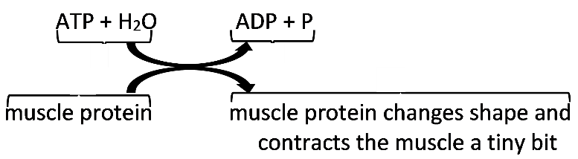

The hydrolysis of ATP typically occurs after the ATP is bound to a substrate molecule (see figure below). This is how the exergonic hydrolysis of ATP is coupled with an endergonic conformational change (movement) or an endergonic synthesis reaction.
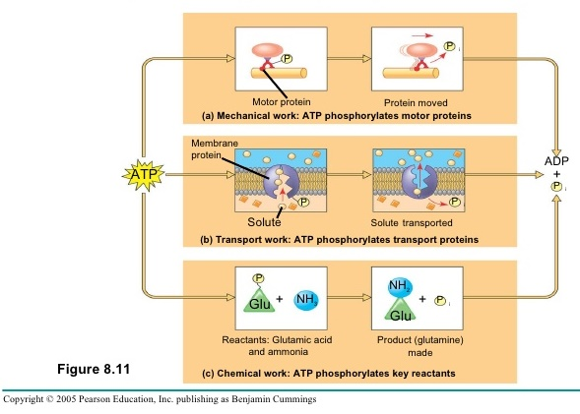
(http://image.slidesharecdn.com/ch8-091101165839-phpapp01/95/forjeffpark-25-728.jpg?cb=1257095688)

C. Cellular Respiration is the major process that produces ATP, so chemical energy is available
in the form that is used for many biological processes. This pair of chemical equations gives a highly simplified overview of the cellular respiration of glucose. | 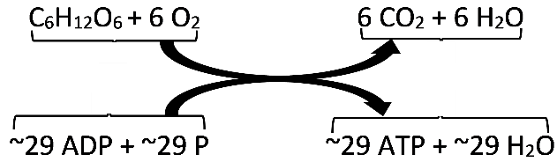

The figure below summarizes the multiple steps of cellular respiration, although it omits many of the specific steps. Notice that the oxidation of glucose is coupled with the production of ATP by a complex sequence of processes. Most of the ATP is produced in the mitochondria.

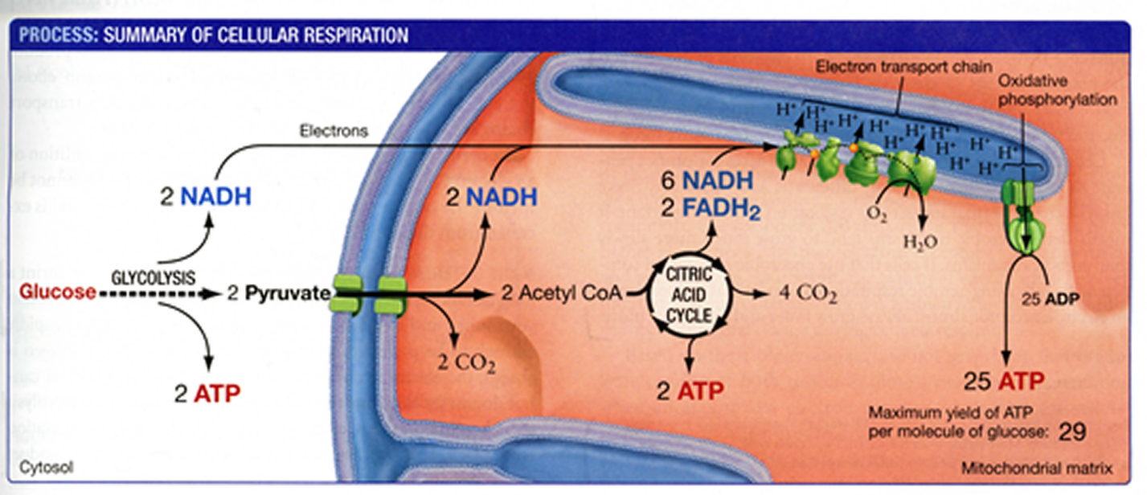(From Scott Freeman, Biological Science, Fourth Edition, 2011)

This drawing shows the basic structure of a mitochondrion.
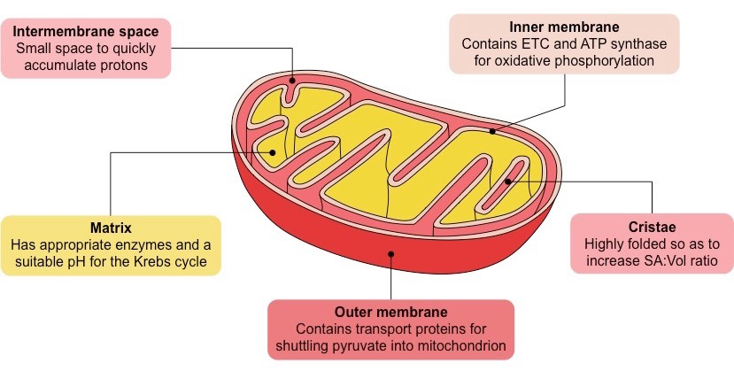
(https://ib.bioninja.com.au/_Media/mitochondrion_med.jpeg)

The figure below provides more detail about how the electron transport chain and ATP synthase work together to produce ATP inside the mitochondria.

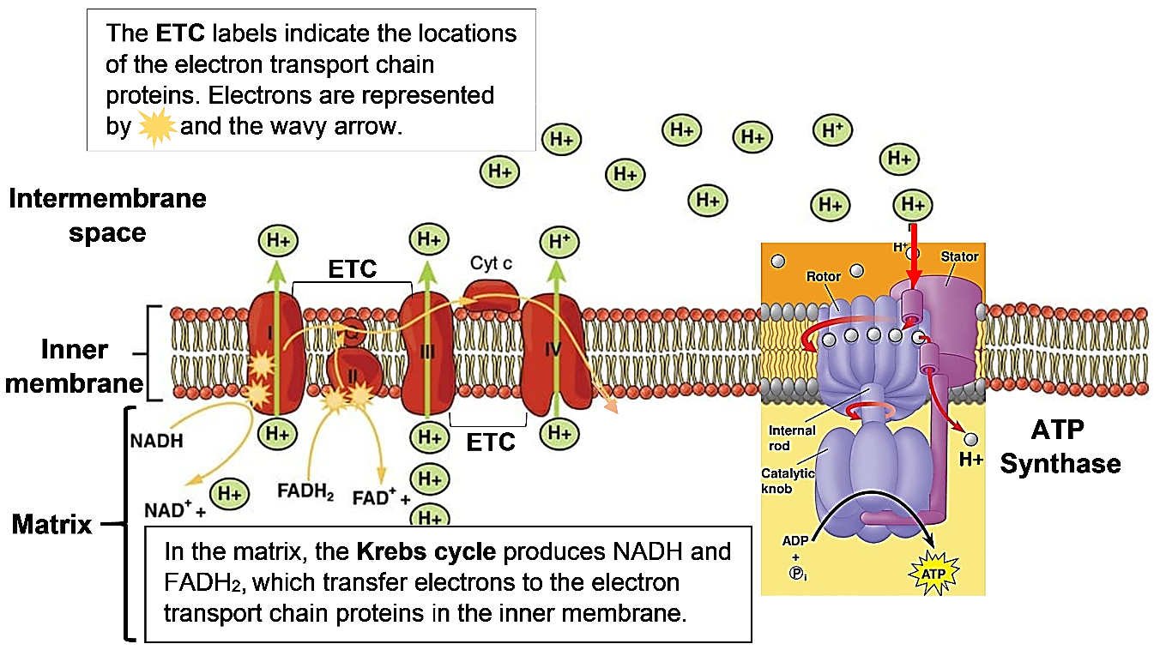

(modified from https://biologydictionary.net/wp-content/uploads/2018/08/The-Electron-Transport-Chain.jpg
and https://slideplayer.com/slide/14082775/86/images/57/Figure+9.14+ATP+synthase%2C+a+molecular+mill..jpg)

Cellular respiration produces ~29 molecules of ATP for each glucose molecule. This number is less than previously believed (and often erroneously stated in textbooks). This revised estimate is based on newly discovered complexities and inefficiencies in the function of the electron transport chain and ATP synthase enzyme. The number of ATP produced per molecule of glucose is variable because of variability in the efficiency of the electron transport chain proton pumps and the ATP synthase. These recent findings are interesting as an example of how science progresses by a series of successively more accurate approximations to the truth.

Two additional important points are:
- Only about 30% the energy released by the cellular respiration of glucose is captured in the production of ATP; much of the energy is lost as thermal energy.
- Cellular respiration can produce ATP using glucose, fatty acids, glycerol or amino acids as input molecules.

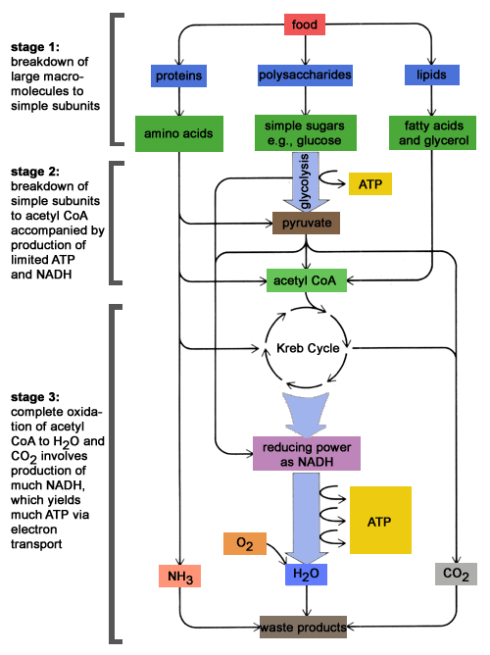
(Krebs cycle is another name for the citric acid cycle shown in the previous figure.
http://schoolworkhelper.net/wp-content/uploads/2010/07/catabolism.gif)

D. Aerobic cellular respiration requires O₂ as an electron acceptor at the end of the electron transport chain. When O₂ is not available, cells use anaerobic fermentation, which produces much less ATP per glucose molecule. The figure below summarizes alcoholic fermentation, e.g. in yeast cells.

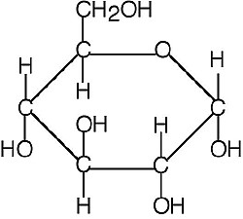  Glucose | 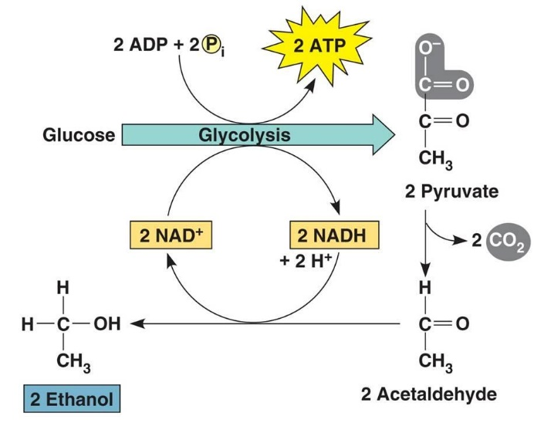
(http://classconnection.s3.amazonaws.com/583/flashcards/751135/jpg/alcohol-fermentation.jpg)

This figure summarizes lactic acid fermentation which occurs in mammalian muscle.
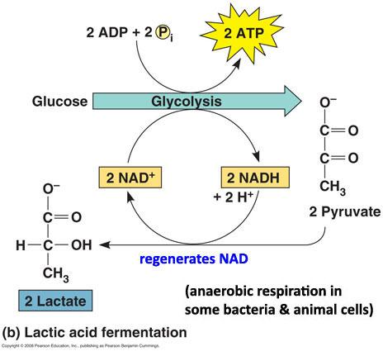
(http://test.classconnection.s3.amazonaws.com/529/flashcards/475529/jpg/lactic-acid-fermentation.jpg

E. To use energy from food:
- Large organic food molecules such as starch and triglycerides are digested to small organic molecules such as glucose and fatty acids that can be absorbed from the gut, travel in the blood, and enter cells to serve as input for cellular respiration.
- Cellular respiration of organic molecules such as glucose is used to synthesize ATP.
- Then, hydrolysis of ATP provides energy for cellular processes.

Common Misconception: Food = calories = energy
Food, calories and energy are related, but not equivalent concepts.
- Food contains organic molecules which can be used for cellular respiration which produces ATP; hydrolysis of ATP provides the energy for the processes of life. Food also provides molecules that can be used for growth and repair of body tissues.
- Energy is a property of all sorts of biological and non-biological systems (e.g. the chemical energy available from cellular respiration of food molecules or the kinetic energy of moving muscles or cars).
- A calorie is a unit of measure of energy (e.g. a measure of the energy available from the oxidation of a given amount of food).

IV. Photosynthesis
Photosynthesis converts light energy to chemical energy. Specifically, photosynthesis uses the sun's energy, carbon dioxide and water to produce sugar molecules and oxygen.

sunlight
6 CO₂ + 6 H₂O C₆ H₁₂O₆ + 6 O₂

Photosynthesis consists of a series of multistep processes inside chloroplasts, as summarized in the figure below.
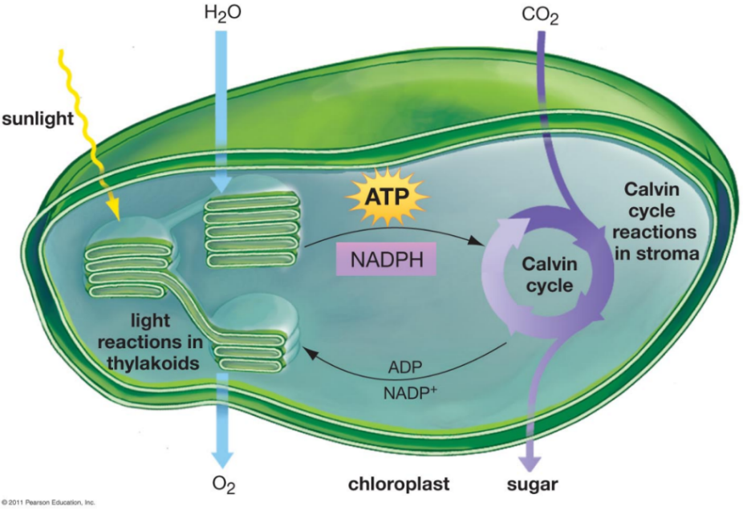
(From Krogh, Biology -- a Guide to the Natural World, Fifth Edition)

- Photosynthesis begins with light reactions which convert the energy in sunlight to chemical energy.
- The second stage of photosynthesis, known as the Calvin cycle, produces a 3-carbon molecule which is converted to glucose and fructose.
- Glucose and fructose can be converted to sucrose which can move throughout the plant and provides input molecules for cellular respiration. Glucose can also be used to produce starch (a storage molecule), cellulose (a major structural molecule in plants) and carbon-containing molecules that are used in the synthesis of lipids and amino acids.

Common Misconceptions:
- Students often do not understand that most of a plant’s biomass comes from CO₂. This misconception can be addressed with the learning activity "Where does a plant's mass come from?" (described in Section VI).
- Many students believe that only animals carry out cellular respiration and plants only carry out photosynthesis; they do not understand that plants also need to carry out cellular respiration to provide ATP for cellular processes. This misconception can be addressed with the learning activity "Photosynthesis and Cellular Respiration – Understanding the Basics of Bioenergetics and Biosynthesis" (described in Section VI).

V. Carbon Cycles and Energy Transfer in Ecosystems
- A producer is an organism that produces all of its own organic molecules from small inorganic molecules, whereas a consumer is an organism that consumes organic molecules produced by other organisms. Consumers can be categorized as primary consumers (herbivores) which eat producers, decomposers which consume dead organic matter, secondary consumers which consume primary consumers or decomposers, tertiary consumers which consume secondary consumers, or trophic omnivores which consume organisms at more than one trophic level.
- In a trophic relationship one organism consumes organic molecules from another organism (or a decomposer consumes organic molecules from dead organic matter). A food chain shows a simple sequence of trophic relationships (e.g. producer → primary consumer → secondary consumer). A food web shows the multiple complex trophic relationships among organisms in an ecosystem.
- Decomposers are crucial to prevent excessive accumulation of dead organic matter.
- Understanding a food web can help us to understand how changes in the population size of one organism can influence the population size of another organism in an ecosystem. For example, a trophic cascade can occur when an increase in a predator population results in a decrease in an herbivore population which in turn results in increased growth of producers.
- The carbon cycle results from the processes of:
- photosynthesis, which moves carbon atoms from CO₂ to small organic molecules, and biosynthesis, which produces larger, more complex organic molecules;
- eating by animals and consumption of dead organic matter by decomposers; these processes move carbon in organic molecules from one organism to another;
- cellular respiration, which moves carbon atoms from organic molecules to CO₂.
- The following general principles apply to all biological processes, including photosynthesis, biosynthesis and cellular respiration.
- The atoms in molecules can be rearranged into other molecules, but atoms cannot be created or destroyed.
- Energy is neither created nor destroyed by biological processes.
- Energy can be transformed from one type to another (e.g. the energy in sunlight can be transformed to chemical energy in glucose).
- During energy transfers and transformations, some of the input energy is transformed to thermal energy.
- Energy flows through ecosystems. Photosynthesis transforms sunlight to chemical energy in organic molecules (e.g. glucose). Glucose and other small organic molecules are used in cellular respiration to produce ATP, which provides the energy for many biological processes. Each of these biological processes produces thermal energy. Thermal energy cannot be used as the input energy for photosynthesis and instead is ultimately radiated out to space. Therefore, the biosphere, with all of the Earth’s living organisms, depends on constant input of light energy from the sun. In contrast, the earth does not receive a significant inflow of carbon atoms, and this is not a problem because the carbon cycle constantly recycles carbon atoms.
- The biomass of an organism is the mass of the organic molecules in the organism. The rate of production of biomass is highest for the producers in an ecosystem and smaller for each higher trophic level in the ecosystem. One major reason why the rate of biomass production is smaller for each higher trophic level is that much of the biomass eaten by consumers is not available for consumption by the next higher trophic levels since many of the organic molecules consumed are used for cellular respiration and carbon atoms are lost as CO₂ is released to the environment. The reduction in the rate of biomass production at higher trophic levels results in a trophic pyramid. One practical implication is that the amount of land needed to produce meat is about ten times greater than the amount of land needed to produce an equivalent biomass of plant food.
VI. Learning Activities
See pages 1-2 for a summary of recommended learning activities. Sections A and B below provide a brief description of each activity. Each of these learning activities supports the Next Generation Science Standards, as described in the Teacher Notes for each activity.

A. Descriptions of Activities That Help Students Learn the Basic Concepts

How do organisms use energy?
This analysis and discussion activity introduces students to the basic principles of how organisms use energy. The focus is on understanding the roles of ATP, cellular respiration, and hydrolysis of ATP. In addition, students apply the principles of conservation of energy and conservation of matter to avoid common errors and correct common misconceptions. Student Handout and Teacher Notes are available at http://serendipstudio.org/exchange/bioactivities/energy.

Using Models to Understand Cellular Respiration
To begin, students analyze two models of cellular respiration – chemical equations that summarize the inputs and outputs of cellular respiration and a figure that summarizes the three major stages of cellular respiration (glycolysis, the Krebs cycle, and the electron transport chain plus ATP synthase). Then, students use what they have learned to develop their own model of cellular respiration. In the optional final section, students analyze how the extensive, folded inner membrane of a mitochondrion contributes to ATP production. This illustrates the general principle that structure is related to function. Student Handout and Teacher Notes are available at http://serendipstudio.org/exchange/bioactivities/modelCR

Using Models to Understand Photosynthesis
In this analysis and discussion activity, students develop their understanding of photosynthesis by answering questions about three different models of photosynthesis. These models are a chemical equation, a flowchart that shows changes in energy and matter, and a diagram that shows the basic processes in a chloroplast. Students learn about the role of scientific models by evaluating the advantages of each of these models for understanding the process of photosynthesis. Student Handout and Teacher Notes are available at http://serendipstudio.org/exchange/bioactivities/modelphoto

Photosynthesis, Cellular Respiration and Plant Growth
This minds-on, hands-on activity begins with the driving question of how a tiny seed grows into a giant sequoia tree. To address this question, students first consider what types of molecules and atoms are in plants. Next, they analyze data from an experiment on changes in plant biomass in the light vs. dark. Then, they conduct an experiment to evaluate changes in CO₂ concentration in the air around plants in the light vs. dark. Students interpret these data to develop an increasingly accurate and evidence-based model of the contributions of photosynthesis and cellular respiration to changes in plant biomass. This activity counteracts several common misconceptions about plant growth, photosynthesis, and cellular respiration. Student Handout and Teacher Preparation Notes are available at https://serendipstudio.org/sci_edu/waldron/#photobiomass
or

Photosynthesis and Cellular Respiration – Understanding the Basics of Bioenergetics and Biosynthesis
In this minds-on activity, students analyze how photosynthesis, cellular respiration, and the hydrolysis of ATP provide energy for biological processes in plant cells. Students learn that the glucose molecules produced by photosynthesis are used for cellular respiration and for the synthesis of other organic molecules. The final section challenges students to use their understanding of photosynthesis and cellular respiration to explain observed changes in biomass for plants growing in the light vs. dark. The Teacher Notes suggest three possible additions to this learning activity. Student Handout and Teacher Notes are available at https://serendipstudio.org/exchange/bioactivities/photocellrespir.

+

Where does a tree’s mass come from?
Students analyze evidence to evaluate four hypotheses about where a tree’s mass comes from. For example, students analyze Helmont’s classic experiment and evaluate whether his interpretation was supported by his evidence. Thus, students engage in scientific practices as they learn that trees consist mainly of water and organic molecules and most of the mass of the organic molecules consists of carbon and oxygen atoms that came from carbon dioxide molecules in the air. Student handout and teacher preparation notes are available at https://serendipstudio.org/exchange/bioactivities/plantmass.

B. Additional Learning Activities

Food, Energy and Body Weight
This analysis and discussion activity helps students to understand the relationships between food, energy, cellular respiration, and changes in body weight. Analysis of a specific example helps students to understand how challenging it is to prevent weight gain by exercising to offset what seems to be a relatively modest lunch. In an optional research project, each student asks an additional question and prepares a report based on recommended reliable internet sources. Student Handout and Teacher Notes are available at http://serendipstudio.org/exchange/bioactivities/foodenergy

How do muscles get the energy they need for athletic activity?
In this analysis and discussion activity, students learn how muscle cells produce ATP by aerobic cellular respiration, anaerobic fermentation, and hydrolysis of creatine phosphate. They analyze the varying contributions of these three processes to ATP production during athletic activities of varying intensity and duration. Students learn how multiple body systems work together to supply the oxygen and glucose needed for aerobic cellular respiration. Finally, students use what they have learned to analyze how athletic performance is improved by the body changes that result from regular aerobic exercise. Student Handout and Teacher Notes are available at https://serendipstudio.org/exchange/bioactivities/energyathlete.

Alcoholic Fermentation in Yeast – A Bioengineering Design Challenge
This multi-part minds-on, hands-on activity helps students to understand both alcoholic fermentation and the engineering design process. In the first two parts of this activity, students learn about alcoholic fermentation and test for alcoholic fermentation by assessing CO₂ production by live yeast cells in sugar water vs. two controls. The third part of this activity presents the bioengineering design challenge where students work to find the optimum sucrose concentration and temperature to maximize rapid CO₂ production. Structured questions guide the students through the basic engineering steps of specifying the design criteria, applying the relevant scientific background to the design problem, and then developing and systematically testing proposed design solutions. Student Handout and Teacher Preparation Notes are available at http://serendipstudio.org/sci_edu/waldron/#fermentation

Photosynthesis Investigation
In the first part of this activity, students learn how to use the floating leaf disk method to measure the rate of net photosynthesis (i.e. the rate of photosynthesis minus the rate of cellular respiration). They use this method to show that net photosynthesis occurs in leaf disks in a solution of sodium bicarbonate, but not in water. Questions guide students in reviewing the relevant biology and analyzing and interpreting their results. In the second part of this activity, student groups develop hypotheses about factors that influence the rate of net photosynthesis, and then each student group designs and carries out an investigation to test the effects of one of these factors. Student Handout and Teacher Preparation Notes are available at http://serendipstudio.org/sci_edu/waldron/#photosynthesis

Food Webs, Energy Flow, Carbon Cycle and Trophic Pyramids
To begin this hands-on, minds-on activity, students view a video about ecosystem changes that resulted when wolves were reintroduced to Yellowstone. Then, students learn about food chains and food webs, and they construct and analyze a food web for Yellowstone National Park. Students use what they have learned to understand trophic cascades caused by the return of wolves to Yellowstone. Next, students learn that the biosphere requires a continuous inflow of energy, but does not need an inflow of carbon atoms. To understand why, students analyze how the carbon cycle and energy flow through ecosystems result from photosynthesis, biosynthesis, cellular respiration, and the trophic relationships in food webs. In the final section, students use the concepts they have learned to understand trophic pyramids and phenomena such as the relative population sizes for wolves vs. elk in Yellowstone. Thus, students learn how important ecological phenomena result from processes at the molecular, cellular, and organismal levels. Student Handout and Teacher Preparation Notes are available at http://serendipstudio.org/sci_edu/waldron/#ecolfoodweb.

or

Food Webs – Understanding What Happened When Wolves Returned to Yellowstone
To begin, students view a video about the trophic cascade that resulted when wolves were reintroduced to Yellowstone. Next, students learn about food chains and food webs. They construct and analyze a food web for Yellowstone National Park. Finally, students use what they have learned to better understand the trophic cascade caused by the return of wolves to Yellowstone. Student Handout and Teacher Notes are available at https://serendipstudio.org/exchange/bioactivities/foodwebRR.
+

Carbon Cycles and Energy Flow through Ecosystems
In this analysis and discussion activity, students learn why the biosphere requires a continuous inflow of energy, but does not need an inflow of carbon atoms. Students analyze how the process of photosynthesis illustrates the general principles of conservation of matter and the second Law of Thermodynamics. Then, students analyze how the carbon cycle and energy flow through ecosystems result from photosynthesis, biosynthesis, cellular respiration, and the trophic relationships in food webs. Thus, students learn how important ecological phenomena result from processes at the molecular, cellular and organismal levels. Student Handout and Teacher Notes are available at https://serendipstudio.org/exchange/bioactivities/carboncycle.
+

Trophic Pyramids
To begin this analysis and discussion activity, students review what happens to the atoms in the nearly 2000 pounds of food the average American eats each year. This provides a context for students to figure out why the rate of biomass production is higher for the producers than for the primary consumers in an ecosystem. Then, students construct and analyze trophic pyramids. Finally, they apply what they have learned to understanding why more resources are needed to produce meat than to produce an equivalent amount of plant food. Student Handout and Teacher Notes are available at https://serendipstudio.org/exchange/bioactivities/trophicpyr.

Food and Climate Change – How can we feed a growing world population without increasing global warming?
In this analysis and discussion activity, students learn how food production results in the release of three greenhouse gases – carbon dioxide (CO₂), nitrous oxide (N₂O), and methane (CH₄). Students analyze carbon and nitrogen cycles to understand how agriculture results in increased CO₂ and N₂O in the atmosphere. Students interpret data concerning the very different amounts of greenhouse gases released during the production of various types of food; they apply concepts related to trophic pyramids and they learn about CH₄ release by ruminants. Finally, students propose, research, and evaluate strategies to reduce the amount of greenhouse gases that will be released during future production of food for the world’s growing population.
Student Handout and Teacher Notes are available at https://serendipstudio.org/exchange/bioactivities/FoodClimateChange.

By Dr. Ingrid Waldron, University of Pennsylvania, © 2022. These Teacher Notes are available at http://serendipstudio.org/exchange/bioactivities/cellrespiration.
http://www.nextgenscience.org/
See http://www.ftexploring.com/energy/definition.html; http://www.nmsea.org/Curriculum/Primer/energy_physics_primer.htm
Quotations from Teaching Energy Across the Sciences K-12, J. Nordine, Ed., 2016, NSTA Press
Sources include "Exothermic Bond Breaking: a Persistent Misconception" (http://pubs.acs.org/doi/abs/10.1021/ed081p523), "The Trouble with Energy: Why Understanding Bond Energies Requires an Interdisciplinary Systems Approach" (http://www.ncbi.nlm.nih.gov/pmc/articles/PMC3671656/), and Teaching Energy across the Sciences, K-12, J. Nordine, Ed., 2016, NSTA Press.
See https://www.quora.com/Is-the-activation-energy-and-the-energy-to-break-bonds-the-same-I-think-its-not-but-can-somebody-explain-this-to-me and http://chemed.chem.purdue.edu/genchem/topicreview/bp/ch22/activate.html).
Hydrolysis is a chemical reaction in which a molecule is split into smaller molecules by reacting with water.
"Approximate Yield of ATP from Glucose, Designed by Donald Nicholson" by Brand, 2003, Biochemistry and Molecular Biology Education 31:2-4 (available at http://www.bambed.org).
We use biosynthesis to refer to the processes that use the product of photosynthesis to make other types of organic molecules. Some sources use the term biosynthesis to include photosynthesis.
Since organisms consist primarily of organic molecules and water, biomass is often estimated as the dry weight of an organism. Another measure of biomass is the mass of carbon in an organism; the mass of carbon is approximately half of the dry weight. (Unfortunately, biomass is sometimes used to refer to the total weight of an organism; this activity makes a crucial distinction between biomass and total mass.)
If your students are not familiar with cellular respiration and photosynthesis, you may want to use parts of Carbon TIME – Transformations in Matter and Energy (http://carbontime.bscs.org/). These well-designed activities can provide a context for the more complex presentation in the activities listed in this section.

