Alcoholic Fermentation in Yeast – A Bioengineering Design Challenge

I. Introduction
1. What do you think makes the many small holes in a piece of bread? (Hint: Assume the bread dough was made with yeast, and watch the first 1 minute and 25 seconds of the video at https://www.youtube.com/watch?v=5UyaZbNkjP0, through champagne bubbles.)

If sugar is available, living yeast cells will carry out the reactions that are summarized in the graphic to the right. Notice that:  - The sugar glucose is broken down to the alcohol ethanol plus carbon dioxide (CO₂).  - ATP is made from ADP plus P.  - Energy released by the first reaction provides the energy needed for the second reaction. | 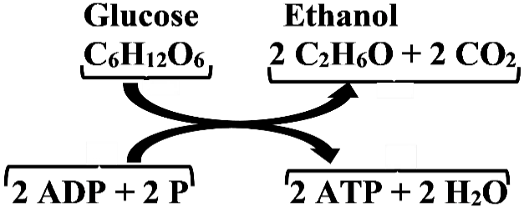  The pair of curved arrows represents coupled chemical reactions; the top reaction provides energy for the bottom reaction.
2a. These reactions summarize the main process that yeast cells use to make ATP. Why do cells need ATP?

2b. This process is called alcoholic fermentation. Which alcohol is produced?

2c. Bread dough rises because alcoholic fermentation produces a gas and bubbles of gas are trapped in the bread dough. These bubbles are responsible for the many small holes in bread. What gas is produced by alcoholic fermentation?

The graphic above summarizes alcoholic fermentation in two simple coupled chemical reactions. Alcoholic fermentation is actually a complex process that includes twelve different chemical reactions. Each of these twelve chemical reactions requires an enzyme.

3a. What are enzymes?

3b. What does it mean to say that a chemical reaction "requires an enzyme"?

4a. Examine the little dry grains of yeast that your teacher will distribute. You will test whether these grains of yeast contain cells that are alive and can carry out alcoholic fermentation. Do you think that these grains of yeast contain cells that are alive ___ or not alive ___?

4b. Explain your reasoning.

II. Do the grains of yeast contain living cells that can carry out alcoholic fermentation?

You will do an experiment to test whether the dry grains of yeast contain living cells that can carry out alcoholic fermentation. You will need to add:
- water to activate the dormant cells in the dry grains of yeast
- sugar to supply the glucose for alcoholic fermentation. (The sugar you will use is sucrose, the common sugar that people put in their coffee or use for baking. Yeast cells convert sucrose to glucose for alcoholic fermentation.)

5. What would you look for as a sign that the yeast cells are carrying out alcoholic fermentation?

6a. If bubbles are produced in your experiment, the bubbles might be due to a physical or chemical reaction between yeast and water. What control could test for this possibility?

6b. Which combination of results would provide evidence that alcoholic fermentation occurred in the experiment?
a. Bubbles in the experiment and the control c. Bubbles in the experiment but not the control
b. No bubbles in the experiment or the control d. Bubbles in the control but not the experiment

Explain your reasoning.

For another control, you will use grains of yeast that have been boiled, so the enzymes in the yeast cells have been denatured so they are not active. You will test whether these definitely dead yeast cells produce bubbles when sugar is available.

7a. Can these definitely dead yeast cells carry out alcoholic fermentation of glucose?
yes ___ no ___
7b. Explain why or why not. Include enzymes in your explanation.

8. Use the information on this page (including your answers to questions 5-7) to briefly summarize the planned experiment and controls in the table below.
- Refer to yeast grains that have been boiled as definitely dead.
- Refer to yeast grains that have not been boiled as possibly living.

 | Brief Description of What You Will Mix Together | Expected Results if the Possibly Living Grains of Yeast Contain Living Cells that  Can Carry Out Alcoholic Fermentation
Experiment
Control 1
Control 2
In your experiment to test for alcoholic fermentation in yeast cells:
- Cup 1 will test for bubble production by possibly living yeast cells in sugar water.
- Cup 2 will test for bubble production by possibly living yeast cells in plain water.
- Cup 3 will test for bubble production by definitely dead yeast cells in sugar water.

Procedure
- Label your cups.
- Weigh the dry ingredients and pour them into the labeled cups.
  - For cup 1: 4 g of yeast + 0.5 g of sucrose
  - For cup 2: 4 g of yeast
  - For cup 3: 0.5 g of sucrose
- Add the liquid to the labeled cups
  - For cups 1 and 2: 80 mL of 35°C water
  - For cup 3: 80 mL of 35°C dead yeast suspension
- Each person in your group should stir the contents of one of the cups for one minute. Smash any clumps of yeast and, if necessary, use your second spoon to scrape off any yeast that is stuck to the first spoon.
- Mark the level of the liquid in each cup, so it will be easy to measure the height of the foam layer. Set up the warm water bath with 35°C water, just up to the level of liquid in the cups.
- Put your cups and the thermometer in the warm water bath. Begin timing 10 minutes. Record the beginning temperature of your warm water bath in question 9.
- Record your observations of any bubbles in the second and third columns of the table in question 9. Do not bump the cups.
- At minute 9, record the temperature of your warm water bath, and record this ending temperature in question 9.
- At the end of 10 minutes, measure the depth of the layer of foam at the edge of each cup. Record your measurements in the last column of the table in question 9. If there is no foam, record the depth of foam as 0.
- Report to your teacher the depth of the foam layer in each cup and the beginning and ending temperatures.
- Empty and clean the cups and bath. Clean up your workspace.

9. Record your group’s data here.

Beginning temperature _______° C Ending temperature _______° C

 | Any bubbles  right at the beginning? | Observations  during minutes 1-9 | Depth of Foam Layer (mm) at  10 minutes
Possibly living yeast in
sugar water (1)
Possibly living yeast in
plain water (2)
Definitely dead yeast in
sugar water (3)

10a. Do your group’s results support the conclusion that the possibly living yeast contained living cells that could carry out alcoholic fermentation?

10b. Explain your reasoning.

11a. Your teacher will display the results for all the student groups in your class. Do the class results change your conclusions in your answers to question 10? yes ___ no ___

11b. If yes, summarize your conclusions based on the class results.

12a. In the cups with possibly living yeast in sugar water, how much variation was there in the depth of the foam layer?

12b. What could be the reasons for any differences?

12c. When your class repeats your experiment, how could you improve your methods to get more reliable and valid results?

III. Bioengineering Design Challenge

The ingredients for bread include yeast, sugar, water and flour. The gluten protein in the flour traps the CO₂ bubbles produced by the yeast so the bread dough rises and the bread is fluffy. The fluffiness of the bread can be influenced by:
- the temperature of the dough as it rises and how long the dough rises
- the relative amounts of sugar, yeast, water and flour in the dough.

Design Challenge. Jim Baker wants to make his bread as fluffy as possible without spending too much time waiting for the dough to rise. He has asked your class to use the same amounts of yeast and water as you used in your previous experiment and find which combination of temperature and amount of sucrose produces the most bubbles in 10 minutes. However, Jim Baker does not want his bread to be too sweet, so he has asked you to find the least amount of sucrose that will result in maximum CO₂ production.
Scientific Background. CO₂ is produced by alcoholic fermentation, which includes multiple chemical reactions, each catalyzed by a different enzyme. Fortunately, you do not need to think about all of these chemical reactions and enzymes to predict the effects of different temperatures and sucrose amounts on the rate of CO₂ production. You can get sufficiently accurate predictions by thinking about the expected effects for a single reaction catalyzed by a single enzyme.
13a. What happens to the rate of a chemical reaction catalyzed by an enzyme as temperature increases? In the graph, draw a curve to show the expected change in the rate of CO₂ production as the temperature increases.  13b. Give molecular explanations for the relationship between temperature and rate of reaction. | 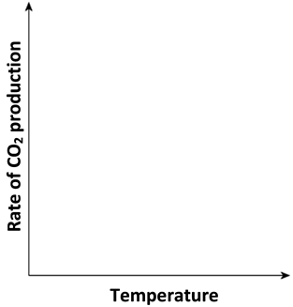

14a. What happens to the rate of a chemical reaction catalyzed by an enzyme as the concentration of the substrate increases? In the graph, draw a curve to show the expected change in the rate of CO₂ production as the amount of sucrose in the solution increases.  14b. Give molecular explanations for the relationship between sucrose concentration and the rate of CO₂ production. | 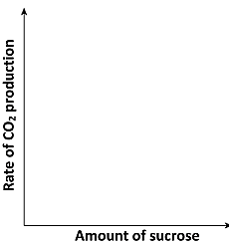

Finding a Design Solution
15a. Based on the temperature in your experiment in Part II and your answer to question 13, what range of temperatures do you think should be tested to identify the best temperature for the Design Challenge?
_________________________________________________________________
15b. Explain your reasoning.

16a. Based on the amount of sucrose in your experiment in Part II and your answer to question 14, what range of grams of sucrose in 80 mL H₂O do you think should be tested to identify the best concentration of sucrose for the Design Challenge?
_________________________________________________________________
16b. Explain your reasoning.

Two students have suggested different strategies for your Class Investigation Plan.
- One student has suggested that each group should use their answers to questions 15-16 to choose three combinations of temperature and sucrose amount that they will test.
- A second student has suggested that the class should agree on the most important temperatures and sucrose levels to test and then cooperate to test each sucrose level at each temperature. (This will also test each temperature at each sucrose level.)

17a. What is a possible advantage of strategy A?

17b. What is a possible advantage of strategy B?

Your teacher will lead a discussion to develop your Class Investigation Plan.

Procedure
- Record your group’s assigned temperature and amounts of sucrose in question 18.
- Label your cups.
- Weigh the dry ingredients – 4 g of yeast + the assigned amounts of sucrose – and pour them into the labeled cups.
- Add 80 mL of water at the assigned temperature to each cup.
- Stir the contents of the cups vigorously for 1 minute. Smash any clumps of yeast.
- Mark the level of the liquid in each cup. Set up the warm water bath with water at the assigned temperature, just up to the level of the liquid in the cups.
- Put your cups and the thermometer in the warm water bath. Begin timing 10 minutes. Record your beginning temperature in question 18.
- At minute 9, record the ending temperature in question 18.
- At the end of 10 minutes, measure the depth of each layer of foam and record your results in question 18.
- Report to your teacher the depth of the foam layer in each cup and the beginning and ending temperatures.
- Empty and clean the cups and bath. Clean up your workspace.

18. Assigned Temperature ____° C
Beginning Temperature _____° C Ending Temperature _____° C

 | Cup 1 | Cup 2 | Cup 3
Amount of Sucrose (grams in 80 mL of water)
Depth of Foam Layer (mm)
at 10 minutes

19. Your teacher will provide the information to fill out as many of the columns as possible in this table. (Each column will give the data from one student group.)

Amount of sucrose (grams in 80 mL of water) | Depth of Foam Layer (mm)
 | Lowest Assigned Temperature (______°C) |  | Next Assigned Temperature (______°C) |  | Third Assigned Temperature (______°C) |  | Highest Assigned Temperature (______°C)
 | Test 1 | Test 2 | Test 1 | Test 2 | Test 1 | Test 2 | Test 1 | Test 2
Lowest amount (_______ g)
Medium amount (_______ g)
Highest amount (_______ g)
Beginning temperature
Ending temperature

20. Graph the depth of the foam layer vs. beginning temperature for each amount of sucrose. Choose a range for each variable that will include all the data points. Label the axes, which should be the same in all three graphs. Use a dot to indicate each Test 1 result and a small x to indicate each Test 2 result.
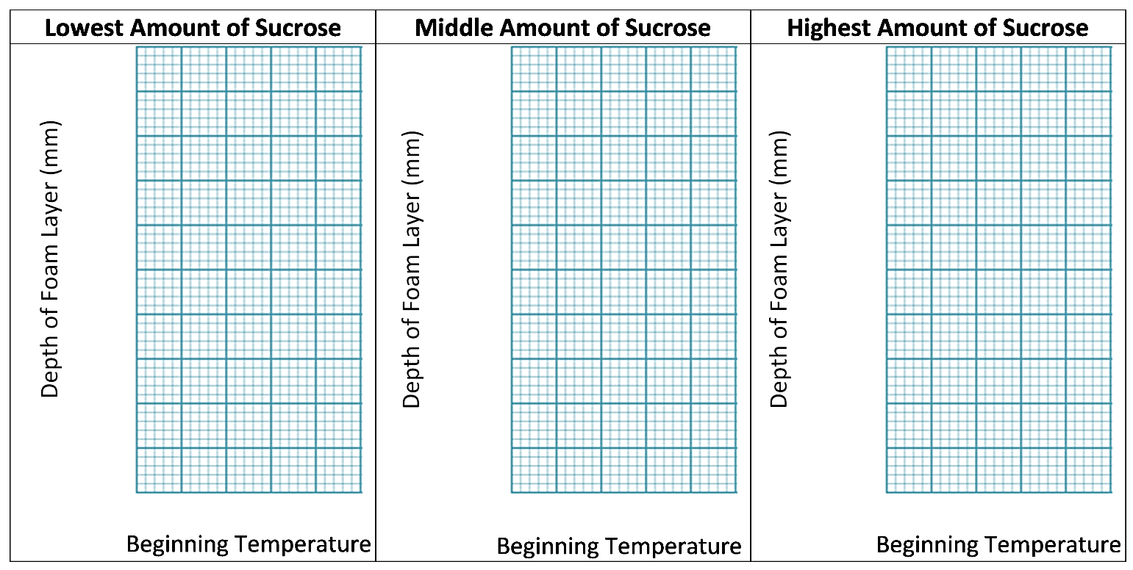

21. Interpret the results shown in the above graphs. What effects did different temperatures have on the amount of CO₂ produced?

22a. This graph shows the expected relationship between temperature and rate of bubble production. Circle the part of the graph that most closely resembles your graphs in question 20. If you are not sure which part of the graph to circle, explain your uncertainty. | 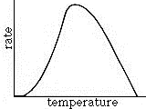

22b. What additional tests would you recommend to find the optimum temperature for maximum CO₂ production? Explain your reasoning.

23a. Compare the effects of temperature for tests 1 and 2 in each graph in question 20. Were the effects of temperature consistent for these replicate tests?

23b. If the effects of temperature were not consistent, what could account for any differences?

23c. Were the effects of temperature consistent for different amounts of sucrose? If not, what could account for the variation?

24a. Graph the depth of the foam layer vs. the amount of sucrose per 80 mL of water for each temperature. Choose a range for each variable that will include all the data points. Label the axes, which should be the same in all four graphs. Use a dot to indicate each Test 1 result and a small x to indicate each Test 2 result.
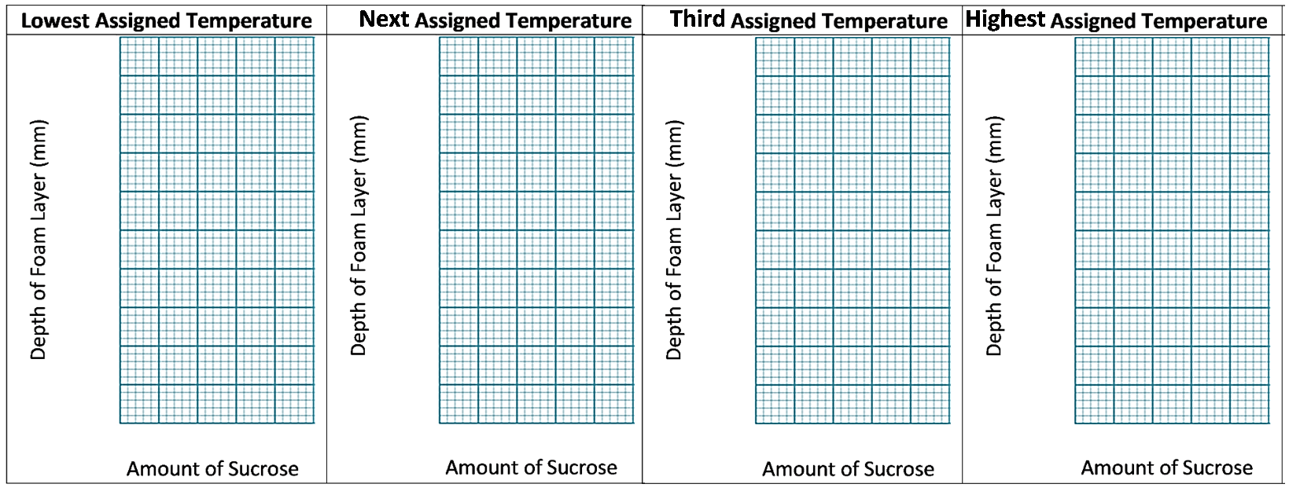
24b. Circle the two highest depth-of-foam-layer results and note here the amount of sucrose and the temperature for maximum CO₂ production.

25. Interpret the results shown in the above graphs. What effects did different amounts of sucrose have on the amount of CO₂ produced?

26. This graph shows the expected relationship between sucrose concentration and rate of CO₂ production. Circle the part of the graph that most closely resembles your graphs in question 24a. If you are not sure which part of the graph to circle, explain your uncertainty.

Jim Baker asked your class to find “the least amount of sucrose that will result in maximum CO₂ production”. This criterion was intended to ensure that the bread would be fluffy, but it wouldn’t be too sweet. However, it’s unclear what the trade-off should be between maximum production of CO₂ bubbles and not too sweet. Should the criterion be set at A or B or some other value?

27a. What would be an advantage of using point A as the criterion for sucrose concentration?

27b. What would be an advantage of using point B as the criterion for sucrose concentration?

28a. Suppose Jim Baker told you to choose point A for the ideal sucrose concentration to meet his design challenge. What advice would you give him concerning the optimum temperature and optimum amount of sucrose per 80 mL of water? Include cautions about any uncertainties that result from the limitations of your class’s data.

28b. Describe any additional testing you would recommend to improve your advice.

28c. Would you advise continued testing with the procedures you have been using, or would you advise Jim Baker to begin testing with bread dough? What are the relative advantages and disadvantages of these two ways of testing different possible design solutions?

By Drs. Ingrid Waldron and Jennifer Doherty, University of Pennsylvania, Biology Department, © 2024. This Student Handout, a simpler shorter Student Handout, and Teacher Preparation Notes with instructional suggestions and background information are available at https://serendipstudio.org/sci_edu/waldron/#fermentation.

