**A Scientific Investigation – What types of food contain starch and protein?**[1]

As you know, most of our food comes from plants and animals. Plant and animal cells contain many types of molecules. This investigation will focus on starch and protein.

**1a.** List some foods that you think contain starch.

**1b.** List some foods that you think contain protein.

**1c.** Label each food in your answers above with A if the food comes from animals, P if the food comes from plants, or A&P if the food has ingredients from both plants and animals.

|  |  |
| --- | --- |
| A **starch** molecule is a polymer of glucose molecules. A **polymer** is a large molecule made up of many repeated subunits, called **monomers**.  **2a.** The monomer in starch is  ____________.  **2b.** Which three types of atoms are found in starch?  Starch molecules store glucose for later use. For example, when a seed sprouts, enzymes break down the starch in the seed to individual glucose molecules which are used by the embryo plant.   * The embryo plant uses glucose for the process that makes ATP, which provides the energy for many of the processes of life. * The embryo plant also uses glucose molecules to synthesize other organic molecules in the growing embryo plant.   **3.** Describe how the starch in a seed helps the embryo plant. |  |
|  |

|  |  |  |  |
| --- | --- | --- | --- |
| **Proteins** are polymers of **amino acids**. This figure shows the basic structure of an amino acid and two examples of the 21 different types of amino acids in human proteins. |  |  |  |

**4a.** Each amino acid has a central carbon atom linked to:

* a nitrogen-containing ______________ group
* a hydrogen atom
* a carboxyl group which acts as an acid
* an R group which varies in different amino acids

**4b.** In the figure, circle the part of each amino acid that is the same in all types of amino acids.

**4c.** Which type of atom is present in amino acids, but not in glucose?

After amino acids have been joined together in a polymer, some of the amino acids in the polymer are attracted to each other so the polymer folds into the complex shape of a protein. The specific sequence of amino acids in the protein determines the structure and function of the protein.

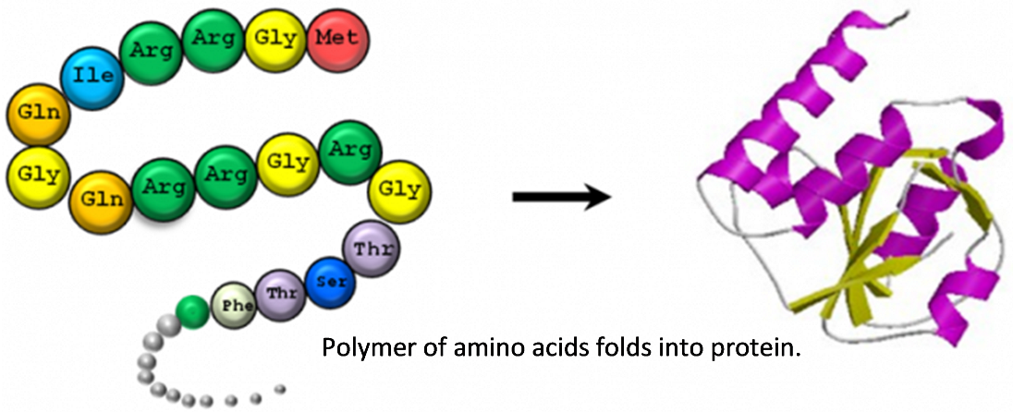

The 21 different types of amino acids are combined in multiple different sequences to make thousands of different types of protein. Proteins have many functions, including:

* enzymes, which speed up chemical reactions
* structure (e.g., the cytoskeleton inside cells)
* movement (e.g., muscle contraction, transport of molecules inside cells).

|  |  |
| --- | --- |
| **5a.** Based on the many functions of proteins, which type of cells contain proteins?   1. animal cells 2. plant cells 3. all types of cells   **5b.** Meat is mainly made up of muscle cells from farm animals. Muscle cells have lots of protein. What is the function of this protein? |  |

This flowchart outlines how plant cells make starch and proteins. To make starch, plant cells join together glucose molecules produced by photosynthesis. To make amino acids, plant cells combine molecules derived from glucose with nitrogen-containing ions from the soil. To make a protein, specific amino acids are joined together in the correct sequence.

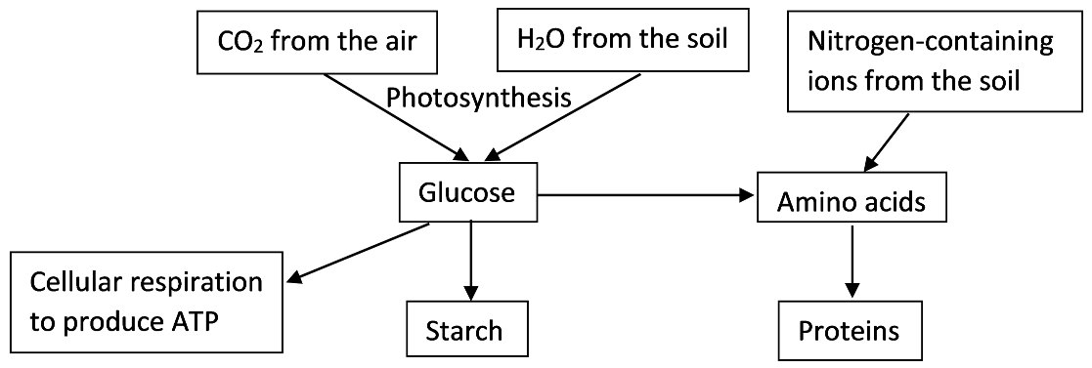

**6**. Explain how photosynthesis contributes to the production of proteins in plants.

|  |  |
| --- | --- |
| Human cells can convert some amino acids to other amino acids. However, we need to consume the essential amino acids that our cells cannot make.  **7.** Describe how human cells get the amino acids they need to make proteins. |  |

**8a.** Name a beverage that contains a lot of protein. Explain how the protein in the beverage is useful for the animal that produces the beverage or for its offspring.

**8b.** Many seeds contain quite a bit of protein. How could this stored protein be useful for the embryo plant that develops from the seed?

**How can we test for starch and protein?**

In this section, you will evaluate whether either of two indicator solutions can be used to test for starch. An indicator solution is a good test for starch if it changes color in the presence of starch, but does not show the same color change in the presence of other molecules such as sugars, proteins or lipids.

The supplies you will have available to test the indicator solutions are:

* Indicator Solution 1
* Indicator Solution 2
* Containers for testing, plus marker and masking tape for labeling these containers
* Stirrers; gloves
* Samples you can use for testing the indicator solutions:

- Corn starch - Sucrose = table sugar

- Egg whites (high in protein) - Vegetable oil

- Gelatin (protein from bones, skin, etc. of farm animals) - Water

- Potato starch

**9.** You will also evaluate whether either of the indicator solutions can be used to test for proteins. Complete this table.

|  |  |
| --- | --- |
| An indicator solution that is a good test  for protein will change color when added  to these samples from the above list: | An indicator solution that is a good test  for protein will *not* change color when added to these samples from the above list: |
|  |  |

To design procedures for testing whether each indicator solution is a good test for starch or for protein, answer questions 10 and 11.

**10.** Circle the samples in the table below that you will include in your test of each indicator solution. Explain your reasons for including or excluding each sample.

|  |  |
| --- | --- |
| Samples | Reasons for including or excluding these samples when you test whether an indicator solution is a good test for starch or for protein |
| Corn starch and potato starch |  |
| Egg whites and gelatin |  |
| Sucrose, vegetable oil, and water |  |

**11.** How will you evaluate each test? What will you look for?

To be confident of your results, you will need to carry out each test carefully and have replicate tests (i.e. have two or more groups carry out each test). A large number of tests will be required to evaluate whether either indicator solution can be used to test for starch or for protein. Your teacher will assign specific tests to each student group. **Before you begin your tests, read the cautions** **and instructions below**.

**Cautions:**

* **Do *not add both* indicator solutions to the same sample; use each indicator solution on a different sample in a separate container.**
* **Be careful when handling indicator solution 1; it can stain hands and clothing**.
* **Indicator solution 2 contains sodium hydroxide, a strong base.** **Be very careful *not to splash or spill any*. If you splash any indicator solution on yourself, wash it off immediately with water and ask your teacher for assistance**.
* **Wear *gloves* to protect yourself.**

**Instructions**:

1. For either type of starch or sucrose, dissolve about 0.3 g in about 2 mL of water. For gelatin, dissolve about 0.1 g in about 2 mL of water. For egg whites, use about 0.8 g as your sample. For oil and water, use about 1 mL.
2. To use indicator solution 1, add up to 5 drops to the sample and stir. To use indicator solution 2, add up to 20 drops to the sample and stir. With indicator solution 2, the color change may take up to a minute.

**12.** Record the results of your group’s tests in this table. Report your results to your teacher.

|  |  |  |  |  |
| --- | --- | --- | --- | --- |
| **Sample** | **Indicator Solution**  **1 or 2** | **Color of Indicator Solution** | | |
| **Before added**  **to sample** | **After added**  **to sample** | **Change?**  **Yes or no** |
|  |  |  |  |  |
|  |  |  |  |  |
|  |  |  |  |  |
|  |  |  |  |  |
|  |  |  |  |  |
|  |  |  |  |  |

**13a.** Two student groups tested the same indicator-sample combination, but they got opposite results. One group reported a color change, but the other group did not. Give at least one possible reason why the two groups observed different results for the same indicator-sample combination.

**13b.** What is the advantage of having replicate tests (i.e. two different groups testing the same indicator with the same sample)?

**14.** Use the data from all of the student groups to complete the following table.

|  |  |  |  |  |
| --- | --- | --- | --- | --- |
| **Sample** | **Did indicator solution 1**  **change color?** | | **Did indicator solution 2**  **change color?** | |
| **Replicate 1** | **Replicate 2** | **Replicate 1** | **Replicate 2** |
| **Corn Starch** |  |  |  |  |
| **Potato starch** |  |  |  |  |
| **Egg whites** |  |  |  |  |
| **Gelatin** |  |  |  |  |
| **Sucrose** |  |  |  |  |
| **Vegetable oil** |  |  |  |  |
| **Water** |  |  |  |  |

If there are any differences between the replicates of any test, your class will probably need an additional, very careful replicate test to resolve the disagreement.

**15a.** Based on the results in question 14, is either indicator solution a good test for starch?

If yes, which one?

**15b.** Briefly summarize the evidence that supports your conclusion.

**16a.** Is either indicator solution a good test for protein?

If yes, which one?

**16b.** Briefly summarize the evidence that supports your conclusion.

**17.** What additional evidence would allow you to be more certain of your conclusions?

You have tested the indicator solutions on samples of food that have high concentrations of starch or protein. If a food contains only a tiny amount of starch or protein, this will not cause a noticeable change in the color of the indicator solution. Therefore, in the next section, “What types of food contain starch?” is shorthand for “What types of food contain enough starch to cause a noticeable color change in the indicator solution?”

**18.** In the next section,“What types of food contain protein?” is shorthand for “__________

________________________________________________________?”

**What types of food contain starch? What types of food contain protein?**

In this part of the activity, you will evaluate whether starch and protein are found in

- all foods derived from animals - some foods derived from animals

- all foods derived from plants - some foods derived from plants

- all foods derived from animals or plants - some foods derived from animals or plants

**19.** Begin by summarizing the results from question 14 in this table.

|  |  |  |  |  |  |  |
| --- | --- | --- | --- | --- | --- | --- |
| Food derived  from animals | Did this food  have starch? | Did this food  have protein? |  | Food derived  from plants | Did this food  have starch? | Did this food  have protein? |
|  |  |  |  |  |  |
|  |  |  |  |  |  |
|  |  |  |  |  |  |
|  |  |  |  |  |  |

**20a.** Use the results summarized in question 19 to write a hypothesis about which types of food contain starch (all or some foods from animals and/or plants).

**20b**. Use the results to write a hypothesis about which types of food contain protein.

**21.** Your class will be given the foods listed below to test your hypotheses. Complete columns 2-4 in this table to predict the expected results if your hypothesis is correct. If your hypotheses do not predict a specific result, put a ?.

|  |  |  |  |  |  |
| --- | --- | --- | --- | --- | --- |
| **Food**  (with instructions to prepare  sample for testing) | **Does this food come from plants or animals?** | **Based on your hypotheses, do you expect this food to contain:** | | **After testing, use the class data to indicate whether the food contains:** | |
| **starch?** | **protein?** | **starch?** | **protein?** |
| **Beans** (mash 2 beans into a paste with ~1 mL water) |  |  |  |  |  |
| **Almond paste** (mix ~0.6 g with ~0.5 mL of water) |  |  |  |  |  |
| **Jelly** (mix ~1.5 g with ~0.5 mL water) |  |  |  |  |  |
| **Butter** (~1 g) |  |  |  |  |  |
| **Yogurt** (~1 g) |  |  |  |  |  |

To evaluate your hypotheses (question 20), you will need to test your predictions (question 21). Many tests will be needed, so your teacher will assign specific tests to each student group.

**22.** Use the cautions on page 5 and the instructions in the first column of the table in question 21 to guide your testing.Record your data in this table and report the results to your teacher.

|  |  |  |
| --- | --- | --- |
| **Sample** | **Based on your results, does this food contain** | |
| **starch?** | **protein?** |
|  |  |  |
|  |  |  |
|  |  |  |
|  |  |  |

**23.** Record the class data in the last two columns of the table in question 21.

**24a.** Is your hypothesis about which types of food contain starch supported by the new data in question 21? yes ___ no ___

**24b.** Explain how the evidence does or does not support your hypothesis.

**24c.** If your hypothesis was not supported, write a new hypothesis that takes account of all of the data you have (in questions 19 and 21).

**25a.** Is your hypothesis about which types of food contain protein supported by the new data in question 21? yes ___ no ___

**25b.** Explain how the evidence does or does not support your hypothesis.

**25c.** If your hypothesis was not supported, write a new hypothesis that takes account of all of the data you have (in questions 19 and 21).

**26**. Indicate any limitations of the evidence and any uncertainty in your conclusions. What additional evidence would be useful to evaluate your hypotheses?

1. By Dr. Ingrid Waldron, Department of Biology, University of Pennsylvania, © 2021. This Student Handout and Teacher Preparation Notes with suggestions for implementation and background biology are available at <https://serendipstudio.org/sci_edu/waldron/#starch>.