Photosynthesis, Cellular Respiration and Plant Growth

The seed of a giant sequoia is only about 5 mm long and about 1 mm in diameter. This tiny seed can grow into a tree as tall as a 20-story building (roughly 250 feet or 80 m).

To see the early growth of a sequoia tree, view https://www.youtube.com/watch?v=3mGrBt0zCOU. To see the enormous size of an adult giant sequoia tree, view https://www.youtube.com/watch?v=vNCH6uhB_Bs.

1. A giant sequoia can weigh as much as 2000 tons (4 million pounds or 1.8 million kilograms). Where do you think that all this mass came from?

Trees gain mass by the same basic processes as other plants. To understand how a giant sequoia can gain tons of mass, we will consider evidence from all types of plants.

The main types of molecules in plants are water and organic molecules. An organic molecule is a carbon-containing molecule that is made by a plant or other organism. Examples of organic molecules include sugars, starch, cellulose, amino acids, and proteins. The mass of the organic molecules in a plant is called the biomass.

2. To figure out where a plant’s mass comes from, we need to learn where and how a plant gets water and organic molecules. To record your initial ideas, answer the question in the second column of this table.

How do you think a plant gets or makes each type of molecule?
Biomass (mass of
organic molecules)
+ Mass of water
molecules
= Total mass of a plant

3a. Identify the kinds of atoms in the organic molecules in this chart.

Organic Molecules |  | Kinds of Atoms in These Molecules
Monomer | Polymer
Glucose
Example of an Amino acid | etc.; folds into Protein

3b. Each kind of atom in these organic molecules must be contained in the molecules that plants use to make organic molecules. Many types of plants can be grown with no soil. Instead, their roots are in water that has small amounts of dissolved minerals (which include nitrogen atoms, but not carbon atoms). For these plants, where do you think that the carbon atoms in their organic molecules come from?

To learn more about where plants’ mass comes from, you will analyze research results from two experiments.

Experiment 1 – Changes in Biomass for Plants Grown in Light vs. Dark

At the beginning of Experiment 1, each dish had 1.5 grams of radish seeds and no soil or water. Then, each dish was exposed to light and/or water for ten days (see figure). The resulting seeds or plants were dried to remove the water they contained. The weight of the dried seeds or plants gave the biomass (the mass of the organic molecules).

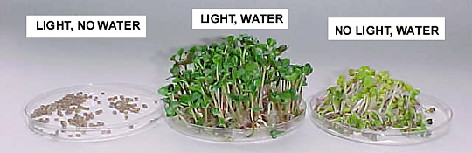
Biomass after 10 days: 1.46 g 1.63 g 1.20 g

4a. The plants that grew with light and water had ___________ biomass than the seeds they sprouted from. (less/more)

4b. The plants that grew with water, but no light had ___________ biomass than the seeds they sprouted from. (less/more)

5a. The results of Experiment 1 indicate that, for seeds to sprout and plants to gain biomass,

both _______________ and ________________ are needed.

5b. Show these two inputs for the tree in this figure. Add any other inputs that you think are needed for growth of a tree. Add any processes that you think contribute to growth of the tree.  5c. Recall that biological processes cannot convert energy to mass. Why is light energy needed for plants to gain biomass? | 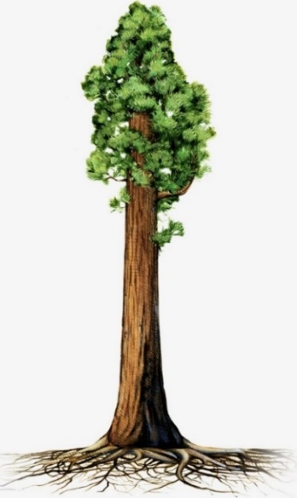

6. What could explain the decrease in the biomass of the plants that grew in the dark? What do you think happened to some of the organic molecules to cause a decrease in biomass?

Experiment 2 – Changes in CO₂ in the Air around Plants in the Light vs. Dark

7a. You and your classmates will do an experiment to evaluate changes in the concentration of CO₂ in the air around plants in the light versus plants in the dark. Why would information about changes in CO₂ concentration be relevant for understanding changes in plant biomass?

7b. Complete this table to predict the results of your experiment.

Plants in a Closed Container | Predicted Change in the Concentration of CO₂ in the Surrounding Air | Explain why you made this prediction.
In the Dark | Decrease ___  Increase ___  No change ___
In the Light | Decrease ___  Increase ___  Could be decrease, increase, or no change ___
8a. In your experiment you will use change in the color of an indicator solution to evaluate changes in CO₂ concentration. To interpret the change in color of the indicator solution, you will first test the change in color in response to air with different amounts of CO₂. Which do you think has more CO₂? room air ___ air that you exhale (breathe out) ___

8b. Explain your reasoning

9a. Your teacher will give you two beakers with indicator solution. Record the beginning color of the indicator solution in the first column of the table below. Follow the instructions in the second column of the table, and then record your observations in the third column.

Beginning Color | Instruction | Final Color
 | Use a straw to blow bubbles into the indicator solution in one beaker.
 | Squeeze a pipette to blow bubbles of room air into the indicator solution in the other beaker.

9b. What change in color indicates an increase in concentration of CO₂?

Procedure and Results for Your Experiment

- Your group will work with a partner group to measure changes in CO₂ in the air around plants in the light vs. dark. One group should mark your large container with an L for light, and the other group should mark your large container with a D for dark.

- In each container, put a pan of growing plants and two petri dishes with the CO₂ indicator. Label your petri dishes 1 and 2. For the indicator in petri dish 2, blow bubbles through a straw to add CO₂.

- Record the color of the CO₂ indicator in each petri dish in each container and the date and time at the beginning of the day in the light or in the dark. You may also want to take a photo of the petri dishes in each container.

 | Color of indicator
 | L Container (in the light) |  | D Container (in the dark)
 | Petri dish 1 | Petri dish 2 | Petri dish 1 | Petri dish 2
At the Beginning Date/Time:
At the End
Date/Time:

- Seal your container. Put the L container under a light. Put the D container in a dark closet, trash bag or box.

- Wait a day. Then, record the color of the CO₂ indicator in each petri dish and the date and time. You may want to take another photo of the petri dishes in each container.

Interpretations and Conclusions

10a. Summarize the results of Experiments 1 and 2 in this table.

Experimental Condition | Biomass  (Decreased or Increased) | CO₂ in the air around the plants  (Decreased or Increased)
Plants in Light
Plants in Dark

10b. Based on these results, what is the relationship between changes in biomass and changes in the concentration of CO₂?

To interpret these results, it is helpful to review photosynthesis and cellular respiration. The figure below shows that, for plants in the light, photosynthesis, cellular respiration, and hydrolysis of ATP work together to provide the energy for plants’ biological processes. Photosynthesis can produce more glucose than the plant needs for cellular respiration; any extra glucose is used to make additional organic molecules such as cellulose and starch.

In the dark, photosynthesis stops, but plants continue to carry out multiple biological processes that require energy. The energy for these biological processes is provided by cellular respiration and the hydrolysis of ATP. Plant cells break down starch to provide the glucose needed for cellular respiration.

11. In this figure,
- circle the process that only occurs in the light
- put a rectangle around the processes that occur in both the light and dark
- show that, in the dark, starch is the source of the glucose that is needed for cellular respiration
- show how plants use any extra glucose made by photosynthesis in the light.

12a. You can use this information to interpret your results from Experiment 2. What caused the change in concentration of CO₂ when plants were in the dark?

12b. What caused the change in concentration of CO₂ when plants were in the light?

12c. When the CO₂ concentration in the air decreased, where did the CO₂ go?

13. For a plant to gain biomass, the number of glucose molecules produced by photosynthesis

must be ____________________ the number of glucose molecules used for cellular respiration.
(greater than / less than / the same as)

This diagram shows a plant, a cell in the plant’s leaf, and a chloroplast inside the cell.

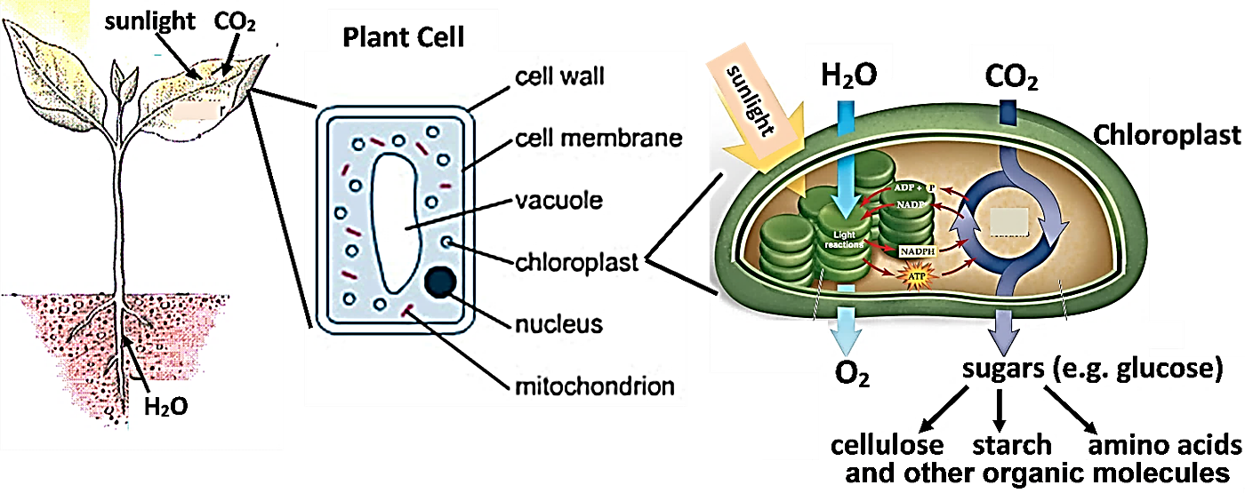

14a. Put a rectangle around the part of this figure that shows photosynthesis.

14b. Circle the part of the figure that shows that sugars produced by photosynthesis are used to make other organic molecules.

14c. Which input to the plant provides the carbon and oxygen atoms that are responsible for most of the mass of the cellulose in plant cell walls? (Remember that cellulose is a polymer of glucose.)

14d. Explain your reasoning.

15a. In this figure, show the inputs needed for a giant sequoia tree to gain biomass. (Include the sources of all the kinds of atoms in your answer to question 3.)  15b. Explain how the giant sequoia tree uses these inputs to create biomass. (If you prefer, you can show your explanation in a diagram.)  15c. Which molecule was the source of most of the biomass of the giant sequoia tree? | 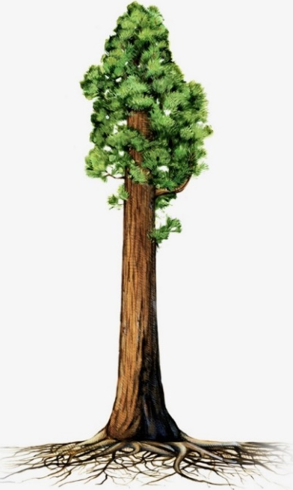
Seeds and Seedlings

This figure shows that a seed contains stored food (starch molecules) and an embryo (which can develop into a new plant). When a seed sprouts, the embryo develops into a seedling.

When the seedling starts to grow underground in the dark, starch stored in the seed is broken down to glucose. Some of this glucose is used for cellular respiration and some is used to make organic molecules in the growing seedling.

16a. The figure below shows how a seed sprouts and grows underground until time E when the seedling’s leaves emerge from the soil into the light. In the graph, show the general pattern of changes in biomass before time E while the seedling’s leaves are still underground. At the
beginning, the biomass of the seed is S.  16b. Draw the changes in biomass after time E when the leaves of the seedling have emerged into the light. | 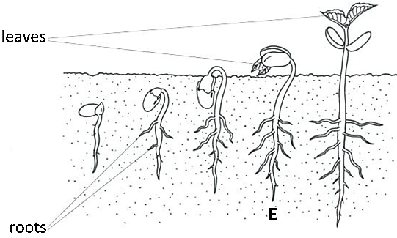

16c. Explain the reasons for the changes in biomass that you have shown.

17. In Experiment 1 (page 2), why did the seedlings that grew in the dark have less biomass than the seeds they spouted from?

18. Many people get most of their daily calories from the starch that is stored in seeds such as rice, wheat or corn. Why is it useful for a plant to include stores of starch in its seeds?

By Drs. Ingrid Waldron, Lori Spindler and Linda Robinson, Department of Biology, University of Pennsylvania, © 2022. This Student Handout and Teacher Preparation Notes with instructional suggestions and background information are available at https://serendipstudio.org/sci_edu/waldron/#photobiomass.

