Evolution by Natural Selection

What is evolution by natural selection?

A population of mice lived in a desert with gray sand. These drawings show how the population changed from time 1 to time 3.
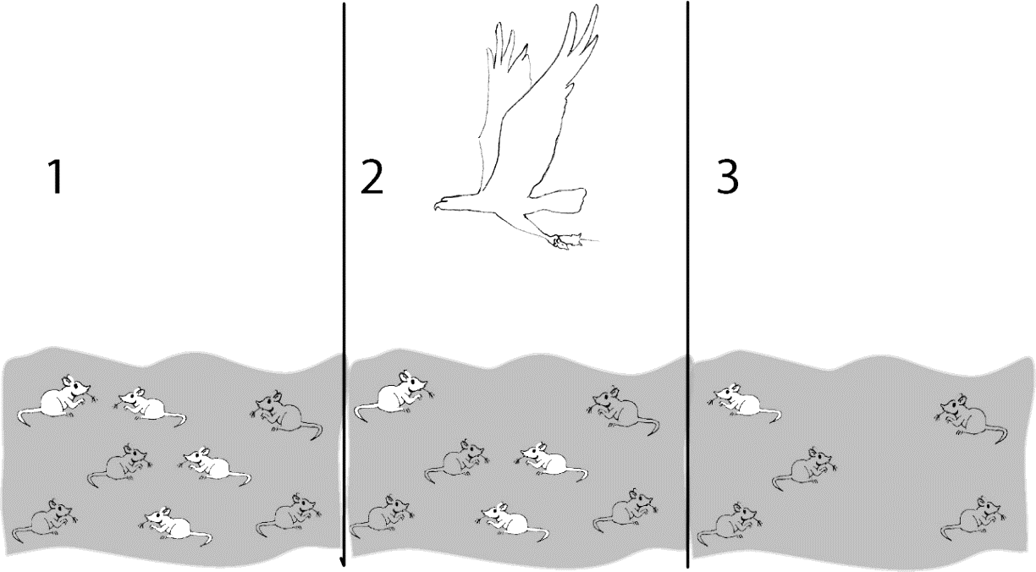

1a. Describe how the population of mice was different at time 3 compared to time 1.

1b. Explain what happened to cause this difference.

1c. Suppose the mice in drawing 3 had babies. What color fur do you think most of the babies would have? Explain your reasoning.

2. Fitness is defined as the ability to survive and reproduce. For the mice in the figure, which characteristic increased fitness?

3. The term fitness can have different meanings, depending on what subject you are discussing.

What does the term physical fitness mean?

What does the term fitness mean when biologists are discussing evolution?

Three pairs of adult mice were released in a gray sand desert; these Generation 1 Adults are shown in the first row of the chart. These mice had the Generation 2 Babies shown in the second row. The babies that survived to become adults are shown in the last row.

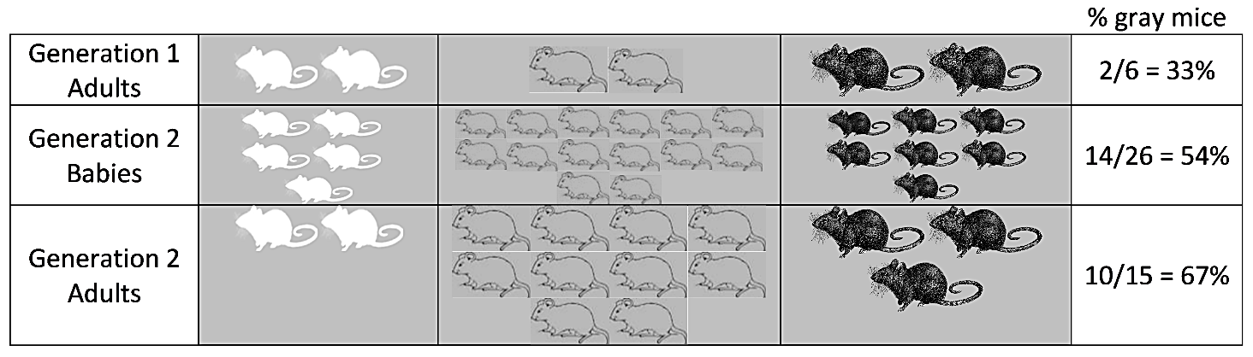

This table shows some characteristics of the Generation 1 adult females.

 | White Fur | Gray Fur | Black Fur
Number of babies born | 5 | 14 | 7
Age at death | 3 months | 6 months | 4 months

4. Give a likely reason why the female with gray fur had the most babies.

- A heritable trait is a characteristic that is influenced by genes and passed from parents to offspring. For example, fur color is a heritable trait for mice.
- An adaptation is a heritable trait that increases fitness (the ability to survive and reproduce).

5a. Which color fur is an adaptation for these mice?

5b. What evidence supports your answer?

5c. The percent of adults with gray fur increased from 33% in Generation 1 to 67% in Generation 2. What caused this increase?

6a. Predict what would happen to this population of mice after many generations on the gray sand.
- About two-thirds (67%) of the mice would have gray fur.
- Almost all of the mice would have gray fur.
- There would be equal numbers of mice with white fur, gray fur, and black fur.

6b. Explain your reasoning.

7a. Suppose that six of the Generation 2 adults migrated to a nearby desert with white sand. Suppose that these six mice included a pair of white mice, a pair of gray mice, and a pair of black mice. What would this population of mice on the white sand desert look like after many generations? 1/3 with each color fur ___ mostly gray mice ___ mostly white mice ___

7b. Which color fur would be an adaptation for the mice on the white sand?

7c. Is the same color fur an adaptation in all environments? yes ___ no ___

8. Explain how an adaptation becomes common in a population. (Remember that an adaptation is a heritable trait that increases fitness.)

This process is called natural selection. A heritable trait that increases fitness tends to become common in a population because (1) individuals that have this trait are more likely to survive and reproduce and (2) their offspring generally have the same trait.

9a. Natural selection occurs in all types of organisms. What is the adaptation in the example of natural selection shown in these pictures?
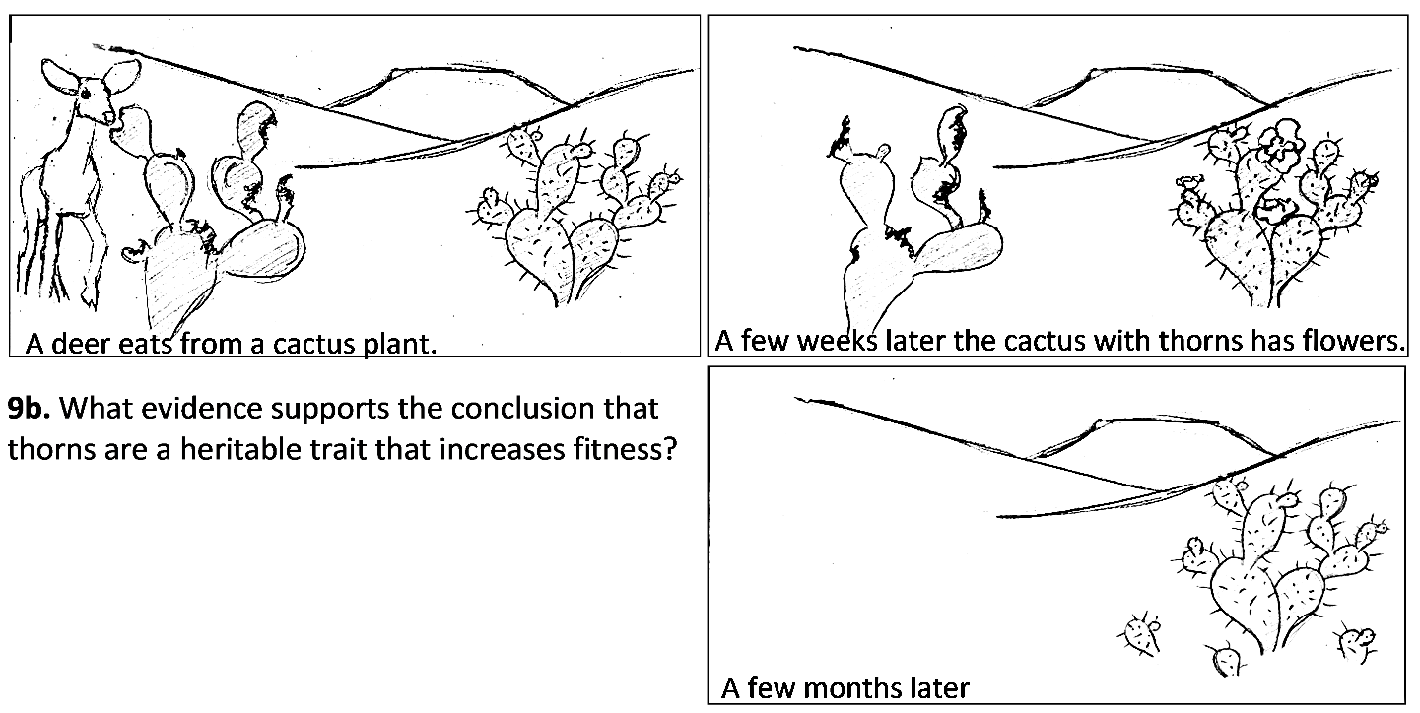

10a. Evolution is defined as a change over time in the inherited characteristics of a population. What is evolution by natural selection? (A complete answer will include adaptations, fitness, and heritable.)

10b. Explain why organisms have many characteristics that help them survive and reproduce in their environment.

Simulation of Natural Selection

Now, you will play a simulation game to show how natural selection works. This simulation involves two populations of pom-poms. One population lives in a Black Forest habitat and the other population lives in a Red Grassland habitat. The only threat to these pom-pom creatures is the presence of hungry hunters (that’s you!).

Each pom-pom is either red or black. Each hunter will have either a fork or spoon as his or her feeding structure. The differences in pom-pom color and hunter feeding structures are heritable. If a pom-pom survives to reproduce, its offspring will have the same color as their parent. Similarly, if a hunter survives to reproduce, the hunter’s offspring will have the same feeding structure as their parent.

11. At the beginning of the simulation, each pom-pom population will have 50% red pom-poms and 50% black pom-poms. How do you think the percent red vs. black pom-poms will change after you and your classmates have hunted for pom-poms?

Black Forest:

Red Grassland:

Explain the reasons for your predictions.

12. You will be given a fork or spoon as your feeding structure and a cup as your stomach. To capture a pom-pom, you must use only your fork or spoon to lift the pom-pom from the habitat and put it into your cup. For each habitat, indicate which feeding structure you think will allow a hunter to capture more pom-poms or indicate if you think the two different types of feeding structures will work equally well.

Black Forest (represented by a rough black material such as faux fur):

Red Grassland (represented by a red fleece material):

Explain the reasons for your predictions.

Simulation Procedure
- Go to your assigned habitat: Black Forest or Red Grassland.

- Rules for Feeding:
- Start and stop when your teacher says to.
- You must pick up each pom-pom with your feeding structure and drop it into your cup. You may not tilt your cup and scoop in pom-poms.
- Once a pom-pom is on a classmate's fork or spoon it is off limits.

- After feeding, count how many red, black, and total pom-poms you have eaten. Line up with the others who were feeding on the same habitat, from fewest total pom-poms eaten to most total pom-poms eaten. Then, follow the instructions from the Student Helper for your group.

- While your teacher is helping the surviving pom-poms in each habitat to reproduce, discuss the following questions with your group:
- Which feeding structure contributed to greater fitness in your habitat?
- What characteristics of forks and spoons increased or decreased fitness in your habitat?

- Next, you will run through the simulation one more time.

13. Use the class data for the trends in fork vs. spoon feeding structures to complete this table.

 | Black Forest | Red Grassland
Describe any changes from generation 1 to generation 3 in the number of hunters with fork feeding structures.
Do the trends in the class data match your predictions in question 12?
Propose possible explanations for the trends or lack of trends in the number of hunters with fork feeding structures in each habitat.

14. Copy the class pom-pom data into the table below. Then, for Generation 2 and Generation 3 in each habitat, calculate the total number of pom-poms and the percent of each color.

 | Pom-poms in the Black Forest |  |  |  | Pom-poms in the Red Grassland
 | Black | Red | Total |  | Black | Red | Total
Generation 1
Number
Percent | 50% | 50% | 100% |  | 50% | 50% | 100%
Generation 2
Number
Percent |  |  | 100% |  |  |  | 100%
Generation 3
Number
Percent |  |  | 100% |  |  |  | 100%

15. Use the data in the table to complete these graphs.

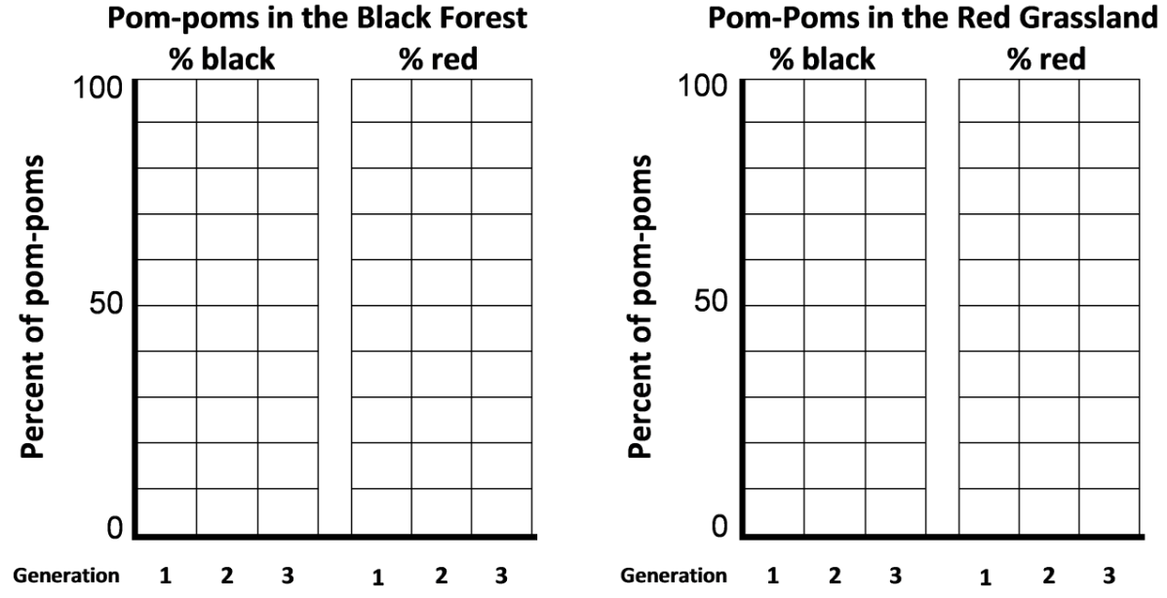

16a. For each habitat, describe the changes in the percent red vs. percent black pom-poms.

Black Forest:

Red Grassland:

16b. Do the results of your simulation match your predictions in question 11? yes ___ no ___

16c. Explain why the trends differed in the two different habitats.

17a. Did any individual pom-poms change color? yes ___ no ___

17b. If no, then why did the percent red vs. black pom-poms differ between Generation 1 and Generation 3?

Notice that natural selection does not refer to individuals changing their characteristics. Rather, natural selection results in a higher proportion of individuals that have an adaptation.

18a. Suppose that the black forest experienced a prolonged drought, so all the trees died and the habitat became red grassland. What do you think would happen to the pom-pom population? First, make your prediction if the population of pom-poms at the beginning of the drought included both red and black pom-poms.

18b. Next, think about a different scenario. Suppose that natural selection over many generations had eliminated all the red pom-poms in the black forest habitat so the population in this habitat only had black pom-poms. After that, a prolonged drought resulted in this habitat turning into a red grassland. Would natural selection for pom-pom color occur? Why or why not?

18c. Based on this example, explain why evolution by natural selection can only occur if there is variation in a trait.

19a. Suppose that your class repeated the simulation, but this time all the hunters were blind-folded so they could only find pom-poms by touch. In each habitat, what fraction of the pom-poms would be red at the end of the simulation? (Remember that at the beginning of the simulation half the pom-poms were red and half were black.)

Black Forest:

Red Grassland:

19b. Explain your reasoning.

19c. Based on this example, explain why evolution by natural selection can only occur if differences in a trait result in differences in fitness.

20a. Next, think about what would happen if your class repeated the simulation, this time with hunters who could see their prey. However, pom-pom color would not be heritable. No matter what color the pom-pom parent was, half of its babies would be red pom-poms, and half would be black pom-poms. After each pom-pom parent had babies, it would die. What fraction of the baby pom-poms would be red in each generation in each habitat?

Black Forest:

Red Grassland:

20b. Describe the long-term trends in the population of pom-poms on the red grassland.

20c. Based on this example, explain why evolution by natural selection can only occur if the variation in a trait is heritable.

21. This simulation helps us to understand the basic process of natural selection. However, a simulation simplifies the biological process that it mimics, so there will be differences between the simulation and the actual biological process. Describe one way that natural selection in real biological populations is more complex than our simulation.

Natural Selection and the Peppered Moth

Scientists have observed natural selection in action in multiple types of animals, plants and other organisms. You will analyze an example of natural selection in peppered moths.
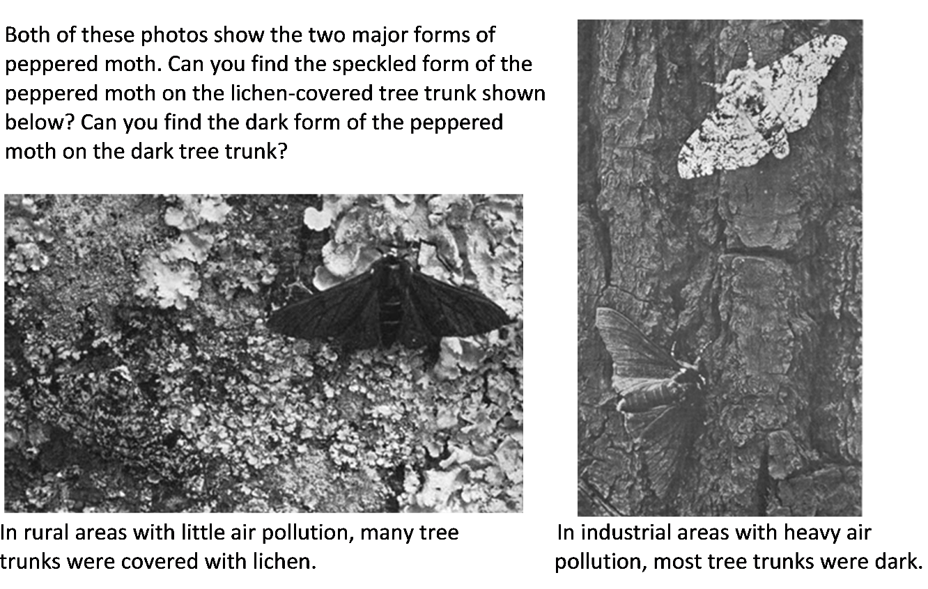
Peppered moths are active at night. During the day, they rest on tree trunks and branches. Some of these resting peppered moths are eaten by birds. Researchers have observed differences in mortality, with one form of peppered moth surviving better in one of the environments shown above and the other form of peppered moth surviving better in the other environment.

22. In each photo, circle the form of the peppered moth that would have higher mortality and lower fitness in that environment.

An individual peppered moth cannot change from speckled to dark or vice versa. The difference between the speckled and dark forms of the peppered moth is a heritable trait. Specifically, this difference results from different alleles of a single gene. The allele for the dark form (D) is dominant over the allele for the speckled form (d).

23a. Complete these Punnett squares. Circle the genotype of each parent or offspring that would have the dark form. Put an * next to the genotype of each parent or offspring that would have the speckled form.

23b. Explain why the offspring of peppered moths generally look like their parents.

24. Complete this table to describe three necessary conditions for evolution by natural selection to occur and the evidence that the peppered moth example fulfills each necessary condition.

Three Necessary Conditions for Evolution by Natural Selection to Occur (Hint: See questions 18c, 19c and 20c.) | What is the evidence that the peppered moth example  fulfills each necessary condition?  (Hint: See page 8.)

25. Complete this table to describe the expected effects of natural selection as the environment changed in regions of England that became industrialized.

Environmental Change for  Industrialized Regions  of England | Expected Effects of  Natural Selection on  % Dark Peppered Moths | Expected Trends in % D Alleles  (for the D/d gene that determines the dark vs. speckled form)
Before 1850, air pollution was low and tree trunks and branches were lighter and often covered with lichen. | The dark form of the peppered moth was more likely to be eaten by birds, so the dark form had low fitness and was very rare. | Moths with the D allele are dark. In this environment, dark moths rarely survived to reproduce. Therefore, the D allele was very rare.
After 1850, industrialization resulted in air pollution which darkened tree trunks and branches. | Decrease ___  Increase ___  Stay the same ___ | Decrease ___  Increase ___  Stay the same ___
Beginning in the late 1950s, government regulation resulted in decreased air pollution, so tree trunks and branches became lighter. | Decrease ___  Increase ___  Stay the same ___ | Decrease ___  Increase ___  Stay the same ___

These graphs show trends in the percent dark moths and the percent D alleles in an industrialized region in England. Each dot in the upper graph represents a data point. The lines show the estimated trends. (The width of each line indicates uncertainty in the estimates.)  26a. Do these graphs support your predictions in question 25?  yes ___ partly ___ no ___  26b. Explain the causes of any trends that are different from your predictions. | 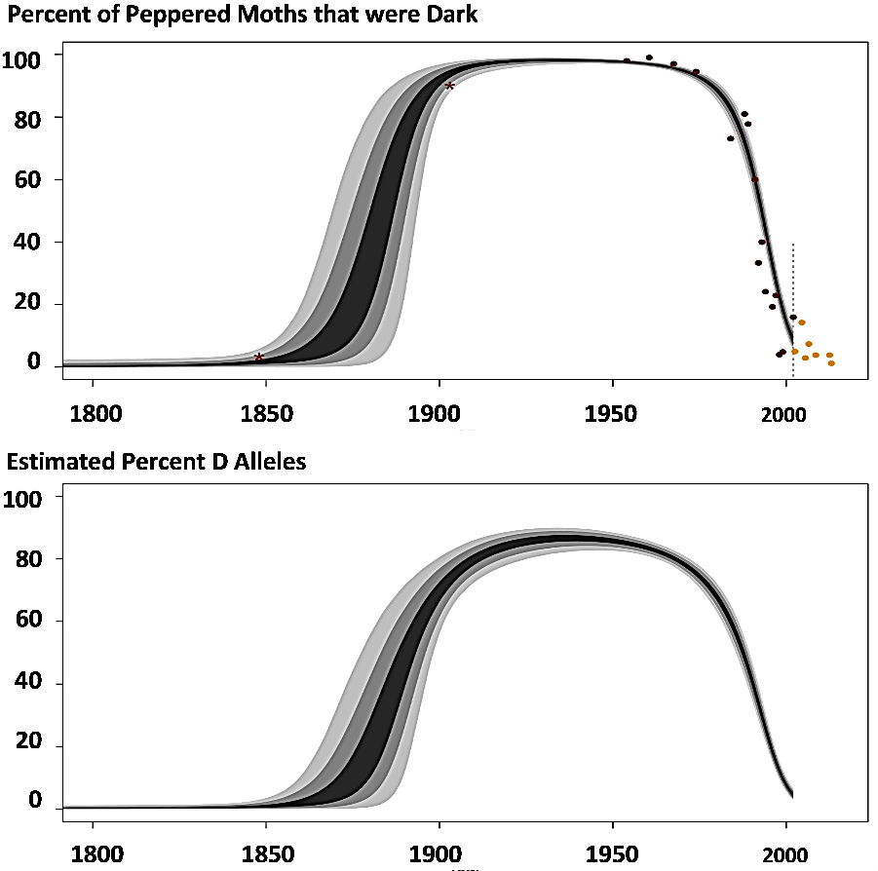
27. A student wrote this paragraph to explain the causes of these trends.
During industrialization, air pollution resulted in dark tree trunks and branches. Most of the peppered moths became dark, because the peppered moths needed to be dark so they would not be seen and eaten by birds. Then air pollution decreased, so tree trunks and branches became lighter, so the peppered moths became lighter so they would not be eaten by birds.

Write a scientifically more accurate explanation of what happened to cause the trends in the graph. (A complete answer will include camouflage, fitness, and natural selection.)

28. In this graph, predict the trend in the percent of peppered moths that were dark in non-industrialized rural regions. Explain your reasoning. | 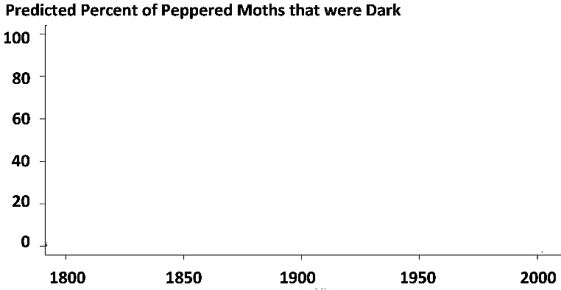

During the second half of the twentieth century, similar trends were observed in industrialized regions in England and the US.  Air pollution decreased and the percent of peppered moths that were dark decreased.  In rural regions, air pollution remained low and dark peppered moths were rare throughout this time period. | 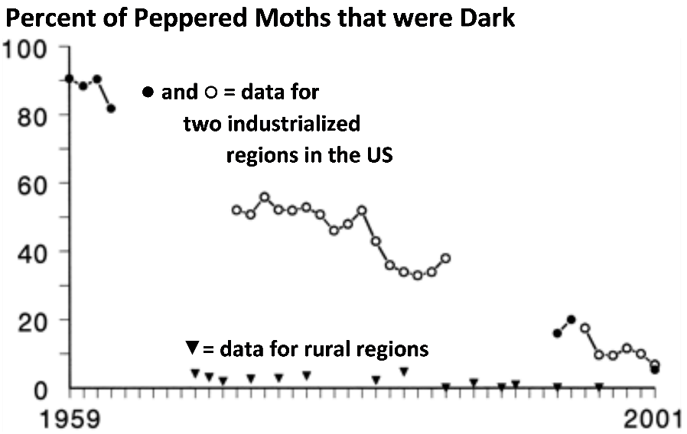

29a. Was natural selection occurring in the rural regions? yes ___ no ___

29b. Explain your reasoning.

Scientists have observed multiple additional examples of natural selection in action. For example, natural selection has increased antibiotic resistance in many types of bacteria, and natural selection has increased resistance to pesticides in many types of insects.

30a. Many people think of the process of evolution as "survival of the fittest". How do you think most people interpret "survival of the fittest"?

30b. How do biologists define fitness?

30c. What are some examples of characteristics that contribute to fitness?

31. Explain how the peppered moth example illustrates the following general principles.

A. Natural selection acts on individuals, but only populations evolve.

B. Natural selection acts on phenotypes, but natural selection results in changes in allele frequencies.

By Drs. Ingrid Waldron and Jennifer Doherty, Dept Biology, University of Pennsylvania. © 2024. Teachers are encouraged to copy this Student Handout for classroom use. A Word file, alternative version of the simulation, and Teacher Preparation Notes with instructional suggestions and background information are available at http://serendipstudio.org/exchange/waldron/naturalselection

