Teacher Preparation Notes for “Mitosis and the Cell Cycle
– How a Single Cell Develops into the Trillions of Cells in a Human Body”

In this hands-on, minds-on activity, students learn how the cell cycle produces genetically identical daughter cells. They use model chromosomes and answer analysis and discussion questions to learn how DNA replication and mitosis work together to ensure that each new cell gets a complete set of chromosomes with a complete set of genes. The model chromosomes are labeled with the alleles of several human genes, and students learn how the alleles influence phenotypic characteristics. To understand how a single cell (the fertilized egg) can develop into the trillions of cells in a human body, students analyze an exponential growth model for the increase in number of cells. The final section provides a brief introduction to cellular differentiation.

This activity can be used as an introduction to the cell cycle and mitosis or to reinforce understanding of these topics. We estimate that this activity will require 2-4 50-minute periods.

Before beginning this activity, students should know what a cell is and have a basic understanding of the functions of DNA and proteins (e.g. using "Understanding the Functions of Proteins and DNA"; https://serendipstudio.org/exchange/bioactivities/proteins).

These Teacher Preparation Notes include:
- Learning Goals (page 2-3)
- Making the Model Chromosomes (pages 3-5)
- Additional Supplies and Requirements for the Modeling Activity (page 5)
- Instructional Suggestions and Background Biology
  - General Comments (pages 5-6)
  - Cells, Chromosomes and Genes (pages 6-7)
  - The Cell Cycle – How One Cell Becomes Two Cells (page 7)
  - Mitosis – How Each Daughter Cell Gets a Complete Set of Chromosomes (pages 7-8)
  - Genes and Human Characteristics (pages 9-10)
  - Modeling Mitosis with One Pair of Homologous Chromosomes and
Multiple Pairs of Homologous Chromosomes (page 10)
  - How Repeated Cell Division Can Make Trillions of Cells (pages 10-12)
  - Cell Differentiation (page 12)
- Background Information on Albinism, Sickle Cell Anemia and Alcohol Intolerance (pages 12-15)
- Follow-up and Related Activities (pages 15)
- Sources for Figures in the Student Handout (page 16)
- Page you may want to give your students to help them answer question 23 (page 17)

Learning Goals
In accord with the Next Generation Science Standards:
      - Students will gain understanding of several Disciplinary Core Ideas:
- LS1.A: Structure and Function – "All cells contain genetic information in the form of DNA molecules. Genes are regions in the DNA that contain the instructions that code for the formation of proteins."
- LS1.B: Growth and Development of Organisms – "In multicellular organisms individual cells grow and then divide by a process called mitosis, thereby allowing the organism to grow. The organism begins as a single cell (fertilized egg) that divides successively to produce many cells, with each parent cell passing identical genetic material (two variants of each chromosome pair) to both daughter cells. Cellular division and differentiation produce and maintain a complex organism, composed of systems of tissues and organs that work together to meet the needs of the whole organism."
- LS3.A: Inheritance of Traits – "Each chromosome consists of a single very long DNA molecule, and each gene on the chromosome is a particular segment of that DNA. The instructions for forming species' characteristics are carried in DNA. All cells in an organism have the same genetic content …"
- Students will engage in the Scientific Practices:
- “Developing and Using Models – Develop, revise, and/or use a model (including mathematical and computational) to generate data to support explanations, predict phenomena, analyze systems, and/or solve problems."
- “Constructing Explanations – Apply scientific ideas, principles and/or evidence to provide an explanation of phenomena…".
- This activity provides the opportunity to discuss the Crosscutting Concepts
- "Systems and system models – … Models can be valuable in predicting a system’s behaviors…"
- “Cause and Effect: Mechanism and Explanation – … A major activity of science is to uncover such causal connections, often with the hope that understanding the mechanisms will enable predictions… [Students] suggest cause and effect relationships to explain and predict behaviors in complex natural and designed systems. They also propose causal relationships by examining what is known about small-scale mechanisms within the system."
- This activity helps to prepare students for the Performance Expectations:
- HS-LS1-4, "Use a model to illustrate the role of cellular division (mitosis) and differentiation in producing and maintaining complex organisms."
- HS-LS3-1, "Ask questions to clarify relationships about the role of DNA and chromosomes in coding the instructions for characteristic traits passed from parents to offspring."
More Detailed Content Learning Goals
- Each cell contains chromosomes and each chromosome contains a long DNA molecule. Each DNA molecule has many genes. A gene provides the instructions for making a protein. Different versions of a gene are called alleles, and different alleles give the instructions for making different versions of a protein. These different versions of a protein can result in different phenotypic characteristics.
- Chromosomes come in pairs of homologous chromosomes. In each pair of homologous chromosomes, both chromosomes have the same genes at the same locations, but a gene may have different alleles in the two chromosomes of a homologous pair.
- The cell cycle includes growth of the cytoplasm, DNA replication, mitosis and cytokinesis. DNA replication and mitosis ensure that each daughter cell receives a complete copy of the DNA in the parent cell. The cell cycle produces new cells for growth and repair.
- At the beginning of mitosis, the two copies of the DNA in each chromosome are condensed into compact sister chromatids which are attached at a centromere. During mitosis, spindle fibers line up the chromosomes in the middle of the cell and then separate the sister chromatids of each chromosome, resulting in two complete sets of chromosomes at opposite ends of the cell.
- At the end of mitosis, cytokinesis separates the two halves of the cell to form two genetically identical daughter cells.
- An exponential growth model illustrates how the number of cells can increase from a single-cell zygote to roughly a trillion cells in a newborn baby. If each cell divided each day, the number of cells would double each day; after 40 days, this would produce a trillion cells.
- Cell differentiation produces the many different cell types in a baby’s body. During differentiation of each type of cell, specific genes are turned on to produce the proteins needed for the function of that type of cell.

Making the Model Chromosomes
We recommend 2-4 students per group for this activity. If you have four students in a group, for the modeling activity on page 6 of the Student Handout, two students can use their arms as spindle fibers to separate the sister chromatids and the other two can enact cytokinesis. For the modeling activity on page 7, each student can use their arms as spindle fibers to separate the sister chromatids for the two pairs of homologous chromosomes.

Each student group will need two pairs of homologous model chromosomes. For the follow-up activity "Meiosis and Fertilization – Understanding How Genes Are Inherited" (https://serendipstudio.org/sci_edu/waldron/#meiosis), you will need the two pairs of homologous model chromosomes to be different colors.

First Pair of Homologous Model Chromosomes |  | Second Pair of Homologous Model Chromosomes
a  h  a  h  A  H | A  H | i  I  i | I

Each model chromosome consists of two sister chromatids which are attached with hook and loop fasteners (Velcro) in the centromere region (approximately the location where the two chromatids touch in the above figures). For each pair of homologous chromosomes, one of the chromosomes has a stripe on each chromatid to represent the multiple differences in alleles between the two chromosomes in a homologous pair.

You can use rolosomes (made from hair roller curlers) or sockosomes (made from socks). Both types of model chromosomes are engaging for students. Sockosomes are more time-consuming to make. The figures in the above chart show the approximate shape of sockosome model chromosomes; the shape of rolosomes is shown in the photo on the next page.

Rolosomes
Supplies
For each group of 2-4 students in your largest class:
- 8 hair roller curlers, 4 in one color and 4 in another color (Hereafter, these hair roller curlers will be referred to as rollers. Rollers are readily available online. You may need to order from two different manufacturers in order to get rollers that have similar diameter but different colors.)
- 4 pairs of self-stick hook-and-loop dots (Velcro). (The hook and loop dots should have a slightly smaller diameter than the rollers. In our experience, the dots do not stick well if the diameter of the dots is larger than the diameter of the rollers.)

You will also need a permanent marker to make the rolosomes.

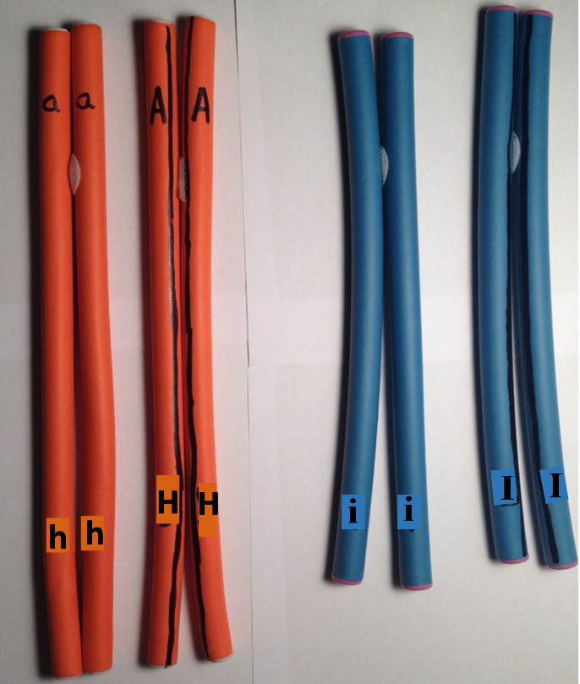 | The rolosomes in this photo represent two pairs of homologous chromosomes. Each rolosome has sister chromatids attached by Velcro fasteners in the centromere region.  The first rolosome has the alleles a and h. The second rolosome is homologous to the first rolosome and has the alleles A and H.  The two rolosomes on the right of the figure represent a pair of homologous chromosomes with the alleles i and I, respectively.  Both chromatids of the second and fourth chromosomes have a stripe to indicate that multiple alleles are different from the alleles in the other chromosome of the homologous pair.

Making the Rolosomes
To make the four rolosomes for each group of 2-4 students you will need four rollers of one color and four rollers of a different color.

1. For two rollers of the same color, stick a Velcro hook-and-loop dot with hooks on one roller and a matching fuzzy dot with loops on the other roller, so the two rollers can be attached as sister chromatids.
Note: The pair of rollers attached by hook-and-loop dots is a rolosome. In the rolosome, each roller represents a chromatid. After mitosis is completed, each roller represents a chromosome in a daughter cell.

2. Repeat step 1 three times to make a total of four rolosomes, each with two sister chromatids.

3. Use the figure on this page (supplemented by the chart on page 3) to label the alleles on each pair of homologous model chromosomes. Make a long stripe down both chromatids of two pairs of homologous chromosomes, as shown.

Sockosomes (You do not need these if you make rolosomes. These instructions are provided in case you prefer to make sockosomes.)
Supplies
- Small or medium children’s crew socks (four pairs of socks for each group of 2-4 students in your largest class; an even number of pairs of each color sock; no more than half the socks of any one color; avoid black and dark blue socks typically found in packs of boys socks).
- Fiber fill
- Self-stick circles of hook-and-loop fasteners (Velcro; if you are making more than 36 sockosomes it may be more cost effective to purchase a roll of self-stick hook-and-loop tape and cut it into 1/2" pieces.)
- Needle and thread
- 1" wide masking tape and permanent marker

Making the Sockosomes
1. Attach one part of a self-stick hook-and-loop fastener (the fuzzy part) to the heel of one sock, and attach the other part (the part with hooks) to the heel of the other sock; secure with staples or by sewing.
2. Fill each sock with fiber fill, and sew the end of each sock closed.
3. Stick the socks together at the heels. You now have a model chromosome with two chromatids, where each sock represents a chromatid. Note that a sockosome refers to the pair of socks attached by hook-and-loop fasteners, not the individual socks. After mitosis is completed, each individual sock represents a chromosome in a daughter cell.
4. Pairs of homologous chromosomes will be represented by two sockosomes of the same color, one with a stripe marked along the length of each sock with a permanent marker (see chart on page 3). In the location of each allele, put a ring of tape around each sock in each sockosome; the tape stays on best if it goes completely around the sock, overlapping at the ends. Use the chart on page 3 to guide you as you label the alleles on each chromatid in your sockosomes.

Additional Supplies and Requirements for the Modeling Activity
Students sometimes have difficulty recognizing that the two sets of chromosomes are in two different daughter cells at the end of mitosis. Therefore, you should have your students use chalk or dry erase marker to draw the cell membranes on their lab tables. Alternatively, you can provide pieces of string or yarn for students to use as cell membranes. For example, for the modeling activity on page 6 of the Student Handout, each student group will need a piece of string approximately 6 feet long to represent the membrane around the original cell and then the membranes around the daughter cells.

Students should carry out the modeling activities on a lab table or similar large flat surface, so they can more easily see the processes and outcomes.

Instructional Suggestions and Background Biology
In the Student Handout, numbers in bold indicate questions for the students to answer and letters in bold indicate the steps in the modeling procedures for the students to do.

If you are using the Word version of the Student Handout, please check the PDF version to make sure that all figures and formatting are displayed properly in the Word version on your computer.

To maximize student learning and participation, we recommend that you have students work in pairs to answer each group of related questions. Student learning is increased when students discuss scientific concepts to develop answers to challenging questions; furthermore, students who actively contribute to the development of conceptual understanding and answers to questions gain the most. After pairs of students have worked together to answer a group of related questions, we recommend that you have a class discussion to probe student thinking and help students develop a sound understanding of the concepts and information covered.

If you would like to have a key with the answers to the questions in the Student Handout, please send a message to iwaldron@upenn.edu. The following paragraphs provide additional instructional suggestions and background information.

In the Student Handout for this activity, we have introduced multiple technical terms (shown in bold). We have omitted the technical terms for some of the concepts introduced in the Student Handout to allow students to focus on learning the basic concepts without becoming overwhelmed by memorizing vocabulary. Several suggestions about how to incorporate additional technical terms are included in the following sections.

Cells, Chromosomes and Genes

Question 1 should stimulate students to begin thinking about the driving question, “How does a single cell (the fertilized egg) develop into the trillions of cells in a human body?” Scientists have estimated that a newborn baby has 1-4 trillion cells and an adult has 20-40 trillion cells (not counting bacteria; http://journals.plos.org/plosbiology/article?id=10.1371/journal.pbio.1002533). You may want to show your students this 1-minute time-lapse video of human zygotes dividing in vitro (https://www.youtube.com/watch?v=4TGiIW7-9eQ) or the first minute of a time-lapse video of the development of a salamander (https://www.youtube.com/watch?v=SEejivHRIbE).

Many students have difficulty distinguishing the concepts of DNA, genes and chromosomes, so you will probably want to reinforce student understanding that a gene is part of a DNA molecule contained in a chromosome. You could use either or both of the following questions for this purpose.

2. Fill in the blanks in the following sentences.

A chromosome contains one long ______ molecule. Each gene in this molecule gives
the instructions for making a ____________________.

3a. Each cell has
- more chromosomes than genes.
- more genes than chromosomes.
- the same number of genes and chromosomes.

3b. Explain how you know.

In the Student Handout a gene is defined as a segment of DNA that gives the instructions for making a protein. You should be aware that the definition of a gene has changed as scientific understanding has progressed. Initially, a gene was conceived as a unit of heredity that determines a phenotypic characteristic. A more sophisticated contemporary definition of a gene is a segment of DNA that codes for an RNA molecule, which may be pre-mRNA (which is modified to be messenger RNA that codes for the sequence of amino acids in one or more proteins), ribosomal RNA, transfer RNA or regulatory RNA. There is no single universally agreed-upon definition of a gene at this time. The changing definition of a gene illustrates the constantly evolving nature of science as scientists develop progressively more sophisticated understanding of concepts such as the gene. For additional information about the challenges and complexities of defining a gene, see http://www.biologyreference.com/Fo-Gr/Gene.html.

The Student Handout includes the statement, "each cell needs to have a complete set of chromosomes". As you no doubt know, there are exceptions to this generalization, e.g. mammalian red blood cells (which do not have any chromosomes) and gametes (which have only one from each pair of homologous chromosomes). To avoid undue complexities, we have omitted discussion of the special case of red blood cells and we have postponed discussion of gametes to “Meiosis and Fertilization – Understanding How Genes Are Inherited” (https://serendipstudio.org/sci_edu/waldron/#meiosis).

The Cell Cycle – How One Cell Becomes Two Cells
The S phase is named for DNA synthesis. The G₁ and G₂ phases were named for the gaps between the S phase and mitosis, but the gap terminology is not introduced in the Student Handout. Not all daughter cells produced by the cell cycle continue to divide; for example, differentiated nerve cells do not divide.

After question 7, if you have previously discussed the reasons why cell size is limited, you may want to refer back to that discussion by asking your students why our bodies aren’t made up of just one or a few large cells. You should be aware that mitosis can occur without cytokinesis; for example, this is how multinucleate skeletal muscle fibers are formed. Also, some cells lose their nucleus as they differentiate (e.g. red blood cells).

Question 8 should stimulate students to think about what would be needed to separate the long strands of DNA systematically so that each daughter cell gets a complete set of chromosomes. This will prepare them for the next section on mitosis.

For additional information on the cell cycle, see https://courses.lumenlearning.com/biology1/chapter/the-cell-cycle/. If you would like your students to know more about DNA replication, you can use pages 3-4 of the Student Handout for “DNA Structure, Function and Replication” (https://serendipstudio.org/exchange/bioactivities/DNA).

Mitosis – How Each Daughter Cell Gets a Complete Set of Chromosomes
The figures on pages 3 and 4 of the Student Handout show mitosis in hypothetical cells with either one or two pairs of homologous chromosomes. Many students know that human cells have 23 pairs of homologous chromosomes, so you may want to explain that the same process is observed for all 46 chromosomes in a human cell, but these figures show simplified cases for clarity.

The figure below provides additional information about how DNA is structured in chromatin during interphase vs. in chromatids during mitosis. For human cells, the total extended length of the DNA would be nearly 2 meters (2 million micrometers). This DNA must fit into a nucleus
with a diameter of 5-10 micrometers. During interphase, most of the DNA is wound around histone proteins, so a typical human chromosome is about 1000 micrometers in length. Each chromosome is folded in loops within the nucleus. Chromatin’s more extended, thin form allows proteins such as RNA polymerase or DNA polymerase to contact the DNA to carry out important cellular functions such as producing RNA or replicating the DNA.  At the beginning of mitosis, several types of protein guide the folding of chromatin into sister chromatids. The shorter, fatter structure of the chromatids protects the relatively fragile DNA molecules from being broken as they are moved during mitosis. Also, the shorter chromatids help to prevent entanglement of sister chromatids or of different chromosomes during mitosis. | 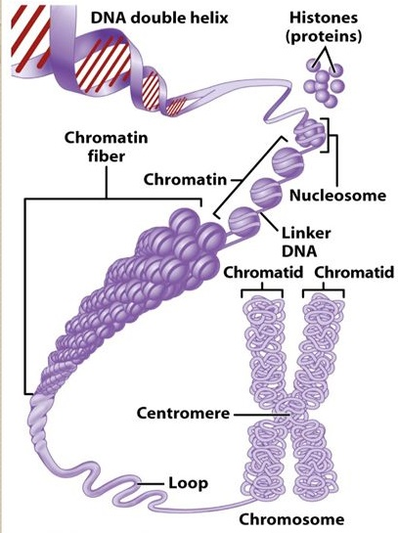  http://images.slideplayer.com/38/10791695/slides/slide_3.jpg

After question 11, you may want to show one or more of the following videos:
- A Great Mitosis Video (https://www.youtube.com/watch?v=AhgRhXl7w_g or https://www.youtube.com/watch?v=VlN7K1-9QB0; 1.5 minutes)
- Actual Footage of Cell Division (Kidney Cells) (https://www.youtube.com/watch?v=N97cgUqV0Cg; 1 minute)
- Mitosis (https://www.youtube.com/watch?v=C6hn3sA0ip0; ~6 minutes).
The last video will be particularly appropriate if you want your students to learn the stages of mitosis. If you want your students to learn the names of the phases of mitosis, these terms can easily be incorporated in question 12.

Students often have difficulty understanding the difference between chromosomes and chromatids, so we have made a special effort to clarify this distinction (in questions 11b and 12 in the Student Handout). It may help your students if you mention that there is no such thing as a single chromatid without a sister chromatid; once the chromatids have separated they have become independent chromosomes.
The Student Handout shows cytokinesis in animal cells. Cytokinesis in plant cells is illustrated in this figure. | 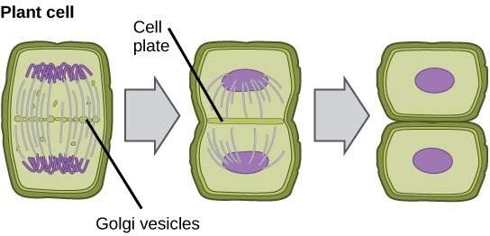  http://cnx.org/resources/7c37e6164130acd4023480c18ba926e8/  Figure_10_02_04.jpg

Genes and Human Characteristics
In our experience, our emphasis on understanding genes and how they move during mitosis, meiosis and fertilization contributes to student interest and understanding, especially in our follow-up activity on meiosis and fertilization where the use of model chromosomes with labeled
alleles leads naturally to understanding inheritance and provides an excellent introduction to Punnett squares.  In answering question 13a, your students should recognize that enzymes and hemoglobin are proteins, but they may not know that melanin is not a protein. This figure shows part of the structural formula of the most common type of melanin (eumelanin); the arrow shows where the polymer continues. | 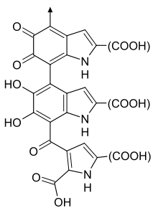

We do not introduce the terms homozygous, heterozygous, dominant or recessive in the Student Handout for this activity, but instead introduce them in our Genetics activity (https://serendipstudio.org/sci_edu/waldron/#genetics). If you prefer, these terms can easily be introduced when you discuss page 5 of the Student Handout. For this purpose, you may want to include the following prose and questions before questions 14 and 15 (which will be renumbered as questions 15 and 17, respectively).

If both copies of a gene have the same allele, the person is homozygous for that gene. If the two copies of a gene have different alleles, the person is heterozygous.

14. Match each item in the list on the left with the best match from the list on the right.

Aa genotype ___ a. heterozygous
HH genotype ___ b. homozygous

___________________________________

Often, in a heterozygous individual a dominant allele determines the observable characteristic and the other recessive allele does not affect the phenotype. Thus, a heterozygous person has the same phenotype as a person who is homozygous for the dominant allele. In our example, the A allele is dominant because it codes for normal, functional enzyme and, even in a heterozygous individual, there is enough of this normal, functional enzyme to produce enough melanin to result in normal skin and hair color. The a allele is recessive because it codes for a non-functional enzyme which does not affect skin or hair color in a heterozygous individual.

16a. What are two different genotypes for the albinism gene that result in the same phenotype?

16b. Explain how two people with different genotypes can have the same phenotype.
For more information on each of the genes discussed in the Student Handout and their phenotypic effects, see pages 12-15 of these Teacher Preparation Notes. You will probably want to mention that other genes and the environment affect phenotypic characteristics such as skin color.

Modeling Mitosis with One Pair of Homologous Chromosomes and with
Multiple Pairs of Homologous Chromosomes
Before beginning the modeling of mitosis, you may want to review mitosis by showing one of the videos listed on page 8 of these Teacher Preparation Notes.

To prevent student confusion during the modeling activities:
- As the students model mitosis, remind them to check the figures on pages 3 and 4 of the Student Handout. They should notice that the spindle fibers line up all the chromosomes in the middle of the cell and then simultaneously separate the sister chromatids of each of the chromosomes.
- You will probably want to reinforce student understanding that the modeling activity begins with chromosomes that have replicated DNA in sister chromatids (represented by complete rolosomes) and ends with chromosomes that do not have replicated DNA (represented by a single roller in each daughter cell).
- It is crucial to circulate among student groups continuously and provide input as needed to help students avoid inaccurate modeling that can reinforce faulty concepts.

To ensure accurate modeling and reinforce understanding of sister chromatids, you may want to add the following question to the middle of page 6 of the Student Handout.
17. Suppose that your partner has put the model chromosomes back together as shown in the diagram. What is wrong? Explain how you know. | What is wrong with these model chromosomes?  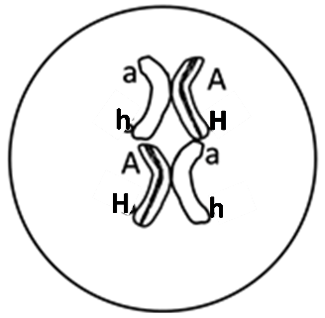

The Student Handout emphasizes that mitosis produces genetically identical daughter cells. Recent research indicates that in some cases the daughter cells are not entirely genetically identical so human bodies typically have some minor mosaicism (https://www.nytimes.com/2018/05/21/science/mosaicism-dna-genome-cancer.html).

How Repeated Cell Division Can Make Trillions of Cells
Questions 21-22 help students to understand how a process that adds only one cell each time a cell divides can produce a newborn baby’s 1-4 trillion cells in just nine months. The model implied in these questions is relatively realistic for the first four days, but after that it is only representative of the potential for exponential growth in number of cells (see figure below). Although the model presented in questions 21-22 is not a realistic description of embryonic and fetal development, it does demonstrate how mitosis can produce trillions of cells from a single cell in just nine months.

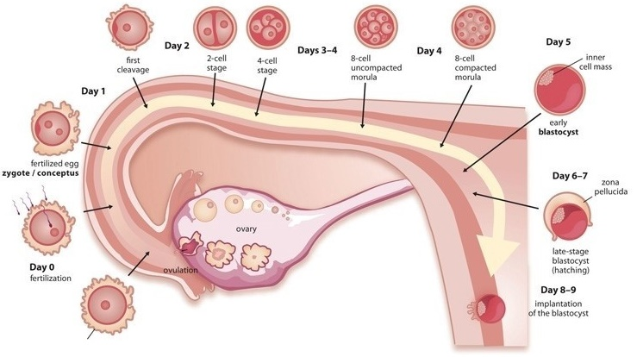
(https://rockthebabybump.com/wp-content/uploads/2015/10/blastocyst-transfer.jpg)

To answer question 22a, your students should recognize that they need to multiply 1000×1000. To answer question 22b, they should calculate:
10³ x 10³ x 10³ x 10³ = 10¹² = 1,000,000,000,000 = 1 trillion cells

You may want to introduce the term, exponential growth, and explain the relevance of exponential growth for other topics such as population growth (see “Understanding and Predicting Changes in Population Size – Exponential and Logistic Population Growth Models vs. Complex Reality”, available at https://serendipstudio.org/exchange/bioactivities/pop).

Question 23 in the Student Handout engages students in synthesizing and summarizing what they have learned about the cell cycle, mitosis, and how a single cell develops into the trillions of genetically identical cells in a human body. This question can be used for formative assessment. If this question is too challenging for your students, you can provide scaffolding as follows.
- If your students have trouble learning vocabulary, you may want to precede question 23 with a question that asks for definitions of the terms listed (or perhaps a matching question in which you provide your preferred definitions for these terms).
- You may want to provide your students with the “Possible Handout to Provide Scaffolding to Help Students Answer Question 23” shown on the last page of these Teacher Preparation Notes.
- You can suggest to your students, “Cross off each term in the list in question 23 after you have included the term in your answer.”
- Students may benefit from a preliminary small group discussion of this question. However, each student should prepare a written answer in his or her own words.

To consolidate student learning and correct any misunderstandings your students may have, we recommend a whole-class discussion of student answers to question 23. To facilitate this discussion, you may want to require your students to use diagrams in their answers to question 23 and have pairs or small groups of students prepare their answers on whiteboards. For information about how to make inexpensive whiteboards and use them in your teaching, see "The $2 interactive whiteboard" and "Resources for whiteboarding" in
https://fnoschese.wordpress.com/2010/08/06/the-2-interactive-whiteboard/.

Question 24 engages students in thinking about the need for cell division even in a fully grown adult. The rate of cell replacement by mitosis varies for different types of cells and in different circumstances. The rate is greater when an injury has occurred. Cells that are routinely exposed to injury (e.g. skin cells or the epithelial cells that line the lumen of the stomach) are replaced within days or a couple of weeks. In contrast, nerve cells and muscle cells can last a lifetime.

You may want to conclude this section with a class discussion of the Crosscutting Concept, Systems and System Models. It may be helpful for students to think about how the hands-on modeling and the first figure on page 3 of the Student Handout helped them to understand mitosis. You may also want to include a discussion of how the quantitative modeling in questions 21-22 helped them to understand how a process that adds only one cell each time a cell divides can produce roughly one trillion cells in nine months.

Cell Differentiation
This section introduces the concept of multiple different types of cells which have different types of proteins to support their different functions. In discussing question 25, you may want to mention the different levels of organization shown in the figure, i.e., cells, tissues and organs.

Each type of cell has a complete set of genes, but in each type of cell only certain genes are turned on for protein production. In the final stages of red blood cell differentiation, the nucleus is ejected. Fully differentiated skin cells also lack a nucleus. This is the reason why question 26 refers to "Cell that is differentiating to become a" red blood cell or skin cell. For simplicity, the Student Handout does not mention the multiple genes that code for different types of hemoglobin or keratin proteins. If you want your students to understand some of the molecular biology of cell differentiation, we recommend “Cell Differentiation and Epigenetics” (https://serendipstudio.org/exchange/bioactivities/epigenetics).

Background Information on Albinism, Sickle Cell Anemia and Alcohol Intolerance

Much of the information in this section is more sophisticated than would be appropriate for high school students, but this information can be useful for your own understanding and for responses to student questions.

Albinism
This figure shows that melanocytes produce melanin which is packaged in melanosomes which are transferred to the keratinocytes that make up the bulk of our skin. Melanin protects the DNA of the keratinocytes from UV damage and helps to prevent the breakdown of folic acid. On the other hand, too much melanin can interfere with the production of vitamin D, which is needed for calcium absorption.  In the most common form of albinism, the defective enzyme for producing melanin not only results in albino skin and hair color, but also affects the appearance and function of the eyes.  In a heterozygous individual, the normal allele is dominant because it codes for the functioning enzyme and even when there is only one copy of the normal allele there is enough of this functioning enzyme to produce enough melanin to prevent albinism. This illustrates the generalization that recessive alleles | 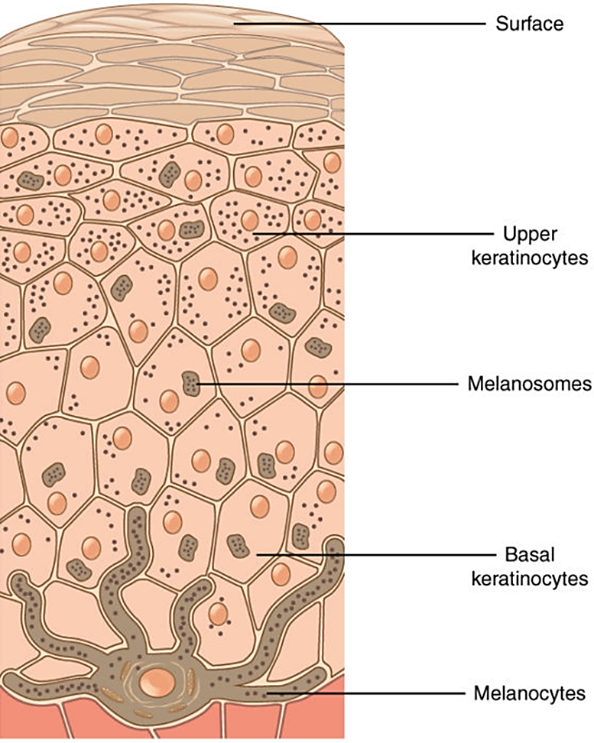  Melanin in the keratinocytes should be shown as clustered between the nucleus and the surface of the skin.  (https://courses.lumenlearning.com/wm-biology2/chapter/pigmentation/)
(e.g., the allele for albinism) often code for a non-functional protein, while dominant alleles often code for a functional protein.

Further information about albinism is available at https://medlineplus.gov/ency/article/001479.htm and http://omim.org/entry/203100.

Sickle cell anemia
Sickle cell hemoglobin is less soluble in the watery cytosol of the red blood cells than normal hemoglobin, particularly when oxygen concentrations are low. Consequently, sickle cell hemoglobin tends to form long stacks or rods of hemoglobin molecules, which results in the sickled shape of some red blood cells in a person who is homozygous for the sickle cell allele and consequently has sickle cell anemia. The sickled red blood cells tend to clog the tiny capillaries, blocking the circulation in different parts of the body. Also, the sickled red blood cells do not survive as long as normal red blood cells, which contributes to anemia. Resulting symptoms include pain, physical weakness, impaired mental functioning, and damage to organs such as the heart and kidneys.

Genotype (genes) | → | Protein | → | Phenotype (characteristics)
2 copies of the allele  that codes for  normal hemoglobin  (SS) | → | Normal hemoglobin dissolves in the cytosol of red blood cells. | → | Disk-shaped red blood cells can squeeze through the smallest blood vessels → normal health  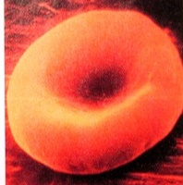
2 copies of the allele  that codes for  sickle cell hemoglobin (ss) | → | Sickle cell hemoglobin  can clump in long rods  in red blood cells. | → | When sickle cell hemoglobin clumps in long rods  → sickle-shaped red blood cells  → clogged small blood vessels  + fragile red blood cells  → pain, damage to body organs  + anemia = sickle cell anemia  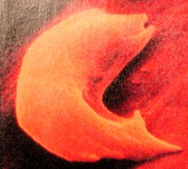

In a person who is heterozygous for the sickle cell and normal hemoglobin alleles, each red blood cell has both sickle cell and normal hemoglobin. The amount of normal hemoglobin is sufficient to prevent the symptoms of sickle cell anemia in almost all cases. The sickle cell hemoglobin in each red blood cell decreases the severity of malaria in heterozygous individuals because the malaria parasite doesn't grow as well in red blood cells containing sickle cell hemoglobin. Decreased severity of malaria is an advantage that resulted in natural selection for the sickle cell hemoglobin allele in regions of Africa where malaria is prevalent.

-A good summary of the medical aspects of sickle cell anemia, including symptoms, diagnosis and treatment is available at http://www.mayoclinic.com/health/sickle-cell-anemia/DS00324.
-A video, "Sickle cell anemia" is available at
https://www.biointeractive.org/classroom-resources/sickle-cell-disease.
-Recent progress in gene therapy for sickle cell anemia is described in
https://www.nytimes.com/2019/01/27/health/sickle-cell-gene-therapy.html, https://www.nature.com/articles/d41586-018-07646-w, https://sicklecellanemianews.com/gene-therapy/.

Alcohol Intolerance The enzyme, acetaldehyde dehydrogenase, plays an important role in alcohol metabolism.

alcohol dehydrogenase acetaldehyde dehydrogenase
alcohol acetaldehyde acetic acid

An inactive form of acetaldehyde dehydrogenase results in the accumulation of high levels of acetaldehyde after drinking alcohol. The accumulation of acetaldehyde results in unpleasant symptoms including increased heart rate and stroke volume and associated heart palpitations, increased blood flow to the skin and flushing, and a general "terrible feeling overall". This condition is called alcohol sensitivity or alcohol intolerance.

Heterozygous individuals have alcohol intolerance, due to substantial accumulation of acetaldehyde. One major reason why the allele for the nonfunctional enzyme is dominant is that the functional enzyme is a tetramer and even one abnormal protein in the tetramer may inactivate the enzyme. Although heterozygous individuals are sensitive to alcohol, alcohol sensitivity is more severe in homozygous individuals who experience very unpleasant symptoms whenever they drink alcohol and consequently almost never develop alcoholism.

The drug Antabuse (disulfiram), which is given to treat alcohol abuse, works by blocking the enzyme acetaldehyde dehydrogenase. This results in increased concentrations of acetaldehyde and the resultant highly unpleasant symptoms if a person drinks.

The allele that results in alcohol sensitivity is relatively common in people of East Asian descent, but extremely rare in people of European descent.

Useful general introductions to this topic are available at https://www.mayoclinic.org/diseases-conditions/alcohol-intolerance/symptoms-causes/syc-20369211 and http://en.wikipedia.org/wiki/Alcohol_flush_reaction, and a more technical description is available at https://omim.org/entry/100650?search=100650&highlight=100650.

Follow-up and Related Activities
We recommend that you follow this mitosis activity with "Meiosis and Fertilization – Understanding How Genes Are Inherited" (http://serendipstudio.org/sci_edu/waldron/#meiosis). In this hands-on, minds-on activity, students use model chromosomes and answer analysis and discussion questions to learn how a child inherits one copy of each gene from each parent via the processes of meiosis and fertilization. Students first analyze how the processes of meiosis and fertilization result in the alternation between diploid and haploid cells in the human lifecycle. To learn how meiosis produces genetically diverse gametes, students analyze the results of crossing over and independent assortment. As they model meiosis and fertilization, students follow the alleles of a human gene from the parents' body cells through gametes to zygotes. Thus, students learn how a person inherits one copy of each gene from each of his/her parents. A brief final section contrasts sexual reproduction with asexual reproduction.

These activities are part of an integrated sequence of learning activities for teaching genetics ("Genetics – Major Concepts and Learning Activities"; available at http://serendipstudio.org/exchange/bioactivities/GeneticsConcepts)

"Chromonoodles: Jump into the Gene Pool" by Farrar and Barnhart, The Science Teacher, Summer 2011, 78:34-39 presents an informative series of activities using chromonoodles (made from swim noodles) to demonstrate fertilization, the cell cycle, meiosis, karyotyping and genetics concepts, including Punnett squares. These activities are whole class demonstrations, in contrast to the more structured modeling activities for small groups of students presented in the Student Handouts for our activities. Additional suggestions for the use of chromonoodles are provided in “Using Pool Noodles to Teach Mitosis and Meiosis”, Genetics 2005, 170(1): 5-6.

Additional resources that you may find helpful are provided in the podcasts available at http://www.bozemanscience.com/028-cell-cycle-mitosis-and-meiosis/ .

Sources for Figures in the Student Handout
- First figure on page 1 modified from http://media1.britannica.com/eb-media/16/166816-004-5EA0F269.jpg
- Second figure on page 1 and figure on page 2 modified from https://www2.le.ac.uk/projects/vgec/diagrams/22-Cell-cycle.gif
- First figure on page 3 modified from https://dr282zn36sxxg.cloudfront.net/datastreams/f-d%3A878df64c63462553305d51d5deccdec3c0cb0aee48fa51aeb9297f1b%2BIMAGE_THUMB_POSTCARD_TINY%2BIMAGE_THUMB_POSTCARD_TINY.1
- Second figure on page 3 modified from https://www.researchgate.net/profile/Kevin_Verstrepen/publication/51196608/figure/fig1/AS:276923784679429@1443035183356/Chromatin-structure-DNA-is-wrapped-around-a-histone-octamer-to-form-nucleosomes.png
- Figures on pages 4 and 9 adapted from Krogh, Biology – A Guide to the Natural World
The other figures were prepared by the authors.

Possible Handout to Provide Scaffolding to Help Students Answer Question 23

Label this diagram to explain how one cell becomes two genetically identical daughter cells.

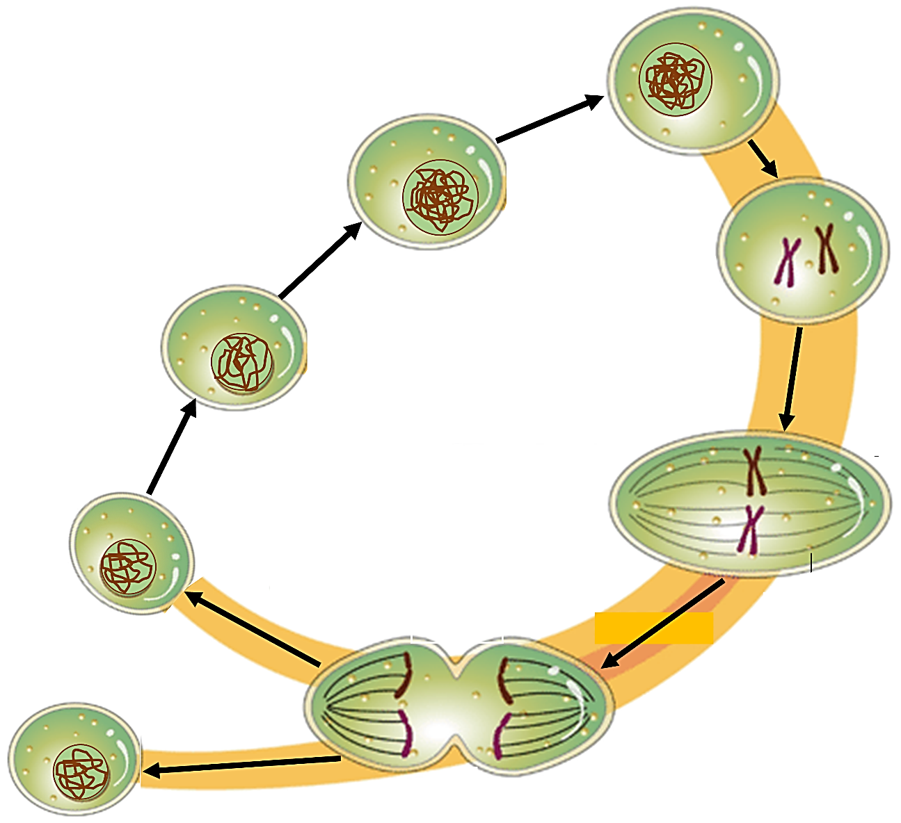

Explain how a single cell becomes more than a trillion cells in nine months.

By Drs. Ingrid Waldron, Jennifer Doherty, Scott Poethig and Lori Spindler, Department of Biology, University of Pennsylvania, 2022. These Teacher Preparation Notes and the Student Handout are available at https://serendipstudio.org/sci_edu/waldron/#mitosis. We are grateful to K. Harding for her helpful suggestion to use hair roller curlers for the model chromosomes and to local high school and middle school teachers who have contributed helpful suggestions for revision of this activity.
This prepares students for learning about meiosis, fertilization, and genetics in subsequent activities. In our follow-up meiosis and fertilization activity (https://serendipstudio.org/sci_edu/waldron/#meiosis) students learn how the movement of gene-carrying chromosomes during meiosis and fertilization results in the inheritance of genes. Analysis and discussion versions of these activities (which can be used for remote instruction) are available at https://serendipstudio.org/exchange/bioactivities/MitosisRR and https://serendipstudio.org/exchange/bioactivities/meiosisRR.
Quotations from http://www.nextgenscience.org/sites/default/files/HS%20LS%20topics%20combined%206.13.13.pdf
Another option is to use pipe cleaners with different color beads to represent the different alleles of the various genes. Two pipe cleaners can be twisted together when representing sister chromatids and untwisted when mitosis separates the sister chromatids.
https://education.asu.edu/sites/default/files/the_role_of_collaborative_interactions_versus_individual_construction_on_students_learning_of_engineering_concepts.pdf
One reason that we have included both the albinism and sickle cell genes on one pair of model chromosomes is to counteract the tendency for some students to assume that each chromosome has only a single gene. A chromosome contains not only a DNA molecule, but also proteins (e.g. histones; see top figure on page 8 of these Teacher Preparation Notes).
Mammalian red blood cells have no nucleus or mitochondria which maximizes the amount of hemoglobin and thus oxygen that each red blood cell transports. In consequence, red blood cells only survive about four months and red blood cells cannot undergo mitosis; new red blood cells are produced by mitosis and differentiation of stem cells in the bone marrow.
Chromatin structure changes as the molecular activity in the cell changes. For example, when a gene becomes active, the chromatin typically unwinds.
In a heterozygous individual, typically each allele is transcribed and both versions of the protein are produced. For many genes, the allele that codes for a functional protein results in the production of enough normal protein to produce a normal phenotype. In these cases, the allele that codes for a functional protein is dominant and the allele that codes for a nonfunctional protein is recessive. The example of albinism is shown on page 5 of the Student Handout. An exception, where the allele for the nonfunctional protein is dominant, is the gene for the enzyme that disposes of a harmful molecule produced by alcohol metabolism (see page 7 of the Student Handout). The functional enzyme consists of four normal polypeptides bound together; even one nonfunctional polypeptide in this tetramer may inactivate the enzyme. This helps to explain why the allele for the nonfunctional protein is dominant. The sickle cell allele could best be described as co-dominant, since both alleles affect the phenotype of a heterozygous person; a heterozygous person does not have sickle cell anemia (due to the allele for normal hemoglobin) and also has increased resistance to malaria (due to the sickle cell allele).
The exponential growth model also ignores the important roles of cell differentiation, cell death, and morphogenesis in development. Cell differentiation is briefly introduced in the last section of this activity. A brief introduction to cell differentiation and morphogenesis in the development of embryos is available at http://www.biology-pages.info/E/EmbryonicDevelopment.html.
Some additional tips for using whiteboards are: – Coat the white boards with Endust (or similar product) before using. Every once in a while, wipe them clean and reapply Endust. – Do not use markers that are old or almost empty, since the ink from these is more difficult to erase. Black markers erase easiest. For effective erasing, it's best to erase the white boards immediately after use. – Teacher and/or students can take a picture of the information on the whiteboard if they want to save it.
Differentiated blood cells and epithelial skin cells are replaced by stem cells; each stem cell divides to form one daughter cell that remains a stem cell and a second daughter cell that differentiates. Some other types of differentiated cells (e.g., skin fibroblasts, liver cells, and smooth muscle cells) can divide to replace cells that have been injured or died. Other types of differentiated cells (e.g., cardiac muscle cells) cannot divide and are not replaced if they die (https://www.ncbi.nlm.nih.gov/books/NBK9906/#:~:text=A%20few%20types%20of%20differentiated,of%20turnover%20in%20adult%20animals.).
A model is a simplified representation of reality that highlights certain key aspects of a phenomenon and thus helps us to better understand and visualize the phenomenon. Many students tend to think of a model as a physical object and may not understand how a figure or quantitative model can be considered a model. It may be helpful to introduce the idea of a conceptual model and give examples of conceptual models that students may have used, e.g a map, a diagram of a football play, a concept map, and an outline for an essay a student is writing.
Students may ask about the distinction between inherited albinism and vitiligo. Albinism is the inability of the body's cells to produce melanin and affects the whole body. Vitiligo is a patterned loss of melanin pigment resulting from the destruction of melanocytes; the hypopigmented areas appear on the skin of a person with normal pigmentation (http://www.mayoclinic.org/diseases-conditions/vitiligo/home/ovc-20319041).

