Mitosis and the Cell Cycle

– How a Single Cell Develops into the Trillions of Cells in a Human Body

Cells, Chromosomes and Genes
Every person started as a single cell – a fertilized egg.

1. How do you think a single cell developed into the trillions of cells in your body?

Before you learn how new cells are made, we need to briefly review chromosomes and genes.
- Each chromosome contains a long molecule of DNA.  - Each DNA molecule contains many genes.  - A gene is a segment of a DNA molecule that gives the instructions for making a protein. Many of these proteins are needed for normal cell structure and function.  2. Explain why each cell needs to have a complete set of chromosomes. Include genes and proteins in your answer. | 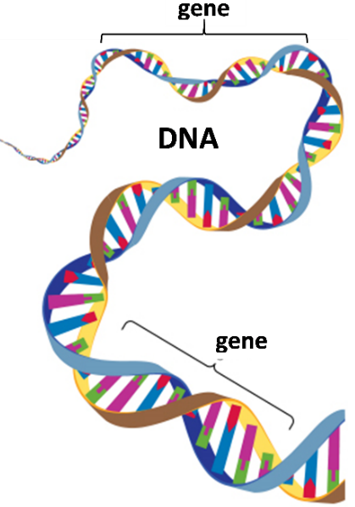

How does the number of cells increase? This figure shows the answer – one cell divides into two daughter cells.

Each daughter cell has half as much cytoplasm and half as much DNA as the cell that divided. However, each daughter cell receives a complete set of chromosomes.

3. Suppose that, after the cell division shown in the figure, each daughter cell is preparing for another cell division. In the second column of the table, describe two things that each daughter cell would need to do to be ready for another cell division.

How a cell prepares for cell division
Hint 1: Remember that each new daughter cell will need a complete set of chromosomes.
Hint 2: What else would the cell need to do to be big enough to divide?
The Cell Cycle – How One Cell Becomes Two Cells
This figure shows the cell cycle, which begins with a single cell and produces two daughter cells.

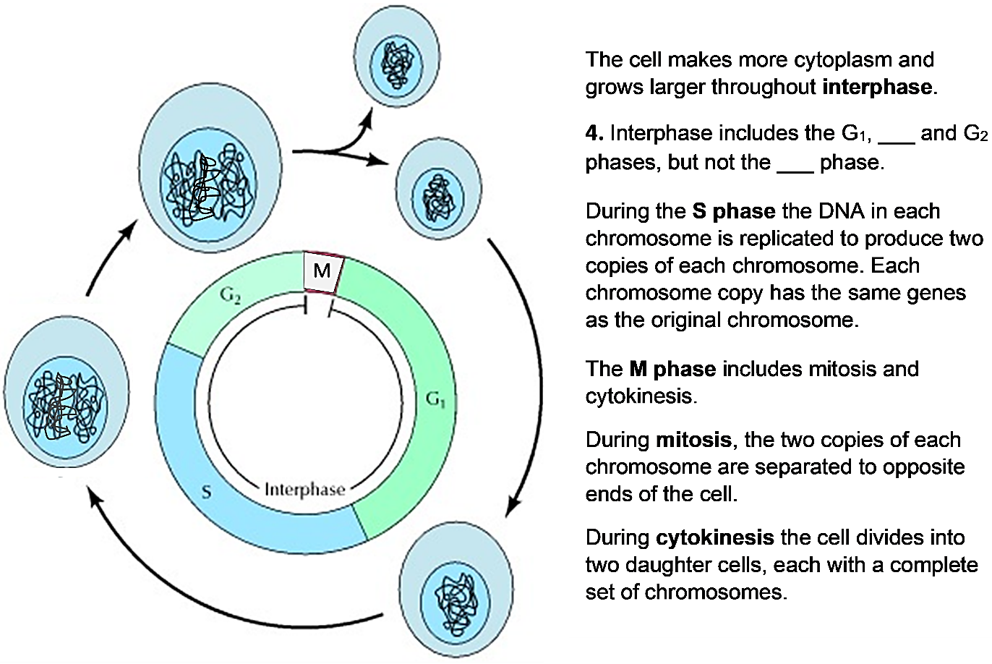
5a. The cell cycle produces two daughter cells, and each daughter cell can begin a new cell cycle. Circle the cell in the figure that represents both a daughter cell that has been produced by the cell cycle and a cell that is beginning a cell cycle.

5b. Explain why the cell is smallest at this time in the cell cycle.

6a. Use 2x to label the arrow(s) when the amount of DNA doubles.

6b. Use ½ to label the arrow(s) when the amount of DNA in each cell is halved.

7. Complete this table to explain why specific phases of the cell cycle are required for successful cell division.

What would go wrong if the cell cycle occurred without the S phase?
What would go wrong if the cell cycle occurred without cytokinesis?

8. How do you think that a cell accomplishes mitosis? How are the two copies of each chromosome separated so that each daughter cell gets a complete set of chromosomes?

Mitosis – How Each Daughter Cell Gets a Complete Set of Chromosomes
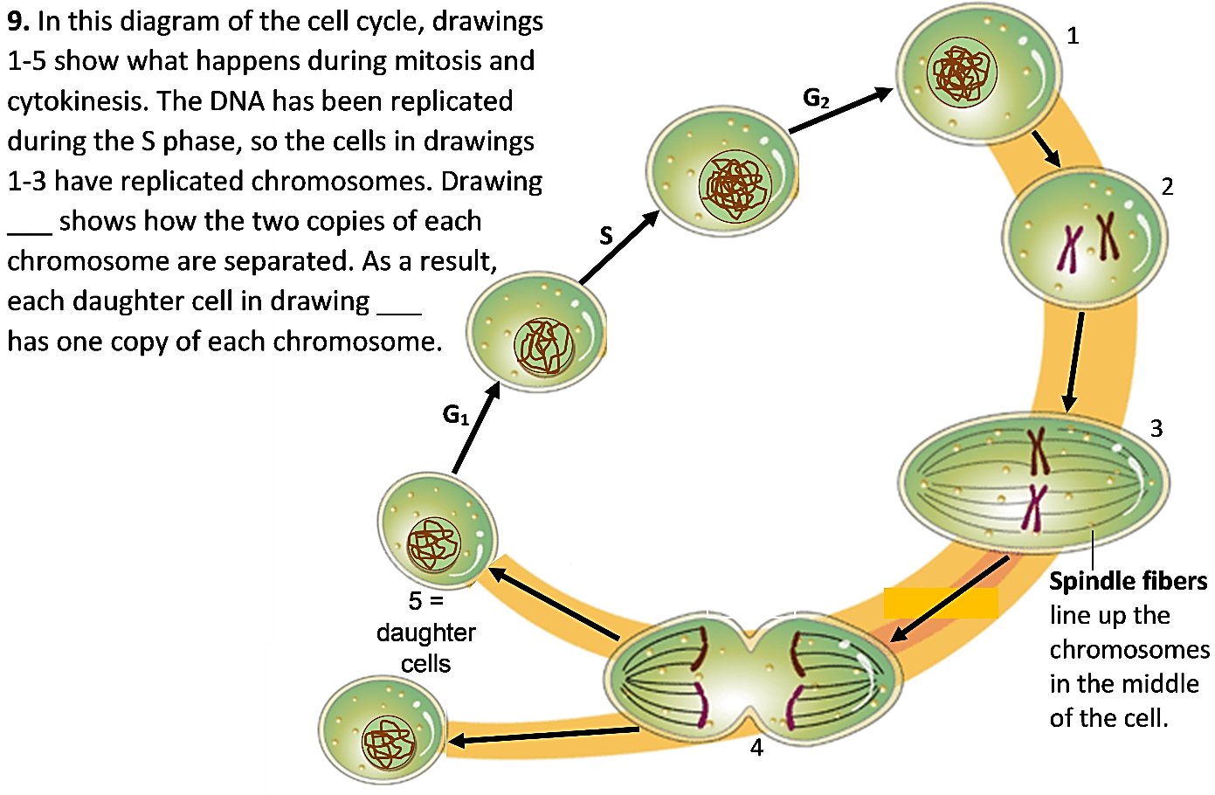
Notice that the chromosomes have a different shape in drawings 2-4, compared to other times 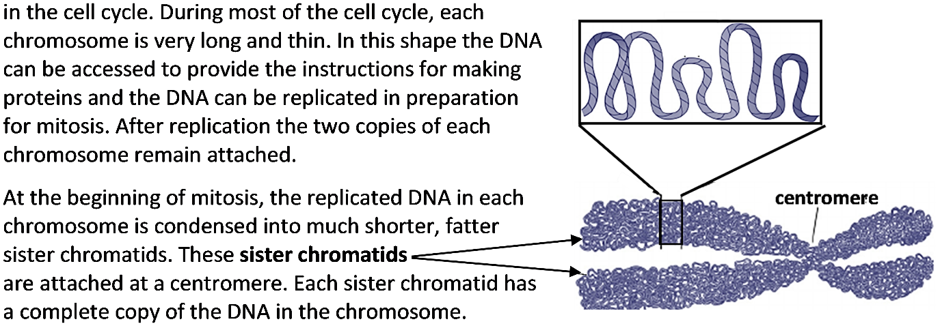

10. Suppose that the very long thin chromosomes observed during interphase did not condense into shorter fatter sister chromatids at the beginning of mitosis. What problems could occur during mitosis if the chromosomes had a long thin shape?

11a. Put the letter for each of these descriptions next to the appropriate drawing in the top figure.
- In the daughter cells, DNA has unwound into long thin threads so genes in the DNA can be accessed to provide the instructions for making proteins.
- Near the beginning of mitosis, the replicated DNA has been condensed into sister chromatids.
- Spindle fibers have separated the sister chromatids into independent chromosomes. Cytokinesis begins.
11b. In drawings 2 and 3 there are two chromosomes, each with sister chromatids. In drawing 4 there are four chromosomes with no sister chromatids. Explain what happened.

12. The figure below shows six stages of cell division for a cell that has two pairs of chromosomes, but these stages are not shown in the correct sequence.
- Draw arrows to show the correct sequence for these stages of cell division.
- Use an * to mark the arrow which shows when sister chromatids are separated to become individual chromosomes.
- Label the drawing that shows the beginning of cytokinesis.

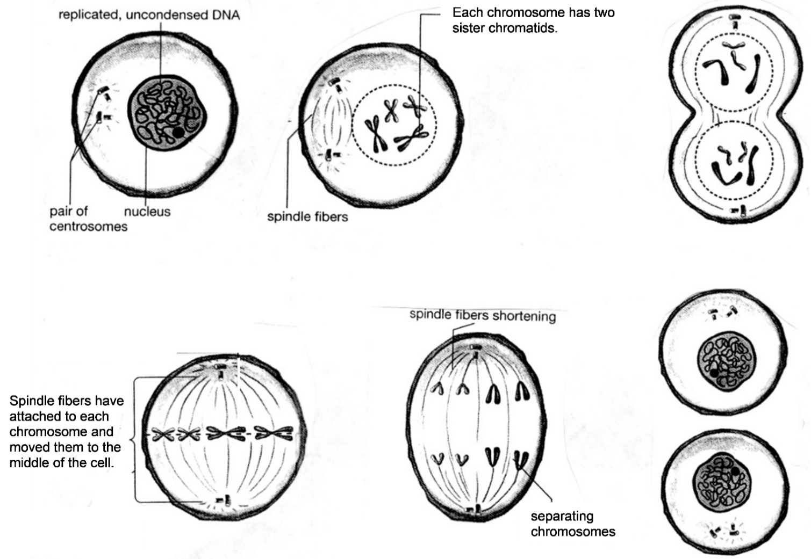

Genes and Human Characteristics
To learn more about mitosis, you will use model chromosomes that are labeled with specific human genes. The table below describes two of these genes. Different versions of the same gene are called alleles. Different alleles give the instructions for making different versions of a protein.

Allele | → | Protein
A | → | Functional enzyme that can make melanin, a pigment molecule that gives color to human skin and hair
a | → | Nonfunctional enzyme that cannot make melanin
H | → | Normal hemoglobin
h | → | Sickle cell hemoglobin

13a. In this table:
- Circle each symbol that represents part of a DNA molecule.
- Underline each word that is the name of a protein.

13b. What do the arrows in the table represent?

Each human cell has 23 pairs of homologous chromosomes. In a pair of homologous chromosomes, both chromosomes have the same genes in the same locations. This
figure shows a pair of homologous chromosomes in a cell at the beginning of mitosis. In addition to the genes with labeled alleles, there are more than 1000 other genes on this chromosome.  A gene may have different alleles in the two homologous chromosomes (e.g. Aa), or a gene may have the same allele in both chromosomes (e.g. HH).  14a. In the figure, label two sister chromatids. | 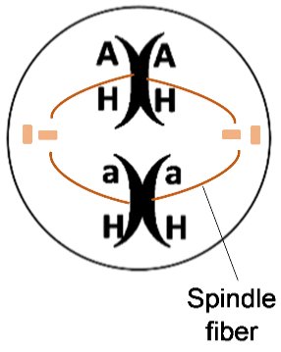

14b. Explain why the sister chromatids in each chromosome always have the same alleles for each gene.

All of a person’s body cells have the same combination of alleles; this combination of alleles is the person’s genotype. The person’s observable characteristics are called the phenotype. This table shows how different genotypes provide the instructions for making different versions of a protein, and these different versions of the protein result in different phenotypes.

Genotype | → | Protein | → | Phenotype (characteristics)
AA or Aa | → | Enough functional enzyme to make melanin in skin and hair | → | Normal skin and hair color
aa | → | Nonfunctional enzyme that cannot make melanin | → | Very pale skin and hair color; albinism
HH or Hh | → | Enough normal hemoglobin to prevent sickle cell anemia | → | Normal red blood cells; no sickle cell anemia
hh | → | Sickle cell hemoglobin, which can cause red blood cells to become sickle shaped | → | Sickle shaped red blood cells can block blood flow in small blood vessels, causing pain and organ damage; red blood cells die faster, so fewer red blood cells; sickle cell anemia

15. Suppose that Amanda’s cells have the pair of homologous chromosomes shown in the drawing at the top of the page.
- What is Amanda’s genotype? aaHH ___ AaHH ___ AaHh ___
- Does Amanda have albinism? yes ___ no ___
- Does Amanda have sickle cell anemia? yes ___ no ___

16. Explain why a person with the aa genotype has very pale skin and hair color. Include the words enzyme and melanin in your explanation.

Modeling Mitosis with One Pair of Homologous Chromosomes

Complete each step in this modeling procedure and check the box.

- Get a pair of model homologous chromosomes, one with the a and h alleles and the other with the A and H alleles. Both model chromosomes should be the same color, but one model chromosome will have a stripe on both sister chromatids to indicate that, although | 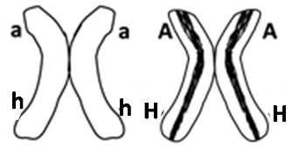
these two homologous chromosomes have the same genes, they have different alleles for
many of these genes.

- Sit across from your partner and use your arms to represent the spindle fibers that move the chromosomes. Line up the model chromosomes as shown in the first cell in question 17. Use erasable marker, chalk or string to represent the cell membrane.

- Demonstrate how the sister chromatids of each chromosome are separated into two separate chromosomes which go to opposite ends of the cell.

- Next, cytokinesis will produce two daughter cells, each with a complete set of chromosomes. Use erasable marker, chalk or string to show the cell membranes after cytokinesis.

- Prepare to model mitosis again by putting the sister chromatids of your model chromosomes back together, as shown above. (This does not correspond to any biological process – it is a substitute for the biological process of replicating the DNA in each chromosome.)

17. Model mitosis again and record the results in the figure below. Draw and label the chromosomes in the oval and in the daughter cells.
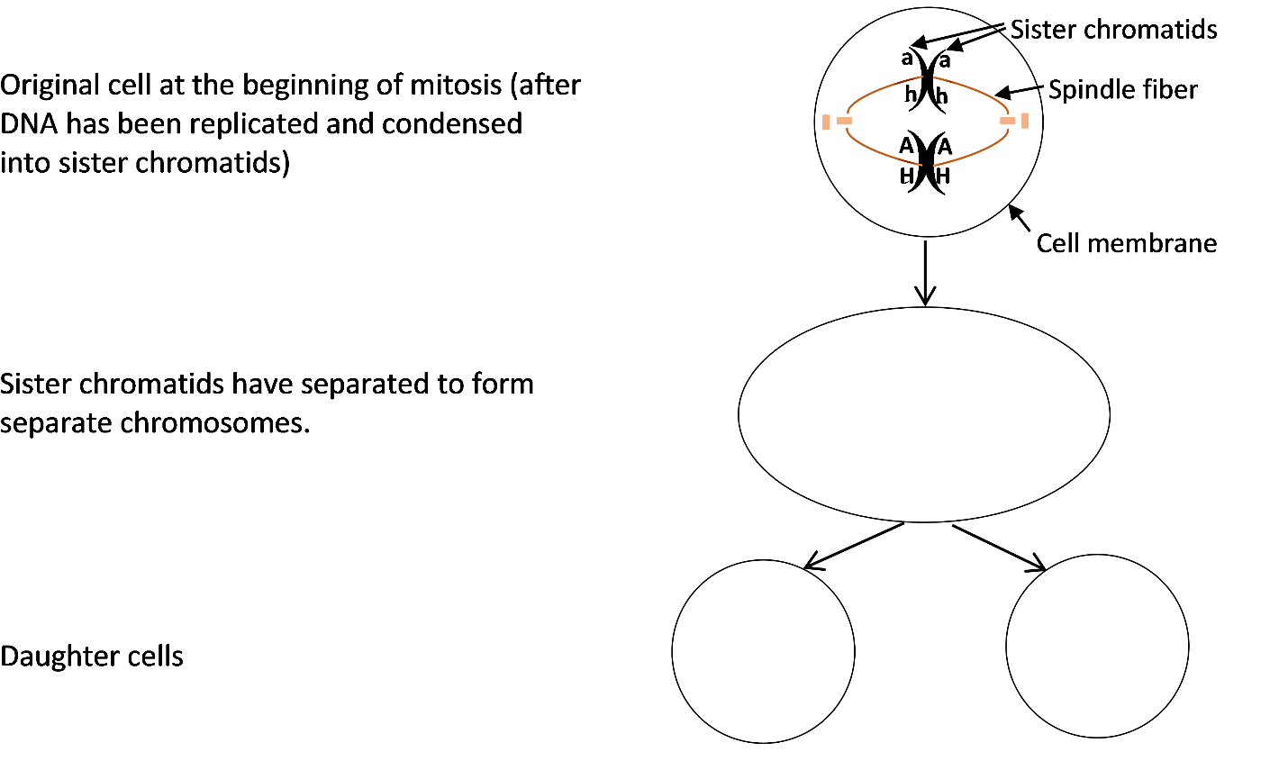
18a. The original cell had the genetic makeup AaHh. What is the genetic makeup of each daughter cell?

18b. Is the genetic makeup of each daughter cell the same as the genetic makeup of the original cell?

Multiple Pairs of Homologous Chromosomes

In a human cell, each of the 23 pairs of homologous chromosomes has its own unique set of genes. For example:
- Human chromosome 11 has the genes that can result in albinism or sickle cell anemia, as well as more than 1000 other genes.
- Human chromosome 12 has more than 1000 additional genes, including a gene that can result in alcohol intolerance. This table shows the effects of the I and i alleles of this gene.

Genotype | → | Protein | → | Phenotype (characteristics)
II or Ii | → | Nonfunctional enzyme that cannot dispose of harmful molecules produced by the metabolism of alcohol | → | Alcohol intolerance (skin flush and discomfort after drinking alcohol)
ii | → | Functional enzyme that disposes of harmful molecules produced by alcohol metabolism | → | Not alcohol intolerant (no skin flush or discomfort after drinking alcohol)

Modeling Mitosis with Two Pairs of Homologous Chromosomes
- Get a second pair of model homologous chromosomes, one with the I allele and the other with the i allele. Model mitosis for a cell with two pairs of homologous chromosomes.

19. Record the results of your modeling in this figure.
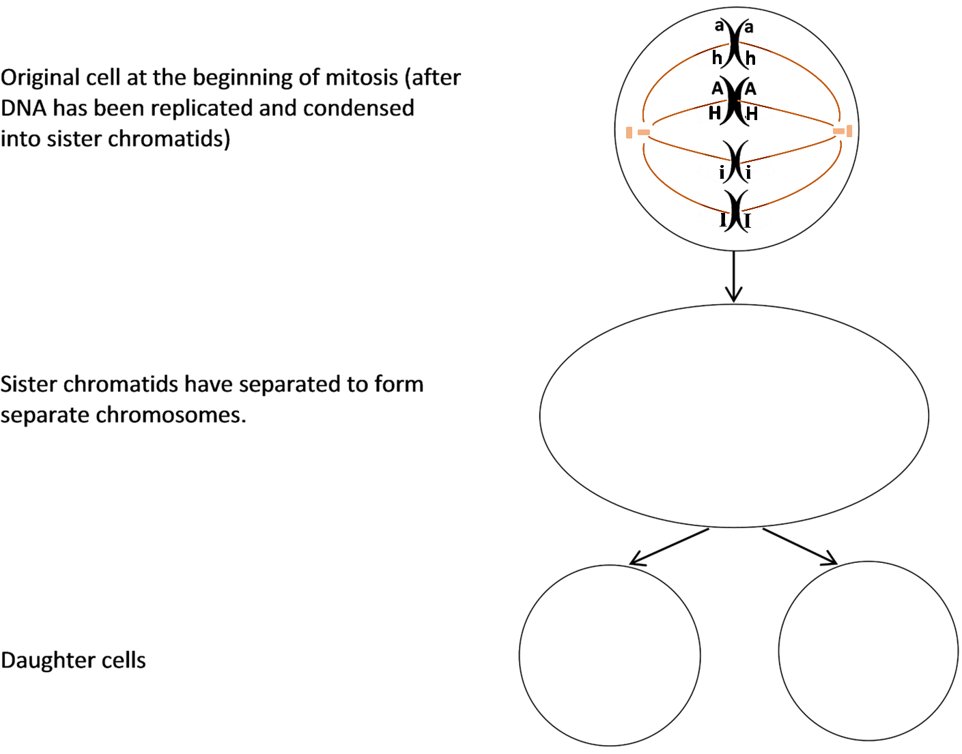
20a. The original cell had the genetic makeup AaHhIi. What is the genetic makeup of each daughter cell?

20b. Does each daughter cell have the same genetic makeup as the original cell?
How Repeated Cell Division Can Make Trillions of Cells

Each of us began as a single cell which divided into two daughter cells. How can multiple repetitions of one cell dividing into two cells produce the trillions of cells in a human body? To understand, answer the questions below.

21a. Complete this table to show the number of cells an embryo would have if every cell divided each day, so the number of cells doubled each day.

Day | 1 | 2 | 3 | 4 | 5 | 6 | 7 | 8 | 9 | 10 | 11
# Cells | 1 | 2 | 4

21b. On day 2 there was only 1 more cell than on day 1.
On day 6 there were ______ more cells than on the previous day.
On day 11 there were _______ more cells than on the previous day.

21c. Explain why more cells were added on day 11 than on any previous day.

22a. An embryo begins as a single cell. If each cell divides each day, then the number of cells will double each day. 10 days after day 1, the number of cells will be multiplied by 2¹⁰, which is approximately 1000. If the number of cells is multiplied by 1000 = 10³ every 10 days, approximately how many cells will there be after 20 days of cell division?

22b. Approximately how many cells will there be after 40 days of cell division?

As an embryo grows, the number of cells available to divide increases, so cell division can add more and more cells each day. This explains how cell division can produce more than a trillion cells in a newborn baby, starting from a single cell just nine months earlier!

23. To summarize what you have learned, explain how a single cell developed into the trillions of genetically identical cells in your body. A complete answer will include the following terms:
DNA replication, mitosis, sister chromatids, spindle fibers, chromosomes, cytokinesis, daughter cells, genes.

24. Even in a fully grown adult, some cells continue to divide. Why is cell division useful in an adult who is no longer growing? (Hint: Think about what happens when you have an injury that scrapes off some of your skin.)

Cell Differentiation

Repeated cell division produced the trillions of genetically identical cells in your body. Obviously, your body is not just one big blob of trillions of the same type of cell. During development, cell differentiation converted your cells into the many different types of specialized cells in your body.
25. Give a brief description of the function of each type of cell shown in this figure. | 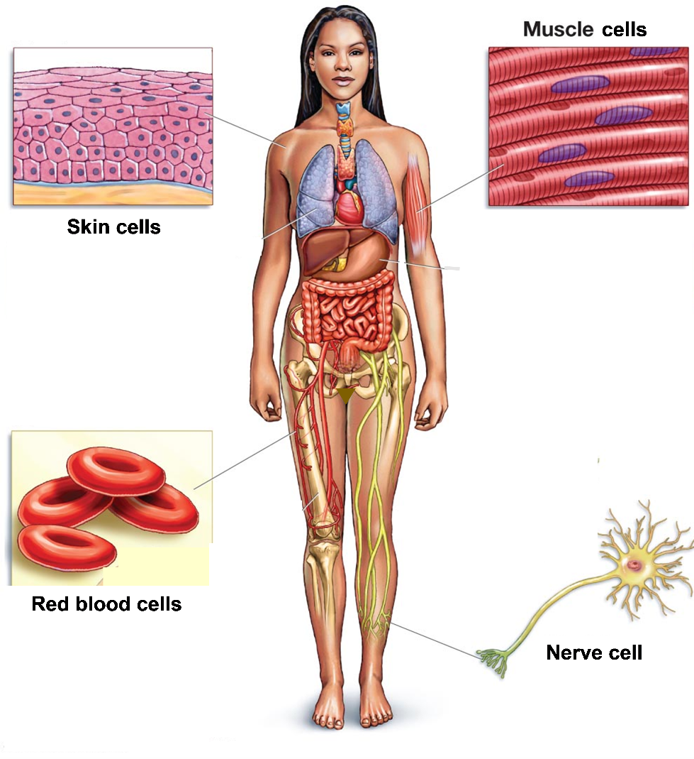
Different types of cells have different types of proteins. For example, red blood cells have lots of hemoglobin to carry oxygen, while skin cells have lots of keratin which helps to make the skin strong and waterproof.

Since your cells are produced by mitosis, each cell begins with a complete set of genes. However, in each type of cell, some genes are turned on for protein production, and other genes are turned off. Cell differentiation depends on changes in which genes are turned on.

26a. Which gene or genes are in the DNA of each type of cell shown? Write the letters inside each cell.  H = gene that gives the instructions to make hemoglobin  K = gene that gives the instructions to make keratin | Cell that is differentiating to become a:
 | red blood cell | skin cell

26b. In each type of cell, put an * next to the letter of the gene that you would expect to be turned on for protein production.

Turning on specific genes for protein production is part of the complex processes of cell differentiation and development.

By Drs. Ingrid Waldron, Jennifer Doherty, R. Scott Poethig, and Lori Spindler, Department of Biology, University of Pennsylvania, © 2022. This Student Handout and Teacher Preparation Notes with instructions for making the model chromosomes, instructional suggestions, and background information are available at http://serendipstudio.org/exchange/waldron/mitosis.

