Teacher Preparation Notes for “Cell Membrane Structure and Function”

This activity includes two hands-on experiments and numerous analysis and discussion questions to help students understand how the characteristics and organization of the molecules in the cell membrane result in the selective permeability of the cell membrane. In the hands-on experiments, students first evaluate the selective permeability of a synthetic membrane and then observe how a layer of oil can be a barrier to diffusion of an aqueous solution. Students answer analysis and discussion questions to learn how the phospholipid bilayer and membrane proteins play key roles in the cell membrane function of regulating what gets into and out of the cell. Topics covered include ions, polar and nonpolar molecules; simple diffusion through the phospholipid bilayer; facilitated diffusion through membrane proteins; and active transport by membrane proteins. An optional additional page introduces exocytosis and endocytosis.

We recommend that you precede this activity with "Introduction to Osmosis" (available at http://serendipstudio.org/sci_edu/waldron/#osmosis).

These Teacher Preparation Notes include:
- Learning Goals (pages 1-2)
- Equipment and Supplies, including preparation before class (pages 2-3)
- Instructional Suggestions and Background Information
  - General and Introduction (pages 3-4)
  - Experiment 1 – Diffusion across a Synthetic Membrane (page 4)
  - Experiment 2 – Polar vs. Nonpolar Molecules (pages 4-5)
  - How Phospholipids and Proteins Combine to Form the Selectively Permeable Cell Membrane (pages 5-9)
  - Optional Addition: How do large molecules or bacteria get into or out of a cell? (pages 9-12)
- Additional Information (page 11)

Learning Goals
In accord with the Next Generation Science Standards:
- Students learn the Disciplinary Core Idea (LS1.A) "Multicellular organisms have a hierarchical structural organization, in which anyone system is made up of numerous parts and is itself a component of the next level.”
- Students engage in recommended Scientific Practices, including:
  - “Using Models: Develop and/or use multiple types of models to provide mechanistic accounts and/or predict phenomena, and move flexibly between model types based on merits and limitations."
  - “Interpreting Data: Evaluate the impact of new data on a working explanation and/or model of a proposed process or system."
  - “Constructing Explanations: Apply scientific ideas, principles, and/or evidence to provide an explanation of phenomena…"
- This activity helps students understand these Crosscutting Concepts:
  - "Structure and Function: The functions and properties of natural and designed objects and systems can be inferred from their overall structure, the way their components are shaped and used, and the molecular substructures of its various materials."
  - “Systems and System Models: Models can be used to predict the behavior of a system, but these predictions have limited precision and reliability due to the assumptions and approximations inherent in models.”
- This activity helps students to prepare for the Performance Expectation, HS-LS1-2: “Develop and use a model to illustrate the hierarchical organization of interacting systems that provide specific functions within multicellular organisms.”

Specific Learning Goals include:
- In biological organisms, each cell is surrounded by a selectively permeable cell membrane which regulates what gets into and out of the cell.
- A selectively permeable membrane allows some types of molecules and ions to pass through, but not others.
- Nonpolar molecules can diffuse across the phospholipid bilayer of the cell membrane.
- Membrane proteins allow ions and small polar molecules to cross the cell membrane. In passive transport, facilitated diffusion results in the net movement of substances from a region of higher concentration to a region of lower concentration. In active transport, membrane proteins use energy to pump ions or molecules from a region of lower concentration to a region of higher concentration.
- Large molecules such as proteins do not cross the cell membrane, but proteins can be secreted from the cell by exocytosis.

Equipment and Supplies (per group of 2-4 students)
For Experiment 1
- 250 ml beaker or other container with some way to measure 200 mL of water
- 4 ml of 1% starch solution, corn or potato (To prepare ~1 liter of 1% starch solution, mix 10 g of corn starch or potato starch in 50 mL of room temperature distilled water. Bring 1000 mL of distilled water to a full boil. Add the slurry of starch to the boiling water and stir for at least 2 minutes while the mixture continues to boil. Starch is insoluble in cold water and the mixture needs to be boiled for the starch to stay in solution. Allow several hours for the starch solution to cool.)
- 0.8 mL of iodine-potassium iodide solution (IKI)
- 2 1-mL transfer pipettes (You can use fewer pipettes if your students are reliable about not cross-contaminating solutions. Also, if your iodine is in dropper bottles, you may want to provide your students with an estimate of the number of drops in 0.8 mL; typically there are 20 drops per milliliter, but drops can vary in size.)
- 15 cm of 1” dialysis tubing (Before the lab, cut the dialysis tubing into 15 cm lengths and soak these pieces in distilled water for 15 + minutes.)
- 2 12 cm pieces of string or 2 dialysis clamps
- Distilled water
- Paper Towels
- You will probably want additional beakers to set up several stations where students can get the supplies for Experiment 1.

For Experiment 2
- 2 10-ounce clear plastic cups (These taller cups have the advantage of preventing food dye drops from splattering outside the cup, but you can use smaller clear plastic cups.)
- Water
- 30-40 mL of cooking oil (we have had good luck with canola oil, but we assume that other types would work equally well)
- Beaker that students can use to pour the oil gently down the side of the plastic cup
- 1-mL transfer pipette
- Food dye (We have had the best success with McCormick green food color; McCormick red food color seems to be a little bit denser and therefore tends to fall through the layer of oil; you will want to have the food coloring in a container where students can use their transfer pipette.)

Instructional Suggestions and Background Information
We estimate that it will require approximately three 50-minute periods to complete this activity. If you want to complete the hands-on part of the activity in a 50-minute period, you may want to complete pages 1-2 in the Student Handout on the day before the hands-on part of the activity.

In the Student Handout, numbers in bold indicate questions for the students to answer, and capital letters in bold indicate steps in the experimental procedures.

For the analysis and discussion questions, you can maximize student participation and learning, by having your students work individually, in pairs, or in small groups to complete groups of related questions and then having a class discussion after each group of related questions. In each discussion, you can probe student thinking and help them develop a sound understanding of the concepts and information covered before moving on to the next group of related questions.

A key is available upon request to Ingrid Waldron (iwaldron@upenn.edu). The following paragraphs provide additional instructional suggestions and background information – some for inclusion in your class discussions and some to provide you with relevant background that may be useful for your understanding and/or for responding to student questions.

Question 2 helps students recognize that different figures in the Student Handout are drawn at very different scales. To help your students understand the enormous difference in scale between the molecules shown in the figure and the actual molecules, you may want to ask your students this question.
3. If a cell containing a billion protein molecules were magnified by the same amount as the protein shown here, the cell would be as large as
a. a tennis ball b. a basketball c. a large cathedral or mosque
Students should be able to realize that a billion three-dimensional protein molecules with the linear dimensions shown in the Student Handout would not fit into either a tennis ball or a
basketball.

To review the relative sizes of various molecules and cells with your students, you may want to use either or both of these resources:
https://learn.genetics.utah.edu/content/cells/scale/
https://teach.genetics.utah.edu/content/cells/CoffeetoCarbon.pdf

If your students are not familiar with why oxygen and carbon dioxide molecules would need to cross the cell membrane, you can explain that ATP is needed to provide the energy for many cellular processes and the process that our cells use to make ATP requires oxygen as an input and produces carbon dioxide. Therefore, oxygen needs to enter cells and carbon dioxide needs to leave cells.

Experiment 1 – Diffusion across a Synthetic Membrane
If your students are not familiar with diffusion, you may want to review diffusion. For this purpose, you may want to use an animation of diffusion which is available at https://authoring.concord.org/activities/12/pages/77/9bfc37ad-69e1-4ab3-9e7c-85e630d78838.

This experiment uses a highly simplified model of a cell, with a synthetic selectively permeable membrane between an internal aqueous solution with large molecules and an external aqueous solution with ions. Subsequent sections of this activity develop a more complex and realistic model of the cell membrane.

After filling and tying their dialysis tube bags students need to rinse the bags thoroughly in fresh water to remove any spilled starch solution from the outside. If you do not have a sink, a series of large containers of water will work.

Iodine (I₂) is relatively insoluble in water, so potassium iodide (KI) is included to make iodine-potassium iodide solution; this results in the formation of triiodide ions (I₃⁻) which are soluble in water. When triiodide ions and starch are in the same solution the triiodide ions get bound up in the beta amylose coils of the starch. This is what causes the color change of starch from clear or milky white to blue-black or purple. With enough time, the tan iodine solution will get lighter as the triiodide ions continually diffuse through the dialysis tubing and become bound up in the starch molecules.

Question 7 provides the opportunity for students to notice that their experiment will only test permeability to one type of small ion and one type of large molecule. An adequate test of the general hypothesis (on the top of page 2 of the Student Handout) would require more data about the permeability of the synthetic membrane to other small and large ions and molecules.

While your students are waiting for the effects of diffusion to become observable, they should answer questions 12-16 on page 4 of the Student Handout. You may want to explain that diffusion is relatively rapid over very short distances, but diffusion is very slow over long distances because molecular collisions repeatedly change the direction of molecular motion. This explains why the students need to wait 15-20 minutes to see the results of their experiment.

Experiment 2 – Polar vs. Nonpolar Molecules
The hydrogen bonds between water molecules are quite strong (although only about one tenth as strong as the average covalent bond) (https://www.chemguide.co.uk/atoms/bonding/hbond.html). Because of the relatively strong attractions between water molecules, it is energetically unfavorable to pull them apart to make room for solute molecules, unless water molecules are attracted to the solute particles. Water molecules are attracted to ions and polar molecules, but not nonpolar molecules. Another way of understanding why nonpolar molecules do not dissolve in water is as follows. Water molecules are attracted to each other, but not to nonpolar molecules, so the mutually attracted water molecules tend to squeeze out the nonpolar molecules. A useful discussion of why “like dissolves like” is available at https://socratic.org/questions/how-is-molecular-polarity-related-to-solubility.

In Experiment 2, students learn that a lipid layer with nonpolar molecules can serve as a barrier to the diffusion of ions. It may seem that a fluid layer of oil is nothing like a cell membrane. However, the consistency of a cell membrane is closer to a layer of oil than to the synthetic membrane used in Experiment 1. The phospholipid bilayer in the cell membrane is fluid, allowing lateral motion of both phospholipid molecules and many of the embedded protein molecules. (This motion is limited by protein interactions with the cytoskeleton.) This explains why the current model of cell membrane structure is called the fluid mosaic model (http://anatomyandphysiologyi.com/the-plasma-membrane-structure/).

For step C in Procedure – Part 1 on page 5 of the Student Handout, if students pour the oil too quickly or from too high up, the oil may initially mix with the water. Then, the student will have to wait a while for the oil to separate from the water. To understand why the oil separates from the water students should refer back to question 15. The greater density of the water explains why the oil floats on top of water.

It is important for students to follow Procedure – Part 2 carefully to produce a bubble and touch the bubble gently to the surface of the liquid in the cup. Students should not release drops of food dye even a short distance above the surface of the oil, because drops that have momentum tend to fall through the oil layer (unless they are very tiny drops). It is important for students to begin their observations immediately after the bubble has touched the liquid because eventually the greater density of the food dye will result in the drop falling through the oil layer.

How Phospholipids and Proteins Combine to Form the Selectively Permeable Cell Membrane
In this section, students learn how the structure, function and organization of phospholipids and membrane proteins determine the structure and function of the cell membrane. Questions 20-29 provide multiple opportunities to discuss the Structure and Function Crosscutting Concept: "The functions and properties of natural and designed objects and systems can be inferred from their overall structure, the way their components are shaped and used, and the molecular substructures of its various materials." You may want to bring up this Crosscutting Concept as you discuss the phospholipid bilayer and membrane proteins, or you may want to have a discussion after question 29 in which you ask students to identify multiple examples of this Structure and Function Crosscutting Concept.

The diagram of the phospholipid molecule in question 20a of the Student Handout is helpful, both to explain the phospholipid name and also to indicate why the phospholipid bilayer is permeable to small nonpolar molecules, but not to ions. This diagram, unlike almost all textbook diagrams of the phospholipid bilayer, shows that the lipid component of phospholipid molecules is larger than the ionic component.

Experiments with synthetic lipid bilayers have shown the following results:  - greatest permeability for nonpolar molecules such as O₂, CO₂ and steroid hormones  - limited permeability for the very small uncharged polar molecule, H₂O (Rapid transport of water across the cell membrane requires aquaporin, a channel protein.)  - very low permeability for large uncharged polar molecules like glucose and sucrose  - virtually no permeability for ions like H⁺, Na⁺, K⁺, Cl⁻. | 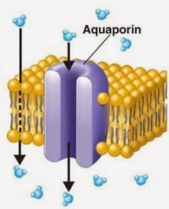  (https://www.gulfcoast.edu/images/natural-sciences/biology/passive-transport.jpg)

When you discuss the proteins embedded in the cell membrane, you may want to ask your students to predict which parts of the outer surface of membrane proteins would be expected to be hydrophilic vs. hydrophobic. | 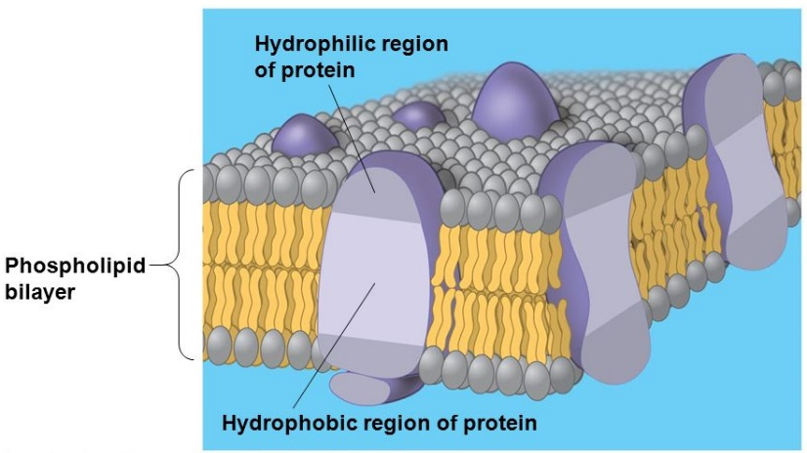  (https://images.slideplayer.com/25/7953466/slides/slide_6.jpg)

Passive transport depends on diffusion, which moves substances from a region of higher concentration to a region of lower concentration. Passive transport includes:
- simple diffusion of small nonpolar molecules through the phospholipid bilayer
- facilitated diffusion of ions through specific channel or pore proteins
- facilitated diffusion of polar molecules like glucose, other sugars, and amino acids which are carried across the membrane by conformational changes of transport proteins.

Active transport proteins use energy to pump ions or molecules from a region of higher concentration to a region of lower concentration. As shown in question 25b and the figure below, ATP often provides the energy for active transport, e.g. for pumping Na+ out of cells.  As shown in the figure to the right, the concentration gradient for one substance can be used to move another substance against its concentration gradient. For example, the concentration gradient of Na⁺ drives the movement of glucose into cells in the lining of the small intestine and in kidney tubules.  (Figure source = https://qph.fs.quoracdn.net/main-qimg-5e26204dea4e378e96474dad65577e23-c) | 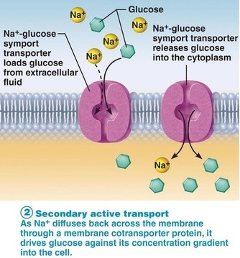

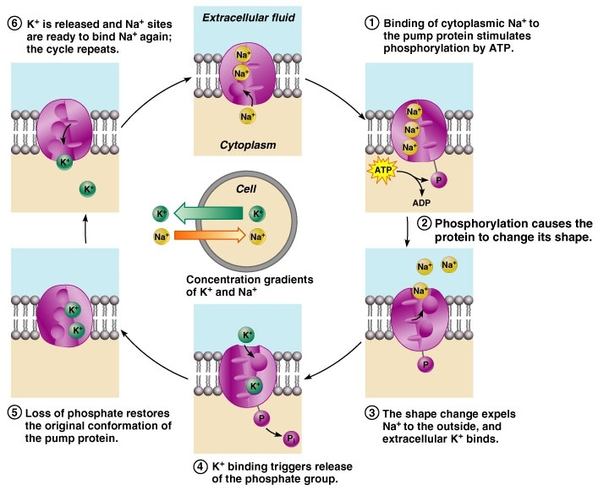
(http://www.apsubiology.org/anatomy/2010/2010_Exam_Reviews/Exam_1_Review/03-10_Na+K+Pump.JPG)

In your discussion of questions 26-28, we suggest that you discuss the Crosscutting Concept, “Systems and System Models: Models can be used to predict the behavior of a system, but these predictions have limited precision and reliability due to the assumptions and approximations inherent in models.” Models are simplified representations of complex natural structures, phenomena or systems, so all models fail to completely accurately represent the complex reality they describe.

Question 26 engages students in noticing that active transport should be added to make the Student Handout figure more complete. The figure below shows several additional features of the structure of a cell membrane. Various membrane glycoproteins serve as receptors for some types of hormones or contribute to cell-cell recognition or strengthening the cell membrane. In the figure below, the cell membrane is called the plasma membrane to distinguish it from the many internal membranes in eukaryotic cells.
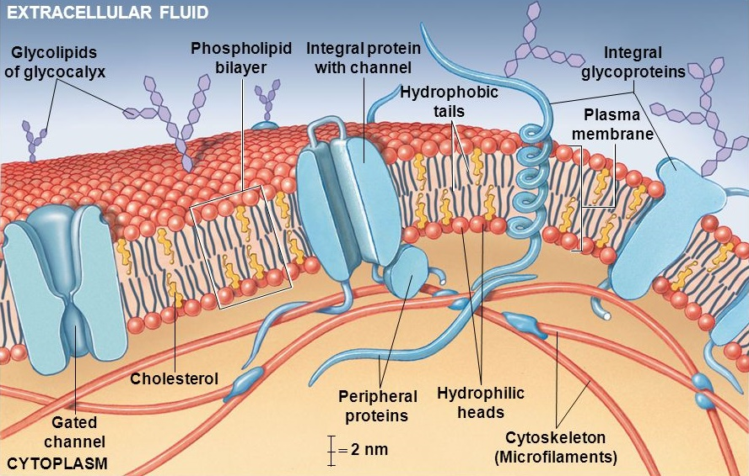
(https://slideplayer.com/slide/10613653/36/images/19/Figure+3-2+The+Plasma+Membrane.jpg)

The synthetic membrane model in Experiment 1 shows selective permeability based on size, which mimics one aspect of the selective permeability of the cell membrane. However, the cell membrane has much more sophisticated selective permeability, due to the selectivity of the channel, carrier and pump membrane proteins. The cell membrane also has much less mechanical strength than the synthetic membrane. The layer of oil in Experiment 2 mimics the ability of the phospholipid bilayer to prevent ions and polar molecules from crossing, while allowing nonpolar molecules to diffuse across the phospholipid bilayer. However, the cell membrane has more sophisticated selective permeability, since membrane proteins allow some ions and polar molecules to cross the cell membrane.

Questions 29 and 30 can be used for formative assessment. To facilitate your class discussion of the unique and shared features of simple diffusion, facilitated diffusion and active transport, you may want to have each group of students prepare the Venn diagram in question 30 on a whiteboard.

This activity can help students understand that cells are made up of organelles which are made up of molecules. This provides the opportunity to discuss the Disciplinary Core Idea: “Multicellular organisms have a hierarchical structural organization, in which any one system is made up of numerous parts and is itself a component of the next level.”

How do large molecules or bacteria get into or out of a cell?
This optional additional page of the Student Handout is shown on page 12 of these Teacher Preparation Notes. To help students understand and remember the terms endocytosis and exocytosis, you may want to explain that “endo” means within or into and “exo” means outside or out of; “cyte” refers to cell; and “osis” means process. As a mnemonic for your students, you may want to link endocytosis to enter and exocytosis to exit.

The figure for question 31 (in the optional addition to the Student Handout) shows protein secretion by exocytosis, as well as formation of lysosomes that contain protein digestive enzymes. This figure illustrates several important general points:
- There are many internal membranes in eukaryotic cells. These allow localization of specific functions within the cell. To distinguish the cell membrane surrounding the cell from these internal membranes, the cell membrane is often called the plasma membrane.
- Multiple parts of the cell cooperate to accomplish specific cell functions.
- Cells are dynamic, not static.

An astute student may notice that a protein that will be secreted by the cell is synthesized by a ribosome on the outside of the endoplasmic reticulum and, as the protein is synthesized, it crosses the membrane of the endoplasmic reticulum. The protein crosses the endoplasmic reticulum membrane through a water-filled protein pore (see figure below). (This type of protein translocator is also observed in the membranes of mitochondria, chloroplasts and bacteria.)

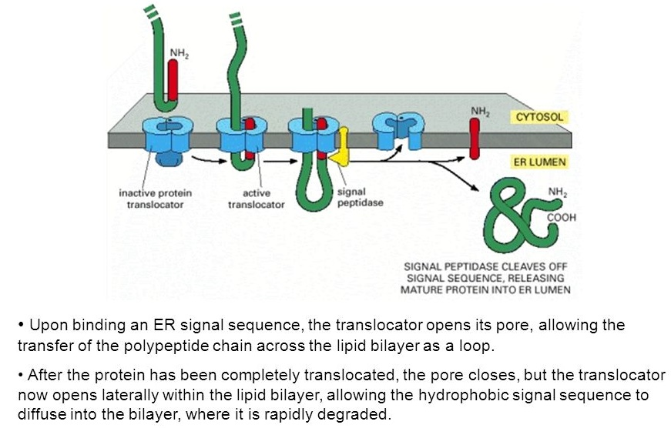
(https://slideplayer.com/8357685/34/images/40/A+model+for+how+a+soluble+protein+is+translocated+across+ER+membrane.jpg)

The figure below shows additional information, including how plasma membrane proteins are transported to the plasma membrane by vesicles from the Golgi apparatus. This illustrates the general point that cell membrane structure and function depend on inputs from other parts of the cell (e.g. nucleus, rough endoplasmic reticulum and Golgi apparatus supply membrane proteins and mitochondria provide ATP for active transport). Conversely, the cell membrane maintains the internal conditions that allow the internal parts of the cell to function properly.

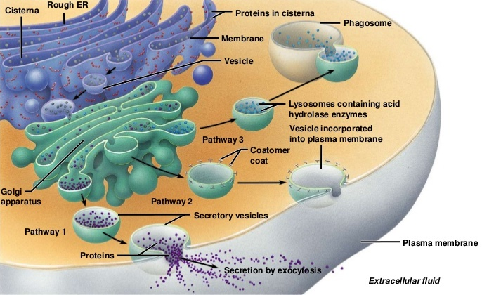
(https://www.slideshare.net/vyahhi/molbiol-201113organelles slide 50)

Question 32 introduces phagocytosis as one type of endocytosis. The lysosomes that provide the digestive enzymes also contain nitric oxide and reactive oxygen intermediates that help to kill the bacteria. The membrane around each lysosome plays a crucial role in protecting the cytoplasm from the harmful effects of the digestive enzymes contained in the lysosome. Lysosomal enzymes work best in an acidic environment; when the lysosome is active, the lysosome membrane pumps in protons. If a lysosome breaks open or leaks, the lysosomal enzymes are not very active because the cytoplasm has a neutral pH. In addition to their role in phagocytosis, lysosomes play a role in breaking down old or damaged organelles so their constituent molecules can be reused. This is an example of the dynamic nature of cells.

Possible Follow-Up Activities
As a follow-up to this activity, you may want to:
- have your students use microscopes, Elodea and various chemicals to study osmosis and rates of diffusion across the plasma membrane for molecules of different size and hydrophobicity as directed in "Diffusion across Biological Membranes" (available at http://faculty.buffalostate.edu/wadswogj/courses/BIO211%20Page/lectures/lab%20pdf's/Diffusion%20lab%2006a.pdf ).
- discuss with your students the contributions of selectively permeable membranes and osmosis to dialysis treatment of patients with kidney failure. (A useful introduction is available at http://en.wikipedia.org/wiki/Dialysis)

Sources for Figures in Student Handout (All other figures were created by the authors.)
- Molecules on Student Handout page 1 – from http://www.goodrichscience.com/uploads/3/1/1/2/31129331/_4892670_orig.png, https://cdn.britannica.com/668x448/20/198720-004-C4127832.jpg, and https://images.slideplayer.com/25/7927044/slides/slide_41.jpg
- Polar water molecule on page 4 – modified from http://www.citruscollege.edu/lc/archive/biology/PublishingImages/c02_08.jpg
- Ions dissolved in water on page 4 – https://www.hpacmag.com/wp-content/uploads/sites/32/2017/02/fig-6-b-salt-molecules-in-H2O.jpg
- Phospholipid molecule on page 6 – modified from https://image.slidesharecdn.com/lipidsmmc2262222011-141104224325-conversion-gate02/95/lipids-chemistry-structure-function-22-638.jpg?cb=1429465137
- Phospholipid bilayer figure on pages 6 and 9 – modified from https://unsig11cellmembrane.wikispaces.com/file/view/PhospholipidDiagram1.jpg/164811335/PhospholipidDiagram1.jpg
- Passive transport across cell membrane on page 7 – modified from https://www.smore.com/8jen8-human-cells
- Active transport on page 7 – modified from https://cardenasbio.weebly.com/uploads/2/7/3/6/27363379/7395215_orig.jpg
- Cell membrane on page 8 – modified from https://i.pinimg.com/originals/b5/3b/2c/b53b2c4a054750c6132a78021a753e60.jpg.

Optional Additional Page for Student Handout
How do large molecules or bacteria get into or out of a cell?

The cell membrane is often called the plasma membrane. This distinguishes the membrane that surrounds the cell from the multiple membranes inside a eukaryotic cell, e.g. the membranes that surround vesicles.  Some cells secrete proteins (e.g. antibodies or the hormone insulin). This figure shows how a cell secretes proteins, even though protein molecules are too large to cross the plasma membrane.  Proteins that will be secreted from the cell are:  - synthesized by the ribosomes of the rough endoplasmic reticulum and  - processed in the rough endoplasmic reticulum and the Golgi apparatus.  31. How does a secreted protein get out of the cell, even though it is too large to cross the plasma membrane? | 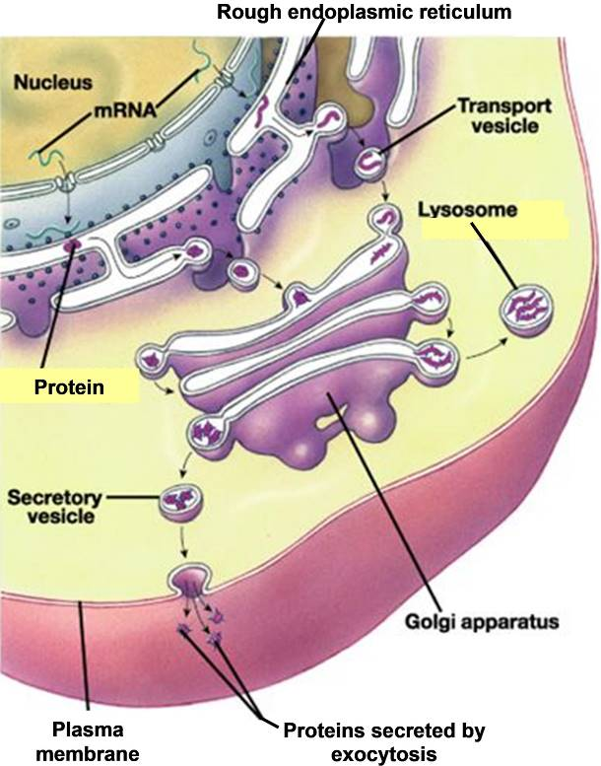

This figure shows how some types of white blood cells rid the body of harmful bacteria.  Endocytosis is the process that moves bacteria or large molecules into a cell. A bacterium is surrounded by a pocket of plasma membrane which pinches off to form a vesicle inside the cell.  Exocytosis is the process that moves large molecules out of a cell. The | 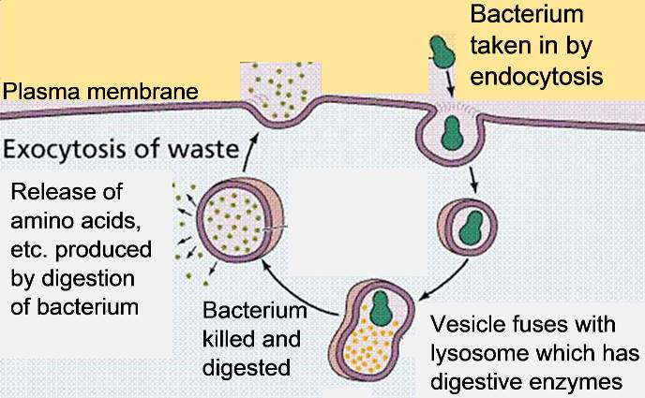
membrane surrounding a vesicle merges with the plasma membrane to release the vesicle’s contents outside the cell.

32. Explain how endocytosis, digestive enzymes and exocytosis work together to get rid of harmful bacteria.

By Drs. Ingrid Waldron and Jennifer Doherty, Dept Biology, Univ Pennsylvania, 2020. These Teacher Preparation Notes and the related Student Handout are available at http://serendipstudio.org/exchange/waldron/diffusion . We are grateful to Jim McCusker, Ridley High School, for his very helpful suggestions for revision.
The osmosis activity introduces students to selectively permeable cell membranes with experiments that use chicken eggs with follow-up analysis and discussion questions.
Quotes from Next Generation Science Standards, available at http://www.nextgenscience.org/next-generation-science-standards
A selectively permeable membrane is also called a semipermeable membrane. The cell membrane is often called a plasma membrane to distinguish it from the multiple membranes inside cells, especially eukaryotic cells.
The estimate of 1-10 billion protein molecules in a cell can be found in https://www.ncbi.nlm.nih.gov/pubmed/24114984. To arrive at the estimate that a cell at the same scale as the protein molecule would be roughly the size of a large cathedral or mosque, I compared the diameter of proteins (~5-12 nm) and animal cells (~10-100 µm) and used online data about the dimensions of large cathedrals and mosques.
A useful overview of this topic is available at https://www.nature.com/scitable/topicpage/cell-membranes-14052567/.
Transport of small nonpolar molecules in our bodies also depends on their solubility in water (e.g. in the blood). O₂ has limited solubility in water (which is why it is useful for blood to have oxygen transport proteins like hemoglobin). CO₂ has much greater solubility in water because of the following chemical reactions: CO₂ + H₂O ↔ H₂CO₃ ↔ H⁺ + HCO3⁻
For ions, the direction of passive diffusion depends on the electrochemical gradient, which includes both differences in concentration and differences in charge inside vs. outside the cell membrane. Your students may be interested to know that cystic fibrosis is caused by mutations in the gene for a Cl⁻ channel protein (https://www.webmd.com/children/what-is-cystic-fibrosis#1; https://www.cff.org/Research/Research-Into-the-Disease/Basics-of-the-CFTR-Protein/).
An animation that shows how this pump works is available at http://highered.mheducation.com/sites/0072495855/student_view0/chapter2/animation__how_the_sodium_potassium_pump_works.html.
For this purpose, you will want one whiteboard per student group in your largest class. For information about how to make inexpensive whiteboards and use them in your teaching, see "The $2 interactive whiteboard" and "Resources for whiteboarding" in https://fnoschese.wordpress.com/2010/08/06/the-2-interactive-whiteboard/. To obtain whiteboards, you can go to Home Depot or Lowe's and ask them to cut a 8' x 4' whiteboard (e.g. EUCATILE Hardboard Thrifty White Tile Board) into six pieces with the dimension 32" x 24". They should have a power saw rig that allows their employees to cut the pieces very easily. They should not charge to cut them and the product cost is reasonable. Some important tips for using whiteboards: – Coat the white boards with Endust (or similar product) before using. Every once in a while, wipe them clean and reapply Endust. – Do not use markers that are old or almost empty. The ink from these are more difficult to erase. – Black markers are easiest to erase. To prevent stains, erase right away, especially red or green markers. Do not use markers that are old or almost empty, since the ink from these is more difficult to erase. Recommended brands are Expo markers and Pilot BeGreen markers. To clean up stains you can use Windex or Expo Whiteboard Cleaner. – Teacher and/or students can take a picture of the information on the board if they want to save it. For this purpose you would want one whiteboard per student group in your largest class. To obtain whiteboards, you can go to Home Depot and ask them to cut a 8' x 4' whiteboard (e.g. EUCATILE Hardboard Thrifty White Tile Board) into six pieces with the dimension 32" x 24". They should have a power saw rig that allows their employees to cut the pieces very easily. They should not charge to cut them and the product cost is reasonable. Some important tips for using whiteboards: – Coat the white boards with Endust (or similar product) before using. Every once in a while wipe them clean and reapply Endust. – Do not use markers that are old or almost empty. The ink from these are more difficult to erase. – Black markers erase easiest. – Best if boards are erased immediately after use. – Teacher and/or students can take a picture of the information on the board if they want to save it.
The figures on this optional page are modified from https://images.slideplayer.com/16/5205959/slides/slide_25.jpg and http://images.slideplayer.com/26/8827236/slides/slide_14.jpg.
Prokaryotic cells have fewer internal membranes and organelles than eukaryotic cells, but the difference is not as absolute as biologists have traditionally thought. Recent research has shown that many photosynthetic prokaryotes have extensive internal membranes where photosynthesis takes place and several bacterial species have internal membrane-bound organelles.
These last two points are discussed in the analysis and discussion activity, “Structure and Function of Cells, Organs and Organ Systems” (https://serendipstudio.org/exchange/bioactivities/SFCellOrgan).

