Teacher Preparation Notes for
Food Webs, Energy Flow, Carbon Cycle, and Trophic Pyramids

To begin this hands-on, minds-on activity, students view a video about ecosystem changes that resulted when wolves were reintroduced to Yellowstone. Then, students learn about food chains and food webs, and they construct and analyze a food web for Yellowstone National Park. Students use what they have learned to understand trophic cascades caused by the return of wolves to Yellowstone. Next, students learn that the biosphere requires a continuous inflow of energy, but does not need an inflow of carbon atoms. To understand why, students analyze how the carbon cycle and energy flow through ecosystems result from photosynthesis, biosynthesis, cellular respiration, and the trophic relationships in food webs. In the final section, students use the concepts they have learned to understand trophic pyramids and phenomena such as the relative population sizes for wolves vs. elk in Yellowstone. Thus, students learn how important ecological phenomena result from processes at the molecular, cellular, and organismal levels. For virtual instruction, you can use Food Webs – Understanding What Happened When Wolves Returned to Yellowstone, Carbon Cycles and Energy Flow through Ecosystems and the Biosphere, and Trophic Pyramids.

As background for this activity, students should have a basic understanding of cellular respiration and photosynthesis. For this purpose, we recommend the analysis and discussion activity, “Photosynthesis and Cellular Respiration – Understanding the Basics of Bioenergetics and Biosynthesis” (https://serendipstudio.org/exchange/bioactivities/photocellrespir) and the introductory analysis and discussion activities recommended in the Teacher Notes for that activity.

This multipart activity will probably require 3-4 50-minute classes. Depending on your students, you may want to use:
- one or part of one 50-minute period to complete pages 1-3 of the Student Handout (through question 10);
- one 50-minute period to make the food web and answer the questions on page 4 of the Student Handout;
- 1-2 50-minute periods for pages 5-9 of the Student Handout.

Table of Contents
Learning Goals – pages 1-4
Supplies – page 4
Instructional Suggestions and Background Information
General – pages 4-5
Wolves in Yellowstone National Park – pages 5-6
Food Chains and Food Webs – pages 6-7
Trophic Relationships in Yellowstone – pages 7-10
Carbon Cycles and Energy Flow through Ecosystems and the Biosphere – pages 10-11
Trophic Pyramids – pages 12-15
Additional Resources (including images for food web cards) – pages 15-19

Learning Goals
Learning Goals related to Next Generation Science Standards
Students will gain understanding of Disciplinary Core Idea LS2.B, Cycles of Matter and Energy Transfer in Ecosystems:
“Food webs are models that demonstrate how matter and energy is transferred between producers, consumers and decomposers as the three groups interact within an ecosystem.”
“Plants or algae form the lowest level of the food web. At each link upward in a food web, only a small fraction of the matter consumed at the lower level is transferred upward, to produce growth and release energy in cellular respiration at the higher level. Given this inefficiency, there are generally fewer organisms at higher levels of a food web. Some matter reacts to release energy for life functions, some matter is stored in newly made structures, and much is discarded. The chemical elements that make up the molecules of organisms pass through food webs and into and out of the atmosphere and soil, and they are combined and recombined in different ways. At each link in an ecosystem, matter and energy are conserved.”
“Photosynthesis and cellular respiration are important components of the carbon cycle, in which carbon is exchanged among the biosphere, atmosphere, oceans and geosphere through chemical, physical, geological, and biological processes.”

Students engage in Scientific Practices:
- “Constructing Explanations – Apply scientific ideas, principles, and/or evidence to provide an explanation of phenomena…”
- “Developing and Using Models – Develop, revise, and/or use a model based on evidence to illustrate and/or predict the relationships between systems or between components of the system.”

The Crosscutting Concept, “Energy and Matter: Flows, Cycles and Conservation” is a central theme of this activity. Specifically, this activity helps students to understand that:
- “Changes of energy and matter in a system can be described in terms of energy and matter flows into, out of and within that system.”
- “Energy cannot be created or destroyed – only moves between one place and another place, between objects and/or fields, or between systems.”
- “Energy drives the cycling of matter within and between systems.”
This activity helps to prepare students for the Performance Expectations:
- HS-LS2-4. “Use a mathematical representation to support claims for the cycling of matter and flow of energy among organisms in an ecosystem.”
- HS-LS2-5. “Develop a model to illustrate the role of photosynthesis and cellular respiration in the cycling of carbon among the biosphere, atmosphere, hydrosphere and geosphere.”
Specific Content Learning Goals
- A producer is an organism that produces all of its own organic molecules from small inorganic molecules. A consumer is an organism that consumes organic molecules produced by other organisms. Consumers can be categorized as primary consumers which eat producers, decomposers which consume dead organic matter, secondary consumers which consume primary consumers or decomposers, or trophic omnivores which consume organisms at more than one trophic level.
- In a trophic relationship one organism consumes organic molecules from another organism (or a decomposer consumes organic molecules from dead organic matter). A food chain shows a simple sequence of trophic relationships (e.g. producer → primary consumer → secondary consumer). A food web shows the multiple complex trophic relationships among organisms in an ecosystem.
- Decomposers are crucial to prevent excessive accumulation of dead organic matter.
- Understanding a food web can help us to understand how changes in the population size of one organism can influence the population size of another organism in an ecosystem. For example, a trophic cascade can occur when an increase in a predator population results in a decrease in an herbivore population which in turn results in increased growth of producers.
- The carbon cycle results from the processes of:
- photosynthesis, which moves carbon atoms from CO₂ to small organic molecules, and biosynthesis, which produces larger, more complex organic molecules;
- eating by animals and consumption of dead organic matter by decomposers; these processes move carbon in organic molecules from one organism to another;
- cellular respiration, which moves carbon atoms from organic molecules to CO₂.
- The following general principles apply to all biological processes, including photosynthesis, biosynthesis and cellular respiration.
- The atoms in molecules can be rearranged into other molecules, but atoms cannot be created or destroyed.
- Energy is neither created nor destroyed by biological processes.
- Energy can be transformed from one type to another (e.g. the energy in sunlight can be transformed to chemical energy in glucose).
- During energy transfers and transformations, some of the input energy is transformed to heat energy.
- Energy flows through ecosystems. Photosynthesis transforms sunlight to chemical energy in organic molecules (e.g., glucose). In cellular respiration, glucose is one input for reactions that provide the energy to make ATP from ADP + P. Hydrolysis of ATP provides the energy for many biological processes. Each of these biological processes produces heat. Heat cannot be used as the input energy for photosynthesis and instead is ultimately radiated out to space. Therefore, the biosphere, with all of the Earth’s living organisms, depends on constant input of light energy from the sun. In contrast, the earth does not receive a significant inflow of carbon atoms, and this is not a problem because the carbon cycle constantly recycles carbon atoms.
- The biomass of an organism is the mass of the organic molecules in the organism. The rate of biomass production is highest for the producers in an ecosystem and smaller for each higher trophic level in the ecosystem. One major reason why the rate of biomass production is smaller for each higher trophic level is that much of the biomass eaten by consumers is not available for consumption by the next higher trophic levels; this is because many of the organic molecules consumed are used for cellular respiration and carbon atoms are lost as CO₂ is released to the environment. The reduction in the rate of biomass production at higher trophic levels results in a trophic pyramid. One practical implication is that the amount of land needed to produce meat is about ten times greater than the amount of land needed to produce an equivalent biomass of plant food.
Supplies for Section II. Food Chains and Food Webs
For each group of 2-4 students:
- a deck of 24 cards for a partial Yellowstone food web (to be reused in each class, so you will need a deck of cards for each student group in your largest class)
- Pages 16-19 of these Teacher Preparation Notes have the images for these cards. We recommend that you print the cards on card stock and/or laminate these cards for durability. A PDF file suitable for professional printing and cutting of cards is available at https://serendipstudio.org/exchange/bioactivities/foodweb.
- Before you laminate the cards we recommend that you use markers to mark the edges of each deck with a different color stripe to help you keep track of which cards belong in which deck.
- There are 41 trophic relationships between the 23 organisms and dead organic matter represented on the 24 cards of the full deck. If you have limited time for your students to make the food web, you can use an alternative deck with 18 cards and 28 trophic relationships. This alternative smaller deck is available at https://serendipstudio.org/exchange/bioactivities/foodweb.
- a lab table or other surface ~2 ft.² (~60 cm²) which students can write on with chalk or dry erase marker as they create their food web or a large piece of paper (e.g. from an easel pad) or poster board). If it is not feasible for you to provide such a large surface for students to write on, you can provide each group with a reusable card stock or poster board set of the rectangles described in the chart on the bottom of page 3 of the Student Handout; if you are using this approach, we recommend that you provide masking tape or 41 thin strips of paper of varying length that students can use to draw arrows (one set for each student group in your largest class, plus a few extras in case some are damaged).
- if students are writing on lab tables, chalk or a dry erase marker to draw rectangles and arrows

Instructional Suggestions and Background Information
In the Student Handout, numbers in bold indicate questions for the students to answer, and capital letters in bold indicates steps for students to do as they model the Yellowstone food web.

To maximize student learning, we recommend that you have your students work in pairs to complete groups of related questions. Student learning is increased when students discuss scientific concepts to develop answers to challenging questions; students who actively contribute to the development of conceptual understanding and question answers gain the most (https://education.asu.edu/sites/default/files/the_role_of_collaborative_interactions_versus_individual_construction_on_students_learning_of_engineering_concepts.pdf). After students have worked together to answer a group of related questions, we recommend having a class discussion that probes student thinking and helps students to develop a sound understanding of the concepts and information covered.

Word files display differently on different computers, so please use the PDF files to see the correct formatting of the Student Handout and the images for the cards for the food web in these Teacher Preparation Notes.

A key for this activity is available upon request to Ingrid Waldron (iwaldron@upenn.edu). The following paragraphs provide additional instructional suggestions and background biology information – some for inclusion in your class discussions and some to provide you with relevant background that may be useful for your understanding and/or for responding to student questions.

Wolves in Yellowstone National Park
The recommended part of the “Ecosystems Video” (https://www.learner.org/series/the-habitable-planet-a-systems-approach-to-environmental-science/ecosystems/ecosystems-video/) should engage student interest and introduce your students to the Yellowstone ecosystem. The part on Yellowstone begins at 13 minutes and 40 seconds. We recommend that you end at 22 minutes and 37 seconds, but obviously you could continue to the end if you think the additional complexities would be suitable for your students.

Yellowstone National Park includes ~3500 square miles, mainly in Wyoming. The park includes a variety of habitats, including forests, grasslands, and aquatic habitats. | 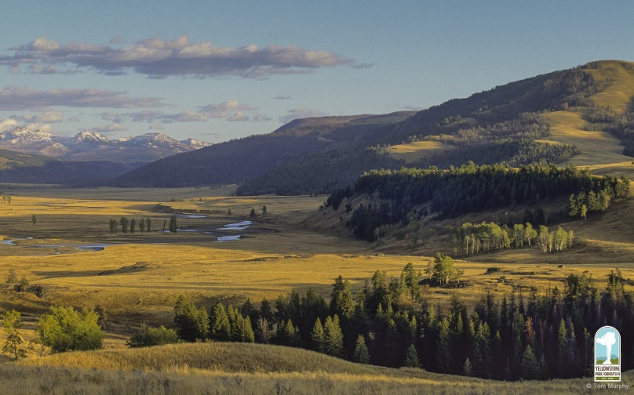

The graph on page 1 of the Student Handout shows trends in wolf and elk populations in the Northern Range of Yellowstone where many elk and wolves spend the winter. This graph shows trends in number of wolves for larger areas.  Wolf Population | 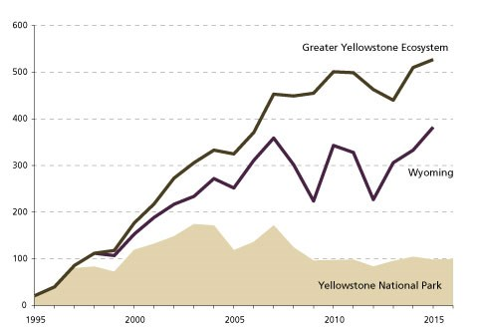  (https://www.nps.gov/yell/learn/nature/wolves.htm)

Questions 1-4 are intended to start students thinking about phenomena that will be revisited in the rest of the activity. As your students discuss their answers to these questions, you can guide them to ask questions and formulate hypotheses that will set the stage for later sections.

Food Chains and Food Webs
For the discussion of food chains and food webs, your students should understand that the arrows point from the organism that is consumed to the organism that consumes. In other words, the arrows show the direction of flow of nutrition.

We use the term producer (but not the equivalent term autotroph) for organisms that use energy from sunlight to make all of their organic molecules. Producers include not only plants (which are mentioned in the Student Handout), but also other photosynthesizing organisms such as algae and cyanobacteria. We use the term consumer (but not the equivalent term heterotroph) for organisms that consume other organisms. If you want, you can easily include the terms autotroph and heterotroph.

Decomposers such as bacteria and fungi release enzymes into dead organic matter; these enzymes digest complex organic molecules into smaller soluble molecules that are absorbed by the decomposers. Detritivores such as earthworms and termites ingest dead organic matter, extract nutrition, and excrete smaller particles which decomposers can more readily digest. Other animals such as coyotes, bears, ravens, and eagles feed on carrion such as the remains of an elk killed by a wolf pack. An entertaining and informative brief video, “Dead Stuff: The Secret Ingredient in Our Food Chain” (https://www.youtube.com/watch?v=KI7u_pcfAQE), summarizes some of the information in this activity and introduces food chains and food webs. You may want to show this video during your discussion of student answers to question 6.

If your students are not familiar with fungi, you may want to introduce them to the basic structure of an above ground fruiting body that produces spores (e.g. a mushroom), and the mycelium, a vast network of hyphae in the soil, rotting log, or other organic matter. The hyphae in the mycelium secrete digestive enzymes and absorb nutrients. | 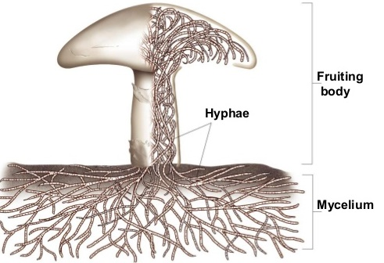
(http://image.slidesharecdn.com/funginotes-131009165742-phpapp02/95/fungi-notes-4-638.jpg?cb=1381337957)

The trophic omnivore category includes the more familiar category of omnivores (animals that eat both producers and primary consumers). However, the trophic omnivore category also includes other organisms that consume organisms at more than one trophic level (e.g. a carnivore that consumes both primary and secondary consumers). To understand why an animal that eats a trophic omnivore is also categorized as a trophic omnivore, consider the following example. If a trophic omnivore eats producers and primary consumers, it can be considered to be both a primary consumer and a secondary consumer; therefore, an animal that consumes the trophic omnivore is consuming from two different trophic levels, so it is also considered to be a trophic omnivore. You are no doubt aware that, despite the name, an omnivore doesn’t eat everything.

Trophic Relationships in Yellowstone
The Latin names for the animals and plants included in the Yellowstone National Park food web are as follows:
American Robin – Turdus migratorius
Aspen – Populus tremuloides
Beaver – Castor canadensis
Bison – Bison bison
Coyote – Canis latrans
Cutthroat trout – Oncorhynchus clarkii
Deer mice – Peromyscus maniculatus
Earthworm – Lumbricina spp.
Elk – Cervus elaphus
Gray Wolf – Canis lupus
Grizzly bear – Ursus arctos
Springtails – Collembola spp.
Uinta ground squirrel – Spermophilus armatus
Yellow-bellied marmot – Marmota flaviventris
Willow – Salix spp.

As your students begin to construct their Yellowstone food webs, you may want to point out that the cards include not only the trophic relationships, but also a general estimate of the size range (length) for the organism. We have used the more familiar term “eat” for most of the cards, but for bacteria and fungi we have used the term “consume” since these organisms do not ingest dead organic matter, but rather secrete enzymes into the environment and then absorb digested nutrient molecules.

To make an accurate food web in a reasonable amount of time, it is important for your students to complete each step in the procedure and check it off before proceeding to the next step. You may need to remind students that a primary consumer eats only producers and a secondary consumer eats only primary consumers or decomposers. The chart on the bottom of page 3 of the Student Handout provides both a helpful organization and hints for making the food web.

The Yellowstone food web includes both a green food web that begins with producers and a brown food web that begins with dead organic matter. This is an example of the general principle that the Yellowstone food web is made up of many interrelated sub-webs, which can be identified in different habitats, e.g., in the soil, above-ground in grassland or forest, in rivers, streams and ponds, or in the adjacent riparian ecosystems.

After your students have made their initial attempt to create the Yellowstone food web, if there are discrepancies between their food web and the food web shown in the key (available upon request to iwaldron@upenn.edu), you may want to ask questions that call your students’ attention to information on the cards that they can use to make a more accurate food web.

To make a manageable food web for the students to construct, we have made multiple simplifications. As discussed on page 4 of the Student Handout, we have omitted most of the types of organisms found in Yellowstone National Park, we have omitted many of the trophic relationships for the organisms included in this activity, and we have not distinguished between more important and less important trophic relationships. Additional complexities include the following.
- We have not distinguished between the many different types of fungi, Protista, nematodes, mites, grasses, and other flowering plants in Yellowstone. We have omitted mention of the different trophic relationships for different species within each of these groups.
- Many types of animals consume different types of food at different times of year and/or at different life stages.
- None of the many parasites present in any biological community have been included.
- Humans are an important part of the Yellowstone food web. Although hunting is not permitted in Yellowstone National Park, many Yellowstone elk are killed by human hunters when they migrate out of the park during the winter. Human hunters killed roughly 25,000 elk per year in Wyoming, compared to roughly 10,000 elk per year killed by the ~500 wolves living in the greater Yellowstone ecosystem (https://www.wyofile.com/many-elk-yellowstone-wolves-eat/).

All or almost all published food webs are incomplete, since it is virtually impossible to research and describe all the many species and trophic relationships in real biological food webs. For example, one analysis of a plant-mammal food web for the Serengeti ecosystem included 129 species of plants and 32 species of mammals, but excluded many other mammals, reptiles, amphibians, birds, invertebrates and decomposers. The Serengeti food web in the figure below shows one way to organize complex food web data by grouping species according to similarities in spatial location and trophic relationships.
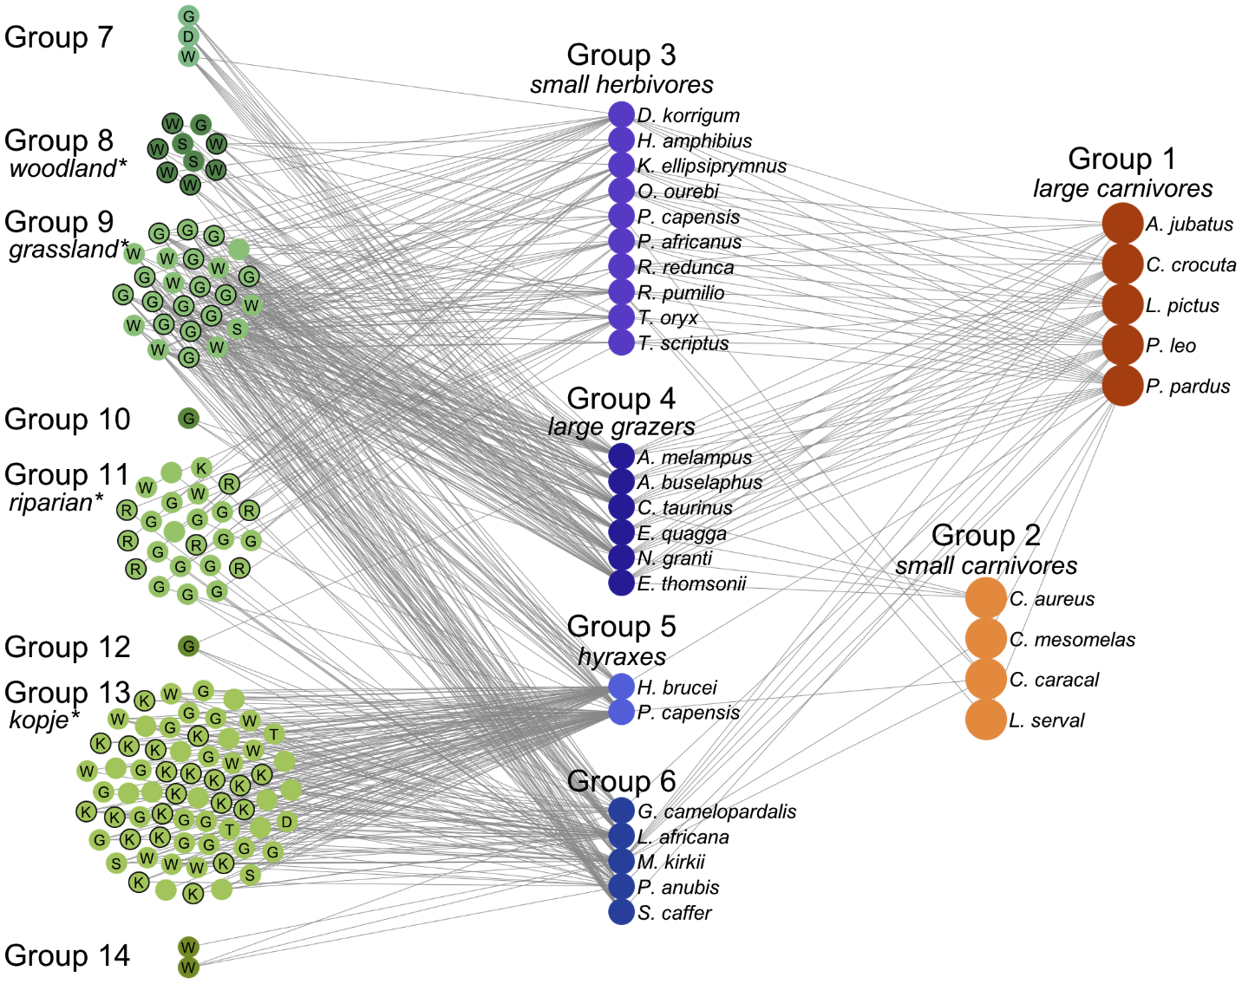
(http://journals.plos.org/ploscompbiol/article/figure/image?size=large&id=info:doi/10.1371/journal.pcbi.1002321.g003)

Top-down control occurs when population size for a higher trophic level influences population size for a lower trophic level. Bottom-up control occurs when the population size of a trophic level is influenced by the rate of production of its food source (or the producers’ population size is influenced by the availability of resources needed for growth). The trophic cascade from wolves to elk to willows (introduced on page 1 and analyzed further on page 4 of the Student Handout) is an example of top-down control of population size. The trends in elk population size were influenced by additional factors, including the very severe winter of 1996-97 when ice over snow prevented access to grass and other forage for elk; this resulted in high elk mortality. This is an example of bottom-up control.

For question 14, the changing availability of taller willows is believed to be one important reason for the changes in number of beaver colonies. The presence of a beaver colony often fosters greater willow growth by raising the water table. Thus, beavers and willows have a mutually beneficial relationship, known as mutualism. The recovery of willows in some parts of Yellowstone, but not in others, appears to be due in part to insufficient soil moisture in many places in the absence of beaver dams. Thus, in order to recover, willows need beavers and beavers need willows; this creates a "catch 22" that appears to have slowed recovery of both willows and beavers after wolves were reintroduced to Yellowstone. Although the Student Handout focuses on trophic cascade effects, the trends in willow growth and number of beaver colonies appear to have been influenced by multiple additional factors (including the release of beavers and changes in the weather and human hunting) (https://www.nps.gov/yell/learn/nature/elk.htm; http://www.bioone.org/doi/abs/10.3955/046.086.0404).

If you want your students to learn more about trophic cascades and keystone predators, we recommend the video “Some Animals Are More Equal Than Others: Keystone Species and Trophic Cascades” (http://www.hhmi.org/biointeractive/some-animals-are-more-equal-others-keystone-species-and-trophic-cascades).

Carbon Cycle and Energy Flow through Ecosystems and the Biosphere
In this section, students develop an understanding of the carbon cycle and energy flow through ecosystems by building on their understanding of food webs and reviewing the processes of photosynthesis, cellular respiration and biosynthesis.

Question 15 in the Student Handout is intended to stimulate students to think about questions and hypotheses which will be explored in the rest of this section. By the time students reach question 22 at the end of this section, they should be prepared to provide an accurate explanation of why the biosphere requires a constant input of energy from the sun, but does not need an inflow of carbon atoms. You may want to clarify that, although we speak of energy flow, energy is always a property of a physical system and not a disembodied separate substance. For example, increased heat energy corresponds to increased random motion of molecules.

The general principle in question 16b is the familiar Conservation of Matter, stated in a form that will be easier for students to apply to the analysis of photosynthesis. The general principles in question 16c will be familiar as the first Law of Thermodynamics and an implication of the second Law of Thermodynamics. Additional information about energy and the processes of photosynthesis and cellular respiration is provided in “Cellular Respiration and Photosynthesis – Important Concepts, Common Misconceptions, and Learning Activities” (http://serendipstudio.org/exchange/bioactivities/cellrespiration; this includes an explanation of the estimate that cellular respiration of one molecule of glucose results in the production of ~29 ATP).

Students may be puzzled by the idea that photosynthesis and cellular respiration produce heat, since leaves generally do not feel warm. This can be explained by considering that only a relatively small amount of heat is produced by the biological processes in a single leaf and other processes such as transpiration tend to cool leaves. If your students are familiar with compost piles, you may want to discuss how compost piles heat up due to the metabolic activity of decomposers.

The following chemical equation and diagram provide additional information about how cellulose is synthesized from glucose. The details of this reaction are not important for our purposes; the reaction is included only to illustrate an example of biosynthesis. The chart on the top of page 6 of the Student Handout includes the hydrolysis of ATP to provide the energy for biosynthesis.
n(HO–C₆H₁₀O₄–OH) → H–(O–C₆H₁₀O₄)_{n}–OH + (n – 1)H₂O
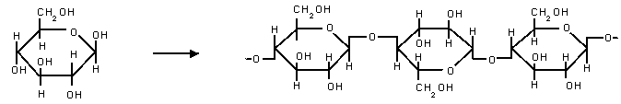
(http://www.easychem.com.au/production-of-materials/biomass-research/condensation-polymerisation)

One goal for this activity is to help your students understand the relationships between phenomena observed at different organizational levels, including the relationships between the molecular/cellular processes of cellular respiration, photosynthesis and biosynthesis and the carbon cycle and energy flow observed at the ecosystem level. Students often find it challenging to link their understanding of phenomena observed at different organizational levels, so you may want to reinforce this understanding in your class discussions of the questions in this activity. Questions 18-19 focus on how photosynthesis, biosynthesis, cellular respiration and trophic relationships contribute to the carbon cycle. Questions 20-21 focus on how the same processes result in the through-flow of energy.

The carbon cycle shown in the Student Handout are simplified to help students clearly understand the basic processes. However, this may leave students puzzled about how CO₂ concentration in the atmosphere has been increasing. To help them understand this, you may want to show them the more complete overview of the carbon cycle shown in the figure below. Resources for teaching about the carbon cycle and global warming are available at http://serendipstudio.org/exchange/bioactivities/ClimateChange and https://serendipstudio.org/exchange/bioactivities/global-warming).
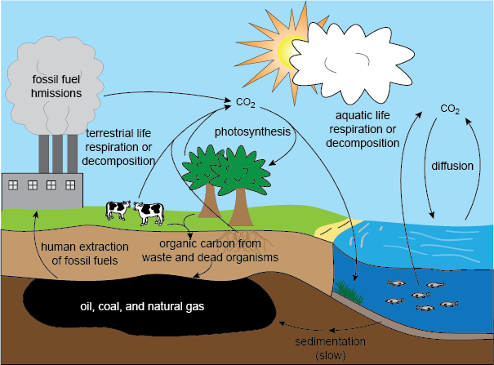
(http://media1.shmoop.com/images/biology/biobook_eco_11.png)

Useful background for this section is provided in Sections 3 and 4 of Unit 4 of the online textbook available at https://www.learner.org/series/the-habitable-planet-a-systems-approach-to-environmental-science/ecosystems/online-textbook/.

Trophic Pyramids
Biomass is the mass of the organic molecules in an organism. Organic molecules and water are the main types of matter in most organisms. Therefore, biomass is often estimated by weighing a dried specimen.

Question 23 should help students link their own experience to basic phenomena that play important roles in determining the shape of trophic pyramids. The annual per capita food consumption in the US is estimated as total mass (not biomass). Estimated annual per capita food consumption in the US includes 75 pounds of added fats and oils, 152 pounds of caloric sweeteners, 195 pounds of meat and fish, 200 pounds of grains, 593 pounds of dairy, and 708 pounds of fruit and vegetables (http://www.usda.gov/factbook/chapter2.pdf). Notice that the types of foods at the beginning of this list have high caloric density; foods in the last two categories weigh substantially more per calorie consumed, in large part because they contain a lot of water. In other words, more of the mass of fats, oils, and caloric sweeteners is biomass and less of the mass of dairy, fruits and vegetables is biomass.

Page 8 of the Student Handout discusses the net rate of biomass production at different trophic levels in a forest in New Hampshire (see table below). For each trophic level, the net rate of biomass production is the total mass of the organic molecules produced in a year minus the mass of the organic molecules used for cellular respiration. This is equivalent to the increase in biomass for the organisms in a trophic level, plus the amount of biomass lost to consumers or death due to other causes.
Trophic Level | Rate of Production  of Biomass
Producers | 1000 g/m²/year
Primary Consumers and Decomposers  (produce only 20% as much biomass as producers) | 200 g/m²/year
Secondary Consumers  (produce only 15% as much biomass as primary consumers and decomposers) | 30 g/m²/year
Tertiary Consumers  (produce only 10% as much biomass as secondary consumers) | 3 g/m²/year

Student answers to question 24 should include defecation and production of CO₂ by cellular respiration for primary consumers and cellular respiration for decomposers. The relative importance of these different processes varies for different types of organisms. For example, one study found that the proportion of consumed biomass that is used for cellular respiration is ~80% for chipmunks vs. 33% for herbivorous insects. (This difference reflects the fact that chipmunks are homeotherms, whereas herbivorous insects are poikilotherms; homeothermy is metabolically expensive.) The proportion of the biomass consumed that is lost as feces is ~18% for chipmunks vs. ~50% for herbivorous insects that eat leaves. (Leaves have more cellulose and other relatively indigestible molecules than the nuts, seeds and fruits eaten by chipmunks). As a result of these differences, biomass production for chipmunks is ~2% of the biomass consumed, whereas biomass production for herbivorous insects is ~17% of the biomass consumed.

To construct trophic pyramids like the one shown on page 9 of the Student Handout, each trophic omnivore is classified in the consumer level of the main type of food they eat. The quantitative results in question 26a can help students understand why food chains are generally limited to 4 or 5 trophic levels. Question 26b helps students to understand that generalizations such as the “10% rule” often do not apply in specific cases. For example, the forest primary consumers plus decomposers had a rate of biomass production that was 20% of the rate for producers. One reason for this relatively high percent may be that the researchers included decomposers, which are often ignored in simplified trophic pyramids.

You should be aware that the shape of trophic pyramids is highly dependent upon the specific methodology used. You have already seen that the relative size of the first and second trophic levels for rate of biomass production depends on whether decomposers are included at the second trophic level. Although trophic pyramids for the rate of biomass production always show the classic pyramid shape with each trophic level smaller than the previous trophic level, this is not true for trophic pyramids for number of organisms or for total biomass of organisms at each trophic level. For example, a trophic pyramid for the number of individuals may show more individuals at a higher trophic level, e.g. if the organisms at the higher trophic level are smaller, such as insects feeding on trees or other plants (see figure below). Similarly, the amount of biomass may be greater at a higher trophic level, e.g. if the organisms at the higher trophic level are more long-lived, such as fish or whales feeding on plankton. This explains why, the biomass of marine consumers is roughly 5 times the biomass of marine producers (https://www.pnas.org/content/pnas/115/25/6506.full.pdf, pages 6508-6509). In conclusion, trophic pyramids for number of individuals or amount of biomass tend to show the classic pyramid shape only if organisms at different trophic levels have similar size and longevity (http://www.esa.org/history/Awards/papers/Brown_JH_MA.pdf, page 1785).

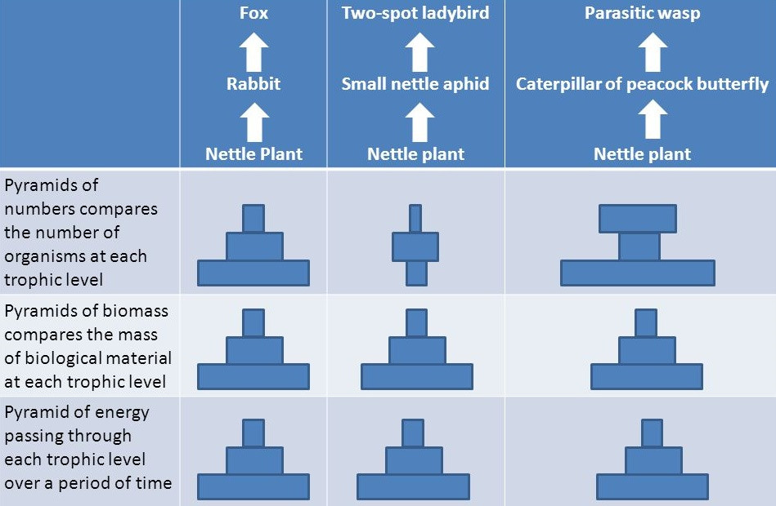
The bottom row of this figure illustrates that sometimes trophic pyramids
are presented as the energy equivalents to biomass production or biomass.
(https://slideplayer.com/slide/3461369/12/images/20/Caterpillar+of+peacock+butterfly.jpg)

If you want to discuss these issues with your students, you could add the following.

So far, we have discussed trophic pyramids that show the net rate of biomass production at different trophic levels. Another type of trophic pyramid shows the number of organisms at different trophic levels. As you can see in the figure below, comparisons of the number of organisms at different trophic levels do not always show a pyramid shape.

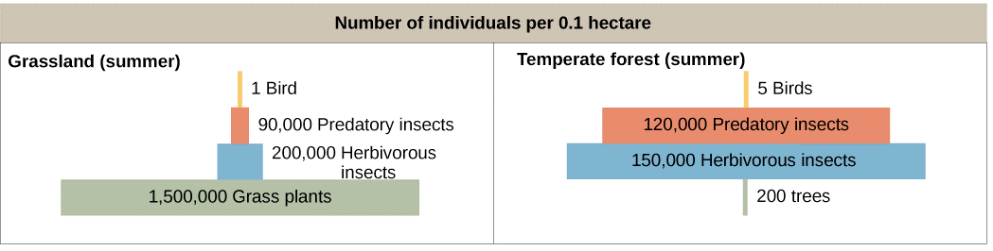

27a. Label the appropriate trophic levels in the figure as producers, primary consumers, or secondary consumers.

27b. Explain why the grassland data show a trophic pyramid with more producers than primary consumers, but the forest data show many more primary consumers than producers.

In question 27 in the Student Handout, students apply the trophic pyramid concepts to the relative number of elk and wolves in Yellowstone (following up on question 2c). It should be noted that several factors influence the relative population size of predators and prey, including the following.
- As noted above, the relative size of the animals will influence their relative numbers.
- For individual species of predator and prey, the relative numbers will depend on how many of the prey species are eaten by other predators and how much the predator species consumes other prey species. Elk are the primary prey for Yellowstone wolves. However, other animals such as grizzly bears, coyotes and ravens feed on elk that have been killed by wolves. In addition, humans kill ~2-3 times as many elk as Yellowstone wolves (see page 8).

In discussing question 28 from the Student Handout, you may want to mention that eating meat from primary consumers instead of eating plant foods not only requires ~10 times as much land, but also requires ~10 times as much water and other resources. The first follow-up activity recommended below explains why eating meat also contributes much more to global warming than eating plant foods. To reinforce student understanding of why it takes so much more land to grow enough food for a person who is a carnivore, compared to the land needed to grow the food for a person who is an herbivore, you may want to show your students the PowerPoint that is available at https://slideplayer.com/slide/8731637/.

Possible Follow-Up Activities
Food and Climate Change – How can we feed a growing world population without increasing global warming?
(https://serendipstudio.org/exchange/bioactivities/global-warming)
In the first section of this activity, students analyze information about climate change, global warming and greenhouse gases. Students learn that correlation does not necessarily imply causation, and they analyze the types of evidence that establish causal relationships. In the next two sections, students analyze carbon cycles, how food production results in the release of greenhouse gases, and the reasons why the production of different types of food results in the release of very different amounts of greenhouse gases. In the last section, students propose and research strategies to feed the world’s growing population without increasing global warming. (This activity will help students meet the Next Generation Science Standards.)

You may want to encourage your students to research related topics such as:
- aquatic food webs
- eutrophication as an example of bottom-up regulation
- nutrient cycles for nitrogen, phosphorus and water
- biomagnification of concentrations of persistent organic pollutants, mercury, etc. at higher trophic levels
- other topics that students may ask about during the activity.

Sources for Figures in Student Handout
- Trends in wolf and elk populations on page 1 – modified from “Riparian vegetation recovery in Yellowstone: The first two decades after wolf reintroduction” Biological Conservation 198: 93-103, 2016
- Food web on page 3 – http://www.biorewind.com/ecology/
- Giraffe carbon cycle – modified from http://www.bbc.co.uk/schools/gcsebitesize/science/images/bi01002.gif
- Trophic pyramid – modified from https://www2.nau.edu/lrm22/lessons/food_chain/energy_pyramid.jpg

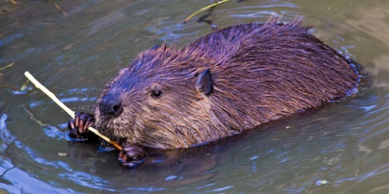58-99 cm (length, excluding tail)  Beavers  Eat: Willows  Eaten by: Gray wolves | 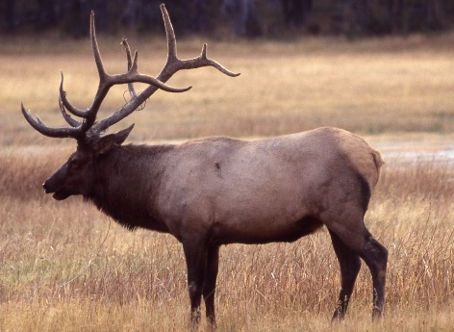  2.1-2.4 m  Elk  Eat: Grasses, willows,  other flowering  plants  Eaten by: Gray wolves,  grizzly bears | 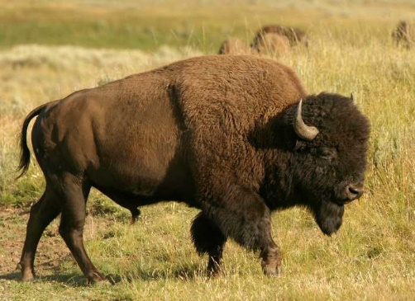  2.1-3.5 m  Bison  Eat: Grasses  Eaten by: Gray wolves
http://g  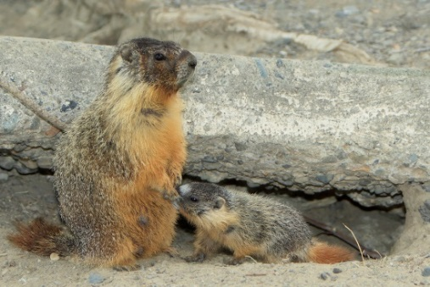  47-70 cm  Yellow-bellied  Marmots  Eat: Grasses; other  flowering plants  Eaten by: Coyotes | 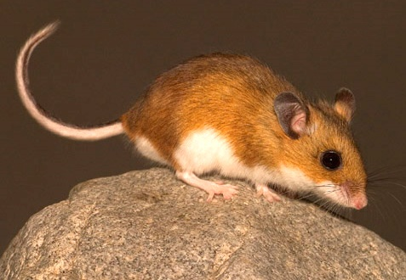  8-10 cm (length, excluding tail)  Deer Mice  Eat: Grasses; other  flowering plants  Eaten by: Coyotes | 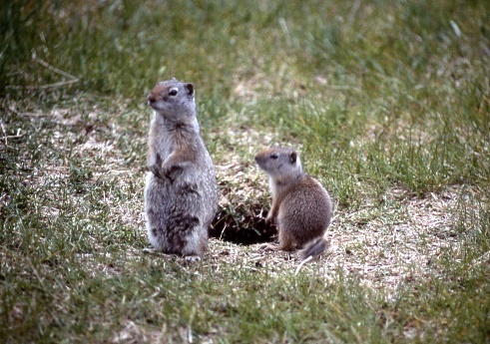  28-30 cm  Uinta Ground Squirrels  Eat: Grasses, other  flowering plants,  mushrooms,  Eaten by: Coyotes,  grizzly bears

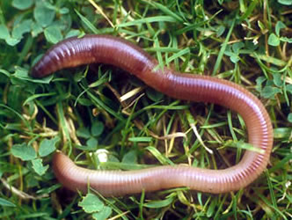  7-35 cm  Earthworms  Eat: Dead organic matter,  fungi, bacteria  Eaten by: American robins | 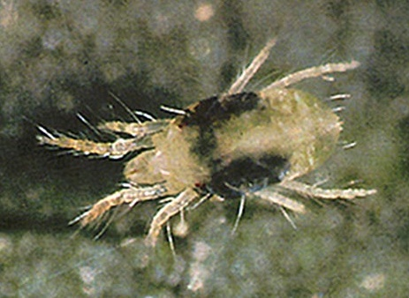  0.5-1 mm  Mites  Eat: Nematodes, fungi  Eaten by: Beetles | 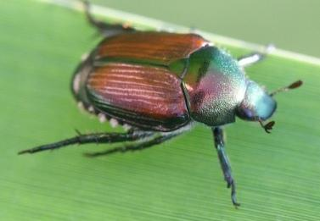  5-20 mm  Beetles  Eat: Springtails, mites  Eaten by: American  robins
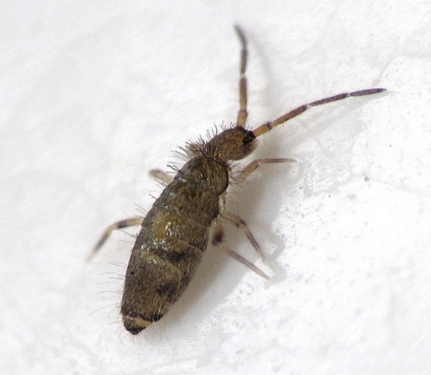  0.25-5 mm  Springtails  Eat: Fungi  Eaten by: Beetles | 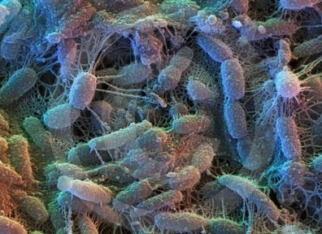  2-6 µm  Bacteria  Consume: Dead organic  matter  Eaten by: Protista,  nematodes,  earthworms | 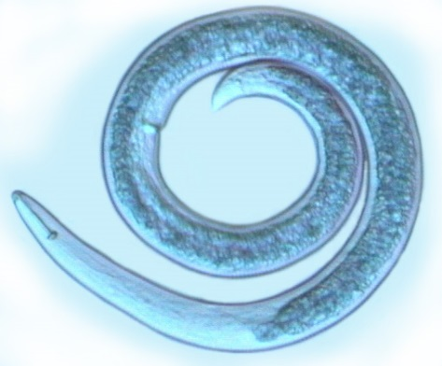  0.1-2.5 mm  Nematodes  Eat: Protista, fungi,  bacteria  Eaten by: Mites

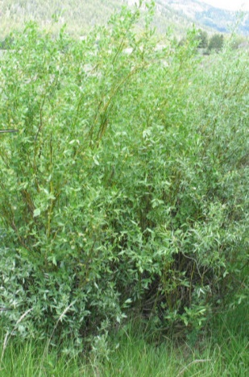  <80-400 cm  Willows  Eaten by: Beavers, elk | 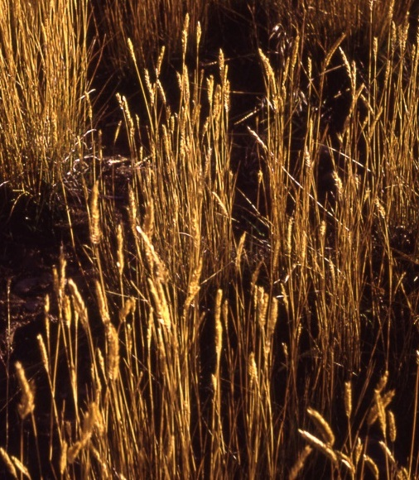  Grasses (including seeds)  Eaten by: Bison, elk, deer  mice, Uinta ground  squirrels, yellow-  bellied marmots | 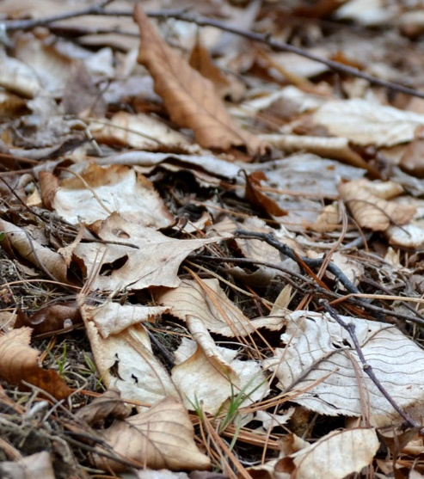  Dead Organic Matter  Consumed by: Bacteria,  fungi, earthworms
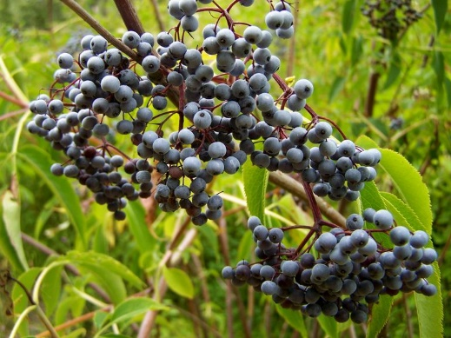  Other flowering plants  (including berries)  Eaten by: American  robins, deer mice,  elk, grizzly bears,  Uinta ground  squirrels, yellow-  bellied marmots | 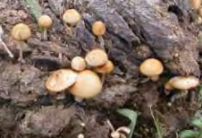  Fungi  Consume: Dead organic  matter  Eaten by: Springtails,  mites, nematodes,  earthworms,  Uinta ground squirrels | 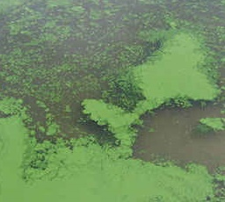  Algae  Eaten by: Cutthroat trout

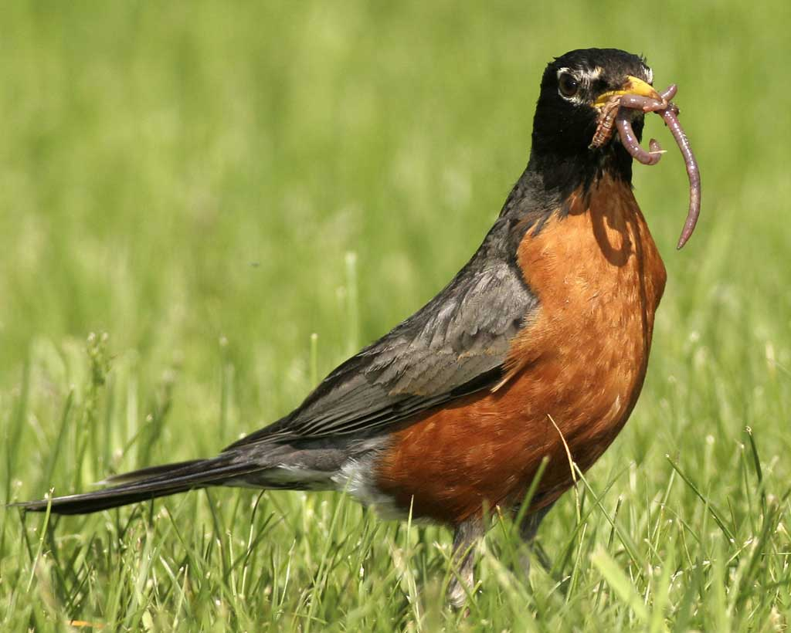  23-28 cm  American Robins  Eat: Earthworms, beetles,  other flowering plants  Eaten by: Snakes and  birds of prey (not  included in this food web) | 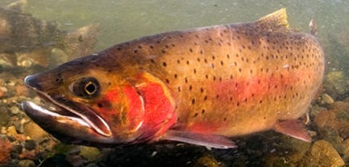  15-50 cm  Cutthroat Trout  Eat: Algae  Eaten by: Grizzly bears | 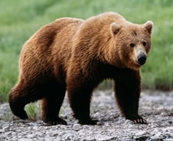  1.8-3.3 m  Grizzly Bears  Eat: Other flowering  plants, cutthroat  trout, Uinta ground  squirrels, elk
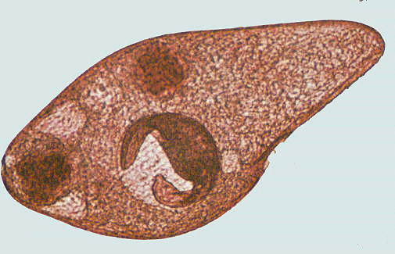  <1 mm  Protista  Eat: Bacteria  Eaten by: Nematodes | 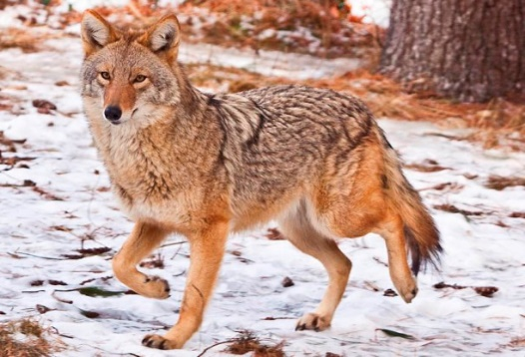  1-1.4 m  Coyotes  Eat: deer mice, Uinta  ground squirrels,  yellow-bellied  marmots  Eaten by: Gray wolves | 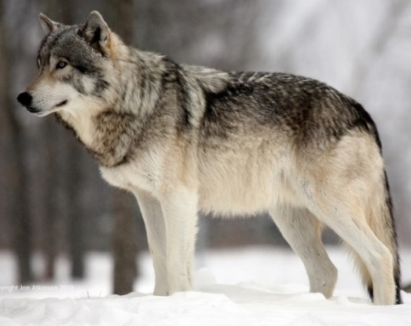  1.4-2 m  Gray Wolves  Eat: Elk, beavers, bison,  coyotes

By Drs. Ingrid Waldron and Lori Spindler, Department of Biology, University of Pennsylvania. © 2022. The Student Handout and these Teacher Preparation Notes are available at https://serendipstudio.org/sci_edu/waldron/#ecolfoodweb.
Quotations are from http://www.nextgenscience.org/sites/default/files/HS%20LS%20topics%20combined%206.13.13.pdf
This activity can be used to prepare middle school students for Performance Expectation, MS-LS2-3. “Develop a model to describe the cycling of matter and flow of energy among living and nonliving parts of an ecosystem.” For middle school students, you may want to use one of the following as a complementary or alternative activity. Carbon TIME (http://carbontime.bscs.org/) provides a sequence of activities about carbon cycles and energy flows. “Eco-Inquiry” (http://www.caryinstitute.org/educators/teaching-materials/eco-inquiry/who-eats-what) includes "Who Eats What?" which is an introduction to food webs.
We use biosynthesis to refer to the processes that use the product of photosynthesis to make other types of organic molecules. Some sources use the term biosynthesis to include photosynthesis.
Throughout this activity we have used heat as a more familiar, although somewhat inaccurate, term for thermal energy. "Thermal energy refers to the energy contained within a system that is responsible for its temperature. Heat is the flow of thermal energy." (https://www.khanacademy.org/science/physics/work-and-energy/work-and-energy-tutorial/a/what-is-thermal-energy) Heat is "energy that is transferred from one body to another as the result of a difference in temperature" (https://www.britannica.com/science/heat). Thus, throughout the Student Handout and Teacher Notes, it would be more accurate to substitute "thermal energy" for the term "heat".
We are grateful to Craig Douglas (http://www.douglasanimation.com/) for his help with preparing the cards and the PDF.
If you use this alternative smaller deck you will need to modify the chart near the bottom of page 3 of the Student Handout (see page 3 in the Student Handout for “Food Webs – Understanding What Happened When Wolves Were Returned to Yellowstone”, https://serendipstudio.org/sci_edu/waldron/#foodweb). You may want to have your students use the Jamboard for this smaller food web (see the Teacher Preparation Notes at https://serendipstudio.org/sci_edu/waldron/#foodweb).
You may be attracted to the video "Wolves of Yellowstone", but we recommend that you not use this video because many of the statements that are presented as fact in this video are actually quite speculative.
In addition to producers that use sunlight as their energy source, there are producers in deep-sea hydrothermal vents and iron-rich rocks deep below the earth’s surface that use chemical energy contained in compounds such as ammonia or hydrogen sulfide.
American robins and Uinta ground squirrels belong to both the green and brown food webs. Your students should notice the tiny size of most of the organisms in the brown food web.
We have used somewhat simplified language to discuss energy, and you may prefer to follow the more sophisticated recommendations for helping students understand energy in the NSTA Press book, “Teaching Energy Across the Sciences K-12”.
The biosynthesis of many types of organic molecules requires minerals in addition to the products of photosynthesis. For plants, these minerals are taken up from the soil. For example, plants use mineral sources of nitrogen (e.g. NH₄⁺), together with carbon-containing molecules to make amino acids that can be joined together to form proteins. Humans and other mammals obtain minerals primarily from the food they eat.
A proxy measure of biomass is the mass of carbon in an organism; the mass of carbon is approximately half of the dry weight. Unfortunately, biomass is sometimes used to refer to the total weight of an organism; this definition is not used in this learning activity.
Information about the ecology of the Hubbard Brook Experimental Forest in New Hampshire is available in pages 1151-2 in Freeman et al., Biological Science, 2014; Scientific American, March 1978, pages 93-102; and https://hubbardbrook.org/online-book/online-book.
The figure is from https://www.khanacademy.org/science/high-school-biology/hs-ecology/trophic-levels/a/energy-flow-and-primary-productivity.

