**DNA – Teacher Preparation Notes[1]**

In this activity, students extract DNA from their cheek cells and relate the steps in the procedure to the characteristics of cells and biological molecules. Students learn key concepts about DNA structure and function during the intervals required for the extraction procedure. Student understanding of DNA replication is developed by additional analysis and discussion questions and hands-on modeling of DNA replication.

If school policies do not allow your students to extract DNA from their cheek cells, we recommend:

– a similar activity which involves extracting DNA from the archaeon *Haloferax* *volcanii*

(<https://serendipstudio.org/sci_edu/waldron/#dna>) or

– our analysis and discussion activity "DNA Structure, Function and Replication"

(<https://serendipstudio.org/exchange/bioactivities/DNA>) which can be used alone or with

the directions for extracting DNA from strawberries

(<https://sites.google.com/view/biologypd-home/topics/biological-molecules>).

Before students begin the activity, they should have a basic understanding of the structure and functions of proteins. For this purpose, we recommend "Introduction to the Functions of Proteins and DNA" (<https://serendipstudio.org/exchange/bioactivities/proteins>).

DNA extraction and the sections on structure and function (pages 1-3 and the top of page 4 of the Student Handout) will probably require a 50-minute laboratory period. DNA replication (pages 4-5) should require less than a full additional 50-minute period.

**Learning Goals**

In accord with the Next Generation Science Standards[2]:

* Students will gain understanding of the Disciplinary Core Ideas:
* LS1.A, Structure and Function, "All cells contain genetic information in the form of DNA molecules. Genes are regions in the DNA that contain the instructions that code for the formation of proteins."
* LS3.A, Inheritance of Traits, "Each chromosome consists of a single very long DNA molecule, and each gene on the chromosome is a particular segment of that DNA. The instructions for forming species' characteristics are carried in DNA."
* Students will engage in the Scientific Practices, constructing explanations and using models.
* This activity provides the opportunity to discuss the Crosscutting Concept, "structure and function".
* This activity helps to prepare students for two Performance Expectations:
* HS-LS1-1, "Construct an explanation based on evidence for how the structure of DNA determines the structure of proteins which carry out the essential functions of life…"
* MS-LS3-1, "Develop and use a model to describe why structural changes to genes located on chromosomes may affect proteins and may result in harmful, beneficial, or neutral effects to the structure and function of the organism."

Additional Content Learning Goals

* DNA carries the genetic information in all types of organisms. Each DNA molecule contains multiple genes.
* A DNA molecule has two strands of nucleotides wound together in a double helix. Each nucleotide is composed of a phosphate group, a sugar molecule, and one of four different bases: adenine(**A**), thymine (**T**), guanine (**G**), or cytosine (**C**). The phosphate and sugar parts of the nucleotides form the backbone of each strand in the DNA double helix.
* The bases extend toward the center of the double helix, and each base in one strand is matched with a complementary base in the other strand. In accord with the base-pairing rules, **A** pairs with **T** and **G** pairs with **C**.
* Proteins are polymers of amino acids. The specific sequence of amino acids determines the structure and function of the protein. Proteins have many important functions in cells, including protein enzymes that catalyze chemical reactions and transport proteins.
* The sequence of nucleotides in a gene gives the instructions for the sequence of amino acids in a protein. A difference in the sequence of nucleotides in a gene can result in a different sequence of amino acids which can alter the structure and function of the protein. This can result in different characteristics, e.g., albinism vs. normal skin and hair color.
* DNA replication produces two new DNA molecules that have the same sequence of nucleotides as the original DNA molecule; thus, each of the new DNA molecules carries the same genetic information as the original DNA molecule. During DNA replication, the two strands of the original DNA double helix are separated and each old strand is used as a template to form a new matching DNA strand. The enzyme DNA polymerase adds nucleotides one-at-a-time, using the base-pairing rules to match each nucleotide in the old DNA strand with a complementary nucleotide in the new DNA strand.
* In eukaryotic cells, each chromosome consists of DNA wrapped around proteins.

**Supplies and Equipment for DNA Extraction**[3]

Single Use Items:

Sports drink like Gatorade (10 mL per student) (avoid drinks with color)

Liquid dish soap (0.25 mL per student)

# Meat tenderizer (a pinch per student) (unseasoned works best)

# (or several drops of contact lens cleaner)

95-99% isopropyl or ethyl alcohol (4 mL per student)

3 oz. dixie cups (1 per student)

Gloves (1 per student)

Bleach (1% bleach solution to sterilize test tubes)

Reusable Items:

Small test tubes (tubes should hold ~15 mL) (1 per student)

Test tube rack (1 per group)

Freezer or tub of ice to keep alcohol cold (1 per class)

Tub to hold 1% bleach solution to sterilize test tubes

For Optional Necklace:

String (2.5 ft per student)

0.5-1.5 mL fliptop microcentrifuge tubes (1 per student)

Transfer pipettes (1 per student)

**Procedures for DNA Extraction**

**Preparation Before Class:**

1. If each student is making a necklace, cut string into 2.5 ft pieces.
2. Put alcohol in the freezer until needed and/or or set up a bucket of ice to keep alcohol cold.
3. Pour ~10 mL sports drink in a small cup for each student.

**During class:**

1. Distribute a cup with ~10 mL of sports drink to each student. To ensure that your students obtain enough cheek cells, we recommend that you have all of them swish the sports drink in their mouths while you time at least 1 minute and encourage your students to swish the drink in their mouths vigorously.
2. Distribute a test tube rack with one test tube per student to each group. Distribute one glove to each student. Pass out the detergent and enzymes (meat tenderizer or contact lens cleaner). Alternatively, you can have a station somewhere in the classroom where the students can access the supplies.
3. After your students have completed page 2 of the Student Handout and at least 10 minutes after they have added the enzymes, pass out the cold alcohol and pipettes. Remind your students to add the alcohol slowly, running it down the side of the test tube so it forms a layer on top of the soapy liquid. Also, remind them not to mix or bump the test tube.
4. After your students have completed page 3 of the Student Handout and at least 10 minutes after they have added the layer of alcohol, they should be able to observe the DNA. If your students are making a necklace, distribute one microcentrifuge tube and piece of string to each student.
5. Assist students’ transfer of their DNA to their microcentrifuge tubes using the pipettes. It helps to twirl the DNA around the end of the pipette to get a large wad together before sucking the DNA into the pipette. Warn the students to be gentle while pipetting so they do not damage the fragile strands of DNA. Inexperienced pipetters tend to blow air into the liquid and suck up and expel the DNA several times in the test tube before transferring it to the microcentrifuge tube; this tends to break the DNA strands.
6. Put on a pair of gloves and collect the test tube racks from the students. Pour test tube contents out down the sink drain, rinse the test tubes, and place them in a tub of 1% bleach solution for 10 minutes to sterilize them.
7. Remove test tubes from bleach water, rinse and invert them in the racks to dry for the next class.
8. Return the alcohol to the ice bucket or freezer.

**Supplies and Preparation for Modeling DNA Replication**

* nucleotide pieces – A template for making enough nucleotide pieces for nine students or pairs of students is provided on the last page of these Teacher Preparation Notes. After you photocopy enough copies for the number of students you have, you can:
* precut each page in nine parts and provide your students with scissors as well as tape or
* recruit student helpers to precut each page to make 9 packets of 10 nucleotides each.
* tape

If you prefer, you can use the online [**DNA Replication Simulation**](https://docs.google.com/document/d/128x0ErPKfsjFCqZyQBd4g9f8v-rCMs9supfX86sVkiU/copy). This simulation will allow the students to move each individual nucleotide from the table at the bottom of the page to the

appropriate location in the drawing of the separated DNA strands.

**Instructional Suggestions and Biology Background**

To maximize student learning and participation, we recommend that you have your students work in pairs or small groups to answer each section of related questions. Student learning is increased when students discuss scientific concepts to develop answers to challenging questions. After your students have answered each section of related questions, we recommend that you have a class discussion to probe student thinking and help students develop a sound understanding of the concepts and information covered. In order to consolidate accurate understanding, you may want to offer students the opportunity to prepare revised versions of their answers to key questions.

In the Student Handout, numbers in bold indicate questions for the students to answer and

letters in bold indicate steps in the extraction procedure for the students to do.

If you use the Word version of the Student Handout to make changes for your students, please check the PDF version to make sure that the figures and formatting in the Word version are displaying correctly on your computer.

A key for the version of this activity that involves extraction of DNA from *Haloferax* is available upon request to Ingrid Waldron ([iwaldron@sas.upenn.edu](mailto:iwaldron@sas.upenn.edu)). The following paragraphs provide additional instructional suggestions and background information – some for inclusion in your class discussions and some to provide you with relevant background that may be useful for your understanding and/or for responding to student questions.

Extracting DNA from Your Cells and Questions 1-5

Question 1 will help students recall their previous learning about DNA, and a class discussion of their answers will help you to understand your students’ current knowledge of DNA, including any misconceptions they may have.

During the wait of at least 10 minutes after the students have added enzymes, students should review the information on page 2 of the Student Handout and answer questions 2-3.

The Student Handout has a highly simplified explanation of how detergent breaks open the cell membrane and nuclear membrane. For a more sophisticated understanding, students need to:

* understand that water is a polar molecule that is attracted to polar substances
* know that much of the cell membrane is made up of a bilayer of phospholipid molecules
* know that both detergents and phospholipids have a polar head and a long nonpolar tail (detergent) or two nonpolar tails (phospholipids).

The figure below shows the interaction between detergent and the phospholipid molecules and proteins in the cell membrane.

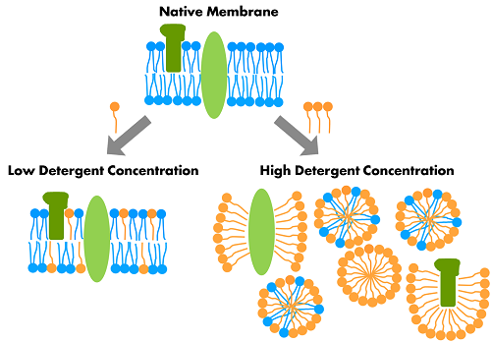

(<https://www.jenabioscience.com/crystallography-cryo-em/screening-membrane-proteins/jbscreen-detergents>)

Curious students may wonder why washing your hands with detergent or soap does not break open the cell membranes of your skin cells. The answer is that the outer layer of skin consists of highly specialized dead cells embedded in an insoluble protein structure (the stratum corneum in the figure). This outer layer also contains molecules that prevent detergent from reaching the living skin cells underneath.

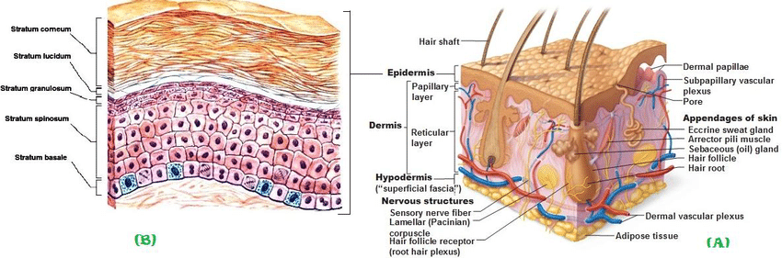

(<https://www.researchgate.net/profile/Amir_Alsharabasy3/publication/284712479/figure/fig1/AS:614257750192181@1523461868960/Figure-1-A-Cross-section-of-skin-showing-its-different-layers-B-Cross-section-in.png>)

You may also want to explain why washing your hands with soap is effective in fighting infection by coronavirus, influenza and some other respiratory viruses. You can use one or more of the following resources for this purpose.

* The 2-minute video “Fighting Coronavirus with Soap” (<https://www.youtube.com/watch?v=s2EVlqql_f8>) provides a good explanation of how soap breaks down the phospholipid bilayer of the viral envelope, so the coronavirus falls apart.
* Another good 6-minute video, “Which is Better: Soap or Hand Sanitizer?” (<https://www.youtube.com/watch?v=x7KKkElpyKQ>) provides a more in-depth explanation; if you use this video, make sure your students understand that hand sanitizer needs to have at least 60% ethanol or 70% isopropanol to be effective.
* Another good ~4-minute video, “How soap kills the coronavirus” (<https://www.vox.com/2020/2/28/21157769/how-to-prevent-the-coronavirus>) provides a somewhat simplified explanation of how soap works to inactivate the coronavirus and why you should wash your hands for at least 20 seconds. One caution is that most scientists believe viruses are not alive, so a better title would be “How soap inactivates the coronavirus”. One advantage of this video is that it explains that antibacterial soap is not more effective in killing viruses. In fact, it is better not to use antimicrobial soap, since it may contribute to bacterial antibiotic resistance (<https://massivesci.com/notes/soap-and-water-is-enough-antibiotic-resistance-covid19/>).
* The 1.5-minute video, “WHO: How to handwash? With soap and water” (<https://www.youtube.com/watch?v=3PmVJQUCm4E>) demonstrates how to wash your hands effectively.

The proteases in the meat tenderizer or contact lens cleaner not only digest histones (the proteins that DNA wraps around; see figure below), but also break down cell enzymes which could digest the DNA. The high salt concentration (from the sports drink and meat tenderizer) is also important since DNA molecules are negatively charged and the salt neutralizes the repulsion among the negatively charged strands of DNA and allows the DNA to clump together.

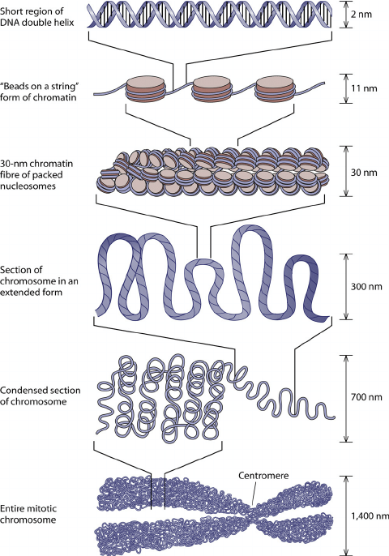

(<https://www.researchgate.net/profile/Kevin_Verstrepen/publication/51196608/figure/fig1/AS:276923784679429@1443035183356/Chromatin-structure-DNA-is-wrapped-around-a-histone-octamer-to-form-nucleosomes.png>)

The structure of eukaryotic chromosomes is highly dynamic (see figure above; The Molecular Biology of the Cell, Fifth Edition). During interphase, most of each chromosome is in the chromatin form. These threadlike chromosomes form loops within the nucleus, which has a diameter of only 5-20 µm in eukaryotic cells. Obviously, a real DNA molecule is much narrower (2 nm) and has many more pairs of nucleotides than the DNA molecule shown in the figures in the Student Handout. To help students grasp how very long a real DNA molecule is, you may want to have them guess whether a typical DNA molecule has hundreds, thousands or millions of nucleotides in each strand. The DNA molecule in each human chromosome has between 47 million and 249 million base pairs.[4] A DNA molecule is approximately 2 nm in diameter and roughly 3 cm in length. Thus, a DNA molecule is roughly 10 million times as long as it is wide.

For the right-hand diagram in the top figure on page 2 of the Student Handout, you may want to ask your students about the difference between the solid lines (which represent covalent bonds

|  |  |
| --- | --- |
| within each DNA strand) and the dotted lines (which represent hydrogen bonds between the two strands). As shown in the Student Handout, each nucleotide consists of a deoxyribose sugar, a phosphate group and one of four nitrogenous bases. This figure shows additional detail of a nucleotide that contains the nitrogenous base, adenine. The nitrogenous bases can accept a positive hydrogen ion, which explains why they are called bases (<https://www.quora.com/Why-are-adenine-thymine-cytosine-and-guanine-called-bases>). | (<https://en.wikipedia.org/wiki/Nucleotide>) |

You may want to explain to your students that DNA stands for deoxyribonucleic acid. Deoxyribonucleic refers to both the deoxyribose sugar in each nucleotide and the fact that DNA is a polymer of nucleotides. You can explain why DNA is an acid, even though it contains bases; the phosphate groups in the backbone of each DNA strand are acidic and this effect dominates, in part because the phosphate groups are on the outside of the DNA molecule and the bases are hydrogen-bonded in pairs on the inside of the DNA molecule.

During the wait of at least 10 minutes after the alcohol has been added, the students should read the material on page 3 of the Student Handout and answer questions 4-5.

|  |  |
| --- | --- |
| You may want to use the following information to supplement the explanation for the addition of alcohol on the top of page 3 of the Student Handout. Cold alcohol helps to precipitate the DNA molecules by reducing the temperature and adding alcohol to the solution of DNA immediately under the alcohol layer. DNA is soluble in water because the negatively charged phosphate groups in the outer backbone of each strand are attracted to the partial positive charge of the H atoms in the polar water molecules. Ethanol has a polar component, but also has a | Ethanol Water  <http://www.cavemanchemistry.com/cavebook/images/figalcohol2.jpg> |

large nonpolar component, so DNA is less soluble in ethanol.

To ensure student understanding in this introductory activity, the Student Handout includes multiple simplifications. For example, the definition of a gene on page 3 of the Student Handout ignores multiple complexities, including the facts that many genes code for more than one polypeptide and many other genes code for RNA that has different functions from mRNA (e.g., ribosomal RNA and regulatory RNA).

You will want to be sure that your students understand that DNA carries the genetic information in all types of organisms, and the basic function and structure of DNA is similar in all types of organisms.

Question 4 discusses genes that are crucial for the cells to survive; if a version of one of these genes gives instructions to make a nonfunctional version of the protein, this would result in cell death.[5] In contrast, the chart near the bottom of page 3 of the Student Handout describes an example of a gene that is not crucial for cell survival; therefore, an allele of this gene that codes for a nonfunctional version of the protein enzyme is not lethal and instead can result in albinism.[6]

|  |  |
| --- | --- |
| The allele for albinism codes for a defective enzyme (tyrosinase) for producing melanin, a dark pigment that protects skin cells’ DNA from the damaging effects of the sun's UV radiation. In the most common form of albinism, the defective enzyme for producing melanin not only results in albino skin and hair color, but also affects the appearance and function of the eyes. | A small part of a melanin molecule[7] |

|  |  |
| --- | --- |
| Melanin is produced in melanosomes inside melanocytes and transported into the epidermal cells in the outer layers of the skin. A good explanation is provided in the short video, “How We Get Our Skin Color”.[8] | (<https://image.slidesharecdn.com/smartscreen-skin-150715094615-lva1-app6891/95/skin-14-638.jpg?cb=1436953811>) |

Question 5 is crucial for students to understand the function of DNA and why DNA replication needs to preserve the precise sequence of nucleotides. After question 5, you may want to ask your students the question shown below. This question will alert your students that skin color is influenced by other genes (e.g., genes that influence how much melanin is made) and environmental factors (e.g., sun exposure which can result in increased production of melanin).[9]

**6a.** Based on what you know about human skin color, are these two versions of a gene the only factors that influence skin color? no ___ yes ___

**6b.** Explain your reasoning.

Further information about albinism is available at <https://medlineplus.gov/ency/article/001479.htm> and <https://omim.org/entry/203100>.

After the wait of at least 10 minutes, when your students are ready to examine the extracted DNA, emphasize that they should first look at the undisturbed test tube. They should see a translucent layer and/or clump where the DNA is located, usually near where the alcohol meets the soapy mixture. They may also see lengths of DNA, sometimes with bubbles on them.

DNA Replication

Eukaryotic DNA changes shape during the cell cycle; as a cell prepares for cell division, each chromosome is highly condensed (as shown at the bottom of the figure on page 7 of these Teacher Preparation Notes). The upper figure on page 4 of the Student Handout would be more accurate if it showed the chromosomes in a threadlike, more extended form in the initial cell before DNA replication and in the daughter cells produced by cell division; this complexity has been ignored for this introductory learning activity.

See page 3 of these Teacher Preparation Notes for information about the supplies and preparation for the DNA replication activity on the top half of page 5 of the Student Handout.

To answer question 8, students should remember that DNA provides the information to make crucial proteins and the sequence of nucleotides in each gene specifies the sequence of amino acids in each protein, which determines the protein’s structure and function. The rate of errors in DNA replication is extremely low (approximately one in a billion nucleotides). DNA replication is highly accurate, in part because DNA polymerase “proofreads” each new DNA strand for mistakes and backtracks to fix any mistakes it finds.[10]

For question 9, if your students are not familiar with the use of the suffix "ase" to designate an enzyme, you will need to provide that information. If your students would benefit from more scaffolding of question 10, you can use this alternative version.

**10a.** During DNA replication, the double helix structure, the base-pairing rules, and DNA polymerase work together to make two DNA molecules that are identical to the original DNA molecule. How does the double helix structure help to produce two new DNA molecules that are identical to the original DNA molecule?

**10b.** How do the base-pairing rules help to produce two new DNA molecules that are identical to the original DNA molecule?

**10c.** Explain why DNA polymerase is needed for DNA replication.

The description of DNA replication and question 10 provide a good opportunity to discuss the Crosscutting Concept, Structure and Function, “The functions and properties of natural and designed objects and systems can be inferred from… the way their components are shaped and used, and the molecular substructures of its various materials.

Assessment

After your students have completed the Student Handout, you can assess their understanding of key concepts by having them complete the “DNA Quiz” on page 13 of these Teacher Preparation Notes. After students complete this quiz, you should have a class discussion in which students compare their answers and you provide prompt feedback so they can improve the accuracy and completeness of their answers. This type of active recall with feedback helps to consolidate student understanding and retention of the concepts learned during the activity.[11]

**Follow-Up Activities** **and Additional Resources** (All the recommended activities are aligned with the [Next Generation Science Standards](http://www.nextgenscience.org/next-generation-science-standards).)

To further develop student understanding of how DNA provides the instructions for protein synthesis and influences our characteristics, we recommend:

– our analysis and discussion activity From Gene to Protein via Transcription and Translation (<https://serendipstudio.org/exchange/bioactivities/trans>)

or

– our hands-on modeling activity From Gene to Protein – Transcription and Translation (<https://serendipstudio.org/sci_edu/waldron/#trans>).

### To help students understand how chromosomes are separated during cell division and how genes are transmitted from parents to offspring, we recommend our mitosis activities and our meiosis and fertilization activities:

### – <https://serendipstudio.org/sci_edu/waldron/#mitosis>

### or <https://serendipstudio.org/exchange/bioactivities/MitosisRR>

### and

### – <https://serendipstudio.org/sci_edu/waldron/#meiosis>

### or <https://serendipstudio.org/exchange/bioactivities/meiosisRR>

In UV, Mutations and DNA Repair, students learn about the effects of UV light, mutations and DNA repair on the survival of prokaryotes and the risk of skin cancer. In the first experiment, students evaluate the effects of different durations of UV exposure on survival and population growth of *Haloferax* *volcanii*. This experiment also tests for photorepair of DNA damage. Students design the second experiment, which evaluates the effectiveness of sunscreen. In addition, students answer analysis and discussion questions that promote their understanding of molecular biology, cancer, and the interpretation of experimental results. ([NGSS;](http://serendipstudio.org/science_edu/waldron/#UVmutations)  <https://serendipstudio.org/sci_edu/waldron/#uvmutations>)

Additional background information and suggestions for follow-up activities are provided in:

- Molecular Biology: Major Concepts and Learning Activities

(<https://serendipstudio.org/exchange/bioactivities/MolBio>)

- Genetics – Major Concepts and Learning Activities

(<https://serendipstudio.org/exchange/bioactivities/GeneticsConcepts>).

To ensure student understanding of the basics of DNA structure, function, and replication, this activity ignores many complexities. For additional information, see:

<https://bio.libretexts.org/Bookshelves/Introductory_and_General_Biology/Book%3A_Introductory_Biology_(CK-12)/04%3A_Molecular_Biology>

– helpful resources available at <https://learn.genetics.utah.edu/content/basics/> and <https://www.biointeractive.org/classroom-resources/teacher-guide-dna>

– videos available at <https://www.biointeractive.org/classroom-resources/chemical-structure-dna> and <https://www.biointeractive.org/classroom-resources/dna-replication-basic-detail>.

**DNA Quiz Name** ______________________________

**1**. Complete this table to describe how two different versions of a gene can result in normal skin and hair color vs. albinism.

|  |  |  |  |  |
| --- | --- | --- | --- | --- |
|  | **→** |  | **→** |  |
|  | **→** |  | **→** |  |
|  | **→** |  | **→** | Normal skin and hair color |
|  | **→** |  | **→** | Very pale skin and hair = albinism |

**2.** Write sentences and label the figure to describe the structure of DNA.

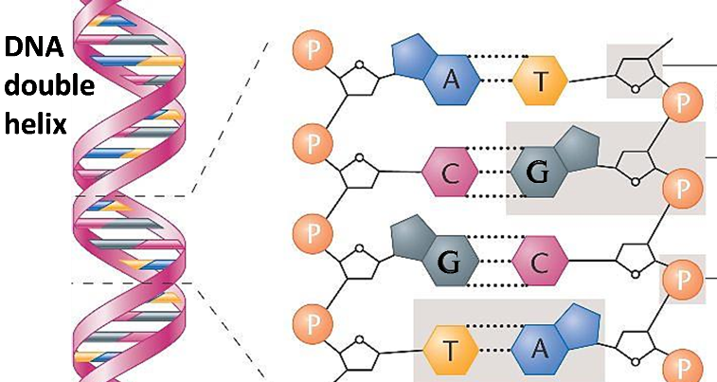

|  |  |
| --- | --- |
| **3.** Describe how DNA is replicated. |  |

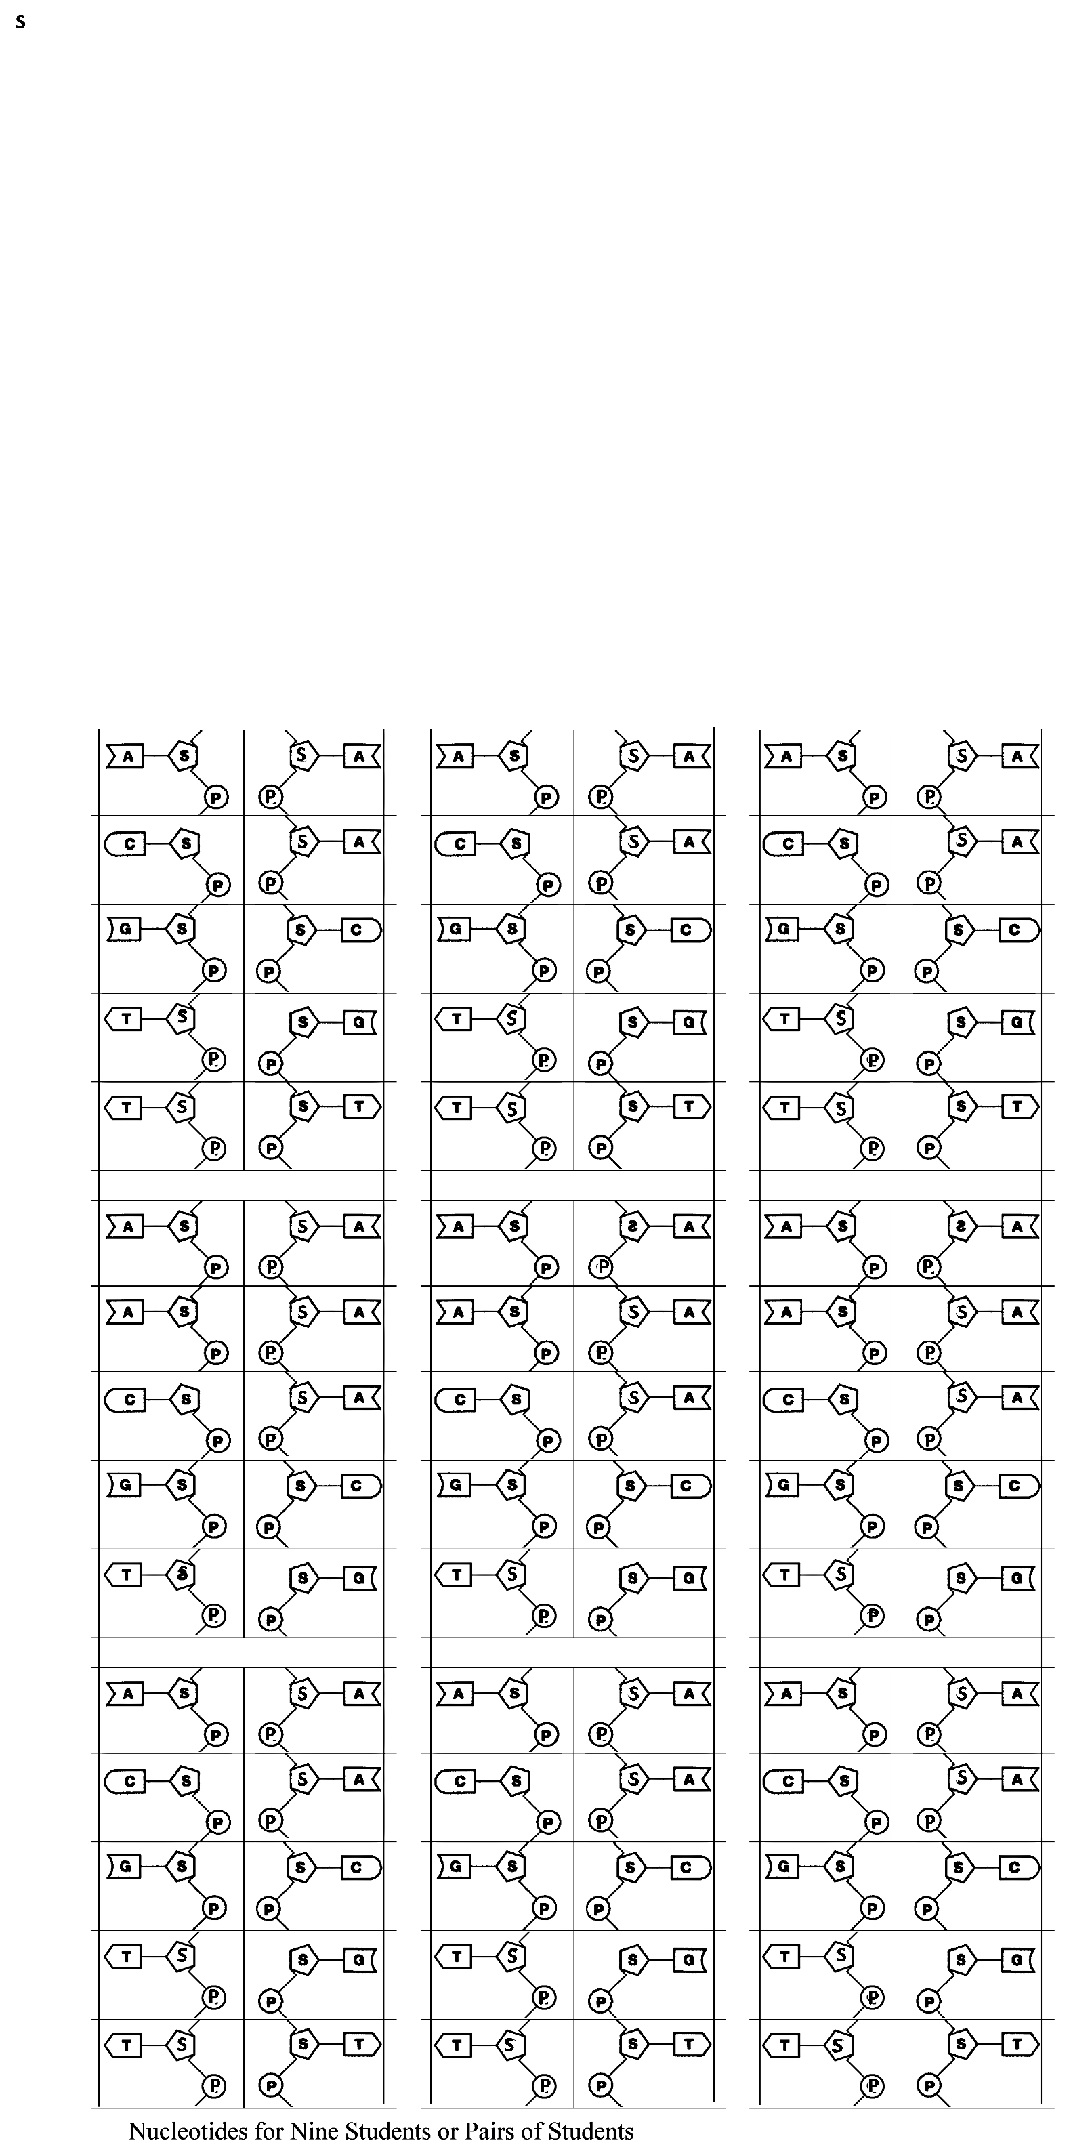

1. By Drs. Ingrid Waldron and Jennifer Doherty, Department of Biology, University of Pennsylvania, © 2023. Instructions for DNA extraction based on and adapted from BioRad’s “Genes in a bottle” (<http://www.bio-rad.com/cmc_upload/Literature/54133/4110034B.pdf>**),** and the simulation of DNA replication is adapted from *Instructor Guide to Biology – A Guide to the Natural World* by Jennifer Warner. These Teacher Preparation Notes and the Student Handout are available at <https://serendipstudio.org/sci_edu/waldron/#dna>.
2. Quotations from <http://www.nextgenscience.org/sites/default/files/HS%20LS%20topics%20combined%206.13.13.pdf>
3. A more expensive technique that may give a higher yield and be more reliable is described at <https://www.ox.ac.uk/sites/files/oxford/field/field_document/Biochemistry%20workshop%20presentation.pdf>. This source reports that some meat tenderizer contains enzymes that break down DNA.
4. The number of genes per human chromosomes varies from roughly 200 (Y chromosome) to over 3000 (chromosome 1) (<https://www.ncbi.nlm.nih.gov/books/NBK22266/>). Each human cell has 23 pairs of homologous chromosomes. The total number of human genes is estimated to be over 20,000.
5. Although DNA with genes is required to give the instructions for making proteins, not all cells have DNA. For example, mature red blood cells do not have DNA because they have ejected their nuclei after hemoglobin and other proteins have been synthesized.
6. Since this allele is recessive, a person would be albino only if both copies of the gene coded for a nonfunctional version of the protein enzyme; this complexity is not discussed in this learning activity, but instead is discussed in “Genetics” (<https://serendipstudio.org/sci_edu/waldron/#genetics>) or "Introduction to Genetics – Similarities and Differences between Family Members" (<https://serendipstudio.org/exchange/bioactivities/geneticsFR>).
7. <https://upload.wikimedia.org/wikipedia/commons/thumb/3/3a/Eumelanine.svg/220px-Eumelanine.svg.png>
8. Available at <http://www.hhmi.org/biointeractive/how-we-get-our-skin-color>.
9. These points are developed in “Were the babies switched?” (<https://serendipstudio.org/sci_edu/waldron/#blood>).
10. Additional repair mechanisms contribute to the accuracy of DNA copies. Nevertheless, sometimes a mistake is made and not found, and then the mistake can become a permanent mutation. Any daughter cells will have this same mutation. A mutation in a gamete that forms a zygote can result in significant effects, such as muscular dystrophy. (See Mutations and Muscular Dystrophy, <https://serendipstudio.org/exchange/bioactivities/mutation>.) Mistakes in DNA replication during mitosis can contribute to the development of cancer.
11. Evidence for the benefits of active recall with prompt feedback is described in <http://www.scientificamerican.com/article/researchers-find-that-frequent-tests-can-boost-learning/>.