DNA

1. Everyone has heard of DNA, but what is it and what does it do? Briefly summarize what you already know about DNA and how DNA influences a person’s characteristics.

Extracting DNA from Your Cells

In this activity, you will extract DNA from your cheek cells. Each cell in your body has a nucleus with 46 chromosomes. Each chromosome contains a DNA molecule.  Each cell is surrounded by a cell membrane that regulates what gets into and out of the cell. The nucleus | 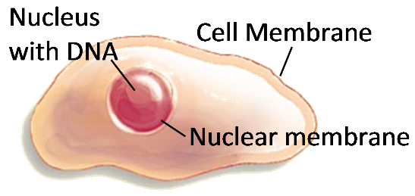
is also surrounded by a membrane.

To extract DNA from human cells, you will need to break open the cell membranes and nuclear membranes and separate the DNA from the other types of biological molecules in human cells. You will be using the same basic steps that biologists use to extract DNA. You will follow these 3 easy steps to extract the DNA:

Detergent

eNzymes (meat tenderizer)

Alcohol

Getting Your Sample of Cells
Cells from the lining of your mouth come loose easily, so you will be able to collect cells containing your DNA by swishing sports drink around in your mouth. You will need to get thousands of your cheek cells in the sports drink in order to extract enough DNA to see.
- Get a cup with 10 mL of sports drink.
- Swish the sports drink around in your mouth vigorously for at least one minute.
- Then spit the drink back into the cup.

Safety Caution. You should only handle your own sample.

Step 1: Detergent
- Add a small amount of detergent (about 0.25 mL) to a test tube.
- Put a glove on the hand you will use to hold your test tube.
- Carefully pour the drink containing your cheek cells into the test tube with detergent until the tube is half full.

Step 2: Enzymes
- Add a pinch of enzyme (meat tenderizer) to your test tube.
- With your gloved thumb covering the top of the test tube, gently swirl the tube or invert it five times to mix. Do not shake it.
- Remove your glove and throw it in the garbage. Let the mixture sit for at least 10 minutes.

While you're waiting, read the information on the next page and answer questions 2-3.

Why did I add detergent?
To get the DNA out of your cheek cells you need to break open both the cell membranes and the nuclear membranes. Cell membranes and nuclear membranes consist primarily of lipids. Detergents break up clumps of lipids. This is why you use detergents to remove fats (which are lipids) from dirty dishes. Adding the detergent to your cheek cell solution will break open the cell membranes and nuclear membranes and release your DNA into the solution.

Why did I add enzymes?
Each chromosome in the nucleus of a cell contains a very long molecule of DNA. If you stretched out the DNA found in one of your cells, it would be 2-3 meters long. To fit all of this DNA inside a tiny cell nucleus, the DNA is wrapped tightly around proteins. The enzyme in meat tenderizer is a protease, which is an enzyme that cuts proteins into small pieces. As this enzyme cuts up the proteins, the DNA will separate from the proteins and unwind.

DNA Structure
A DNA molecule has two strands of nucleotides twisted together in a long spiral called a double helix. This figure shows a small part of a double helix and the chemical structure of a short segment of this double helix.
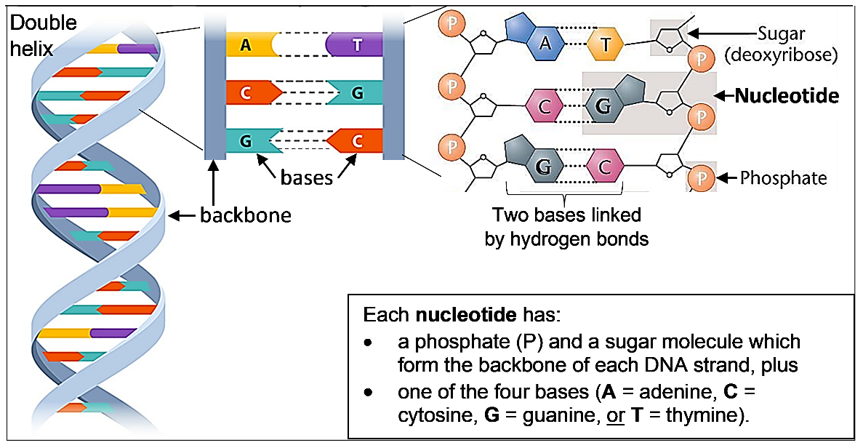
2. The sugar of each nucleotide is bound to the phosphate of the next nucleotide to make the backbone of each DNA strand. Draw a rectangle around the backbone of the right-most strand of DNA in the above figure.

3a. Each base in one strand of the DNA double helix is paired with a base in the other strand. The base-pairing rules describe which bases pair together in a DNA double helix.
A in one strand pairs with _____ in the other strand.
C in one strand pairs with _____ in the other strand.

3b. The only difference between DNA nucleotides is the base each nucleotide contains. Therefore, a nucleotide is given the same symbol as the base it contains (A, C, G, or T) and the base-pairing rules apply to the nucleotides. The nucleotides that pair together are called complementary nucleotides. Which nucleotide is complementary to G?

Step 3: Alcohol
- Using a pipette, slowly add cold absolute alcohol; let the alcohol run down the side of the test tube so it forms a layer on top of the soapy liquid. Add alcohol until you have a layer of about 2 cm of alcohol in the tube. (Alcohol is less dense than water, so it will float on top.)
- Do not mix or bump the test tube for at least 10 minutes.

While you're waiting, read the information on the next page and answer questions 4-5.

Why did I add alcohol?
The cold alcohol reduces the solubility of DNA. When cold alcohol forms a layer on top of the solution, the DNA molecules will clump together where the cold alcohol above meets the soapy water below. The lipids and proteins will stay in the solution.

DNA Function
Each DNA molecule contains many genes. A gene is a segment of DNA that provides the instructions for making a protein. A cell needs many different types of proteins to function. For example, a cell needs:
- protein enzymes to carry out the chemical reactions that sustain life
- transport proteins to move ions and molecules into and out of the cell

4. All organisms, including bacteria, plants, humans and other animals, have DNA inside their cells. Why does each type of cell need to have DNA?

Different versions of a gene have a different sequence of nucleotides. As shown in the figure below:
the sequence of nucleotides in the DNA of a gene
determines the sequence of nucleotides in RNA which
determines the sequence of amino acids in a protein which
determines the structure and function of the protein which
influences the characteristics of the organism.

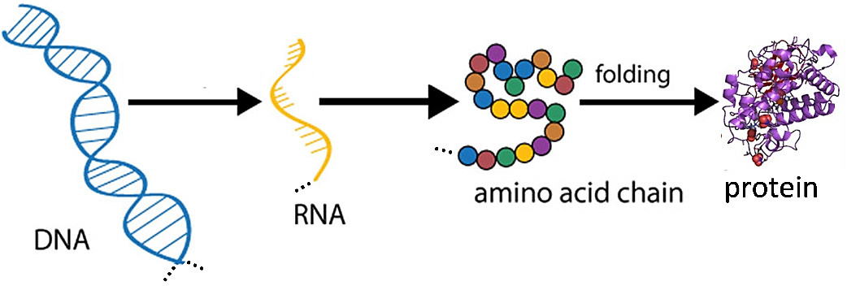

The table below shows the effects of two different versions of a human gene. The sequence of nucleotides in one version of the gene codes for a sequence of amino acids that folds into a protein enzyme that makes melanin. The other version of the gene has a different sequence of nucleotides that codes for a different sequence of amino acids which does not make a functional enzyme.

Gene in DNA | → | Protein | → | Characteristic
One version of the gene gives the instructions for making a functional protein enzyme. | → | The functional enzyme makes melanin, the pigment molecule in skin and hair. | → | Normal skin and hair color
Another version of this gene gives the instructions for making a nonfunctional version of this protein. | → | The nonfunctional protein does not make melanin. | → | Very pale skin and hair = albinism

5. Explain how a difference in the sequence of nucleotides in a gene can result in one boy being albino and the other boy having normal skin and hair color. | 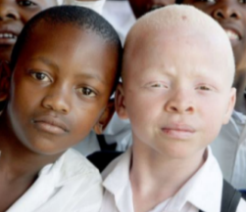

Observing your DNA
- Carefully observe your DNA which should be visible as clumps of white strands floating at the bottom of the alcohol layer. There may be air bubbles attached to the strands.
M. If you will be making a necklace that features your DNA, follow these instructions to
transfer your DNA to your necklace. Be sure to squeeze the air out of your pipette before
you put the pipette in the test tube; then twirl your DNA around the tip of your pipette and
gently suck up your DNA. (Do this only once to avoid breaking the delicate DNA strands.)
Transfer the DNA to the small capped tube and fill it the rest of the way with alcohol. Close
the cap of the tube around a piece of string.

DNA Replication
Our bodies need to make new cells to grow and to replace damaged cells. This figure shows how new cells are formed by cell division. Before a cell divides into two daughter cells, the cell makes a copy of all of its DNA (DNA replication).

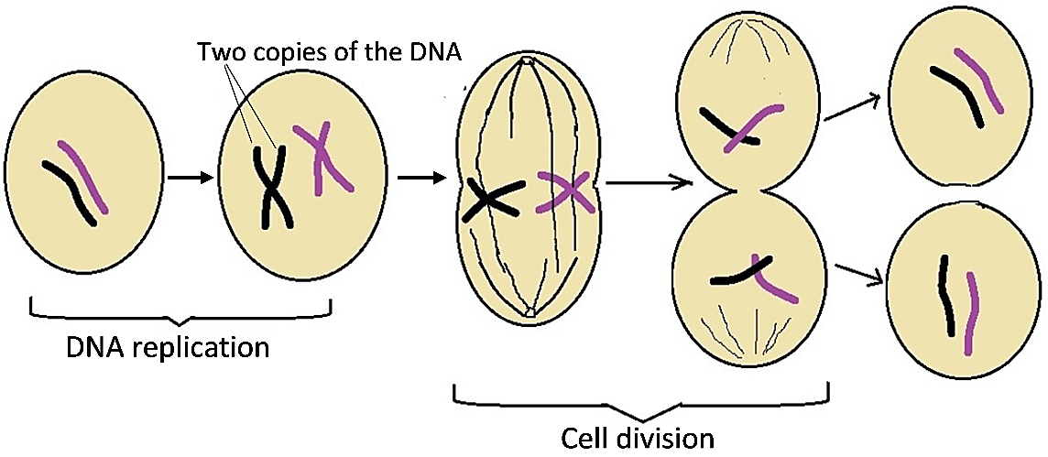

6. Explain why a cell needs to replicate its DNA before the cell divides into two daughter cells.

This figure shows how DNA replication produces two new DNA molecules that are identical to the original DNA molecule.
- First, the two strands of the DNA double helix are separated.
- Then, each nucleotide in the old strand is matched by the base-pairing rules with a complementary nucleotide in the new strand.
An enzyme, DNA polymerase, joins each new nucleotide to the previous nucleotide in the new DNA strand.

The top half of this figure shows a short segment of DNA. In the bottom half of the figure, the two DNA strands have been separated in preparation for replication.  - Your job is to play the role of DNA polymerase and create new strands of complementary nucleotides to produce two segments of double-stranded DNA. Use the base pairing rules to add complementary nucleotides one-at-a-time. (Your teacher will give you additional instructions.)  7. Compare the two new double-stranded segments of DNA with the original double-stranded segment of DNA. Do they all have the same sequence of | 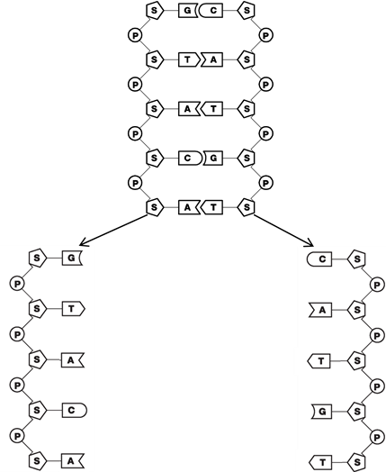
nucleotides in both strands? yes ___ no ___

8. Why is it important for both copies of the DNA produced by DNA replication to have the exact same sequence of nucleotides as the original DNA?

9. Based on the function of DNA polymerase, explain why each part of the name DNA polymerase (DNA, polymer, -ase) makes sense.

10. Explain how DNA polymerase, the double helix structure of DNA, and the base-pairing rules work together to produce two identical copies of the original DNA molecule.

By Drs. Ingrid Waldron, Lori Spindler and Jennifer Doherty, Dept Biology, Univ Pennsylvania, © 2023. This Student Handout and Teacher Preparation Notes (with instructional suggestions and biology background) are available at https://serendipstudio.org/sci_edu/waldron/#dna.

