Teacher Preparation Notes for
“Negative Feedback, Homeostasis, and Positive Feedback – Examples and Concepts"

This minds-on, hands-on activity begins with an anchoring phenomenon, how a person’s breathing changes when he/she is re-breathing the air in a plastic bag. Students develop a negative feedback model of how the changes in breathing stabilize blood levels of O₂ and CO₂. To understand changes in breathing when running, students analyze cellular respiration. Next, students use a negative feedback model to understand temperature regulation and homeostasis. Then, students analyze how failures of negative feedback can result in diabetes. Finally, students compare and contrast positive and negative feedback.

The Appendix for these Teacher Preparation Notes suggests an optional activity in which each student group formulates a question or hypothesis concerning negative feedback, homeostasis and changes in breathing. The student groups design a relevant experimental investigation, carry it out, and interpret the results. Information provided in the Appendix can be used to facilitate student investigations of the effects of blood levels of CO₂ vs. O_{2,} breath-holding, exercise, or changes in rate vs. depth of breathing.

We estimate that everything except the optional activity can be completed in roughly two 50-minute class periods. The optional activity proposed in the Appendix will probably take at least two 50-minute periods. An alternative analysis and discussion learning activity is “Negative Feedback, Homeostasis, and Positive Feedback” (~50-70 minutes; https://serendipstudio.org/exchange/bioactivities/homeostasis).

Table of Contents
Learning Goals – pages 1-2
Supplies – page 2
Instructional Suggestions and Background Information
General – page 2-3
Changes in Breathing – pages 3-7
Negative Feedback Regulation of Body Temperature – pages 7-12
Diabetes – A Failure of Negative Feedback Regulation of Blood Glucose Levels – pages 12-15
Positive feedback produces rapid change. – pages 15-16
Appendix. Investigating a Hypothesis or Question Concerning Negative Feedback, Homeostasis and Changes in Breathing – pages 17-25

Learning Goals
In accord with the Next Generation Science Standards:
- This activity helps students to meet the Performance Expectation:
- HS-LS1-3. "Plan and conduct an investigation to provide evidence that feedback mechanisms maintain homeostasis."
- Students learn the following Disciplinary Core Idea:
- LS1.A "Feedback mechanisms maintain a living system's internal conditions within certain limits and mediate behaviors, allowing it to remain alive and functional even as external conditions change within some range. Feedback mechanisms can encourage (through positive feedback) or discourage (negative feedback) what is going on inside the living system."
- Students engage in recommended Scientific Practices, including:
- “Developing and Using Models – Develop, revise, and/or use a model based on evidence to illustrate and/or predict the relationships between systems or between components of the system.”
- “Constructing Explanations – Apply scientific ideas, principles, and/or evidence to provide an explanation of phenomena…".
- Students learn the Crosscutting Concept, "Stability and Change – Systems in dynamic equilibrium are stable due to a balance of feedback mechanisms."

Additional Content Learning Goals
- Negative feedback occurs when a change in a regulated variable triggers a response that reverses the initial change and brings the regulated variable back to the set point. For example, negative feedback regulation of blood levels of CO₂ and O₂ helps to ensure that enough O₂ is delivered to meet the cells’ needs for cellular respiration and enough CO₂ is removed to prevent harmful effects.
- Cells carry out cellular respiration to make ATP, and hydrolysis of ATP provides energy for many cellular processes. Cellular respiration requires O₂ and produces CO₂. The respiratory system and circulatory system work together to bring O₂ to cells all over the body and get rid of CO₂.
- Homeostasis refers to the maintenance of relatively constant internal conditions. Negative feedback plays an important role in maintaining homeostasis.
- However, homeostasis and negative feedback do not mean that body temperature is always constant. For example, cells that are fighting an infection can release a chemical signal that is carried by the blood to the temperature control center, where this chemical signal can increase the setpoint for temperature regulation, resulting in a fever.
- Positive feedback occurs when a change in a variable triggers a response which causes more change in the same direction. Positive feedback is useful when there is an advantage to making a rapid change. For example, positive feedback facilitates rapid formation of a platelet plug which helps to prevent excessive blood loss when a blood vessel is injured.

Supplies
For “Changes in Breathing”:
– one 8 gallon plastic garbage bag per student (13 gallon plastic garbage bags are much easier to obtain and can be used; students may need to breathe into the bag longer than 4 minutes or gather the bag to hold it over their mouth and nose partway down from the bag’s opening so the volume of air available for rebreathing is reduced.)
– some way of timing 4 minutes for each group of four students

Instructional Suggestions and Background Information
In the Student Handout, numbers in bold indicate questions for the students to answer, and capital letters in bold indicate steps in experimental procedures.

For the analysis and discussion questions, you can maximize student participation and learning, by having your students work in pairs to answer each group of related questions, alternating with class discussions of student answers to each group of related questions. In each discussion, you can probe student thinking and help them develop a sound understanding of the concepts and information covered before moving on to the next group of related questions.

A key is available upon request to Ingrid Waldron (iwaldron@upenn.edu). The following paragraphs provide additional instructional suggestions and background information – some for inclusion in your class discussions and some to provide you with relevant background that may be useful for your understanding and/or for responding to student questions.

Changes in Breathing
Question 1 is intended to get students thinking about the issues that are analyzed in this section. A class discussion of different student answers can stimulate further thinking. However, we recommend that you do not try to explain the “correct” answers at this time, but rather let students discover these as they work their way through pages 1-2 of the Student Handout.

You may need to reassure your students that the warnings about the hazards of suffocation that they have seen on plastic bags refer to infants. There is no risk that middle school, high school or college students will suffocate during this experiment! However, a student who has a serious respiratory or heart problem probably should not be a subject in the experiments. It may be advisable for a participating student with asthma to keep his/her inhaler close at hand for use if needed.

The video available at https://www.youtube.com/watch?v=l60LE0M0bk8&feature=youtu.be demonstrates how to prepare the bag and breathe into the bag. We recommend that you view this video and then either demonstrate the procedure for your students or have them watch this video. Helpful advice includes:
- To begin, the bag should be opened completely and swished through the air to fill it.
- Gather the top of the bag in your hands and poke a hole just big enough for your nose and mouth. Make sure to have a tight seal between the bag and your face, so no air is leaking in and out of the bag.
- Maintain a tight seal throughout the entire test interval.

Most students will notice a change in their breathing, typically after 2-3 minutes of re-breathing the air in an 8-gallon plastic bag. A subjective feeling of discomfort is most immediately noticeable, but each student should also try to notice whether his or her breathing becomes deeper and/or more rapid. Changes in the amount of air breathed into the lungs per minute can result from changes in breathing rate and/or changes in depth of breathing.
Minute Volume (milliliters/minute)
= Breathing Rate (breaths/minute) x Tidal Volume (milliliters/breath)

Questions 4-8 guide students in developing a negative feedback model that explains the changes in breathing they observed.

If your students are not familiar with how people breathe, you may want to provide some additional explanation. During inhalation, the diaphragm muscle shortens which pulls down the bottom of the lungs (see figure below); the lung is also expanded by contraction of certain rib muscles. The expansion of the lungs reduces the pressure inside the lungs below the air pressure in the surrounding environment, so air moves into the lungs. As the diaphragm and rib muscles relax, the elasticity of the lungs causes the lungs to get smaller. This increases the air pressure inside the lungs above the external air pressure, so air moves out of the lungs. Thus, quiet breathing is due to the alternation between contraction of breathing muscles (which results in inhalation) and relaxation of breathing muscles (which results in exhalation). This rhythmic pattern of contraction and relaxation of the breathing muscles is due to a rhythmic pattern of stimulation that originates in the medulla in the brainstem. In deep breathing, contraction of certain rib muscles contributes to exhalation.

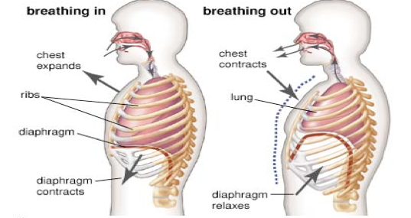

The figure below provides additional information about the structure of the respiratory system. If your students are familiar with the terms alveolus/alveoli, you may want to use these terms to replace the terms air sac/air sacs on page 2 of the Student Handout.

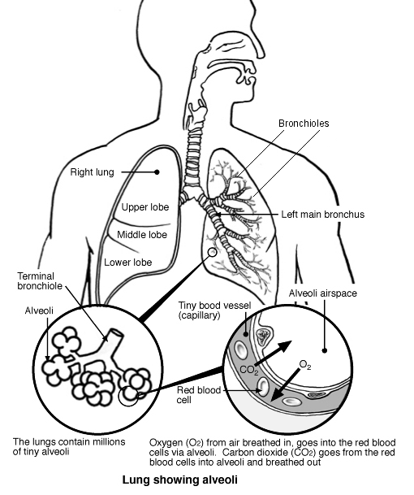

Trachea
Pharynx
(Modified from http://medical.cdn.patient.co.uk/images/310.gif)

You may want to ask your students why we need to have both a respiratory system and a circulatory system. The respiratory system is needed to bring air with O₂ into the air sacs of the lungs where O₂ can diffuse into the blood in the tiny blood vessels that surround these air sacs. The circulatory system is needed to carry O₂ from the lungs to the cells throughout the body. Also, the circulatory system is needed to carry CO₂ from the body cells to the lungs where the respiratory system can move stale air with excess CO₂ out of the body. As you discuss the role of the circulatory system, you may want to mention to your students that the circulatory system has multiple additional important functions such as transport of hormones, food molecules (e.g., glucose), heat, and antibodies and white blood cells to fight infection.

In question 9, students describe how changes in breathing contribute to negative feedback regulation of blood levels of O₂ and CO₂. You may want to discuss with your students how negative feedback keeps regulated variables nearly constant by changing something else (e.g., negative feedback keeps blood levels of O₂ and CO₂ nearly constant by changing breathing rate and depth).

If your students are not familiar with cellular respiration and ATP, you may want to introduce these topics with the analysis and discussion activity, "How do organisms use energy?" (https://serendipstudio.org/exchange/bioactivities/energy). A continuous, but variable supply of O₂ is needed for cellular respiration to make varying amounts of ATP. Muscle cells can substitute lactic acid fermentation for cellular respiration for a while, but neurons have little or no ability to carry out lactic acid fermentation. Therefore, the brain is particularly sensitive to low O₂. If the brain is deprived of O₂ for a few minutes, parts of the brain can be permanently damaged. If oxygen deprivation continues, the person can become “brain-dead”. Excess CO₂ can result in excess acidity which can disrupt the function of many proteins. This can cause muscle spasms, racing heart, disorientation, and even death. (H₂O + CO₂ H₂CO₃ H⁺ + HCO₃⁻)

To answer question 13, students should recognize that vigorous exercise uses more ATP which is generated by higher rates of cellular respiration. Because of the increased rate of cellular respiration, increased breathing is needed to bring in more O₂ and get rid of the increased CO₂. As shown in the figure below, both rate and depth of breathing increase as exercise intensity increases. This change in breathing helps to maintain homeostasis by providing more O₂ and removing more CO₂ to meet the demands of increased cellular respiration in the muscles and heart.

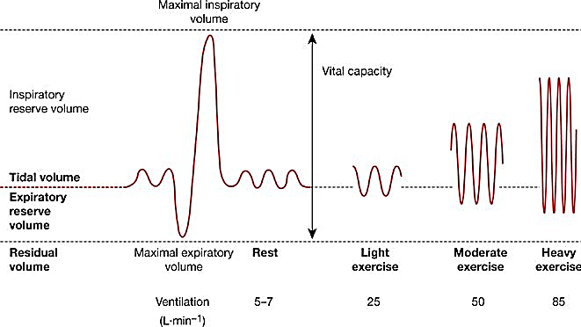
(https://thoracickey.com/respiratory-system-response-to-exercise-in-health/)

This figure shows the typical time trend of changes in breathing during and after moderate exercise. Notice that breathing increases rapidly when exercise begins, with a substantial increase within seconds. After exercise ends, breathing does not immediately return to resting levels; this increased breathing brings in the extra oxygen needed to metabolize the lactic acid that accumulates during vigorous exercise. | 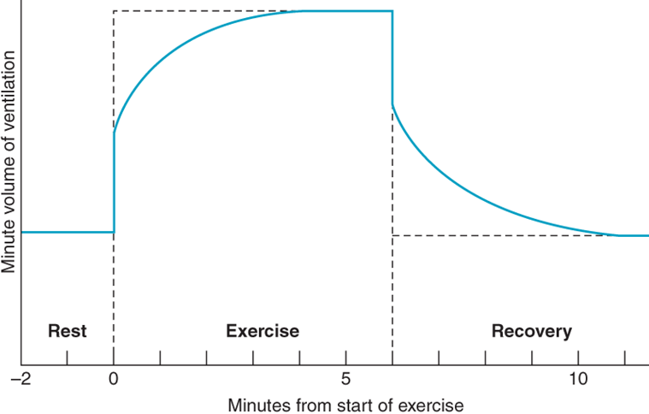  Minute volume = volume of air inhaled in a minute  = breathing rate x volume per breath (https://accessmedicine.mhmedical.com/data/books/levi8/levi8_c009f011.png)

Although we have analyzed the increase in breathing during exercise in the context of negative feedback regulation of blood levels of O₂ and CO₂, multiple lines of evidence indicate that this negative feedback is not the primary cause of increased breathing during exercise. This evidence includes the very rapid increase in breathing when exercise begins and the observation that, during exercise, blood levels of O₂ and CO₂ generally show only small and inconsistent changes from the levels observed at rest; these small and inconsistent changes in blood levels of O₂ and CO₂ are in sharp contrast to the substantial increases in breathing rate and depth during many types of exercise.

A broad range of evidence indicates that multiple mechanisms contribute to the increase in breathing during exercise.
- Available evidence indicates that the motor areas of the cerebral cortex simultaneously stimulate the motor neurons of the exercising muscles and the respiratory neurons in the medulla. The direct input from motor areas to the respiratory center is a major reason for the very rapid increase in breathing at the beginning of exercise. This feedforward mechanism illustrates how homeostasis can result from other mechanisms besides negative feedback.
- Sensory receptors that respond to joint and muscle movement provide input that stimulates increased breathing during exercise. (This response can also be observed during passive movement of a person's limbs).
- During moderate exercise, sensory receptors that respond to blood levels of H⁺, O₂, CO₂, and epinephrine, as well as body temperature, may influence breathing. During intense exercise, anaerobic fermentation results in the production of lactic acid which reduces pH which can help to stimulate increased breathing during and after exercise. Thus, negative feedback contributes to fine-tuning the changes in breathing during exercise.

The first three responses have evolved as a more efficient substitute for negative feedback during exercise. These findings illustrate the important principle that, even when observations are compatible with a hypothesis (e.g., the hypothesis that the increases in breathing rate and depth during exercise are due to negative feedback), it is important to consider possible alternative interpretations before concluding that the results support the hypothesis. The multiple reinforcing mechanisms that contribute to the regulation of breathing are typical of the redundancy observed in many biological regulatory systems.

Negative Feedback Regulation of Body Temperature
For question 14, you may want to encourage your students to consider the effects of temperature on the structure and function of molecules (e.g., optimum temperature for enzyme function). For example, if body temperature gets too low or too high, many enzymes will not function properly so the chemical reactions required for life will slow down. If body temperature gets really low, body fluids can freeze and the ice crystals will damage cells (e.g., resulting in frostbite). If body temperature gets too high a person may develop heat exhaustion or even heat stroke.

The Student Handout gives the set point for normal body temperature as ~37°C = ~98.6°F. As shown in this figure, this is a good estimate for rectal temperatures. However, oral temperatures in healthy individuals tend to be lower, with a mean value of ~36.4°C. It should also be mentioned that body temperature varies by time of day, with lower temperatures in the early morning and higher temperatures in the late afternoon or early evening. | 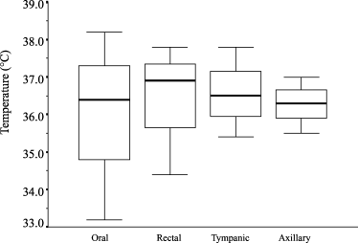  The results from 20 studies with strong or fairly strong evidence of normal oral, rectal, tympanic (ear), and axillary (armpit) temperature (°C) in adult men and women are presented. Temperature is obtainable as mean value (bold lines), 1st and 3rd quartiles (unfilled bars) and range (thin lines). (From Sund-Levander et al, 2002, Scand. J. Caring Sci. 16:122-8)

For question 15, you may want to discuss how physical activity, including shivering, results in increased production of heat (thermal energy). All types of energy conversion are inefficient and result in the production of heat. During cellular respiration, only about 50% of the energy in nutrient molecules is transferred to ATP and the other 50% is converted to heat. During muscle activity, only about 20-25% of the chemical energy expended is captured in the kinetic energy of muscle contraction and the rest of the energy is converted to heat. You should point out the general principle that body temperature depends on the balance between the amount of heat generated by the body’s metabolism (influenced, e.g., by shivering and exercise) and the amount
of heat lost to or gained from the environment (influenced e.g. by sweating and changes in circulation to the skin). This figure shows that changes in blood flow in a cold environment maintain core body temperature while allowing the extremities and body surface to become cooler. Under many circumstances, temperature regulation near the setpoint is accomplished by small changes in metabolism and blood flow, with little or no shivering or sweating.  (Figure showing distribution of body temperatures in warm vs. cold environments from http://www.bbc.co.uk/staticarchive/b57e4fc3b663a79474c8dcf51ed31b0faf72f98f.gif) | 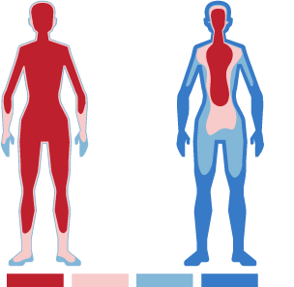
After question 15, you may want to ask students one or more of these additional questions to further their understanding of negative feedback regulation of temperature:
- Why should you drink more water if you are exercising in a hot environment?
- Why is a person’s temperature more likely to get dangerously high if he or she is exercising in an environment that is both hot and humid? (In a humid environment, sweat tends to drip off the body instead of evaporating, so the cooling effect of sweating is reduced.)

You may also want to include the following question, which asks students to relate the changes in blood flow in response to temperature to a familiar phenomenon, bruises and black eyes.

If an injury causes damage to the small blood vessels just under the surface of the skin, the blood that leaks out of the injured blood vessels can cause swelling and a black and blue bruise or a black eye.

16. Doctors advise cooling the injured area (for about ten minutes several times during the first day or two). How could cooling the injured area minimize swelling and the dark color of a bruise
or black eye?

Cooling the bruised area immediately after an injury reduces blood flow to the damaged capillaries near the surface of the skin; this reduces the amount of blood that leaks out to cause swelling and discoloration. A bag of ice or frozen vegetables should be wrapped in a washcloth and applied for about 10 minutes several times during the first day or two. For additional information, see https://www.webmd.com/first-aid/helping-bruise-heal#1 and https://www.medicalnewstoday.com/articles/249231.php.

The figure below demonstrates another way to show the negative feedback mechanisms in question 15.
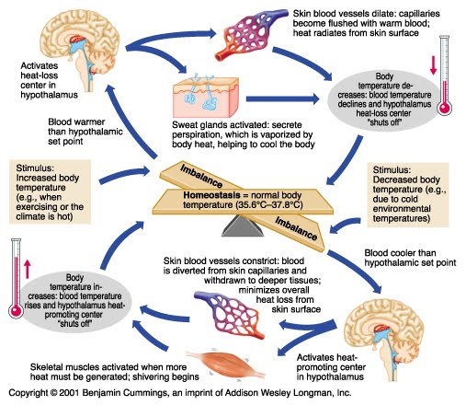
(https://d2jmvrsizmvf4x.cloudfront.net/42IFA2i2ShiS1MpwS2yL_thermoregulation-campbell.jpg)

The above figure and the flowchart in question 15 illustrate several important points about negative feedback regulation of internal body temperature.
- Negative feedback maintains body temperature within a narrow range by changing other aspects of body physiology (sweating, shivering, blood flow to the skin). These changes persist until body temperature is restored to the set point range and then the sweating or shivering and the changes in blood flow are turned off.
- The key stimulus for these changes is the discrepancy between the set point temperature and the actual body temperature.
- Negative feedback often operates via more than one type of physiological response. In addition to the responses shown in the figure above, behavioral responses such as putting on a sweater or moving out of the sun contribute to negative feedback regulation of body temperature.
- Your body temperature depends on the balance between the amount of heat generated by your body’s metabolism (influenced e.g. by shivering and exercise) and the amount of heat lost to or gained from the environment (influenced e.g. by sweating and changes in circulation).

After question 16, you may want to help students recognize the generality of the principles analyzed by discussing the Crosscutting Concept, "Stability and Change – Systems in dynamic equilibrium are stable due to a balance of feedback mechanisms."

Several complexities are not included in the Student Handout. For example, the Student Handout refers to a temperature control center in the singular, but human body temperature is regulated by several interconnected regions within the hypothalamus, with at least one region that stimulates responses that warm the body and another that stimulates responses that cool the body.

This figure shows a general flowchart with the components needed for negative feedback regulation. For regulation of body temperature, the sensors are temperature receptors in the temperature control center in the hypothalamus, other parts of the central nervous system, the skin, and abdominal organs. The effectors are the sweat glands, skeletal muscles, and blood vessels (as shown in the figure below). | 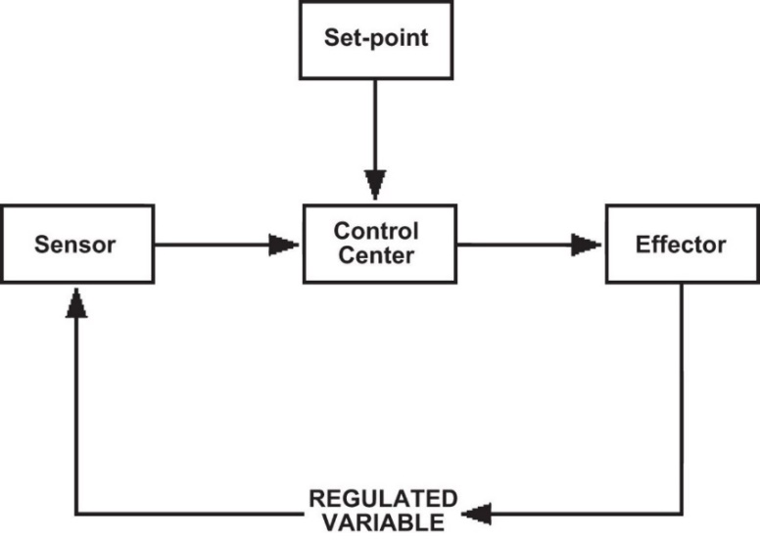  (https://physiology.org/doi/full/10.1152/advan.00107.2015)

After question 16, you may want to show the 3.6-minute video on homeostasis, negative feedback and temperature regulation (https://www.khanacademy.org/partner-content/mit-k12/mit-k12-biology/v/homeostasis).

As discussed on page 5 of the Student Handout, negative feedback regulation does not imply that temperature is the same at all times. You can change the set point on the thermostat in a home and, similarly, physiological responses can change your body's set point for temperature regulation. For example, when you have an infection, the phagocytic cells that defend against bacteria and viruses send a chemical signal to the temperature control center in the brain. This chemical signal increases the set point for temperature regulation, so you develop a fever. When a person’s set point for body temperature is increased above normal, but body temperature is normal, then the person may feel chills and shiver until actual body temperature increases to the new setpoint. The fever helps your immune system fight the infection, because the increase in temperature generally increases the immune response and decreases population growth for many types of infectious microorganisms.

Sometimes an increase in body temperature is not due to a change in set point, but instead is due to inability of the negative feedback mechanisms to cope with the amount of heat being generated or lost. For example, during exercise, body temperature tends to increase because the increased energy expenditure (up to 15-fold above resting levels) results in increased heat production which may exceed the ability of the body to get rid of heat. Usually, | 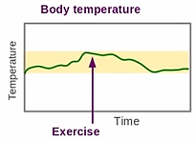  (https://www.youtube.com/watch?v=SRgHeHQ9ud0)
this results in fluctuation of body temperature within an acceptable range. In extreme circumstances, this can result in heat exhaustion or heat stroke (see footnote 4 on page 3).

Question 17 provides the opportunity to point out that in biology, “why” can have two distinct meanings. “Why” questions can inquire about the mechanism, e.g. the sequence of steps that result in higher temperatures during an infection; this type of why question usually can be worded as a “how” question. “Why” questions can also inquire about the adaptive value of a response such as a fever during infection; this type of why question makes sense in biology because natural selection results in adaptations.

Diabetes – A Failure of Negative Feedback Regulation of Blood Glucose Levels
Many students are familiar with at least some aspects of diabetes mellitus, so you may want to begin by asking your students, “What do you know about diabetes?” You can weave their responses (both accurate and inaccurate) into your discussions of this section.

Chronic high blood glucose levels can damage blood vessels and nerves, which can result in heart disease, stroke, kidney disease, blindness, and/or the need for amputations. Hypoglycemia can also be a problem (e.g., when diabetics inject too much insulin). The brain is highly dependent on glucose for cellular respiration to produce ATP. Symptoms of low blood glucose include fatigue, shakiness and anxiety. Severe hypoglycemia can result in seizure, loss of consciousness, and even death.

The negative feedback diagram immediately preceding question 20 shows normal regulation of blood glucose levels. Increased blood glucose levels after a meal stimulate the pancreas to secrete the hormone, insulin, which travels in the blood to cells all over the body. In response to insulin, the liver takes up glucose and stores the glucose in the polymer, glycogen. Most cells respond to the hormone insulin by taking up glucose, which is used for cellular respiration to
produce ATP. For example, glucose uptake by muscle cells depends on the glucose transporter GLUT-4, which is inserted in the muscle plasma membrane in response to insulin or muscle contraction (see figure). In contrast, the brain | 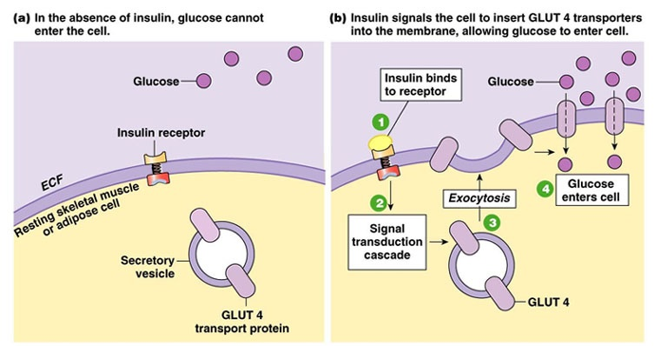  (https://fanaticcook.files.wordpress.com/2014/06/glut4.jpg)
requires a constant supply of glucose and has glucose transporter molecules that are always present in the plasma membrane.

When blood glucose levels begin to fall too low (e.g., if a person has not eaten for a while), the pancreas secretes the hormone, glucagon. Glucagon stimulates the liver to break down glycogen to glucose and convert amino acids to glucose; both of these responses increase blood glucose levels. The figure below shows that other hormones also help to increase blood glucose when levels have fallen too low. In contrast, insulin is the only hormone that acts to lower blood glucose levels that are too high.
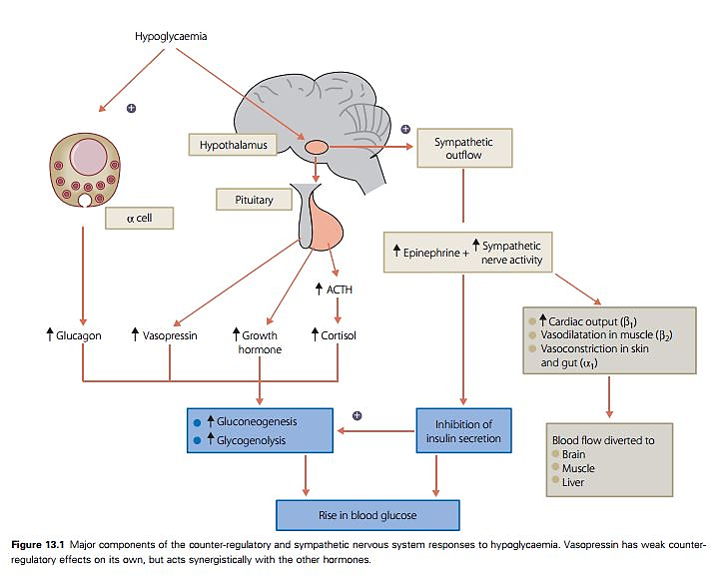
In this figure, hypoglycemia refers to low blood glucose. The alpha cells are located in the pancreas. (The alpha cells secrete glucagon, as opposed to the beta cells which secrete insulin.) Gluconeogenesis refers to the synthesis of glucose from amino acids or fatty acids. (Figure from https://www.diabetesincontrol.com/handbook-of-diabetes-4th-edition-excerpt-12-hypoglycemia/).

Notice that the brain controls levels of several of these hormones. For example, a stress response can increase the release of epinephrine (adrenaline) and cortisol, and both these hormones stimulate an increase in blood glucose levels. Thus, the effects of stress can increase blood glucose which can provide fuel for a fight or flight response. These effects of stress can be thought of as increasing the setpoint for negative feedback regulation of blood glucose levels.

It should be noted that, even in the absence of stress, healthy subjects’ blood glucose levels vary quite a bit (see figure below). This type of variation is often observed when negative feedback regulation involves relatively slow hormonal and metabolic responses.
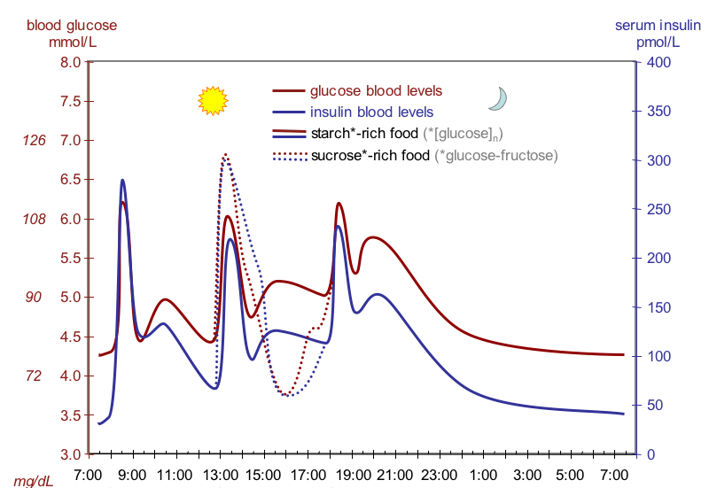
This figure shows fluctuation of blood glucose and insulin in subjects who received a standardized breakfast, lunch, dinner and late small “supper”; about 50% of the calories in these meals were from carbohydrates (starch-rich food or sucrose-rich food); https://academic.oup.com/ajcn/article/67/6/1186/4666071; https://upload.wikimedia.org/wikipedia/commons/4/4d/Suckale08_fig3_glucose_insulin_day.png).

In people with diabetes, negative feedback regulation of blood glucose levels does not function normally. Unless the diabetes is adequately treated, blood glucose levels are higher than normal, particularly after a meal.

Type 1 diabetes results from an autoimmune reaction that destroys the beta cells in the pancreas, so the pancreas is unable to secrete insulin. People with type 1 diabetes must monitor their blood sugar levels and inject insulin as needed; both of these processes can be automated (https://my.clevelandclinic.org/health/diseases/21500-type-1-diabetes).

Type 2 diabetes accounts for 90-95% of diabetes cases in the US. Type 2 diabetes begins with insulin resistance. This means that, for a given amount of insulin, the person’s cells (including liver cells) take up less glucose from the blood. This results in higher blood glucose levels, which stimulate the pancreas to secrete more insulin. In type 2 diabetes, the pancreas cannot secrete enough insulin to overcome the insulin resistance; this results in blood glucose levels that are higher than normal. Recommendations to prevent and control type 2 diabetes include regular exercise, avoiding weight gain (if needed, weight loss), and avoiding simple carbohydrates (e.g. sugar) (https://www.medicinenet.com/diabetic_diet_for_type_2_diabetes/article.htm).

Useful general introductions to diabetes mellitus are available at:
- https://my.clevelandclinic.org/health/diseases/21500-type-1-diabetes
- https://my.clevelandclinic.org/health/diseases/21501-type-2-diabetes
- https://www.cdc.gov/diabetes/basics/type2.html
- https://www.mayoclinic.org/diseases-conditions/diabetes/symptoms-causes/syc-20371444.
Useful discussions of societal changes to reduce rates of type 2 diabetes are available at:
- https://www.nytimes.com/2022/10/05/health/diabetes-prevention-diet.html
- https://health.gov/about-odphp/committees-workgroups/national-clinical-care-commission/report-congress

Positive feedback produces rapid change.
Positive feedback is useful when there is an advantage to a rapid transition between two states, e.g. from blood flowing freely in a blood vessel to formation of a platelet plug in an injured blood vessel (see figure below). This example illustrates how positive feedback can contribute to homeostasis; rapid platelet plug formation prevents excessive loss of blood, which conserves fluid and helps to maintain blood pressure. The platelet plug is reinforced by a blood clot which provides greater mechanical strength (see figure on the next page).

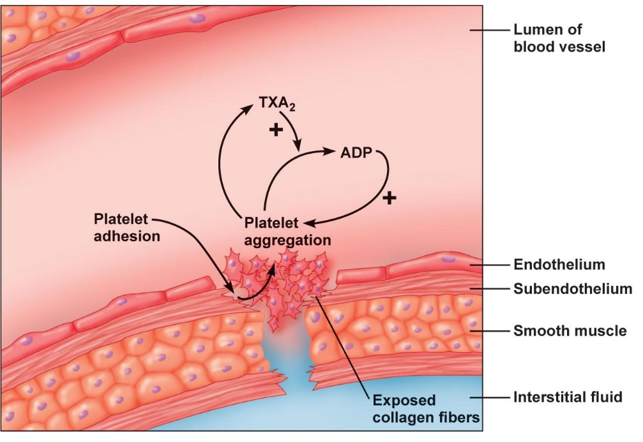
This limits the platelet plug and blood clot to the location where the endothelium has been damaged.
Undamaged endothelial cells secrete prostacyclin and nitric oxide which inhibit platelet aggregation.
TXA₂ also stimulates constriction of the blood vessel which helps to minimize blood loss.
(From Principles of Human Physiology, Third Edition by Stanfield and Germann)

The table in question 25 compares positive and negative feedback. If your students would benefit from additional scaffolding, you can give them these suggested responses to insert in the appropriate blanks: close to a set point / rapid change / reverses / same

Question 26 provides a brief test of student understanding of the difference between negative and positive feedback. After question 26, you may want to add this question.

27. What would go wrong if your body used positive feedback to regulate body temperature? For example, what would happen if a person shivered when temperature increased?

With respect to question 27, the term feedback is appropriate since, in both cases, an initial change in a variable stimulates a response in the same variable. Negative feedback reverses the direction or sign of the change, while positive feedback augments the initial change.

To review this material, you may want to show the ~6-minute video, “Homeostasis and Negative/Positive Feedback” (https://www.youtube.com/watch?v=Iz0Q9nTZCw4).

Physiological Reactions to Blood Vessel Injury (including Clot Formation)

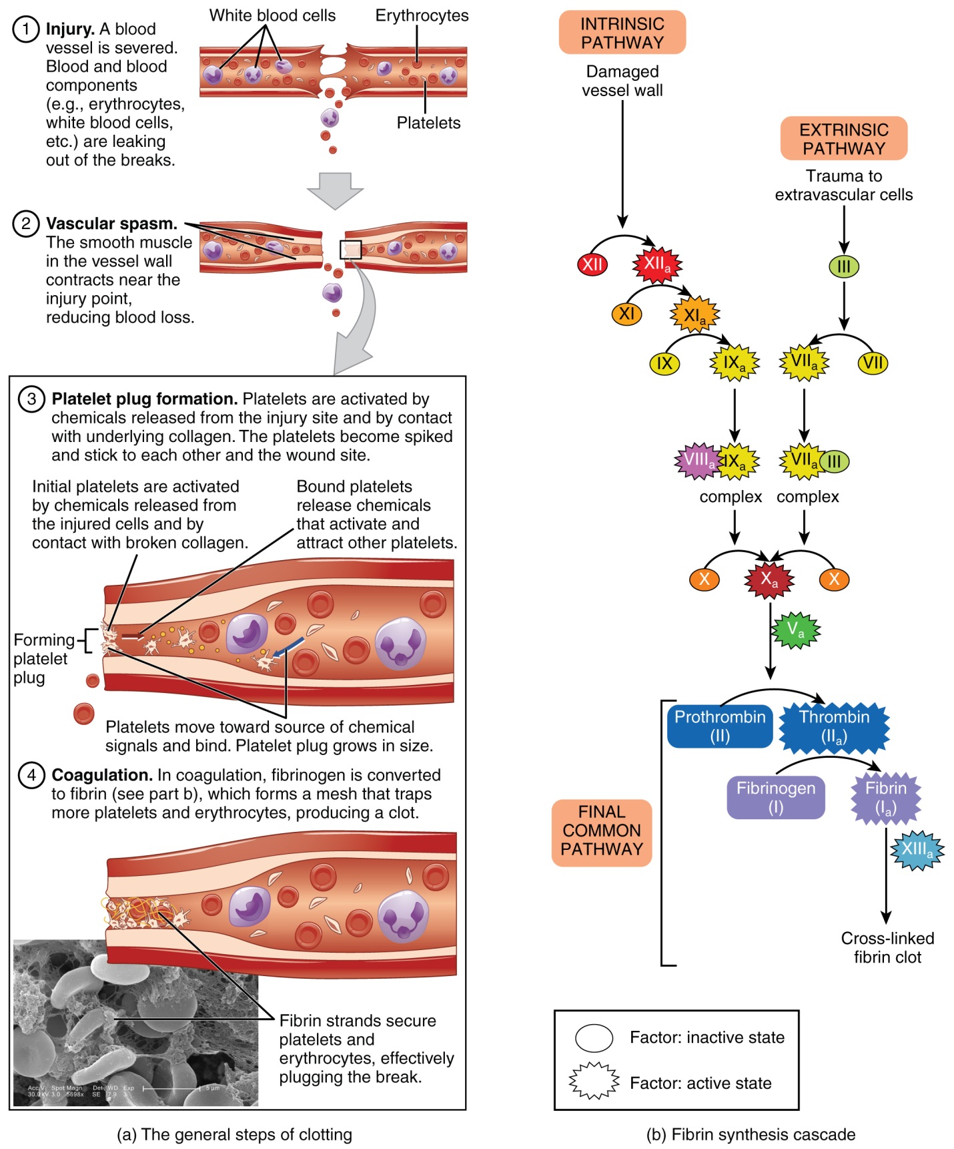

(http://philschatz.com/anatomy-book/resources/1909_Blood_Clotting.jpg)

Appendix – Investigating a Hypothesis or Question Concerning Negative Feedback, Homeostasis and Changes in Breathing

A Student Handout for this optional investigation is shown on page 23. In accord with NGSS, students engage in these additional recommended Science Practices:
- “Asking Questions – Ask questions that arise from examining models or a theory, to clarify and/or seek additional information and relationships."
- “Planning and Carrying out Investigations – Plan and conduct an investigation individually and collaboratively to produce data to serve as the basis for evidence…: decide on types, how much, and accuracy of data needed to produce reliable measurements and consider limitations on precision of the data (e.g., number of trials, cost, risk, time), and refine the design accordingly.”

Section A below provides some general suggestions for helping students improve their experimental design and methods. Sections B-E suggest several topics that student groups may want to explore and provide some methodological advice and required supplies for each topic.

A. Helping Students to Improve Experimental Design and Methods
As you introduce this optional activity, you may want to have a discussion about basic methodological points such as:
- the importance of changing only the variable the students are testing, while controlling other variables in their experimental design
- the importance of replication (e.g., having each member of the group participate as a subject)
- the importance of standardizing their experimental methods, including their methods for evaluating changes in breathing.

Students should understand that scientists need to develop reliable and valid methods of measurement in order to produce scientifically useful information. Reliable methods produce the same, consistent results on different repetitions of the same experiment. Valid methods produce results that accurately reflect the variable the scientist is trying to measure. The development of reliable and valid methods is a major component of scientific research. One suggested approach to developing reliable and valid methods is given in “Developing Quantitative Methods for Evaluating Rate and Depth of Breathing” (pages 24-25).

We have found it useful to check that each data sheet (question 2a in the Student Handout on page 23) corresponds to the student group’s experimental design and clearly specifies what observations will be recorded.

B. Changes in Blood Levels of O₂ vs. CO₂
The experiment described on page 1 of the main Student Handout demonstrates the importance of increased CO₂ and/or decreased O₂ in stimulating increased breathing to maintain homeostasis. However, this experiment does not allow us to distinguish the relative importance of changes in levels of CO₂ vs. O₂. To investigate this question, students can use the same general experimental design, with a comparison between the effects of decreased O₂ combined with increased CO₂ (using a bag with no KOH) vs. the effects of decreased O₂ with relatively little increase in CO₂ (using a bag that contains KOH). Since this experiment will require more accurate quantitative methods to assess breathing rate and depth, students should begin with “Developing Quantitative Methods for Evaluating Rate and Depth of Breathing” (pages 24-25). You may also want to give your students the following instructions.

Repeat the experiment described on page 1 of the Student Handout as originally described vs. while breathing into a plastic bag that has KOH to absorb CO₂. Be very cautious in handling KOH since it is caustic. Use gloves and avoid inhalation of KOH fumes. Also, safe disposal procedures should be observed (https://pubchem.ncbi.nlm.nih.gov/compound/potassium_hydroxide). To prepare the bag with KOH:
– Put a piece of filter paper in the bottom of a finger bowl, and use a spatula to put approximately 6-7 pieces of KOH in the finger bowl.
– Moisten the filter paper with a few scattered drops of water (KOH has to be moist in order to absorb CO₂).
– Cut a piece of cheesecloth a few layers thick and big enough to surround the finger bowl; use a rubber band to close the cheesecloth over the finger bowl.
– Place the finger bowl in an 8-gallon plastic bag which has been filled with air.

Under most circumstances, breathing is regulated primarily by the concentration of CO₂ in arterial blood and the associated changes in pH. However, results of this experiment may vary for different subjects (and even for the same subject in repeated trials). One reason for this variation is that breathing is highly subject to voluntary control. Trends may differ because of distractions in the environment, emotional influences, or other types of brain activity that may influence breathing. This is one reason why multiple subjects should be included in the experiment. | (https://media.cheggcdn.com/study/854/85418484-9928-41d1-885f-0570a6141783/image.png)

C. Changes in Breathing Rate vs. Depth
When a subject is re-breathing the air in a bag, is there more change in breathing rate or in depth of breathing, or do both show a similar change? Results may vary, but in our experience, most subjects who breathe into a bag show a clear trend to increased depth of breathing, while changes in the rate of breathing are inconsistent both within and between subjects. These observations are in accord with scientific research results which show that increased CO₂ is associated with more consistent increases in depth of breathing and smaller, inconsistent increases in rate of breathing. An example of greater changes in depth of breathing than in rate of breathing is shown in the figure below, which presents results for one subject who was re-breathing the air in a “grocery produce bag”.
(https://www.physiology.org/doi/abs/10.1152/advan.00030.2015?url_ver=Z39.88-2003&rfr_id=ori%3Arid%3Acrossref.org&rfr_dat=cr_pub%3Dpubmed

You may want to relate these findings to the observation that deeper breathing is more efficient than rapid breathing for increasing intake of O₂ and exhalation of CO₂. To understand the reason why, consider what happens when you begin to inhale. The first air to enter the air sacs in the lungs is air that was just exhaled into the bronchi, trachea, pharynx, mouth and nose (the anatomical dead space described in the figure below). A very shallow breath will bring only this recently exhaled air into the air sacs. This recently exhaled air has low O₂ and high CO₂. A deeper breath will bring proportionately more fresh air with high O₂ and low CO₂ into the air sacs; this will increase diffusion of O₂ into the blood and diffusion of CO₂ out of the blood.
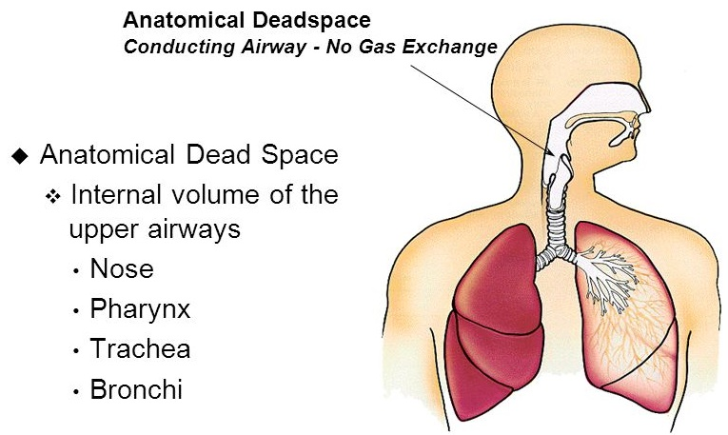
(https://slideplayer.com/slide/8417180/26/images/28/Anatomical+Dead+Space+Anatomical+Dead+Space.jpg)

This experiment will require quantitative methods, so students should begin with “Developing Quantitative Methods for Evaluating Rate and Depth of Breathing” (pages 24-25).

D. Holding Your Breath
Humans have considerable voluntary control over their breathing, as evidenced when you hold your breath, talk, sing, or play a wind instrument. We can temporarily override the negative feedback regulation of blood levels of O₂ and CO₂, but if O₂ gets too low and/or CO₂ gets too high a person will involuntarily start to breathe, thus restoring homeostasis.

To explore the contribution of negative feedback regulation of blood levels of O₂ and CO₂ to the maximum time a person is able to hold his or her breath, students can measure the maximum duration of breath-holding after breathing room air vs. after breathing into the bag (as in the experiment on page 1 of the main Student Handout). To get reliable data on duration of breath-holding:
- Each subject should take a deep breath, keep his or her mouth closed and hold his or her nose, avoid even minor diaphragm contractions, and focus on holding his or her breath as long as possible. (Note: To maximize the probability of seeing a difference, the deep breath should be from room air vs. from the bag of re-breathed air after four minutes of re-breathing of the air in the bag.)
- For each experimental condition, it is best to use the average of three breath-holding times separated by 10-minute intervals.
You may also want to encourage students to notice the characteristics of their breathing immediately after they have held their breath as long as they can.

Additional suggestions for student experiments are available in “The ins and outs of breath-holding: simple demonstrations of complex respiratory physiology” (https://www.physiology.org/doi/abs/10.1152/advan.00030.2015?url_ver=Z39.88-2003&rfr_id=ori%3Arid%3Acrossref.org&rfr_dat=cr_pub%3Dpubmed). One caution concerns their suggestion to assess the effects of hyperventilation on duration of subsequent breath-holding; there is a risk of losing consciousness if a person hyperventilates a lot before breath-holding. Fortunately, it is practically impossible to hold your breath until unconsciousness after normal breathing.

To facilitate student interpretation of their results, you may want to ask the following question.
Negative feedback regulation of blood levels of CO₂ and O₂ is not the only factor that influences the rate and depth of breathing. As you know, you also have voluntary control of your breathing. Use the example of holding your breath to illustrate how voluntary control can override negative feedback for a while, and then negative feedback can override voluntary control.

E. Physical Activity
Through personal experience, students will be familiar with increased breathing rate and depth during strenuous exercise. Students are often tempted to suggest experiments that will simply replicate this phenomenon, which is already well known to them. Scientists do need to replicate previous findings to ensure their reliability, but the observation that rate and depth of breathing increase during and immediately after vigorous physical activity is already well-established. Therefore, we suggest that you encourage students to develop an experiment that can expand their understanding beyond what they already know and provide new information about changes in breathing due to exercise. Appropriate questions might include:
- Is the change in breathing greater for aerobic exercise (e.g. jogging in place) vs. strength training (e.g. using resistance bands) or yoga?
- Does breathing rate double if a person exercises twice as fast (e.g. doubling the number of jumping jacks in a minute) or twice as hard (e.g. two resistance bands instead of one for strength training exercise)?
- How long does it take for breathing rate and/or depth to return to resting levels after different types and durations of exercise?

Feasible methods for measuring breathing rate and depth generally do not work well when a person’s head is moving, so students will probably need to compare breathing rate and depth before each subject begins exercising vs. breathing rate and depth right after the end of exercise and at intervals during recovery. The following paragraphs suggest two possible ways that your students can measure rate and depth of breathing before and after exercise. Alternatively, each student can assess his or her own breathing rate and depth before and after exercise. (If you develop any improvement for either of the methods described below or a good alternative method for measuring the rate and depth of breathing, please let me know (iwaldron@upenn.edu). Thank you!)

One low-tech, effective method for detecting each breath uses a small piece of facial tissue taped to the subject's nose so the tissue hangs over the edge of one nostril (see figures below). A piece of tissue the shape and size shown works well for measuring breathing rate and can provide useful information about depth of breathing under some circumstances. This method only works if you keep your mouth closed and breathe through your nose. Groups which are using this method will need a pair of scissors, a facial tissue, and a length of sensitive skin medical tape.

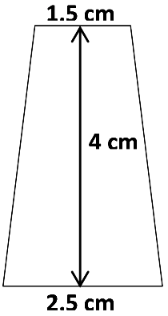
Five Templates for “Breath Detectors” to use in Exercise Experiments

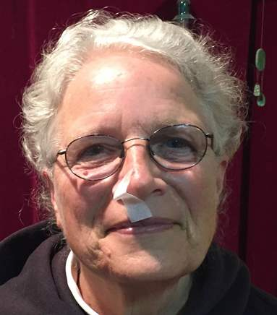  Inhalation | 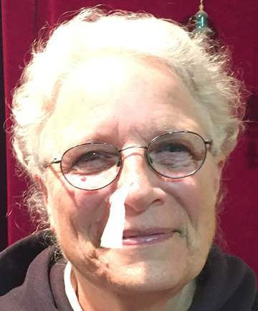  Exhalation

An alternative method for measuring breathing rate and depth is to use a 2-inch length of ¾ inch PVC pipe with a metallic streamer taped so that it flops over one edge. (PVC pipe diameter refers to the internal diameter, not the external diameter.) We have used a metallic streamer ~¼ inch wide, with a total length of ~3 ¾ inches; we obtained the streamers from a "foil fringe garland" purchased at a party store.  To prepare the 2 inch lengths of PVC pipe, we first used a hack saw to cut the needed number of pieces of pipe and then smoothed the edges of the ends using an X-Acto knife or a single-edge razor blade in a holder. For sanitary reasons, you will need one piece of pipe for each student in your largest class.  To disinfect the pieces of pipe for use in another class, we recommend the following procedure: | 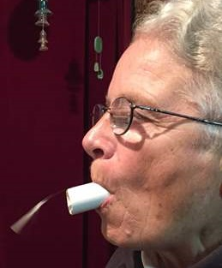  Exhalation
- Wash your hands with soap and water for at least 30 seconds. Rinse and then dry with a paper towel.
- Remove the streamers and tape and scrub the inside and outside of each PVC tube using a brush or pipe cleaner and soap and water until the tube is clean.
- Shake extra water off the tubes. Soak the tubes in 70% isopropyl alcohol for 5 minutes or in bleach (5 mL of 6% bleach in 8 ounces of water) for 3 minutes or microwave the tubes for 5 minutes.
- Rinse the tubes. Place the tubes on a clean surface to dry.
- Be sure to wash your hands with soap and water for at least 30 seconds before handling the dry tubes to store them in a plastic bag.

Any student who has been excused from physical education may need to be excused from participating as a subject in the investigation of physical activity and breathing. You may want a student with asthma to keep his/her inhaler close at hand for use if needed. Students should be advised to wear appropriate clothing and footwear for physical activity.

Students will probably notice that the heart beats faster and stronger during exercise. During exercise the total amount of blood pumped per minute can increase as much as fourfold in an untrained person and eightfold in a trained athlete. Most of the increase in amount of blood pumped per minute goes to the active muscles; at rest ~20% of blood flow goes to skeletal muscles, whereas during vigorous exercise ~90% of blood flow goes to skeletal muscles. You may want to link student observations of faster and stronger heartbeats to the discussion (on page 5 of the Student Handout) concerning how the respiratory and circulatory systems cooperate to provide the O₂ needed for cellular respiration and remove the CO₂ produced by cellular respiration.

Student Handout
Investigating a Hypothesis or Question concerning Negative Feedback, Homeostasis, and Changes in Breathing
Answer the questions in this handout on a separate page or pages.

You will design and carry out an experiment and analyze the results to test a hypothesis or answer a question about changes in breathing that are influenced by negative feedback and/or contribute to homeostasis.

1a. Write a hypothesis or question that you will be able to investigate in your classroom.

1b. Develop a plan for an experiment to test your hypothesis or answer your question. Your teacher can recommend a method for measuring the rate and/or depth of breathing in your experiment. Describe the procedure for your experiment. Be specific about the sequence of steps in your procedure, including:
- what you want your subjects to do
- when and how you will measure breathing.

1c. Your teacher will review your group’s hypothesis or question and your plan for your experiment. Make any improvements recommended by your teacher.

2a. Make a data sheet for collecting your data.

2b. Plan how you will analyze your group’s data. Your plan should include some way to summarize your results in a table and/or graph that will help you to test your hypothesis or answer your question. If you will be making graphs, decide what type of graph you will prepare and what variables will be included.

2c. Your teacher will review your data sheet and your plan for analyzing your data. Make any improvements recommended by your teacher.

3a. Before you begin your experiment, practice your method for measuring the rate and/or depth of breathing until your method is reliable and valid. (Reliable methods produce the same, consistent results on different repetitions of the same experiment. Valid methods produce results that accurately reflect the variable you are trying to measure.)

3b. Carry out the experiment for each subject in your group, and record your data in your data sheet.

3c. Analyze your data.

4. Prepare a brief report that includes:
- your hypothesis or question
- a summary of your methods
- your graph, table or other summary of your data
- your interpretations of your data and conclusions concerning your hypothesis or question
- an interpretation of your results using the concept of homeostasis
- an evaluation of the strengths and weaknesses of your experimental methods and design.
Student Handout
Developing Quantitative Methods for Evaluating Rate and Depth of Breathing

For a scientific investigation to yield accurate results, scientists need to begin by developing reliable and valid methods for measuring the variables in the investigation. The following procedure will help you to develop reliable and valid procedures for collecting quantitative data on breathing rate and depth to test your hypothesis or answer your question.

- You will work in a group of four students.

- To evaluate the rate and depth of breathing, watch how a crease in the bag changes as the person breathes in and out. If feasible for your experiment, both the subject and the observers should stand to make it easier to observe breathing rate and depth.

- Practice evaluating the rate of breathing. One person in your group should breathe into his or her bag for 30 seconds, while another person times the 30-second interval. The other two people in your group should count the number of breaths. Record your count before you say the number out loud. ______ If your results are not in agreement (difference of more than one breath):
  - Discuss possible reasons for the differences and procedures that could improve your accuracy (e.g. having less or more air in the bag).
  - Try again.
Next, switch roles to have a new subject and timer and two new observers.

- Practice evaluating the depth of breathing (how much air a person breathes in and out in each breath). One of you should breathe into your bag for 4 minutes while another person times 30-second intervals. The other two people in your group should use the following rating system to record the depth of breathing in each 30-second interval:
- Start with 1 for the depth of breathing in the first 30-second interval.
- If the depth of breathing doesn't change significantly from one interval to the next, use the same number for depth of breathing in both intervals.
- For any interval where you observe an increase in depth of breathing compared to the previous interval, increase your number by 1.
- For any interval where you observe a decrease in depth of breathing, decrease your number by 1.

Time Interval (minutes:seconds) | 0:00-0:30 | 0:30-1:00 | 1:00-1:30 | 1:30-2:00 | 2:00-2:30 | 2:30-3:00 | 3:00-3:30 | 3:30-4:00
Rating for depth of breathing | 1

Record your results without commenting to each other. Then, compare your results, discuss the criteria you used, and try to agree on reliable procedures for rating the depth of breathing.

Next, switch roles to have a new subject and timer and two new observers. If both observers have similar results, summarize your procedures for rating the depth of breathing. If your results differ significantly, improve your procedures and try again.

How to Use Your Quantitative Methods in Your Experiment
Carry out your experiment once for each experimental subject in your group. Each subject will breathe into the bag for 4 minutes (or 3½ minutes if he or she starts to feel too uncomfortable and can't continue for the full 4 minutes). For each experimental subject, the other three people in the group will be experimenters 1-3.
- Experimenter 1 will time each 30 sec. interval.
- Experimenter 2 will count and record the number of breaths in each 30 sec. interval.
- Experimenter 3 will observe and record the depth of breathing during each 30 sec. interval.

Analyzing and Interpreting the Results of an Experiment
Suppose that Subjects 1-3 in a group re-breathed the air in their bags for 4 minutes each, but Subject 4 breathed into his/her bag for only 3 minutes and 30 seconds. This table shows the
results for the last two 30 sec. intervals. In both of these intervals, the average number of breaths was 9, so the group concluded that the breathing rate did not increase in the last interval. Explain why this conclusion is not valid. | Time Interval  (minutes: seconds) | Number of Breaths in 30 sec.  Interval for Subject:
 |  | 1 | 2 | 3 | 4 | Ave
 | 3:00-3:30 | 8 | 8 | 8 | 12 | 9
 | 3:30-4:00 | 9 | 9 | 9 | X | 9

Describe a data analysis strategy you could use to avoid this type of misleading comparison.

By Drs. Ingrid Waldron, Lori Spindler and Jennifer Doherty, Dept Biology, University of Pennsylvania, © 2023. We are grateful to Philadelphia area teachers for helpful input to improve this activity. These Teacher Preparation Notes and the related Student Handout are available at https://serendipstudio.org/sci_edu/waldron/#breath.
Quotes from Next Generation Science Standards, available at https://www.nextgenscience.org/get-to-know.
A second demo video which shows prolonged breathing into the bag is available at https://www.youtube.com/watch?v=UjzBRiX1Jpc&feature=youtu.be.
If students inquire why a person needs lungs instead of using his/her skin as a gas exchange surface, you can explain that gas exchange surfaces must be moist and also the total surface area of the alveoli is much greater than the surface area of the skin (50 m² vs 2 m²). Frogs can use their skin as a major gas exchange surface because they live in damp environments and they need less gas exchange due to their lower metabolic rate.
Information about lactic acid production and energy metabolism during exercise is presented in the analysis and discussion activity, "How do muscles get the energy they need for athletic activity?" (available at http://serendipstudio.org/exchange/bioactivities/energyathlete).
See https://emedicine.medscape.com/article/926249-overview#a3 for additional physiological mechanisms for the damage caused by frostbite.
Heat exhaustion may result if a person exercises vigorously when the weather is very hot and humid; hot, humid weather decreases the body's ability to get rid of excess heat, due to reduced radiation of heat from the body and sweat dripping from the body without evaporating. Fluid loss through sweating, together with peripheral vasodilation to facilitate heat loss, can result in reduced blood pressure and heat exhaustion. Heat exhaustion can be protective if it prevents continued exertion when the body is unable to give off enough heat. If excessive exertion continues in a hot and humid environment, this can result in heat stroke and even death. Escalating body temperature can result if the body stops sweating to conserve fluids and the cardiovascular system directs blood away from the body surface in order to maintain needed blood flow to the brain and other vital body organs. If internal core temperature reaches 106°F (41°C) most people suffer convulsions, and if internal core temperature exceeds 110°F (43.3°C) neuron malfunction and irreversible damage to proteins are likely to prove fatal. Additional information is available in "Heat and exercise: Keeping cool in hot weather" (http://www.mayoclinic.com/health/exercise/HQ00316).
In mammals, negative feedback regulation maintains a relatively high body temperature which allows mammals to move rapidly even when environmental temperatures are low. This type of thermoregulation depends on a relatively high metabolic rate which requires a high caloric intake. Mammals and birds are homeotherms, in contrast with most other types of animals which are poikilotherms (core body temperature generally varies with the environmental temperature, although some poikilotherms use behaviors like moving into or out of the shade to increase or decrease body temperature).
Throughout this activity we have used heat as a more familiar, although somewhat inaccurate, term for thermal energy. "Thermal energy refers to the energy contained within a system that is responsible for its temperature. Heat is the flow of thermal energy." (https://www.khanacademy.org/science/physics/work-and-energy/work-and-energy-tutorial/a/what-is-thermal-energy) Heat is "energy that is transferred from one body to another as the result of a difference in temperature" (https://www.britannica.com/science/heat). Thus, throughout the Student Handout and Teacher Preparation Notes, it would be more accurate to substitute "thermal energy" for the term "heat".
Figure of a man with black eyes from https://i.ytimg.com/vi/0vfFDJ_4jyM/mqdefault.jpg
For an excellent discussion of homeostasis and negative feedback, see "A Physiologist’s View of Homeostasis" (https://physiology.org/doi/full/10.1152/advan.00107.2015).
Students may ask about goose bumps when a person is cold. In other mammals with dense fur this response traps a layer of air that helps to insulate the skin surface from the environment and thus reduces heat loss. In humans, this response is ineffective because the hair on our skin is not thick enough to trap an insulating layer of air.
It is important to note that regulation of building temperature is not a good model for regulation of body temperature. Regulation of building temperature typically turns a heater or air conditioner on and off. In contrast, regulation of body temperature involves much more continuous and graded responses.
The same chemical signal also triggers a tired, achy feeling so you want to rest, which helps your body mobilize resources to fight the infection.
"Brain damage from a fever generally will not occur unless the fever is over 107.6°F (42°C). Untreated fevers caused by infection will seldom go over 105°F (40.6°C) unless the child is overdressed or in a hot place." (https://medlineplus.gov/ency/article/003090.htm) However, a fever may indicate a serious infection that should be treated medically.
Another example of positive feedback occurs during childbirth (see https://bio.libretexts.org/Bookshelves/Introductory_and_General_Biology/Book%3A_General_Biology_(Boundless)/33%3A_The_Animal_Body-_Basic_Form_and_Function/33.12%3A_Homeostasis_-_Control_of_Homeostasis). This positive feedback helps to speed up the transition from a fetus in the uterus receiving oxygen via the placenta to a baby that has been born and is breathing on his or her own. Of course, positive feedback is not the only way that the body achieves rapid change; for example, neural control of muscles or secretory organs can also produce rapid responses.
Quotation from Next Generation Science Standards, available at https://www.nextgenscience.org/get-to-know
This same research (e.g. Journal of Applied Physiology 47:192-6) has found breathing rates of 16-20 breaths/min. for adults breathing room air at rest (vs.12 breaths/min. generally reported in textbooks and on the web).
You may want to have available resistance bands and/or instructions for and pictures of yoga poses in case students want to include exercise of this type in their experiment.
To calculate valid averages for the number of breaths and depth of breathing, a student group may need to account for the methodological issues that arise if one or more subjects fail to complete the entire four minutes of breathing into the bag. This can lead to erroneous conclusions unless the students adopt one or some combination of the following approaches. - Use only the data for the 30-second intervals when all subjects were breathing into the bag. - Calculate averages for only the subjects who completed all four minutes of breathing into the bag. The best approach will depend on the specific pattern of how many subjects stopped breathing into the bag early and when they stopped. This footnote should be omitted from the "Developing Quantitative Methods for Evaluating Rate and Depth of Breathing" student handout.

