Teacher Preparation Notes for
“Were the babies switched? – The Genetics of Blood Types and Skin Color”

In this minds-on, hands-on activity, students learn about the genetics of ABO blood types, including multiple alleles of a single gene and codominance. Then, students use chemicals to simulate blood type tests and carry out genetic analyses to determine whether hospital staff accidentally switched two babies born on the same day. Next, students analyze the genetics of skin color in order to understand how fraternal twins can have different skin colors. In this analysis, students learn about incomplete dominance and how a single phenotypic characteristic can be influenced by multiple genes and the environment.

As background for this activity, students should have a basic understanding of:
- dominant and recessive alleles (heterozygous individuals have the same phenotype as homozygous dominant individuals)
- how Punnett squares summarize inheritance.
To provide this background you may want to use the first four pages of “Introduction to Genetics – Similarities and Differences between Family Members” (https://serendipstudio.org/exchange/bioactivities/geneticsFR) or the first 2.5 pages of "Genetics" (https://serendipstudio.org/sci_edu/waldron/#genetics).

Table of Contents
Learning Goals – pages 1-2
Supplies, Suggestions for Implementation, and Preparation – pages 2-5
General Instructional Suggestions – page 5
Biology Background and Suggestions for Discussion
How could blood type tests help to determine the true parents of each baby girl? – pp 6-8
Why do blood types matter? – pages 8-9
Testing Blood Types – Procedure, Results and Interpretation – page 9
Why do the twins look so different? – pages 9-12
Additional Genetics Learning Activities – page 12

Learning Goals Related to National Standards
In accord with the Next Generation Science Standards and A Framework for K-12 Science Education:
      - Students will gain understanding of two Disciplinary Core Ideas:
- LS1.A: Structure and Function –"All cells contain genetic information in the form of DNA molecules. Genes are regions in the DNA that contain the instructions that code for the formation of proteins."
- LS3.A: Inheritance of Traits – "The instructions for forming species' characteristics are carried in DNA."
- Students will engage in two Scientific Practices:
- Constructing Explanations. “Apply scientific ideas, principles, and/or evidence to provide an explanation of phenomena…”
- Analyzing and Interpreting Data. “Analyze data using tools, technologies, and/or models (e.g. computational, mathematical) in order to make valid and reliable scientific claims…”
- This activity provides the opportunity to discuss the Crosscutting Concept, Structure and Function. “Cause and effect relationships can be suggested and predicted for complex natural and human designed systems by examining what is known about smaller scale mechanisms within the system."
- This activity helps to prepare students for the Performance Expectation, HS-LS3-1, "Ask questions to clarify relationships about the role of DNA and chromosomes in coding the instructions for characteristic traits passed from parents to offspring."

Additional Content Learning Goals
- Each person has one of the four blood types: A, B, AB, and O. These blood types refer to the presence or absence of two different versions of a carbohydrate molecule (A and/or B) on the surface of red blood cells.
- Genes code for proteins which influence a person's characteristics. The ABO blood type gene codes for a protein enzyme that can attach a carbohydrate molecule to the surface of red blood cells. This gene has three alleles: the E^{A} allele codes for a version of the enzyme that attaches the type A carbohydrate; the E^{B} allele codes for a version of the enzyme that attaches the type B carbohydrate; and the e allele codes for an inactive protein that does not attach either carbohydrate.
- Each person inherits one allele of this gene from his/her mother and a second allele from his/her father. In the cells that are precursors of red blood cells, both inherited alleles provide the instructions for making proteins.
- In a person who has the E^{A}E^{B} genotype, both alleles are transcribed, so the cells produce both the version of the enzyme that puts type A carbohydrates on the surface of red blood cells and the version of the enzyme that puts type B carbohydrates on the surface of red blood cells. Therefore, the person has type AB blood. This is an example of codominance, in which two alleles of a gene each have a different observable effect on the phenotype of the heterozygous individual.
- In a heterozygous person with the E^{A}e or E^{B}e genotype, the single copy of the E^{A} or E^{B} allele in each cell codes for enough enzyme to result in type A or type B blood, respectively. Thus, the e allele is recessive relative to the E^{A} or E^{B} alleles.
- In incomplete dominance, the phenotype of a heterozygous individual is intermediate between the phenotypes of the two different types of homozygous individuals (observed for quantitative traits such as skin color).
- Many characteristics are influenced by multiple genes and environmental factors.

Supplies, Suggestions for Implementation, and Preparation
Note: Throughout this section we will refer to the seven people listed in the table on the next page as the subjects.

Supplies
(See pages 3-5 for information about the needed amounts and types of the first three items.)
- Synthetic blood
- Solutions with synthetic anti-A antibodies and anti-B antibodies
- Small dropper bottles (can be reused in multiple classes)
- Non-porous testing surfaces suitable for mixing samples of blood with antibody solution, e.g. blood-typing trays, microscope slides or white or transparent plastic lids (can be washed and reused in multiple classes); each student group will need a testing surface large enough for 14 tests (two tests each for seven subjects) or several smaller testing surfaces.
- One marker for each student group to identify the 14 specific spots to test for the type A antigen and for the type B antigen for each subject.
- Toothpicks for mixing blood and antibody solution (Each student group will need 14 toothpicks, or they can use both ends of 7 toothpicks.)
- One trash container for each student group (e.g. a cup or bottle), so the students can throw away their toothpicks immediately after use in order to avoid contamination

To determine the required amount of synthetic blood and antibodies, you will need to decide what blood types you will assign to each subject. You may want to vary the blood types for each subject in different classes, in order to maintain some variety and suspense. Each column of this table presents a possible combination of blood types for each subject.

Examples of Blood Type Combinations You Can Use
 | 1 | 2 | 3 | 4 | 5 | 6 | 7 | 8 | 9 | 10
Danielle  (mother of twins) | AB | AB | AB | AB | O | A | B | AB | A | A
Michael  (father of twins) | O | A | B | AB | AB | AB | AB | AB | O | A
Emily  (mother of daughter) | A | A | A | A | B | B | B | B | A | A
Earnest  (father of daughter) | B | B | B | B | A | A | A | A | A | A
Michael Jr.  (boy twin) | A | A | A | A | B | B | B | B | A | A
Baby girl 1  (girl twin, according to hospital) | B | B | B | B | A | A | A | A | O | O
Baby girl 2  (daughter of Emily and Earnest, according to hospital) | O | O | O | O | O | O | O | O | B | B

You can make other combinations, provided that:
- Michael Jr. could be the son of Danielle and Michael
- Baby girl 1 could be the daughter of Danielle and Michael. Baby girl 2 could be the daughter of Emily and Ernest. One of these baby girls could not be the daughter of the other couple.

Option 1. Colored milk as the simulated blood + water or vinegar as the simulated antibody solutions:
You can make simulated blood by combining 25 mL of milk with red food coloring until the solution is bright red (about 15 drops), and then adding a drop of green food coloring for a dark red color. You will need different anti-A and anti-B simulated solutions for each subject, depending on what blood type the sample is supposed to be.

Type of Blood | Simulated anti-A solution contains: | Simulated anti-B solution contains:
A | White vinegar | Water
B | Water | White vinegar
AB | White vinegar | White vinegar
O | Water | Water

We recommend that you set up seven stations, one for each of the seven subjects, with the blood sample and the anti-A and anti-B solutions. Before class you should prepare seven bottles with the simulated blood, labeled with the subject’s name or Baby girl 1 or 2. You will also need the corresponding bottles of simulated anti-A and anti-B solutions. We recommend that you label each bottle of anti-A and anti-B solution with the name of the subject which will help you keep track of which pair of antibody solutions goes with each subject.

You can use the various blood type combinations shown on the previous page. You can estimate amounts of simulated blood and antibody solution needed using the following information:
- For the blood type test for each person, you will need 6 drops of blood, 3 drops of anti-A antibody solution, and 3 drops of anti-B antibody solution.
- There are approximately 15-20 drops in each milliliter of solution.
You will want extra of each solution, in order to be prepared for student error such as using too many drops of blood or antibody solution.

Option 2. Commercial simulated blood and antibody solutions:
To determine the amount of synthetic blood, antibody solutions and dropper bottles that you will need, you should choose one of the following recommendations for implementation (or decide on your own approach).
- Give each student group at their lab table:
  - 7 bottles with the blood samples, each labeled with the name of one of the subjects, as listed in the table on the previous page
  - 1 bottle with the anti-A antibody solution and another bottle with the anti-B antibody solution (each labeled appropriately)
- Or you can set up three stations:
  - one where each student group will get the blood samples for each of the seven subjects
  - one where they will get the anti-A antibody solution
  - one where they will get the anti-B antibody solution.

Please note that the procedure on page 3 of the Student Handout is written for the colored milk simulated blood. If you are purchasing simulated blood, you may need to modify the procedure; for example, you can use only two drops each of simulated blood and simulated antibody solution.

You can purchase kits (and/or refills) from:
- Carolina (http://www.carolina.com/blood-typing/carolina-abo-rh-blood-typing-with-synthetic-blood-kit/FAM_700101.pr?question=700101) (We recommend you not use the Rh antiserum included in this kit.)
- Ward’s Science https://www.wardsci.com/store/product/10424340/simulated-abo-blood-typing-kit
These kits have additional supplies such as some dropper bottles and testing trays. You may want to contact these companies to verify that their kits have the blood types and quantities you will need. This table shows the amounts of antibody solution and blood type solution you will need per student group for each of the blood type combinations in the table on page 3.

Approximate Amount (mL) Needed of Each Type of Solution
for Each Student Group for Blood Type Combinations Listed on page 3
 | 1 | 2 | 3 | 4 | 5 | 6 | 7 | 8 | 9 | 10
Anti-A Antibody Solution | 1.5 | 1.5 | 1.5 | 1.5 | 1.5 | 1.5 | 1.5 | 1.5 | 1.5 | 1.5
Anti-B Antibody Solution | 1.5 | 1.5 | 1.5 | 1.5 | 1.5 | 1.5 | 1.5 | 1.5 | 1.5 | 1.5
A Blood | 0.6 | 0.8 | 0.6 | 0.6 | 0.6 | 0.8 | 0.6 | 0.6 | 1.1 | 1.4
B Blood | 0.6 | 0.6 | 0.8 | 0.6 | 0.6 | 0.6 | 0.8 | 0.6 | 0.3 | 0.3
AB Blood | 0.3 | 0.3 | 0.3 | 0.6 | 0.3 | 0.3 | 0.3 | 0.6 | 0.0 | 0.0
O Blood | 0.6 | 0.3 | 0.3 | 0.3 | 0.6 | 0.3 | 0.3 | 0.3 | 0.6 | 0.3

You will want more of each solution, in order to be prepared for student error such as using too many drops of blood or antibody solution.

General Instructional Suggestions
To maximize student learning, we recommend that you have your students complete groups of related questions in the Student Handout in pairs and then have a class discussion of student answers to each group of related questions. In each discussion, you can probe student thinking and help them to develop a sound understanding of the concepts and information covered before moving on to the next part of the activity.

In the Student Handout, numbers in bold indicate questions for the students to answer and
- indicates steps in the experimental procedure for the students to do.

You can use the Word document to make revisions that will make the Student Handout more suitable for your students. Please check the format in the PDF.

If you would like to have a key, please send your request to iwaldron@upenn.edu. The following paragraphs provide additional instructional suggestions and background information – some for inclusion in your class discussions and some to provide you with relevant background that may be useful for your understanding and/or for responding to student questions.

Biology Background and Instructional Suggestions
In the introductory section of the Student Handout, Danielle asks for blood type tests for the parents and babies to determine whether the baby girls were switched. Modern methods use DNA testing to determine biological relatedness; these results are much more definitive than testing blood types (http://en.wikipedia.org/wiki/Parental_testing).

How could blood type tests help to determine the true parents of each baby girl?

Question 1 is designed to get students thinking about how blood types are inherited and whether children can have a different blood type than their parents have. Student answers to question 1 will let you know what your students already know and alert you to any misconceptions they may have. Please do not try to give complete or accurate answers to these questions, but rather let these answers emerge as students work their way through pages 1-2 of the Student Handout.

Question 2 provides the opportunity to reinforce student understanding that genes code for proteins which influence an organism’s characteristics. The figure below shows that the A and B transferase enzymes add different monosaccharides to the end of an oligosaccharide that had previously been attached to a protein or lipid in the cell membrane. The Student Handout does not mention that other enzymes are needed to add each monosaccharide in the oligosaccharide.

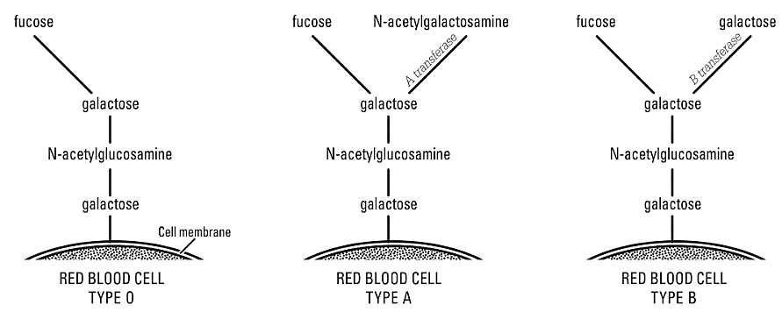
(From “ABO Blood Groups”, American Biology Teacher 77(8): 583-586, 2015; this article provides an excellent explanation of the molecular biology of ABO blood groups.)

The E^{A} allele codes for the A transferase enzyme, and the E^{B} allele codes for the B transferase enzyme. The e allele codes for an inactive protein. Thus, the three alleles of the gene for ABO blood types provide the instructions for making three versions of the protein enzyme that attaches the final monosaccharide to the oligosaccharide molecules on the outer surface of red blood cell membranes. This results in glycoproteins and glycolipids extending outward from the red blood cell membrane. (See figure below.)

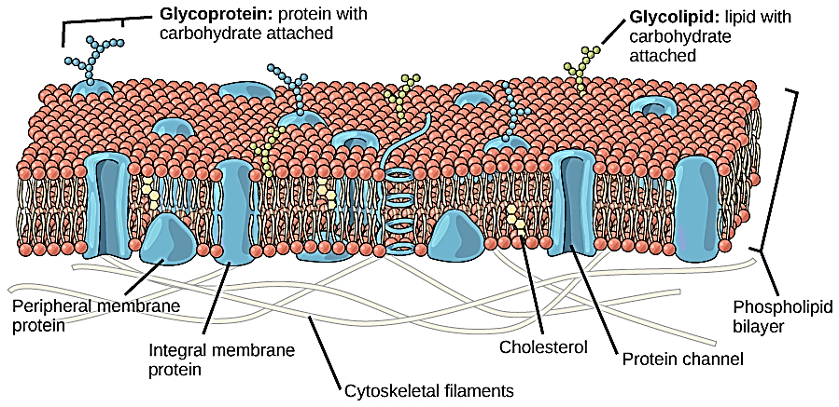
(https://cnx.org/resources/3a229fd6909a56722463c77805188a3f/Figure_05_01_01.jpg)

The function of the blood type carbohydrate molecules is unknown. In general, people who have Type O blood with neither Type A nor Type B carbohydrates are as healthy as people who have the Type A and/or Type B carbohydrates. Different blood types are correlated with certain illnesses and vary in frequency in different ethnic groups, but the reasons are unknown (https://www.webmd.com/a-to-z-guides/ss/slideshow-how-your-blood-type-affects-your-health).

Before question 3, you may want to ask your students to “Explain why a person with the ee genotype has blood type O.”

For a dominant-recessive pair of alleles, heterozygous individuals have the same phenotype as individuals who are homozygous for the dominant allele. You may also want to point out that recessive alleles often code for a nonfunctional protein. In a heterozygous individual, a single dominant allele can code for enough functional protein to result in the same phenotype as the phenotype of the homozygous dominant individual. For example, the e allele codes for a nonfunctional protein, and the e allele is recessive relative to the E^{A} or E^{B} alleles because, in a heterozygous individual, the single dominant E^{A} or E^{B} allele codes for enough functional enzyme to result in the same blood type as observed in a homozygous dominant individual.

Each cell in the body contains two copies of each gene and typically both alleles are transcribed. Thus, at the molecular level, the alleles of most genes are codominant. For example, the E^{A}E^{B} genotype results in the production of both the version of the enzyme that puts type A carbohydrate on red blood cells and the version of the enzyme that puts type B carbohydrate on red blood cells. Therefore, the E^{A}E^{B} genotype results in type AB blood.

As you discuss student answers to question 6, you will want to refer back to question 1. In addition, you may want to reinforce student understanding that:
- Meiosis and fertilization result in new combinations of alleles, so children may have different blood types (and other phenotypic characteristics) than their parents have.
- Transmission of genes via meiosis and fertilization result in similarities between offspring and parents.

Why do blood types matter?
This section introduces antigens and antibodies. An antigen is a molecule that can stimulate an immune response, including the production of antibodies. Antibodies help to protect our bodies against infection by helping to inactivate and destroy invading bacteria and viruses. As shown in this figure, some antibodies bind to the antigens on the surface of bacteria that have infected a person’s body. The other end of each antibody can bind to a protein on the surface of a type of phagocytic cell called a macrophage. This facilitates phagocytosis of the bacteria by the macrophage. The macrophage kills and digests the ingested bacteria. | (http://images.slideplayer.com/21/6239094/slides/slide_84.jpg)

Normally, your body does not make antibodies against any molecules that are part of your body. This is useful because antibodies against antigens that are part of your body can trigger harmful reactions. As would be expected, a person with type A blood does not make anti-A antibodies. However, a person with type A blood does make anti-B antibodies. The figure below shows the type of antibodies in the blood plasma for each blood type. These antibodies are believed to be induced by ubiquitous environmental antigens such as antigens on influenza viruses or gut bacteria.

(https://biology-forums.com/gallery/14755_01_10_12_7_59_21_9228594.jpeg)

The figure below shows what would happen if a person with type A blood were given a transfusion of type B blood. The anti-B antibodies in the recipient’s blood would cause the donated type B red blood cells to clump together and burst. This could block blood vessels and result in kidney failure and other health problems and symptoms (https://medlineplus.gov/ency/article/001306.htm).

This figure shows what would happen if a person with type A blood were given a transfusion of type B blood.
(https://biology-forums.com/gallery/14755_01_10_12_7_59_21_9228594.jpeg)

The most common type of transfusion includes just red blood cells without the liquid plasma which contains the antibodies.
- Type O red blood cells can be safely given to people with type A, B, AB or O blood, since type O red blood cells do not have either A or B antigens. (However, if a person with type O blood is Rh positive, his/her blood should not be given to anyone who is Rh negative because they may have anti-Rh antibodies in their blood.)
- People with type AB blood can safely receive transfusions of type A, B, AB or O red blood cells, since people with type AB blood do not have anti-A or anti-B antibodies in their blood. (However, if a person with type AB blood is Rh negative, he/she may produce anti-Rh antibodies, so he/she should not be given Rh positive blood.) The unique ability of people with type AB blood to safely receive transfusions of all four blood types illustrates codominance at the phenotypic level.

To prevent a transfusion reaction, medical personnel test whether a person's blood is compatible with the donated blood before they give a transfusion. The ABO blood types (and Rh-positive vs. negative) are the major determinants of which type of blood will cause a transfusion reaction. Determination of blood type compatibility is more complex than the ABO blood types discussed in this activity. For additional information on blood types, see:
- http://www.ncbi.nlm.nih.gov/books/NBK2264/.
- https://bio.libretexts.org/Bookshelves/Human_Biology/Book%3A_Human_Biology_(Wakim_and_Grewal)/17%3A_Cardiovascular_System/17.6%3A_Blood_Types
- https://www.britannica.com/science/ABO-blood-group-system

Testing Blood Types – Procedure, Results and Interpretation
For suggestions about implementation of the experimental procedure, see the “Supplies, Suggestions for Implementation, and Preparation” section on pages 2-5 of these Teacher Preparation Notes. The “Results” and “Interpretation” sections are straightforward if students have understood the previous sections and are familiar with Punnett squares.

Why do the twins look so different?
The bottom of page 4 of the Student Handout introduces the important distinction between identical (monozygotic) twins and fraternal (dizygotic) twins.

The top of page 6 of the Student Handout introduces a very simplified model of the genetic determination of skin color, with a single gene that illustrates incomplete dominance. The table below may be helpful for your class discussion of student answers to question 15.

Type of Dominance | Phenotype of Heterozygous Individual
Dominant-recessive pair of alleles | Same as phenotype of individual who is homozygous for the dominant allele
Codominance | Shows different observable phenotypic effects of both alleles; phenotype different from either homozygous individual
Incomplete dominance | Intermediate between phenotypes of the two types of homozygous individual (typically observed for quantitative traits); phenotype different from either homozygous individual
As you discuss question 15, you may want to ask students to give an example of each type of dominance.

The bottom of page 6 of the Student Handout develops a more realistic and complex model of the genetic factors that influence skin color. During your discussion of student answers to question 17, you will probably want to explain that the genotype/phenotype table at the top of the page and their Punnett square in response to question 16 provide a very simplified initial model of the genetics of skin color. A person with a Tt genotype could have lighter or darker skin, depending on whether he or she:
- has alleles for other genes that contribute to lighter or darker skin color
- has developed a tan due to sun exposure or tanning booth use.
Similarly, two people with a TT genotype (or a tt genotype) could have different skin colors, depending on the alleles of the other genes that influence skin color and the amount of UV exposure. You will probably want to explain that scientists often begin with a simple model of a phenomenon, which is superseded by a more complex model as the scientists learn more.

You may want to show your students this Punnett square and compare it to the Punnett square in their answers to question 16. Even this relatively complex Punnett square is a simplified representation of reality, since it assumes an additive model with only two alleles for each gene and incomplete dominance for all of the alleles. | 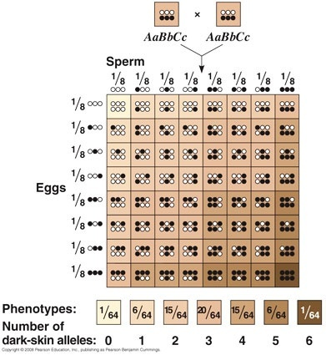  (https://www.quora.com/How-is-skin-color-determined-in-babies )

One gene that influences skin color codes for the enzyme tyrosinase, which is a crucial enzyme involved in the synthesis of melanin, the primary pigment in skin and hair. The normal allele of this gene codes for functional tyrosinase; other alleles code for defective, non-functional versions of this enzyme, which result in albinism. The alleles for albinism are recessive because, even when there is only one copy of the normal allele, this allele codes for enough functioning enzyme to produce enough melanin to result in normal skin and hair color.

Another important gene that influences skin color is the MC1R gene which codes for the melanocortin receptor. When alpha melanocyte stimulating hormone binds to the melanocortin receptor, different versions of the MC1R receptor protein influence the amount and type of melanin produced. More than 80 alleles of the MC1R gene have been identified, resulting in varied functioning of the melanocortin receptor and corresponding variation in skin tones. Heterozygotes for these alleles have intermediate skin color, between the lighter and darker homozygotes (called incomplete dominance or a dosage effect). The multiple alleles and the effects of incomplete dominance result in multiple different phenotypes for skin color (and hair color). Additional information on this gene is available at https://ghr.nlm.nih.gov/gene/MC1R.

Recent research indicates that the genetic control of skin color is very complex. There are multiple genes that code for proteins that directly or indirectly influence skin color. It appears that the activity of these genes is regulated by hundreds of variants in non-coding parts of the DNA (https://www.nature.com/articles/s41588-023-01626-1).

Additional information on the complex genetics and molecular biology involved in regulation of skin color is available at:
- https://www.jbc.org/article/S0021-9258(20)58649-3/fulltext
- https://academic.oup.com/hmg/article/18/R1/R9/2901093 and
- https://penntoday.upenn.edu/news/molecular-look-mechanisms-behind-pigmentation-variation.

This analysis provides the opportunity to reinforce student understanding that, often, an individual phenotypic characteristic is influenced by multiple alleles of multiple genes, as well as environmental factors. Our introductory genetics teaching often focuses on inheritance and phenotypic effects of single genes. However, this is only a beginning for understanding the genetics of most traits.

Additional Genetics Learning Activities
"Genetics – Major Concepts and Learning Activities" (https://serendipstudio.org/exchange/bioactivities/GeneticsConcepts)
Part I summarizes key concepts in genetics. Part II presents common misconceptions. Part III recommends an integrated sequence of learning activities on the biological basis of genetics, plus seven human genetics learning activities. These learning activities develop student understanding of key concepts and counteract common misconceptions. Each of these recommended learning activities supports the Next Generation Science Standards (NGSS).

By Drs. Jennifer Doherty and Ingrid Waldron, Department of Biology, University of Pennsylvania, © 2024. These Teacher Preparation Notes and the Student Handout are available at https://serendipstudio.org/exchange/waldron/bloodtests.
The same genetic concepts are covered in an analysis and discussion activity, "Were the babies switched?" in "Soap Opera Genetics – Genetics to Resolve Family Arguments" (https://serendipstudio.org/exchange/bioactivities/SoapOperaGenetics).
https://www.nextgenscience.org/sites/default/files/HS%20LS%20topics%20combined%206.13.13.pdf
http://www.nap.edu/catalog.php?record_id=13165
We have had success with fat-free milk. We have not tried other types of milk, but they would probably work fine.
We recommend against purchasing these supplies from www.Neoscience.com. One teacher has reported problems with the Ward’s kit. Please send feedback about the Carolina or Ward's kits to iwaldron@upenn.edu.
The E in the symbols for the allele stands for enzyme. The usual symbols use I for isoagglutinogen; isoagglutinogen refers to an antigen that can stimulate the production of antibodies in other members of the same species; these antibodies result in agglutination (clumping) upon exposure to the antigen. The type A and type B glycoproteins and glycolipids are often referred to as type A and type B antigens, because they can trigger an immune response.
There is more than one version of each of these three alleles, but this is not mentioned in the Student Handout.
For example, a person who is heterozygous for the allele for normal hemoglobin and sickle cell hemoglobin has both types of hemoglobin in their red blood cells. Due to the normal hemoglobin in the red blood cells of a heterozygous person, the hemoglobin molecules very rarely clump into rods that distort the shape of the red blood cells, so the heterozygous person very rarely develops the symptoms of sickle cell anemia. The sickle cell hemoglobin in the red blood cells of a heterozygous person inhibits the reproduction of the malaria parasite in the red blood cells, so the heterozygous person is protected against severe malaria infections.
These generalizations apply also to whole blood, since the amount of antibodies in a transfusion is relatively small.
Incomplete dominance can occur when each allele results in the production of a set dose of protein product and the phenotype is proportionate to the amount of protein. The Student Handout uses a capital letter and lowercase letter to indicate two alleles for a gene with incomplete dominance; you may prefer to use an alternate notation such as t/t⁺ or T/T’.
https://www.nextgenscience.org/

